Name
Grade | /50
- When you select SAVE AS ... please add your NAME to the file title.
- One word answers are fine for labeling or matching questions. Check spelling.
- Use elegant writing format for short answer questions.
- Print out the images at the end of SG3 for quick reference.
- Submit the completed homework on, or before, midnight Sunday
- Please feel free to ask any questions!

MODULE 3: BLOOD, LYMPH AND CIRCULATORY SYSTEMS
Module 3 can be found in the online class under: CONTENT, COURSE RESOURCES, and MODULES.
If you have completed the study guide, then you may be able to do this review without referring to the module. Please do use the module if you get stuck, the answers are all there. (80 points)
FIGURE 3.1 COMPONENTS OF BLOOD: Remember to give units for all numerical answers!
5 liters | 1 | About how many liters of blood are in an adult male's body?
45% | 2 | About what percentage of blood is formed cellular elements?
90% | 3 | About what percentage of blood is plasma?
water | 4 | What is the most common component (92%) of plasma?
FORMED ELEMENTS: leukocytes, erythrocytes, thrombocytes
erythrocytes | 1 | What is the medical name for red blood cells?
leukocytes | 2 | What is the medical name for white blood cells?
RBC: Erythropoietin, oxygen, carbon dioxide, hemoglobin
Oxygen | 1 | What gas is carried from the lungs to the body cells?
Carbon dioxide | 2 | What gas is carried from the cells to the lungs?
Hemoglobin | 3 | What blood structure carries the gases?
Erythropoietin | 4 | What enzyme is needed to make more blood ?
120 days | 5 | How many days to RBC's live?
WBC: neutrophil, eosinophil, monocyte, basophil, lymphocytes
Neutrophil | 1 | Which WBCs are "ambulances", the first to an injury?
Eosinophil | 2 | Which WBCs attack parasites such as worms or protozoa?
Monocyte | 3 | Which WBCs are "janitors" and remove dead cells and debris?
Basophil | 4 | Which WBCs produce histamine?
Lymphocytes | 5 | Which WBCs are two types (B&T) active in immunity?
PLASMA: albumin, globulins, fibrinogens, electrolytes
Electrolytes | 1 | Na+ . Ca ++ and K+ are essential for nerve and muscle action.
Fibrinogens | 2 | This egg white protein is a buffer and gives blood viscosity.
Globulins | 3 | These proteins are important in immunity (IgG,IgA IgM, IgE, IgD)
Fibrinogens | 4 | These proteins produce fibrin in the blood clotting process
BLOOD DISEASES: anemia, sickle cell, leukemia, septicemia, hemophilia
Leukemia | 1 | Serious condition of the blood of too many immature WBCs
Anemia | 2 | Serious condition involving 1nadequate hemoglobin
Sickle Cell Anemia | 3 | Abnormal sickle-shaped cells that cannot carry oxygen
Septicemia | 4 | Serious septic bacterial infection of the blood
Hemophilia | 5 | Poor clotting results in hemorrhaging
1MMUNE SYSTEM: viruses, bacteria, prions, protozoa, fungi, mycobacterium
Prions | 1 | Viral particles cause BSE (Bovine spongiform encephalitis or mad cow) and Polio (spinal nerve lesions)
Fungi | 2 | Candida (yeast infection), Tinea pedis (Athelete's foot)
Bacteria | 3 | E. coli , Salmonella (food poisoning), Helicobacter (ulcers)
Viruses | 4 | Common cold, influenza, cold sores, warts are all caused by non-living infection agents.
Mycobacterium | 5 | Tuberculosis - most common bacterial infection world-wide caused by this mucus-coated bacterium which is hard to destroy.
Protozoa | 6 | Plasmodium - malaria is the most common disease in north Africa and the middle east is caused by a unicellular organism.
VIRAL DISEASES: Lytic (active) stage, latent (resting) stage
Lytic (active) stage | 1 | Viruses rupture cells and invade other cells; you run a fever.
Latent (resting) stage | 2 | Viruses hide inside cells; you develop chills
CELL MEDIATED IMMUNITY: killer T, helper T, suppressor T, memory T
Killer T | 1 | Cells that release chemicals to kill invaders
Helper T | 2 | Cells that activate killers
Suppressor T | 3 | Cells that destroy over active killers
Memory T | 4 | Cells that remember the enemy
VACCINATION: passive immunity, active immunity
Active Immunity | 1 | Life -long natural immunity
Passive Immunity | 2 | Short term artificial immunity
HOMEOSTASIS: allergies, rheumatoid arthritis, lupus, diabetes, tuberculosis, pneumonia
Pneumonia | 1 | Lung infection that causes the lungs to fill up with fluid
Tuberculosis | 2 | Bacteria in the lungs form tubercules (encapsulated masses)
Rheumatoid Arthritis | 3 | Inflammation of the joints
Diabetes | 4 | Destruction of the insulin producing cells in the pancreas
Allergies | 5 | Mast cells produce too much histamine so tissues swell
BLOOD TYPES: O, A, B, AB (some are used twice)
O | 1 | Universal donor since there are no antigens on surface of cells
AB | 2 | Universal recipient
A | 3 | Has A antigens on RBC surface and B antibodies in plasma
B | 4 | Has B antigens on RBC surface and A antibodies in plasma
AB | 5 | Has A & B antigens on RBC surface and no antibodies in plasma
CIRCULATORY SYSTEM: Heart, arteries, arterioles, capillaries, venules, veins
Heart | 1 | Pumps blood throughout body
Arteries | 2 | Largest, high pressure vessels from heart- with oxygenated blood
Arterioles | 3 | Smaller high pressure vessels - oxygenated blood
Capillaries | 4 | Tiniest tubes where O₂ and CO2 exchange occurs
Venules | 5 | Low pressure vessels taking CO₂ and wastes away from tissues
Veins | 6 | Large week vessels that lead deoxygenated blood back to heart
HEART: SVC = superior vena cava, IVC = inferior vena cava, RA = right atrium, TV = tricuspid valve, RV = right ventricle SVC = superior vena cava (Use the full words that correspond)
Right Ventricle | 1 | Chamber of heart that pumps blood to the lungs
Tricuspid Valve | 2 | Valve with 3 parts between right atrium and right ventricle
Right Atrium | 3 | Chamber of heart that receives blood from the body
Inferior Vena Cava | 4 | Inferior vena cava that brings blood from lower body to heart
Superior Vena Cava | 5 | Superior vena cava that brings blood from upper body to heart
LUNGS: PSLV = pulmonary semilunar valve, PT = pulmonary trunk, PA = pulmonary artery, PV = pulmonary vein (Use the initials or the full words that correspond)
Pulmonary Valve | 1 | Valve that prevents backflow into the right ventricle
Pulmonary Artery | 2 | Trunk that leads deoxygenated blood from heart to both lungs
Pulmonary Semilunar Valve | 3 | Right and left arteries that lead from heart to right and left lungs
Pulmonary Vein | 4 | Veins that carry oxygenated blood back to the heart
HEART: LA = left atrium, BV = bicuspid valve, LV = left ventricle, ASLV = arotic semilunar valve, A = arota (Use the initials or the full words that correspond)
Left Atrium | 1 | Sac that receives blood from the lungs
Bicuspid Valve | 2 | Mitral or two-sided valve between the left atrium & left ventricle
Left Ventricle | 3 | Largest, strongest chamber of heart - pumps blood through body
Arotic Semilunar Valve | 4 | Valve that prevents back flow from aorta to ventricle
Left Ventricle | 5 | High pressure tube that transports blood
HOMEOSTASIS: 120/80, 140/90, thrombosis, embolism, myocardial infarction, atherosclerosis
Thrombosis | 1 | Stationary clot
Embolism | 2 | Moving clot
Myocardial Infarction | 3 | Heart attack
120/80 | 4 | Normal blood pressure
140/90, | 5 | High blood pressure
Atherosclerosis | 6 | Blockage in artery, usually of fat and cholesterol
HOMEOSTASIS: Ischemia, stroke, aneurysm, angina, arrhythmia
Aneurysm | 1 | Bulge in arterial wall can burst, hemorrhage and lead to death
Angina | 2 | Chest pain due to low oxygen in heart muscles
Ischemia | 3 | Narrowing of blood vessels due to stress or a blockage
Stroke | 4 | Sudden loss of blood flow to the brain leading to nerve damage
Arrhythmia | 5 | Bradycardia (slow), tachycardia (fast) or irregular heart beat

ANATOMY OF THE HEART (12 points)
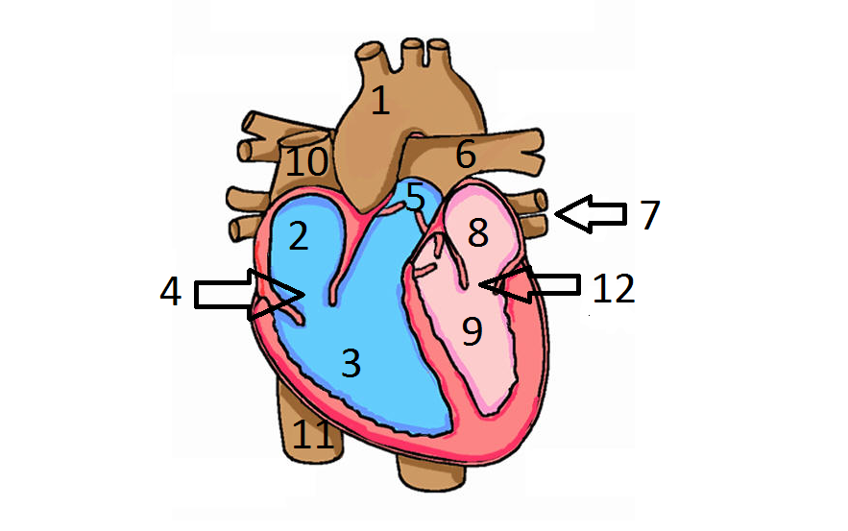
 | Name the structure | Hints
1 | Aorta | Strong walled artery withstands 160 torr pressure
2 | Right Atrium | Chamber receives deoxygenated blood from body
3 | Right Ventricle | Chamber that pushes blood to the lungs
4 | Tricuspid Valve | Valve between chambers 2 and 3
5 | Pulmonary Valve | Valve inside the pulmonary trunk
6 | Pulmonary Artery | Artery that leads to the lungs
7 | Pulmonary Vein | Veins that return blood from lungs to the heart
8 | Left Atrium | Chamber receives oxygenated blood from lungs
9 | Left Ventricle | Chamber that pushes blood to the body
10 | Superior Vena Cava | Vessel with blood from the upper body
11 | Inferior vena cava | Vessel with blood from the lower body
12 | Mitral Valve | Valve between chambers 8 and 9

IDENTIFYING ARTERIES (RED)and VEINS (BLUE). (8 points)
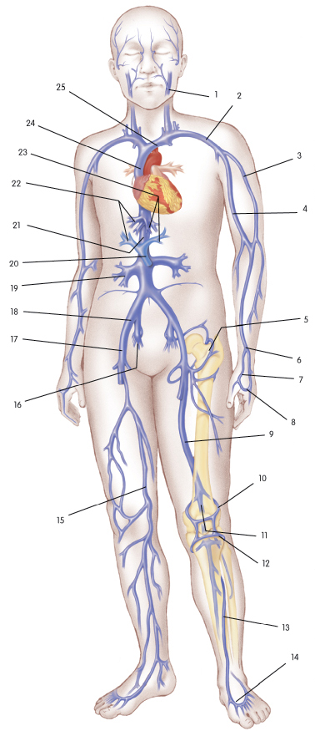
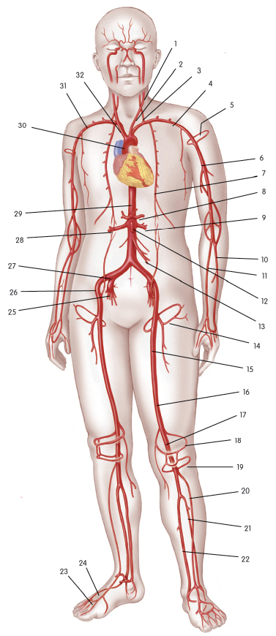

Identify FOUR arteries with the corresponding numbers.
1 | Left common carotid
4 | Left Subclavian artery
10 | Radial
30 | Aorta
Identify the four veins with the corresponding numbers.
1 | Facial vein
2 | Subclavian vein
9 | Femoral vein
15 | Great saphenous vein
CARDIAC EVALUATION:
Please place your formal answers in the white boxes, which will expand as you write.
1. Take your actual pulse by placing two fingers on the radial blood vessel which is on the thumb side of your wrist... or ....on the lunar blood vessel, which is on the baby finger side of your wrist.... and determine your 10 second pulse rate, just as you might do in the gym. You may need someone to time this for you. What is your minute pulse rate? (There are 60 seconds in a minute, so you will need to multiply your 10 second rate by the conversion factor 6 to obtain the minute rate. Show your math, using numbers and units. Start with the formula, then substitute the values and then show the final answer. ) (2 points)
10 second rate:10 pulses
Minute Rate Calculation:
Beats per minutes( bpm) = 60 seconds * number of beats/ 10 seconds
10 seconds – 10 pulses
60 seconds - ?
= 60*10/10
=60*1
=60 pulses per minute

2. Compare your minute pulse rate to what is considered to be normal adult eucardia, bradycardia or tachycardia heart rate. (Give the values for eucardia, tachycardia and bradycardia for comparison.) Explain WHY your pulse rate is higher, lower or exactly normal.
(6 points)
Comparison Statements:
My pulse rate is 60 pulse per minute.
Eucardia (normal heart rate) resting heart rate for an adult is 60 to 100 beats per minute.
Bradycardia is 120 to 150 beats per minute during surgery.
Tachycardia is 150 bpm in children and 160 bpm in infants.
Explanation:
The pulse rate is in the range because I am physically fit and in a resting position.

CARDIAC OUTPUT COMPARISONS. (8 points)
It takes about 1 minute to circulate all the blood in your body once around. For good oxygenation, your cardiac output should equal or slightly exceed your blood volume. If the CO is too low, then some cells will not be fully oxygenated.

Cardiac output equals the stroke volume times the heart rate. CO = SV * HR

Sample Problem: If SV = 120 ml/beat and HR = 140 beats per minute, then what will the CO be?

CO = SV * HR
= 140 beats/minute * 120 milliliters/beat
= 16,800 milliliters / minute
(HINT: Since 1 liter = 1000 milliliters; divide the number of ml by 1000 to obtain the liter value.)
= (16,8000 ml / 1000 ml/l) per minute
= 16.8 liters / minute

- To access your computer calculator go to: Programs > Accessories > Calculator
- The formula must appear before starting the math.
- Put in the substitution values, then do the math step by step.
- Be sure all the units are present
- Place a space between each number and its unit to be clear.
- Give units for the final answer.
- When comparing results, be sure the units are the same.

1. During exercise if your heart is beating at a rate of 140 beats per minute and the stroke volume is 80 ml per beat. What is the cardiac output per minute? Show your math
CO = SV * HR
= 140 beats/minute * 80 milliliters/beat
= 11,200 milliliters / minute
Since 1 liter = 1000 milliliters; divide the number of ml by 1000 to obtain the liter value.
= (11,200 ml / 1000 ml/l) per minute
= 11.2 liters / minute

2. During deep sleep if your heart rate is 50 BPM and stroke volume is only 60 ml, then what is the cardiac output per minute? Show your math.
CO = SV * HR
= 50 beats/minute * 60 milliliters/beat
= 3,000 milliliters / minute
Since 1 liter = 1000 milliliters; divide the number of ml by 1000 to obtain the liter value.
= (3,000 ml / 1000 ml/l) per minute
= 3 liters / minute

3. Assume that your body contains 4950 milliliters of blood. How many liters is that ? Show the math.
Converting 4950 ml to liters
Since 1 liter = 1000 milliliters; divide the number of ml by 1000 to obtain the liter value.
= (4,950 ml / 1000 ml/l)
= 4.95 liters

4. Of the exercising or sleeping cardiac outputs, which one will best deliver oxygen to all the cells of your body? (Compare the exercising CO and resting CO to the known volume of blood from step 3.)
The cardiac output in all the cases will effectively deliver the required oxygen to the body cells. This is because the body cells requirements between sleeping and exercising are conflicting. In the case of sleeping the cells are resting while in the exercise they are actively being used up so need for replenishing. Therefore, we can only compare the cases considering same conditions and environment.

RED BLOOD CELLS: (4 points each) (Remember that if a question is valued at 4 points, then at least 4 simple reasons or 2 very well explained reasons, with examples, should be provided. Full sentences are needed for most short answer questions.)
1. Give at several reasons why and how your red blood cells are important for your survival.
The red blood cells enable transportation of oxygen by hemoglobin all parts of the body. Replenishing all the cells for proper functioning of all organs.
They detoxify the body by removing carbon dioxide from the body cells. Through detoxification the cells are able to regain their energy and function correctly.

2. Imagine that you are blood type AB-, and accidentally received type B + blood in a transfusion. Describe what will happen inside your blood vessels and why.
An ABO incompatibility reaction will occur. The immune system of the recipient will produce antibodies to fight the foreign antigen which are not in his blood. The immune system attacks and destroys the antigens in the blood vessels. This is because a foreign antigen will be perceived by the white blood cell as foreign and harmful hence protect its self against them.

