HA450 Unit 7 Assignment

Name of Student
Institution Name
Name of Professor
Course
Date

HA450 Unit 7 Assignment
We will place our focus on strategic health care management in this field. Because of the following two factors, health care organizations face significant challenges today; an increased challenge in satisfying increasingly rapidly demanding users and a need to adapt their internal organization to change to keep pace with a rapid change in the use of technology. The fundamental requirements of the organization cannot be guaranteed by the increased complexity and capability of doctors. What is needed to tackle the healthcare system's transformative transformation is a systematic strategic management plan. It offers an overview and instructions on carrying out planning, evaluating the world of health systems that are both internal and external, and eventually implementing it.
Part 1
In this case, quality health care refers to the degree to which, in compliance with clinical experience and technological know-how, health facilities for patients improve the possibility of desired health services. Flawed systems and procedures cause many medical accidents, and they are not primarily caused by humans. Inefficient and variable processes, health-related insurance plans to protect, among others, some of the unexpected impediments (Analoui & Karami, 2003).
Certain quality management tools can be used when looking at process control techniques. Movement diagrams, flow charts, Pareto charts, control charts, affinity classification, job distribution charts, fishbone diagrams, and force field analysis are quality management methods. Different methods are used for multiple problem-solving opportunities, and many of the tools can be used in different ways (Lotich, 2020).
There are two distinct quality management instruments that I would like to dig deeper into today, and they are diagrams of fishbone and control charts. "The diagram of the fishbone describes several potential causes of an impact or problem. A brainstorming session can be organized using it. It divides ideas into useful categories instantly (ASQ, n.d). Looking at the cause and effect is a great visual aid, and it can help people see several different effects by placing each idea in those categories. An example of the fishbone or the 'Ishikawa diagram' can be seen below.
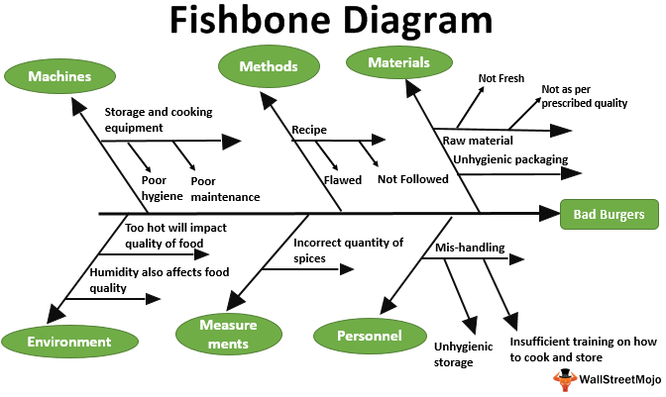
Fishbone diagram example
Control charts are the next quality improvement tool. For a prolonged period, control charts help companies see the success of the process or mission. The control chart is a graph used to study how, over time, a process shifts. Data in time order is plotted. There is often a central line in a control chart for the average, an upper line for the upper control limit, and a lower line for the lower control limit. These lines are calculated from historical data. An example of a control chart in action can be seen below (ASQ, 2020).
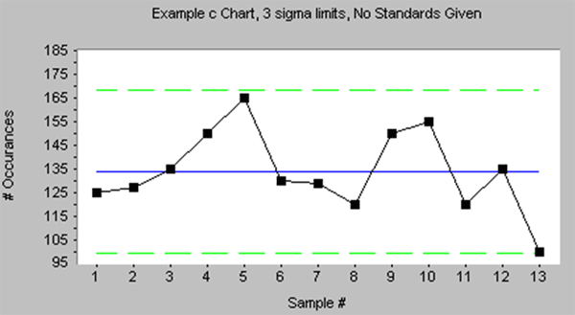
Control chart example
Part 2
We need to build a strategy for assessing and controlling performance during the transition to a EHR to use benchmarking. "Benchmarking compares the performance of a company with that of other companies" (Wilkinson, 2019). There are several benchmarking techniques, such as report cards and dashboards. You can use them.
It is important to look within the business and learn from it when you think about internal benchmarking. The company shall compare related operations. This is incredibly important to increase quality continuously. An excellent example of internal benchmarking is the contrast between two identical procedures by an entity and the gathering of knowledge about how to enhance the result. "External Benchmarking is what most people think of when referring to benchmarking. It requires the comparison of some metrics to a peer group within the same industry" (Sme, 2003).
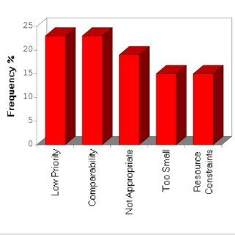
External benchmarking compares response times across various counties. In this case, you can obtain an understanding of how well you do about other jurisdictions. This will help to inspire and promote a sense of pride in their work. In this situation, it will be easier for them to arrive at the scene. If they can use their internal and external benchmarking tools, they will see what is slowing them down and how to strengthen them in their process.
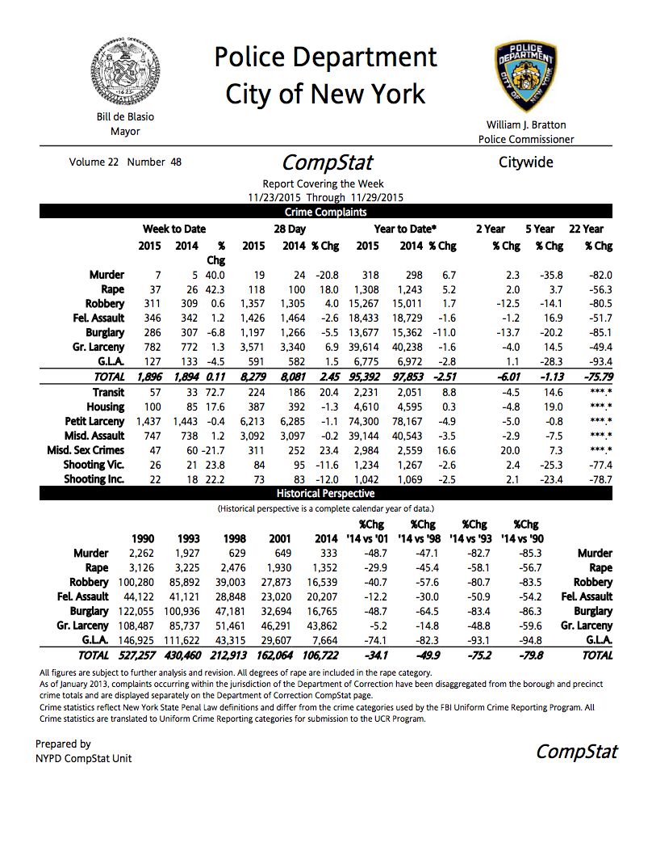
Examples of internal benchmarking explicitly planned for benchmarking forms of crime rates and details using the COMSTAT software. Companies who learn the fastest have a competitive edge as technology, consumer preferences, and competitive responses continue to evolve at a growing pace. Internal benchmarking will build a network through which it shares knowledge and ideas. It is an efficient way of defining and disseminating best practices to others from one segment of a multinational organization, with the ultimate purpose of optimizing business processes to provide consumers with greater value (BIBA, n.d).
Internal benchmarking has many advantages, such as discussing details of what went wrong/right with the process, allowing space for training people who do the actual benchmarking. Finally, the business will be able to "focus external benchmarking operations once you know the strengths and weaknesses of your organization (BIBA, n.d).
Part 3: Workflow Concept
According to Carelee (2007), "workflow management is a core component of modern enterprise information technology infrastructure that automates the execution of critical business processes. Since enterprise transformation typically introduces changes to the corresponding business processes, modern workflow management systems need to provide effective support for the seamless incorporation of these changes."
Workflow diagrams and process flowcharts are two workflow principles that could help handle the transition to an EHR framework. The organization and description of the transition to an EHR will be presented with a workflow diagram. It will explain step by step how work is being done and who is accountable for that task. "Workflows are also useful to help employees understand their roles and the order in which work is completed and to build more unity within different departments" (Lucid Chart, 2018). There are three components of the workflow diagram, and they are input, transformation, and output. Each stage has its steps and effects, with the end of all being the outcome.
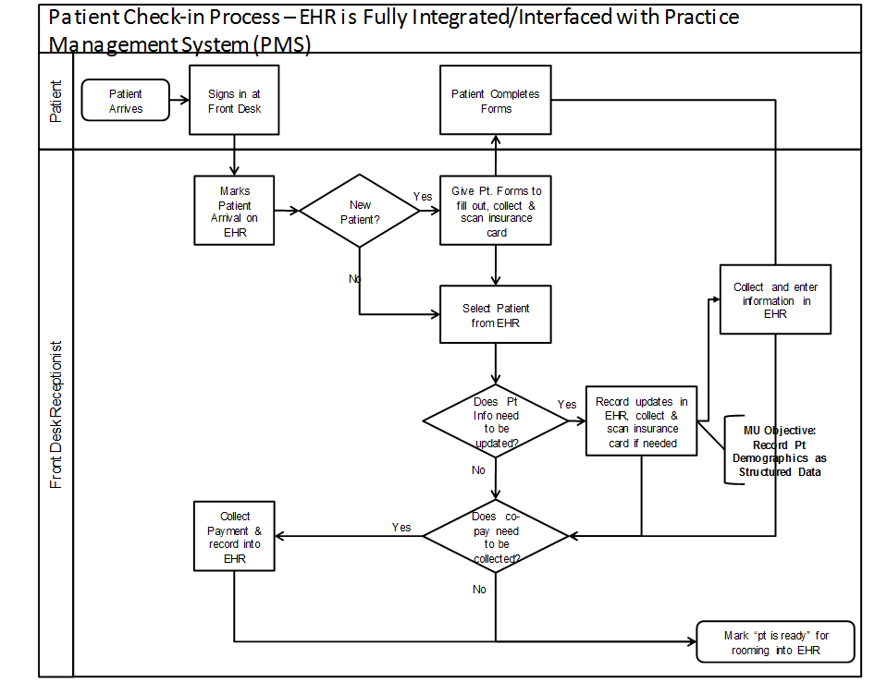
Both of these instruments are similar in that the data is broken down in a way that can be easily understood. It sets out steps for members to follow through the entire process. HelathIT gives some tips on using these tools, such as noting the wait times and holdings, documenting all ideas that can improve the process, taking all steps to prove the need for review, and finally going through the current process. You won't correct problems if you don't know the processes and workflows within the organization yourself.
Part 4
Benchmarking and Gantt Charts are project management tools that I will use for the EHR transition to ensure effective workflow and suitable performance. We have already spoken about benchmarking and how great it is, and the advantages. It is also great for continuous quality improvement. CQI is something that's needed for health care. Fresh methods, strategies, systems, etc., are still available that can benefit from benchmarking. This year, I noticed a publication in the library proposing template matching as a new benchmarking method. Template benchmarking' tests the efficiency of a subset of identical patient hospitalizations from each hospital based on matching (Daniel et al., 2020). For this analysis, they used VA hospitals and found that more than one form of the prototype would be needed to accommodate that organizational magnitude.
A graphical depiction of the length of tasks against the progression of time is "the Gantt Charts." Gantt charts are useful tools to define the chronology of activities in a workflow and project planning and scheduling (Information Knowledge Systems Management, 2007). An example of project management in a Gantt chart can be seen below.
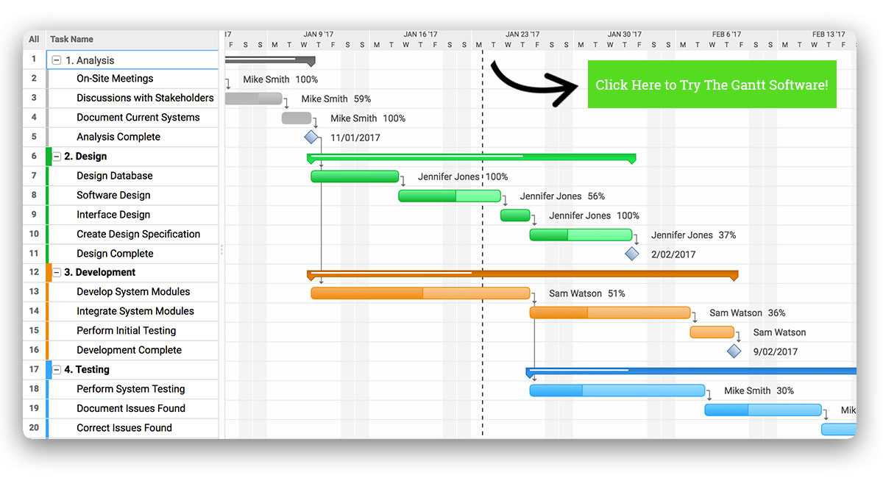
An example of the Gantt charts in action can be seen above. Step by step, it breaks down each task and shows who is at what percentage of completion. I think it will be very affectionate for me as a Human Resources officer. Especially in a situation in which we are training or processes that are changing. This will help me see what needs to be done and see who needs and maybe dealing with further assistance. "Gantt graphs are easy to understand and easy to build and are a powerful visual instrument for project management" (Information Knowledge Systems Management, 2007).
Conclusion
To sum up, in a competitive world, healthcare and hospitals have been working under increased pressure to enhance service quality and reduce costs. To improve its service delivery capability industry should be dynamic and responsive to sector changes. IT integration is widely used for adding value and building a favourable climate for sectoral innovations.

References
Analoui, F., & Karami, A. (2003). Strategic Management in Small and Medium Enterprises.
ASQ. (2020). Control Chart. https://asq.org/quality-resources/control-chart#:~:text=The control chart is a, are determined from historical data
ASQ. (n.d.). Fishbone Diagram. https://asq.org/quality-resources/fishbone#Use
Caverlee, J. (2007). Workflow management for enterprise transformation. https://eds-a-ebscohost-com.libauth.purdueglobal.edu/eds/pdfviewer/pdfviewer?vid=6&sid=00912e90-08ab-442c-bcca-c8165a7a74ae@sdc-v-sessmgr02
Daniel, M., Brenda M., V., Wyndy L., W., Gabriel J., E., Timothy P., H., Vincent X., L., Amy K., R., Andrew M., R., Sarah, S., & Hallie C., P. (2020). Developing a template matching algorithm for benchmarking hospital performance in a diverse, integrated healthcare system. Medicine, 99(24), e20385. https://doi.org/10.1097/MD.000000000002038
Excellence, C. F. (n.d.). External Benchmarking. https://centerforgov.gitbooks.io/benchmarking/content/External.html
Information Knowledge Systems Management. (2007). Different models of work in the modern services en. https://eds-a-ebscohost-com.libauth.purdueglobal.edu/eds/pdfviewer/pdfviewer?vid=6&sid=00912e90-08ab-442c-bcca-c8165a7a74ae@sdc-v-sessmgr02
Kumar, P. P. (2005). Effective Use of Gantt Chart for Managing Large Scale Projects. Cost Engineering, 47(7), 14–21.
Lotich, P. (2020, June 06). 7 Management Tools for Quality Control. https://thethrivingsmallbusiness.com/seven-management-tools-for-quality-control/
Lucid Chart. (2018). What is a Workflow Diagram? https://www.lucidchart.com/pages/tutorial/workflow-diagram
Sme, S. (2003, February 13). Supply Chain Resource Cooperative. https://scm.ncsu.edu/scm-articles/article/internal-benchmarking-looking-in-the-mirror
Wilkinson, J. (2019, February 19). Benchmarking Definition: Benchmarking Techniques The Strategic CFO. https://strategiccfo.com/benchmarking/

