Healthanimatics
Name
Institutional Affiliation

Healthanimatics
Introduction
The use of data analytics in healthcare has been noted by experts as source of important information for optimizing the operation of health services. According to Woodside (2018), health anamatics is a special discipline that is formed from the juxtaposition or intersection of health informatics and data analytics can yield important information that can be utilized by healthcare managers to optimize healthcare systems. Woodside noted that nearly 33% of all world data is generated from the healthcare industry. The use of anamatics therefore promises the world a better health through the elimination of medical errors, reduction in re-admission rates, provision of evidence-based care, demonstration of quality health outcomes, and the addition of cost-efficient health care processes. In this paper, experiential learning strategy was employed via the SAS Enterprise Miner architecture to show the power of data mining as part of data anamatics process.

Data Mining

There are several data mining strategies that can be employed in health anamatics. They include the following;

Clustering:

Clustering is an important method for search engine companies to use in helping their users find similar information. Using clustering technique service providers can group results having similar themes for their users in more concise formats (Berkhin, 2006). For instance, clustering can group the three most frequent words in a given cluster. For search engines this can translate to the most relevant results for a given search criteria.,
- Classification

Classification is a datamining method that can be used by search engine operators to assign results to specific predefined-categories such as “education”, “terrorism”, and “” sports.
- Association Rule Mining:
This method of data mining can be used by data mining companies to discover hidden patterns within a given database by creating links that associate the datasets or data points within the dataset (Jiang, & Gruenwald, 2006). The methodology involves finding interesting relationships between a large databases. The methodology is used to identity strong rules that are discovered in databases by means of certain measures of interestingness. For instance, if a certain area is known as a crime hot spot, then if one searches the name of the location, then suggestions such as “Chicago crime?” Or “Chicago gun violence” pops up as suggestions by the search engine
- Anomaly Detection:
Anomaly detection is a data mining technique or algorithm that can be used to discover unusual patterns in user-generated traffic. For instance, is a given topic begins to trend and becomes more popular. Search engine operators may use anomaly detection to direct their advertising strategies that are based on relevance to the detected anomaly (Borders & Prakash, 2004)
What is experiential learning?
Experiential learning is an educational or learning technique that places emphasis on experiences instead of mere theoretical constructs. It involves designing and improved classroom in order to enhance how learners perceive their learning materials and concepts (Chapman et al, 2016). As opposed to the traditional-learning approaches that do not emphasize on real-world scenarios and content, experiential learning is all about real-life scenarios and content.
Methodology-The data mining process used in the analysis (SEMMA)
The SAS Institute’s definition of data mining is that it involves sampling, exploring, modifying, modelling and assessment (SEMMA) of massive quantities of data in order to uncover patterns and relationships that were previously unknown for the sake of gaining competitive advantage (Woodside, 2018). Data mining is use din many industries for solving a myriad of business problems such as fraud detection, customer retention, householding, database marketing, customer attrition and retention, market segmentation, bankruptcy prediction, and risk analysis among many more uses. In this paper, the SAS Enterprise Miner was used to implement the SEMMA process by accomplishing the following objectives;
- Sampling the data through the creation of one or more suitable data tables. A large quantity of representative dataset was chosen for this process
- Exploring the data by probing for the expected or suspected relationships, unintended trends, as well as anomalies so as to gain a deeper understanding of the udnerlyign relationships
- Modifying the data through the creation, selection, and transformation of the variable sin order to give focus to the model selection process
- Modeling the data by means of analytical tools for the sake of combining the data in order to attain a reliable prediction of the desired outcomes
- Assessing the data through the evaluation of the reliability and usefulness of the findings from the entire data mining process

The process and outcomes

Sampling
Data Set Variable | Role | Level
RecordID
DischargeDisposition
Cohort
FacilitySize
InsuranceType
Age | Secondary variable | 1
ICDCounts | Secondary variable | 1
LengthOfStay | Primary variable | 3
Readmission | Secondary variable | 3

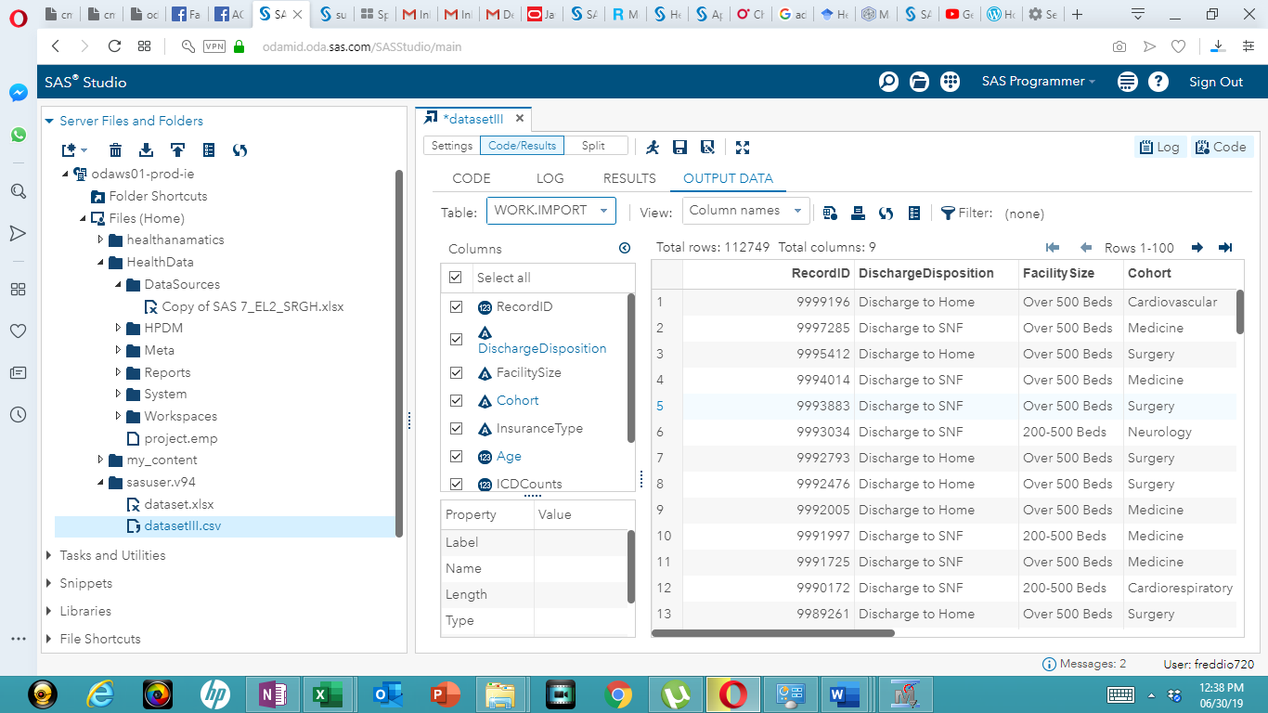

Recommendations
The data mining process using the online version of SAS Enterprise Miner was straightforward. The data was uploaded to the servers via the SAS Studio GUI. The sampling recommendation is that 80% samples selected should be included in the final analysis. The analysis revealed that there is a strong relationship between age, ICD count, readmission rates and cohort.
Model advantage and disadvantage
An evaluation of the model indicated that it showed the nature of relationships between the key variables. However, it does not show the exact nature of the relationship for the variables when considered in groups. The outcome is therefore confusing.
Deployment
In regard to deployment, the model is best suited for studying various relationship between the healthcare variables chosen. The output can be used be used by healthcare managers to plan the various healthcare scenarios for a country’s healthcare industry. As noted earlier, the use of anamatics therefore promises the world a better health through the elimination of medical errors, reduction in re-admission rates, provision of evidence-based care, demonstration of quality health outcomes, and the addition of cost-efficient health care processes

References
Berkhin, P. (2006). A survey of clustering data mining techniques. In Grouping multidimensional data (pp. 25-71). Springer, Berlin, Heidelberg.
Borders, K., & Prakash, A. (2004, October). Web tap: detecting covert web traffic. In Proceedings of the 11th ACM conference on Computer and communications security (pp. 110-120). ACM.
Jiang, N., & Gruenwald, L. (2006). Research issues in data stream association rule mining. ACM Sigmod Record, 35(1), 14-19.

