HIV/AIDS

Name
Institution Affiliation
Course Name
Instructor
Date

Introduction
HIV stands for human immunodeficiency virus. It is the virus that causes AIDS (acquired immunodeficiency syndrome). AIDS is the late stage of HIV infection. It is a virus that attacks the human body's immune system, making it weaker and weaker and more vulnerable to other infections. The first case of the disease was reported in 1981 in the United States. The World Health Organization (WHO) describes HIV as a global epidemic. Around 37.7 million people are living with HIV today (UNAIDS). This paper explores this deadly disease's causes, symptoms, transmission, treatment, and morbidity. The article also discusses the social determinants associated with the disease as well as its epidemiologic triangle. The role of the community health nurse is also explained. The implications of the disease are also discussed.
Causes, symptoms, transmission, treatment
The term communicable disease refers to an infectious disease transmitted directly or indirectly after getting into contact with an infected person as a vector. HIV is one of the most infectious/contagious diseases that are affecting many nations. This epidemic has killed many people leaving children orphans, leading to poverty as individuals by drugs to subdue the disease. The term Human Immunodeficiency Virus (HIV) can refer to a virus that attacks and alters the immune system, thus, increasing the risk of another infectious disease. This contagious disease gradually/progressively advances to another stage called Acquired Immune Deficiency Syndrome (AIDS). HIV is a lifelong infection that leads to other opportunistic diseases such as tuberculosis.
Nevertheless, treatment and managing HIV can help prevent it from reaching severe stages (Liu et al., 2017). It attacks the CD4 cells, which are a type of T cell, thus decreasing the body's potential to fight other diseases. HIV generally arises as an effect of a virus and can be transmitted through bodily fluids. The most common body fluids involved include blood, milk from mothers to children, vaginal secretions, semen, and anal fluids. These fluids are usually transferred through sexual intercourse with an infected person without using a condom or PrEP, sharing sharp objects for hormones, steroids, and injectable illicit drugs with an infected person, lactating mothers can infect their baby, and also during pregnancy and childbirth. Also, this disease can be transferred to another person through blood transfusions without an effective screening procedure before the blood donation, which is usually a rare case.
HIV infections by viruses, parasites, or bacteria are the ones that show more severe symptoms of HIV. This disease is one of the world's most pressing public health challenges. Some people infected with HIV tend to show signs after months or even years have contracted the disease. However, 80% of people may manage to display a set of flu-like symptoms after 2-6 weeks called an acute retroviral syndrome. Early HIV infections' symptoms include joint pain, tiredness, sore throat, sweats mostly at night, weakness, a red rash, rapid weight loss, enlarged glands, extreme fever, and chills. The late-stage of HIV infection include dry cough, night sweats, swollen glands lasting for weeks, blurred vision, diarrhea, and permanent tiredness. Currently, the virus has no cure, but proper treatment and management can help reduce the condition's progression, thus, enabling a relatively healthy life. HIV patients are encouraged to start ART as early as possible to help elevate the life expectancy of the patients as well as reduce transmission. Better and more effective treatments such as taking medicine such as ARVs have been discovered to improve quality of life. Analytical statistics have shown that more people infected by HIV live better lives, and they are not dying like before. The emergence of HIV pills known as post-exposure prophylaxis (PEP) is known to help stop the infection if taken with the last three days of exposure to the virus.
The mortality rate of people infected with HIV has been increasing. A person who has symptoms of HIV should present themselves to the nearest clinic for testing and early treatment and most importantly, avoid spreading it to others. The patient can live a healthy life for a long period of time if they take the drugs to suppress the virus. Statistics demonstrate an increase in poor children with HIV living below the poverty line in the year 2017 (Sashindran, & Thakur, 2020). The above might not generally measure the depth of how many children are in misery. Thus, the patient should visit a VCT see a doctor followed by a psychologist for guidance and counseling. Therefore, it is advisable to be checked and receive a diagnosis and treatment when you suspect that you might have HIV depending on the symptoms ascribed above, right away without hesitation. This issue is because when left untreated, it may lead to adverse effects resulting to further health consequences.
The below diagram is an illustration of a statistical analysis of the spread of HIV among different nations. The highest percentages of people affected by HIV are the white people with 55.2%, followed by the black Africans with 31.6%.
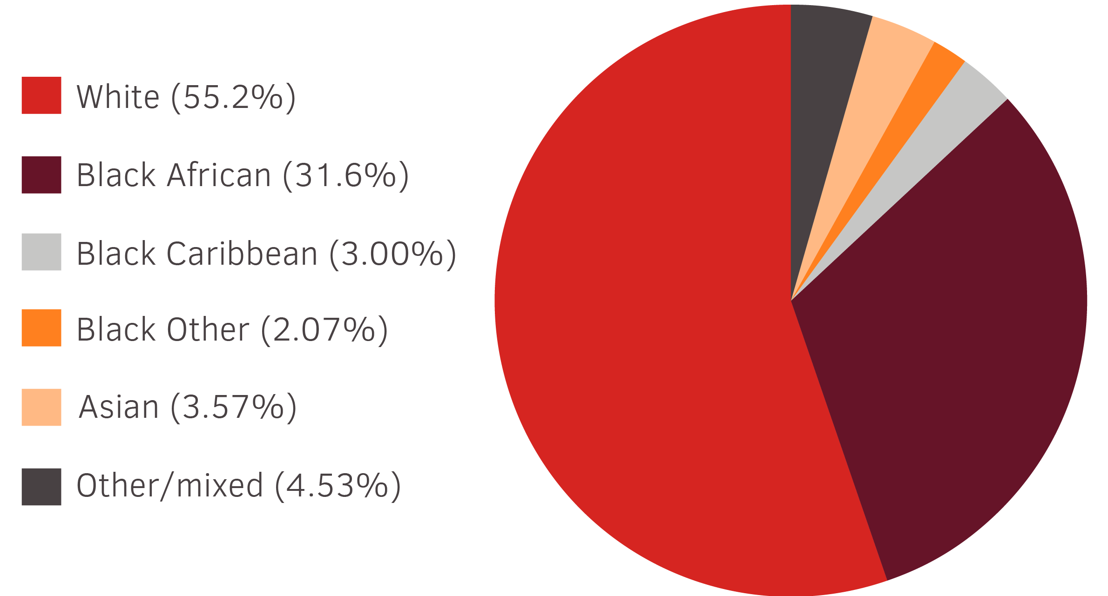
Health determinants
The social health determinants refer to the issues and systems that determine people's way of life. These include the factors that determine how people live, and age, thus, shaping the conditions of daily life. The significant forces involved in this issue include the factors that address the way of life of an individual and another member of the community. The forces also include the relationship between individuals and the system in the respective nation. These factors have contributed to the development of HIV disease. People infected by HIV are affected when people begin to stigmatize them and stop taking the drugs leading to a quick death. A factor such as poverty has led to the development of the disease because of the higher living standards; most victims lack quality food that pertains balanced diet (Rushing, 2018). In the process, many become infected with HIV, which requires high capital for maintenance, thus, resulting in the death of many victims and rapid growth of the HIV disease. Also, the social stigma and discrimination factors have exhibited a great concern to the people living with HIV. Thus, many have died to prevent others from knowing they are carriers of the virus. The pressure of social stigmatization and discrimination has, in the long run, prevent HIV services from reaching them.
Education is another social determinant related to HIV/AIDS. Educated people are likely to have access to contraceptives like condoms and PEPs that reduce the risk of contracting the virus. On the other people with low literacy levels have high chances of contracting the virus because they do not have access to contraceptives like condoms. This is particularly relevant in poor communities in Sub-Saharan Africa, where literacy levels are very low.
Income and social status are other social determinants of health that can exacerbate the risk of contracting HIV. High poverty levels make girls and women engage in sexual activities to earn a living, increasing the chances of contracting the virus. Poverty also forces young girls to get married at very tender ages. The girls are married to older men who may be infected with HIV. Additionally, poverty makes the infected people lack resources like the quality diet needed to sustain the virus.
Epidemiologic triangle
The term Epidemiology relates to HIV in one way or the other. Therefore, this term epidemiology refers to the study of health-related issues, states, or incidents such as disease and control conditions and other health issues on how they are distributed. In other words, this study helps in knowing the extent to which it's distributed to control the spread of diseases to other countries. This study falls into two domains called convection (Classical) and common. Therefore, this study relates to HIV by helping doctors to be able to prevent further spread by putting up preventive measures to it. First, knowing the population affected by the disease and the time frame will help estimate the perception of the essential needs of the health status in relation to identifying between the demand and the necessity thereof (Grimsrud et al., 2016).
The epidemiologic triangle refers to the factors that cause a given disease and the other factors contributing to its spread after rapidly reproducing. The HIV agent is a microbe caused by a virus. It spreads from one person to another through bodily fluids during sexual intercourse with an infected host. The three parts of the epidemiologic triangle include host, agent, and environment (Karon et al., 2016). The environment one leaves can be a facilitator of the disease. This principle is essential in providing standard healthcare depending on medicine, focusing on enhancing the sleep disorder of the affected population through management. The above is likely to be attained by bringing together different variations by studying its ethnicity, geographical coverage, and other issues like gender. It helps to bring about the measurements of results via expected procedures. Also, there can be the implementation of diagrams relating to the number of physicians on the ground.

Role of the community health nurse
Community health nurse plays a very crucial role in the prevention of a particular disease. They provide a conducive environment for patients and community members to receive quality service (Mukherjee & Eustache, 2017). Thus, the community health nurse's primary role is to provide treatment to patients. Also, they help provide education to the community on how to maintain their health to decrease the incidence of deaths and disease. Most patients die daily due to a lack of knowledge concerning specific diseases and how to prevent them from occurring. In the case of an outbreak of a disease, the community health nurses help to perform research to determine the exert cause of the epidemic. Through this, they help to advocate for health improvements in the given community. HIV disease is sometimes not understood by many people, thereby becoming victims of it. Through the community health nurse, they help to offer quality research analysis and educational terms (Gillies & Chin, 2016). The community health nurse can help educate people on the modes of transmission of the disease and how to care for the infected friends and families. The term demographic data refers to the data that is statistically socio-economic such as education, race, and population, among others. The demographic information helps to prepare to deal with issues that may arise due to population growth based on the predictions of the data. The above helps to ensure that the community is safe from impending diseases such as HIV that may affect the economic growth of the given population. The data also helps government and other relevant agencies to plan on how to care for HIV patients, including their medication, guidance, and counseling. It also helps to identify the age group at a higher risk of contracting the virus at a particular time.
Agency
Many organizations have been founded to address some contagious diseases to reduce their impact and increase in nations. One of these organizations that fully funds countries to deal with this virus includes the Global AIDs Society. The IAS is one of the world's largest associations that occurred in 1988 to reduce the global impact of HIV. Since then, it has focused on HIV/AIDs through funding to support programs run by local experts in communities. It stewards the two most prestigious HIV conferences that teach people how to stay healthy and help victims overcome stigmatization and emotional trauma (Rushing, 2018). It is working on the plan to prevent the spread of HIV to the next generation, thus significantly impacting the nation's socio-economic growth. It has helped to deliver vaccines and drugs to HIV patients and food to reduce the death rate experienced by people suffering from HIV.
Global implication
HIV has been one of the major leading epidemics that are wiping many people over the nation. Therefore, this disease has some global implications and impact when not termed. Most people think that it affects an individual and affects nations, economic stability, and general development of the involved nations, impacting households. It is also known that such countries suffer from food insecurity, other infectious diseases, and other issues. There is poverty in states with the highest population of HIV patients because they can't work, leading to over dependency. HIV lowers the nation's standard of living and reduces the expectancy rate among people (Gillies & Chin, 2016). Additionally, the disease diverts a lot of money that could have been used for other development projects like infrastructure building. Therefore, this has made many countries, such as the United States, respond to the global epidemic by setting up measures and establishing organizations to help detect, prevent, and respond to existing and new virus threats. Most nations offer relief food and medication to the affected areas to help reduce the deaths. In a normal situation, HIV disease is known to be endemic to a specific geographic location. Mostly, this is increasing in the African nation that has resulted in over 40million people dying yearly. Statistics show a significant number of individuals that are living with HIV having children been affected also.
There are myths and misconceptions about HIV/AIDS, mainly in African societies and cultures. For example, some societies believe the disease does not exist, while others believe it is a curse from God. Additionally, some cultures believe that having sex with a virgin girl cures the disease. These misconceptions make these primitive communities not take any measures to address the disease.
Conclusion
In summary, HIV/AIDS disease has been one of the significant health challenges to many nations, and this is because there is no cure for the disease. It is a deadly disease that has many adverse effects on an individual and the society/nation as a whole. Although not curable, the disease is preventable. We should all take measures to prevent the spread of disease by avoiding unprotected sex with people who we don’t know their status.

References
Grimsrud, A., Bygrave, H., Doherty, M., Ehrenkranz, P., Ellman, T., Ferris, R., ... & Bekker, L. G. (2016). Reimagining HIV service delivery: the role of differentiated care from prevention to suppression. Journal of the International AIDS Society, 19(1). https://dx.doi.org/10.7448%2FIAS.19.1.21484
Karon, J. M., Rosenberg, P. S., McQuillan, G., Khare, M., Gwinn, M.,& Petersen, L. R. (2016). Prevalence of HIV infection in the United States, 1984 to 1992. Jama, 276(2), 126-131.
Liu, J., Williams, B., Frank, D., Dillon, S. M., Wilson, C. C., & Landay, A. L. (2017). Inside out: HIV, the gut microbiome, and the mucosal immune system. The Journal of Immunology, 198(2), 605-614. https://doi.org/10.4049/jimmunol.1601355
Mhlongo, E. M., Lutge, E., & Adepeju, L. (2020). The roles, responsibilities, and perceptions of community health workers and ward-based primary health care outreach teams: a scoping review. Global Health Action, 13(1), 1806526. https://doi.org/10.1080/16549716.2020.1806526
Rushing, W. A. (2018). The AIDS epidemic: Social dimensions of an infectious disease. Routledge.
Sashindran, V. K., & Thakur, R. (2020). Malnutrition in HIV/AIDS: aetiopathogenesis. Nutrition and HIV/AIDS-Implication for Treatment, Prevention and Cure. [series online].

