Hospital Management System
The purpose of the project entitled as “Hospital Management System” is to computerize the Front Office Management of Hospital to develop software which is user friendly, simple, fast, and cost – effective. It deals with the collection of patient’s information, diagnosis details, etc. Traditionally, it was done manually.
The main function of the system is to register and store patient details and doctor
details and retrieve these details as and when required, and also to manipulate these details meaningfully System input contains patient details, diagnosis details; while system output is to get these details on to the CRT screen.
Our project Hospital Management system includes registration of patients, storing their details into the system, and also computerized billing in the pharmacy, and labs. Our software has the facility to give a unique id for every patient and stores the details of every patient and the staff automatically. It includes a search facility to know the current status of each room. User can search availability of a doctor and the details of a patient using the id.
The Hospital Management System can be entered using a username and
password. It is accessible either by an administrator or receptionist. Only they can add data into the database. The data can be retrieved easily. The interface is very user-friendly. The data are well protected for personal use and makes the data processing very fast.

- Time Table
There are some changes have been made to what we propose in Project Proposal released at the end of the semester on insert date, which are as follows:
- The project plan has been revised to have 2 progresses with final progress instead of 3 progresses with final progress:

Original schedule proposal |  | Current schedule after update
Progress 1 | Feature 1: Schedule management  Feature 2: User registration and authentication  Feature 3: Appointment management | Progress 1 | Feature 1: Schedule management  Feature 2: User registration and authentication  Feature 3: Appointment management
Progress 2 | Feature 4: Patient identification using QR code  Feature 5: Health care consulting and following up | Progress2 | Feature 4: Patient identification using QR code  Feature 5: Health care consulting and following up  Feature 6: A Health clinic information and promotion  Feature 7: Cost estimation of Health treatments
Progress 3 | Feature 6: A Health clinic information and promotion  Feature 7: Cost estimation of Health treatments | Progress2
Final Progress | Overall documentation | Final Progress | Overall documentation

According to the project plan document, the deliverables plan of “Hospital Services Management System” application is defined as follows:
Current schedule after update |  | Status
Progress 1 | Feature 1: Schedule management  Feature 2: User registration and authentication  Feature 3: Appointment management | Complete
Progress 2 | Feature 4: Patient identification using QR code  Feature 5: Health care consulting and following up  Feature 6: A Health clinic information and promotion  Feature 7: Cost estimation of Health treatments | To be completed by end of semester date

System Architecture

Visitors and patients can use both the mobile application and the web application. Doctors can use the web application to manage the schedule, add information via the Google Chrome browser, and identify patients by scanning QR code using a webcam. Doctors can manage their schedule and provide consultation to their patients using the web application. The system generates QR code for the patients and send it to their smartphone. The database of system is stored on the web server.

Sequence Diagram
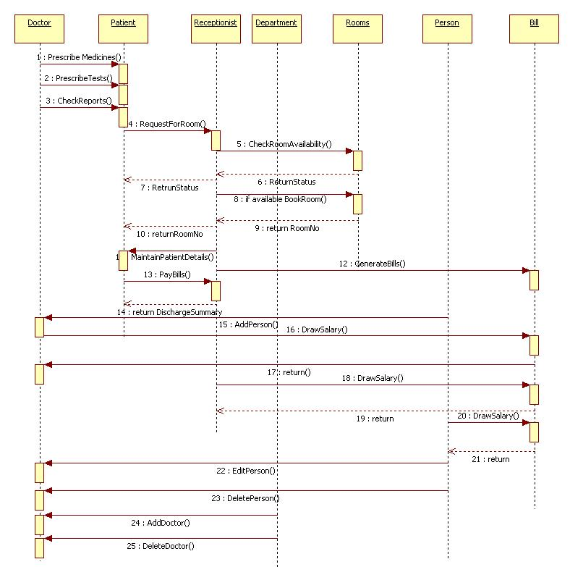
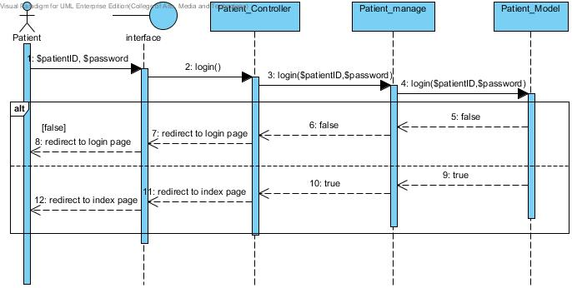
Patient Login

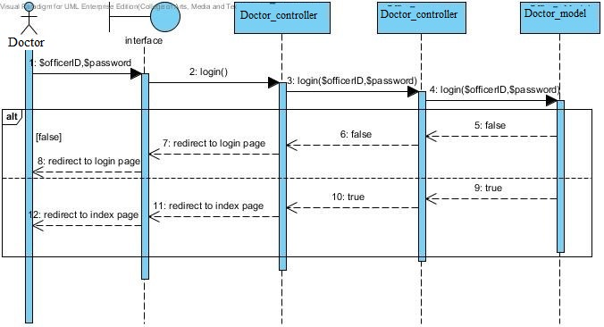
Doctor Login

Use Case Diagram

Hospital services system Use Case for Patient

User Classes and Characteristics

The system divides users into 3 groups. Information and characteristics of each group are listed below.
- Visitor
This group of user no needs to register to the system to use the services on the website or to use their mobile phone. Visitor is able to:
- Visitor can view calendar from Google Calendar.
- Visitor can view Doctor clinic information and promotion
- Visitor can select Doctor treatment to estimate the cost

- Patient
This group of user needs to be registered to the system at the Doctor clinic. They will get patientID and password from the clinic to use the services on the website or to use their mobile phone. Patients use their patientID to login. Patients are able to:
- Patient can receive a pateintID and password from the Doctor clinic.
- Patient can login to the web application and the mobile application.
- Patient can logout from the web application and the mobile application.
- Patient can view his/her appointment in the patient schedule.
- Patient can view all appointments in the Doctor clinic schedule.
- Patient can view their QR code.
- Patient can view follow up question.
- Patient can answer to follow up question.
- Patient can view Doctor clinic information and promotion.
- Patient can select Doctor treatment to estimate the cost.
- Patient can identify him/herself by using the QR code
Doctor
This group of user needs to be registered to the system at the clinic. They will register their account at the clinic. Doctor uses their DoctorID and password to login to the system to use the services. Doctors are able to:
- Doctor can login to the web application by using DoctorID and password
- Doctor can logout from the web application
- Doctor can view his/her appointments in the Doctor schedule
- Doctor can view all appointments in the Doctor clinic schedule
- Doctor can view their follow up question.
- Doctor can post question to follow up their patient

Patient and Visitor

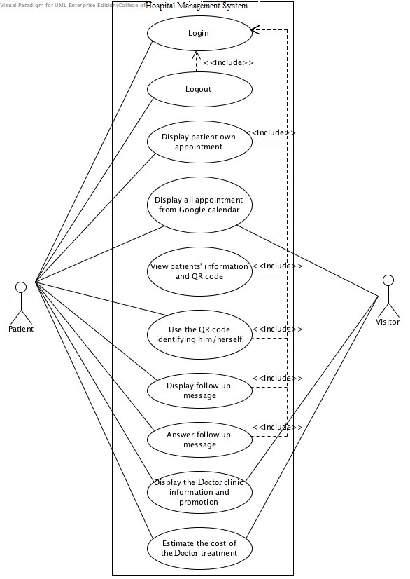
Figure: Health clinic services system patient use case diagram
- Context Level DFD

Medical Advice

Carrier & Job Hospital

PG Programmer

Patient Status

Patient Appointment

Bill Payment

HOSPITAL MANAGEMENT SYSTEM

- User Interface Design
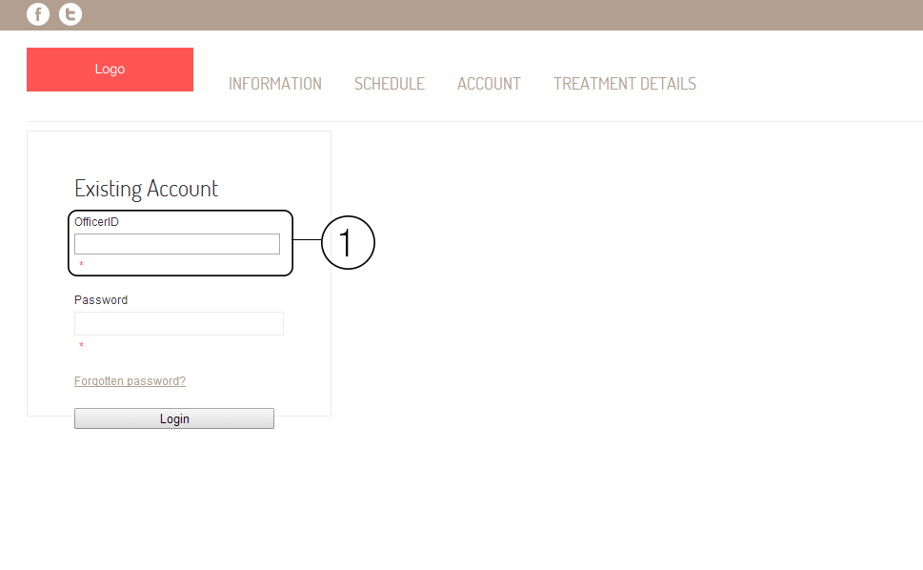
Login.
Shows the login page of the website. The area number 1 is the field of input userID and patientID. In Doctor login page will show as DoctorID, in patient login page will show as PatientID, and in doctor login page will show as DoctorID

Create a new User.
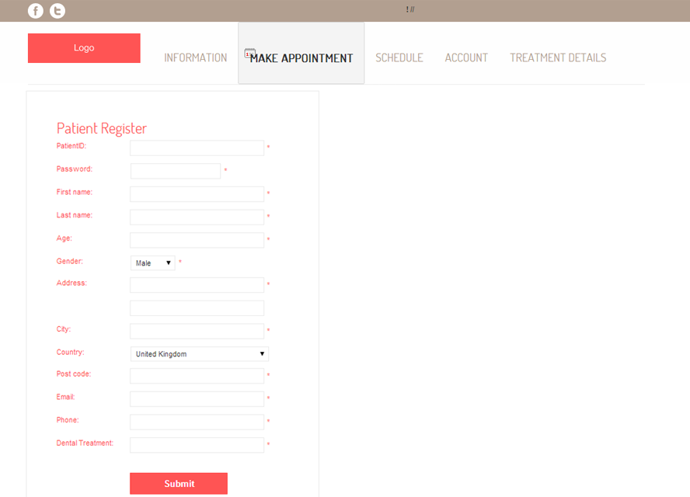
Edit User Details

UC1: Login to System
Primary actors: System Administrator, Receptionist/Management Staff,
Doctor, Patient, Nurse.
Trigger: user hits login Button in HMS home page.
Preconditions: The user is not yet logged in
Post conditions: The user can access the main menu of their Profile
Main Success scenario:

- User types in his/her User Name
- User types in his/her Password
- System Validates given login parameters
- System creates a new session for the user
Alternative flows:
- User provides invalid login parameters:
- System show warning about wrong parameters.
- System redirects the user to the login page again.
- User reenters his/her id and password
Special requirements: Response time less than 3 seconds
Technology and Data Variations List:
User wants to be remembered on a particular Pc.
Frequency of occurrence: Once every time use gets log out.

UC2: Logout from System
Primary actors: System Administrator, Receptionist/Management Stuff, Doctor , Patient, Nurse.
Trigger: User hits logout Button in HMS home page.
Preconditions: The user is logged in
Postconditions: The user successfully gets logged out from his/her account
Main Success scenario:

- User finishes his/her session by hitting logout option and get log out from HMS
Alternative flows:
- Net gets disconnected:
- System will automatically log out if net gets disconnected.
Special requirements: Response time less than 3 seconds
Technology and Data Variations List:
None?
Frequency of occurrence: Once every time use gets logged it.

UC3: Add/Register Patient
Primary actors: System Administrator, Receptionist/Management Stuff
Trigger: Admin/ Receptionist hits register Patient Button in HMS home page.
Preconditions: Patient is not Already Registered
Postconditions: Patient gets Register
Main Success scenario:

- New Patient comes to the hospital.
- Admin/Receptionist starts a new Patient registration
- Admin/Receptionist enters basic Patient information (Name, Age, Gender, Cnic of his/her or guardian, Phone Number, Illness)
- System Assigns New Id and Password to Patient.
- Admin/Receptionist saves Registration Form
- System Displays Profile of new Patients.

Alternative flows:
- at any time system fails:
- Admin/ Receptionist restarts system, logs in and request recovery of prior state.
- System reconstructs prior state
- Admin/ Receptionist starts a new Patient registration
b) Any Required Field Left Blank in Registration Form
- System signals error to Admin/Patient
- Admin/ Receptionist enters missing field to get Patient Register.

Special requirements: Response time less than 3 seconds
Technology and Data Variations List:
Patient Id and Password could be generated by the system or entered by Admin/ Receptionist
Frequency of occurrence: Patient only gets registered once.

