Respiratory System Lab

Purpose:
The purpose of this lab is to become familiar with the anatomy and physiology of the respiratory system.

Materials:
To complete this lab you will need access to McGraw Hill’s Connect platform, and through it you can access the Cadaver Dissection Tool, also known as A&P Revealed.

Procedure:
Log in to Connect, and navigate to the Cadaver Dissection Tool. It will open automatically when you click on it. This is a memory-intensive program, so it is recommended that you close other windows and programs before attempting to utilize it.
- Choose the respiratory module (number 11)
  - Click on Dissection at the top (symbol of a scalpel)
  - Choose Upper Respiratory under topic
  - Choose Lateral under view
  - At the bottom left, remove layer 1 by clicking and dragging the red arrow to the bottom of the scale.
  - Click on the round button under Layer 2 to turn on the tags.
  - Go through each part by clicking on the green pins that show on the image at the right, or by clicking on each name in the list under the view box.
  - Click on Layer 3 tags, and go through the parts as above.
  - Click on Layer 4 tags, and go through the parts as above.
- Choose the respiratory module (number 11)
  - Click Dissection at the top (symbol of a scalpel)
  - Choose Lower Respiratory under topic
  - Choose Anterior under view
  - At the bottom left, remove layer 1 and 2 by clicking and dragging the red arrows to the bottom of the scale.
  - Click on the round button under Layer 3 to turn on the tags.
  - Go through each part by clicking on the green pins that show on the image at the right, or by clicking on each name in the list under the view box.
  - Click on Layer 4 tags, and go through the parts as above.
  - Click on Layer 5 tags, and go through the parts as above.
- Choose the respiratory module (number 11)
  - Click on Dissection at the top (symbol of a scalpel)
  - Choose Larynx under topic
  - Choose Anterior under view
  - At the bottom left, remove layer 1 by clicking and dragging the red arrow to the bottom of the scale.
  - Click on the round button under Layer 2 to turn on the tags.
  - Go through each part by clicking on the green pins that show on the image at the right, or by clicking on each name in the list under the view box.
  - Click on Layer 3 tags, and go through the parts as above.
- Choose the respiratory module (number 11)
  - Click on Histology at the top (symbol of a microscope)
  - Choose Respiratory Epithelium under topic
  - Choose High Magnification under view
  - At the bottom left, click the round button to turn tags on.
  - Go through each part by clicking on the green pins that show on the image at the right, or by clicking on each name in the list under the view box.
- Choose the respiratory module (number 11)
  - Click on Animations at the top (symbol of movie film)
  - Under respiration Interactives complete interactives:
    - 2: Alveolar Gas Exchange
    - 4: Systemic Gas Exchange

Conclusion:
Label the images below, then answer the questions below. Note: Add numbers under the image and answer below the question (or inside the table). .

Respiratory Membrane (Worth up to 5 pts)
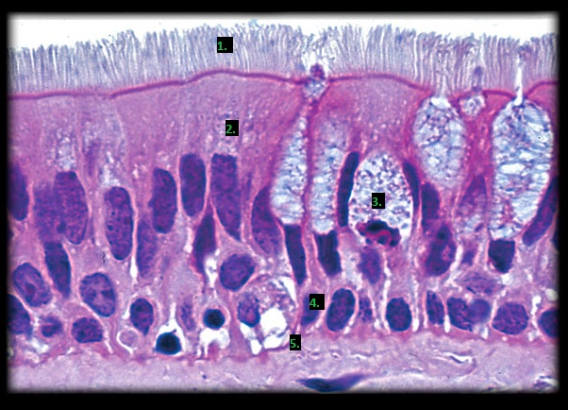

Larynx(Worth up to 5 pts)
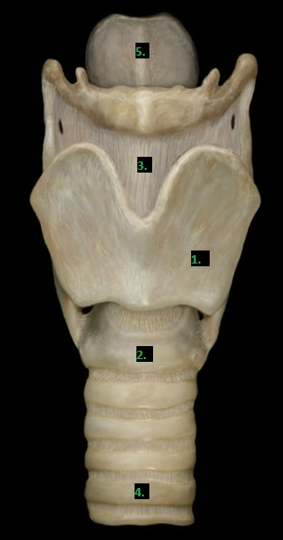

Upper Respiratory (Worth up to 5 pts)
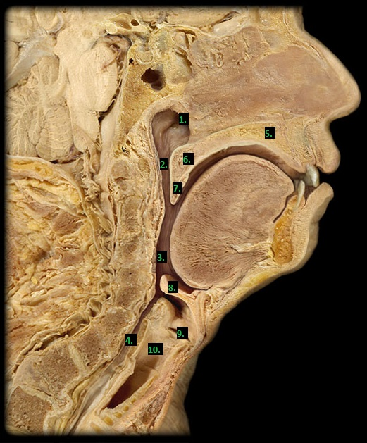

Lower Respiratory 1(Worth up to 5 pts)
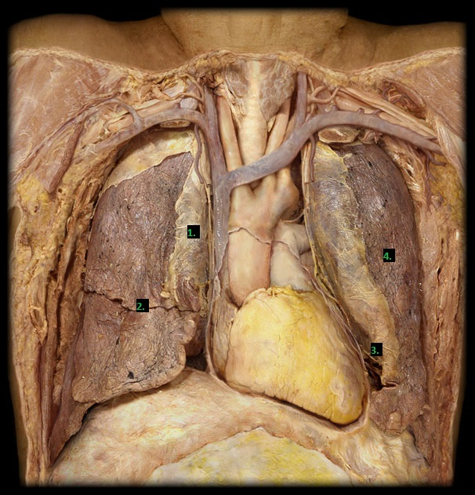

Lower Respiratory 2 (Worth up to 5 pts)
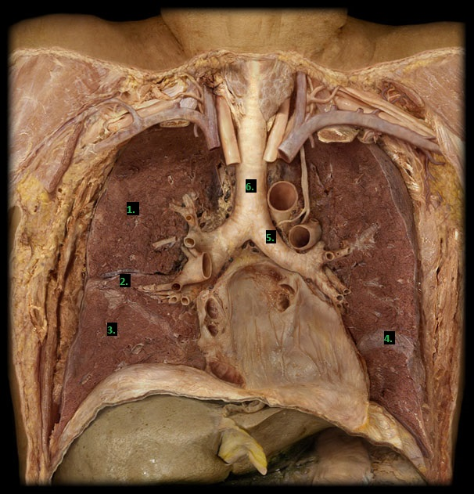

Essential Questions
- What is Boyle’s Law? (Worth up to 5 pts)

- Pulmonary Volumes- amount of air that flows into or out of the lungs during particular events (fill in the table) (Each table is worth up to 5 pts EACH)
Pulmonary volume | Norm | How is it measured?
Tidal Volume (TV)
Inspiratory Reserve Volume (IRV)
Expiratory Reserve Volume (ERV)
Residual Volume (RV)

Pulmonary Capacities- The sum of particular pulmonary volumes (fill in the table)
Pulmonary Capacities | Norm | How is it measured? | Formula
Inspiratory capacity (IC)
Functional Residual Capacity (FRC)
Vital Capacity (VC)
Total Lung Capacity (TLC)

Checking for Understanding (Each question is worth up to 2pts each)
- Name the external opening into nasal cavity.
- Name the bony structures in the nasal cavity that extend from the lateral walls of nasal cavity and form the passageways called the meatuses.
- Name the tube leading to the middle ear from the superior part of the pharynx.
- Name the tonsil in posterior wall of the superior part of pharynx.
- Name the tonsils in fold between oral cavity and oropharynx.
- Name the tonsil at base of the tongue.
- Name the tongue bone.
- What is the proper name for vocal cords?
- Describe the general shape of tracheal cartilages.
- Name the tool used to measure respiratory volumes.
- Name the branches of trachea that transmit air to lungs.
- Name the branches of the airways in question 20 that transmit air to the lung lobes.
- Name the branches of the airways in question 21 that transmit air to the bronchopulmonary segments.
- Name the small, muscular airways that branches off of the tertiary bronchi.
- Name the first airways to exchange gases.
- Name the blind-end tubes that lead to alveoli and alveolar sacs.
- Name the cells within alveoli that secrete surfactant.
- What other name is used for the alveolar macrophages?
- Name the top of lung.
- Name the bottom of lung.
- Name the depression where structures enter and exit the lung.
- What lung has only one fissure?
- Which lung has a horizontal fissure?
- Which lung has a cardiac notch? Why does this lung have the cardiac notch?
- Name the pleural membrane that covers the surface of the lung and extends into the fissures between the lobes.
- Name the pleural membrane that lines the inner surface of the thoracic wall and extends over the diaphragm and mediastinum.
- Name the potential space that lies between the above membranes.
- Name the main muscle of respiration.
- Name the rib muscles used during eupnea.
- Name the epithelium lining most of the nasal cavity, larynx below the vocal folds, trachea, bronchi, and most bronchioles.

