HOMEWORK 5: CS 425 (THEORY OF ALGORITHMS)
DUE DATE: FRIDAY, APRIL 2ND, 2021
(problem 4 is programming exercise)

- Given the following Graph:
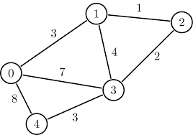
- What is the Graph density of this Graph?
- Classify the Graph based on number of edges.
- Give the adjacency matrix of this Graph.
- Illustrate the Kruskal’s algorithm to determine the minimum spanning tree, and draw the minimum spanning tree.

- Given the graph as below. Show each steps of Prim’s algorithm and from the final table draw the minimum spanning tree.
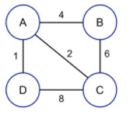

- Using node 3 as the vertex find the shortest path from vertex 3 to any other vertex using Dijkastra algorithm.

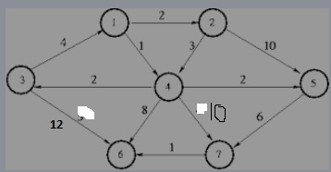

- Given a C++ Program to implement Prim’s algorithm
#include <iostream>
#include <climits>
#include <vector>
using namespace std;
#define V 5
bool createsMST(int u, int v, vector<bool> inMST){
if (u == v)
return false;
if (inMST[u] == false && inMST[v] == false)
return false;
else if (inMST[u] == true && inMST[v] == true)
return false;
return true;
}
void printMinSpanningTree(int cost[][V]){
vector<bool> inMST(V, false);
inMST[0] = true;
int edgeNo = 0, MSTcost = 0;
while (edgeNo < V - 1) {
int min = INT_MAX, a = -1, b = -1;
for (int i = 0; i < V; i++) {
for (int j = 0; j < V; j++) {
if (cost[i][j] < min) {
if (createsMST(i, j, inMST)) {
min = cost[i][j];
a = i;
b = j;
}
}
}
}
if (a != -1 && b != -1) {
cout<<"Edge "<<edgeNo++<<" : ("<<a<<" , "<<b<<" ) : cost = "<<min<<endl;
MSTcost += min;
inMST[b] = inMST[a] = true;
}
}
cout<<"Cost of Minimum spanning tree ="<<MSTcost;
}
int main() {
int cost[][V] = {
{ INT_MAX, 12, INT_MAX, 25, INT_MAX },
{ 12, INT_MAX, 11, 8, 12 },
{ INT_MAX, 11, INT_MAX, INT_MAX, 17 },
{ 25, 8, INT_MAX, INT_MAX, 15 },
{ INT_MAX, 12, 17, 15, INT_MAX },
};
cout<<"The Minimum spanning tree for the given tree is :\n";
printMinSpanningTree(cost);
return 0;
}

The program works fine with 5 vertices and data as given. You need to make this program generalized so that you can input any undirected weighted graph info and the number of vertices should be an user input. You need to modify the program suitably, and run it with at least two different graphs as shown below.
- Assume vertex1, is node 0, vertex2 is node 1 etc, when you input into the program.

