HP-COMPAQ MERGER DECESION
Name
Professor
Course
Date

Merger is the process of combining two different companies to form a new company. Acquisition is purchasing of a company by another company. In this case, there is no formation of a new company. The paper recommends merging of HP and Compaq companies and this will enhance ease of penetration of different markets in the information technology industry. Additionally, in a merger set up, there is provision of flexibility and new ideas satisfy customer demands since the merger is able to acquire a large market share. Mergers are helpful in enhancing cost efficiency by implementing economies of scale.
Reasons for HP and Compaq merger
HP and Compaq merger would give them a competitive advantage so that they are able to compete with the market leader Dell. Considering economies of scale, the merger would lower their costs. Furthermore, HP would take advantage of Compaq’s strategy of development of direct sales hence this would enable flexibility in distribution of services.
Compaq’s adoption of standard servers combined with HP’s Linux and UNIX would enhance a product line with majority of the market share in the server category. Compaq is the leader in storage and combining this aspect with HP’s great performance in high end storage would resort to being the leader in the enterprise storage sector as well as the storage area networks. The merger would be in a good position in provision of solutions that satisfy customers’ requirement of having a wide range of products and services. Therefore, merging of HP and Compaq would enable high account coverage hence a competitive advantage in terms of customers globally. Generally, the merger will acquire complementary leadership in key global markets in the technology industry and this is a competitive advantage. Additionally, the development of new products and services is easier under a merger.

Combination of HP and Compaq’s business services would enhance provision of critical mass that is required to foster growth and development in the market. Merging would facilitate the expansion of the support business which is a crucial factor in enhancing customer loyalty and provision of a greater market share. This would also deliver higher revenues. Considering the cost cutting advantage as a result of merger, high profits are also registered.
The merger would enable cost saving of more than two billion dollars annually. This would generally improve profitability of the institution and enable HP to facilitate more investments in the imaging and printing sectors which are the principle sources of income.
Merging of Hp and Compaq would enable ease in administration of operations. There is also hiring of the correct number of staff members to enhance productivity. Besides, there is cost cutting in terms of labour.
The computer hardware industry has seen tremendous growth in recent years with an increase in the products sold in the market across the world. Computer products have dominated the market with the introduction of new devices and laptops models in the market. In 2019, the computer industry celebrated its 44th anniversary, with a significant increase in market size. As the computer hardware market is expected to grow to over 370 billion dollars by 2022, companies have increased their market presence globally by increasing their product portfolio. The global shipment of personal computers reached 261 million in 2018 for all market players that is, Dell, Hewlett Packard, Lenovo among others. In regards to Dell computer, its market share amounted to 16% in all PC shipments worldwide. Lenovo accounted for 25% with HP recording 23 percent of all personal computers sold globally.
In the third quarter of the 2019 fiscal year, HP's net sales revenue increase by 0.1 percent to approximately $14.6 billion. Dell recorded total revenue worth 24 billion dollars an amount that surpassed its revenue estimates in the 2019 fiscal year. IBM has also seen a significant increase in sales volumes in the past few years with an increase in total revenue in the third quarter of 2019. In the third quarter of the 2019 fiscal year, the company recorded growth in sales revenue of 0.1 percent. The revenue amounted to $21.8 billion, which shows a significant growth in gross margin. The introduction of MacBook personal computers has also increased the competition in both the local and international markets. Apple Inc.'s market position outdone other competitors in the market due to its innovation and high-quality products.
The growth in the computer hardware industry requires new marketing strategies to enhance market position and increase penetration into emerging markets. In this case, HP and Compaq merger will be a strategic move that will see the company increase its market both locally and globally. By combining the two companies’ capital outlays, they will be in a position to finance new marketing strategies such as advertisements. Also, the decrease in the cost of production will enable HP to sell its product at relatively low prices; hence, attracting new customers in developing countries. In regards to market competencies and capabilities, the merger will play an integral role in ensuring that the company achieves its targets. The projected growth in the computer hardware market will need the companies to increase their production to accommodate new market opportunities across the world.

Exhibits
Annual Compaq segment performance
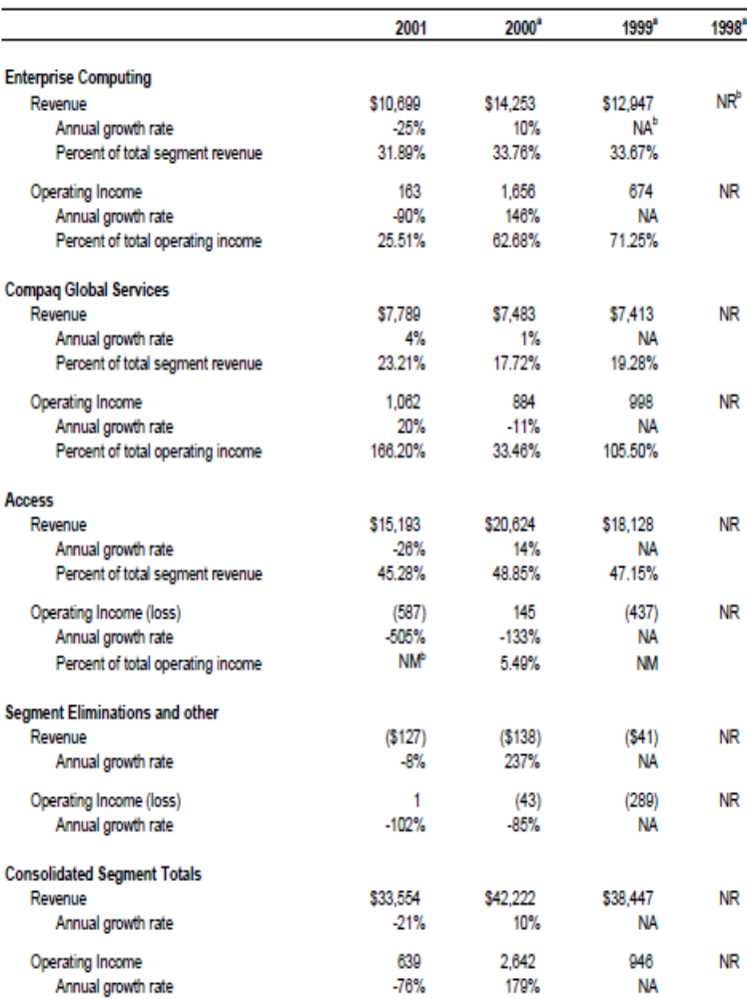
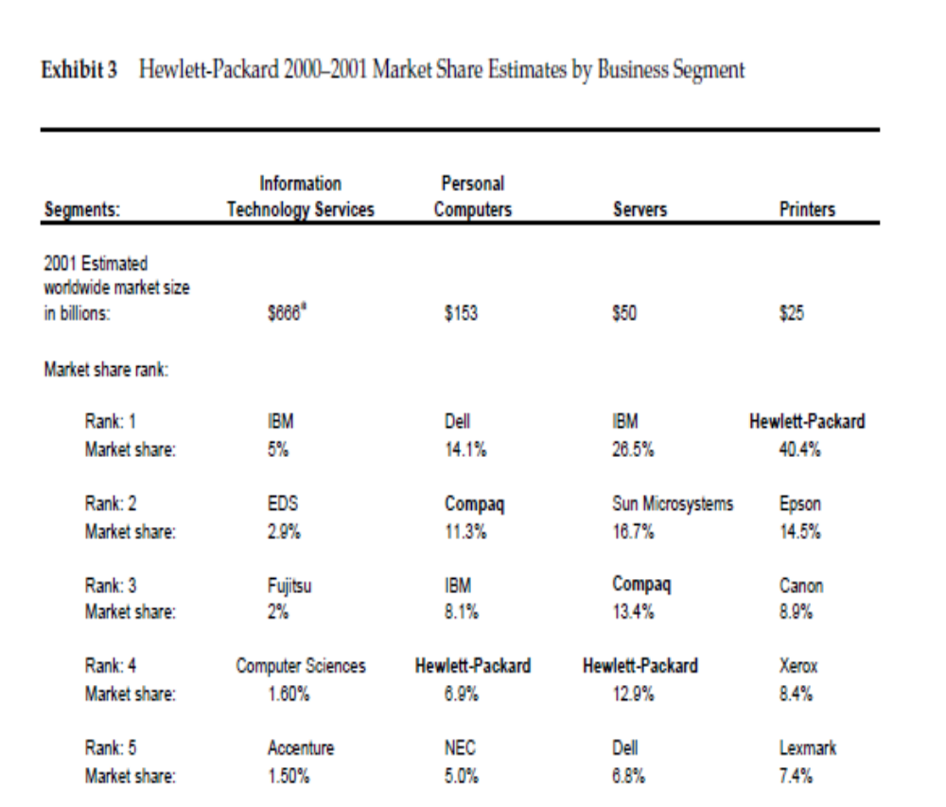
Hewlett-Packard segment annual performance
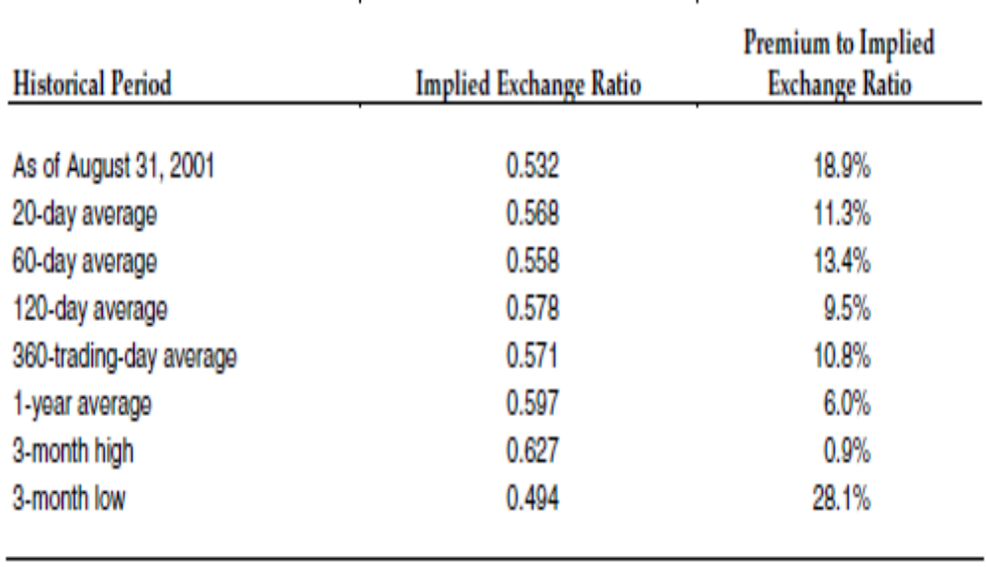
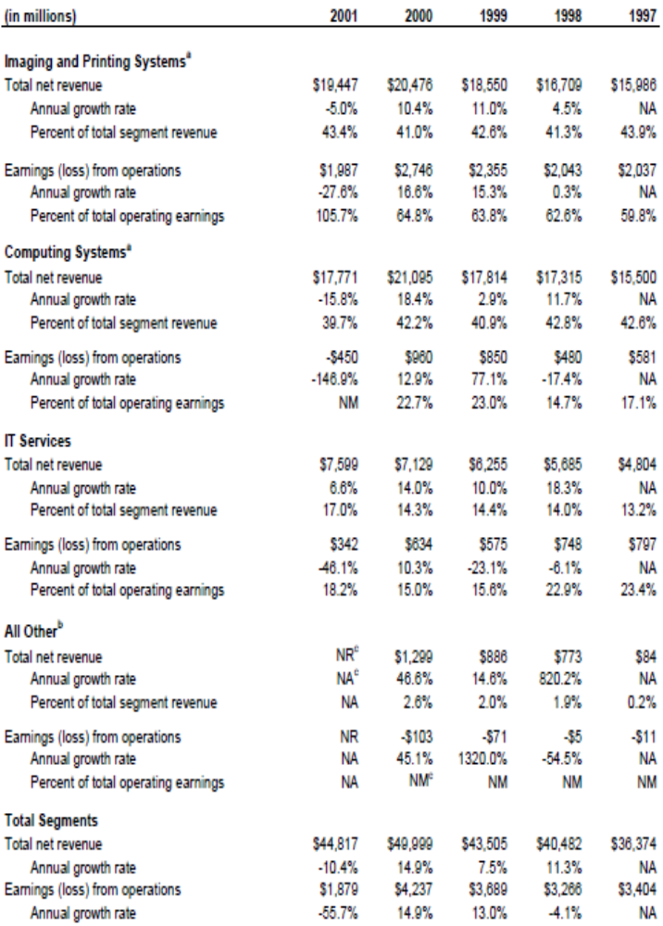
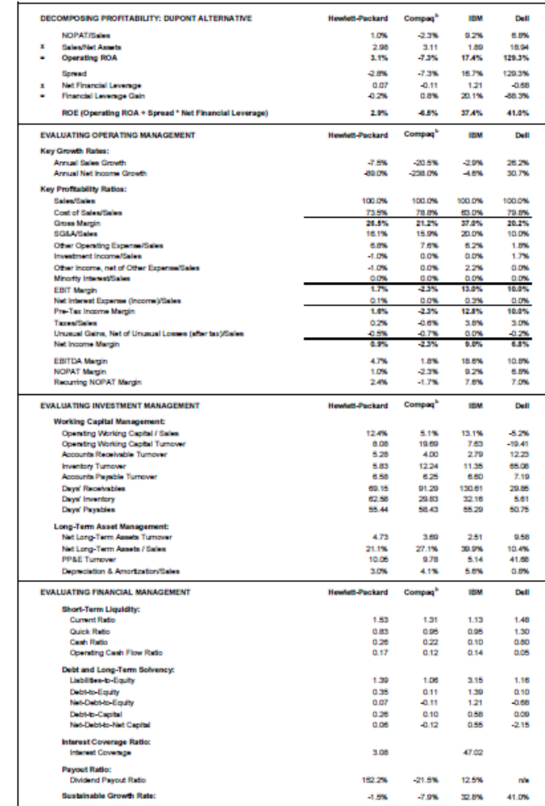
Goldman’s Contribution Analysis
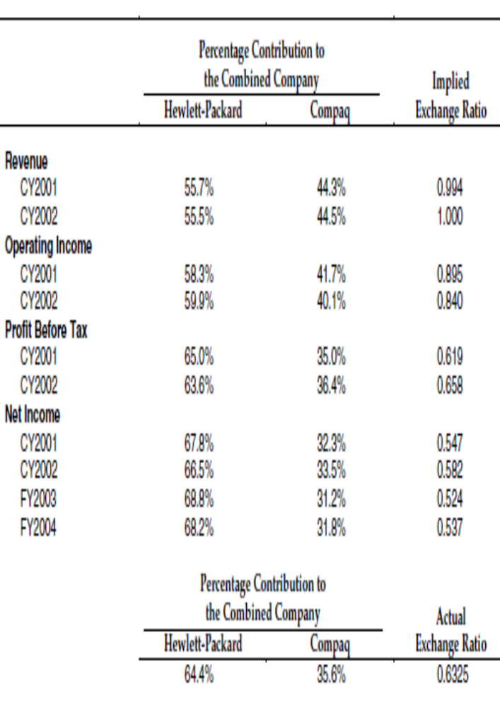

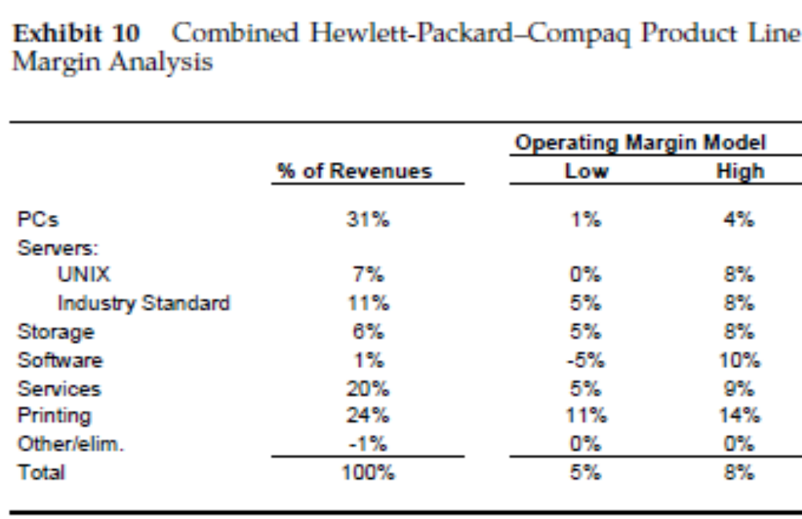

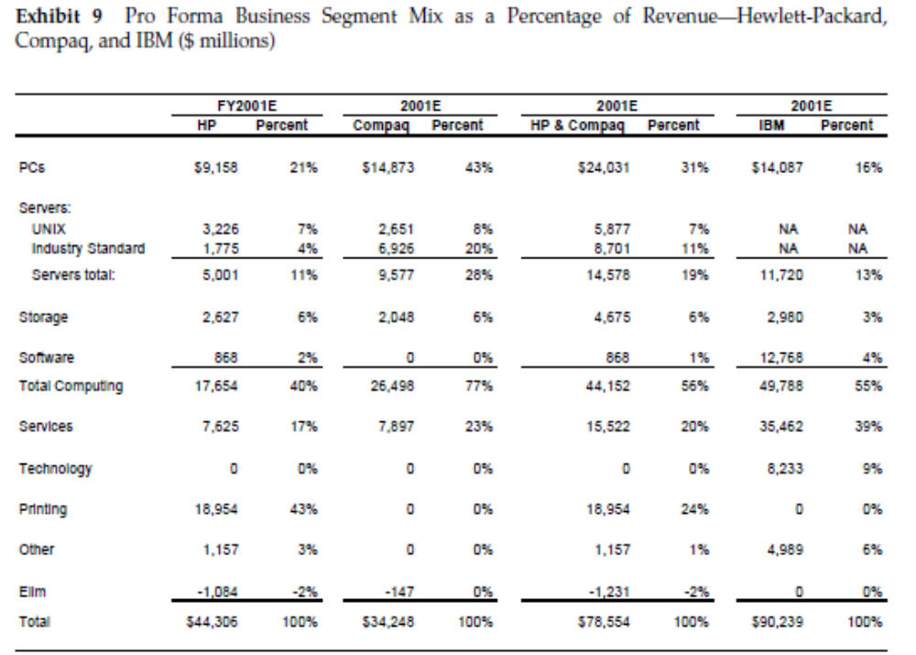
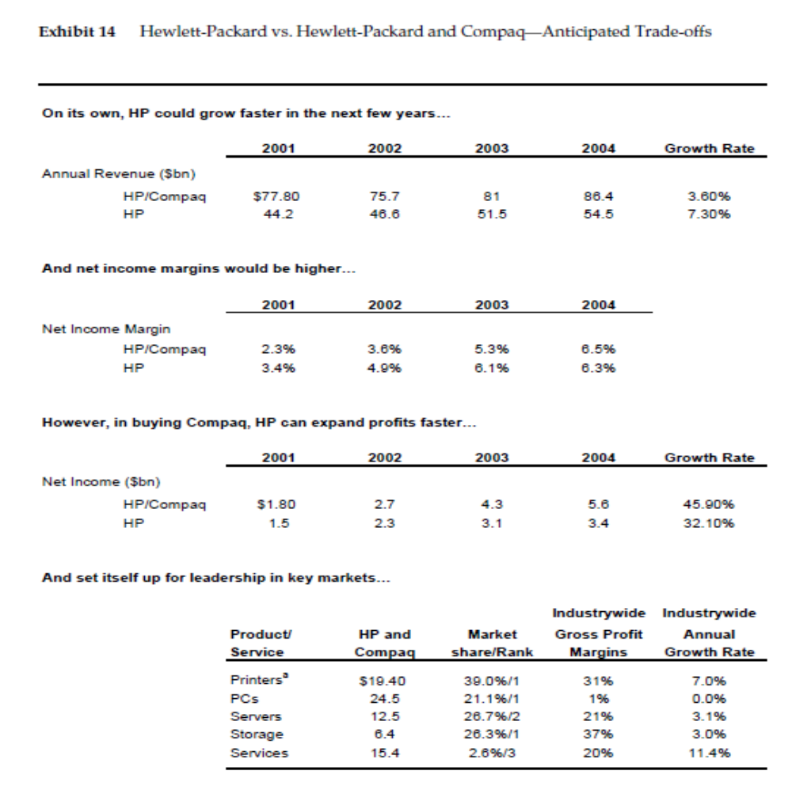

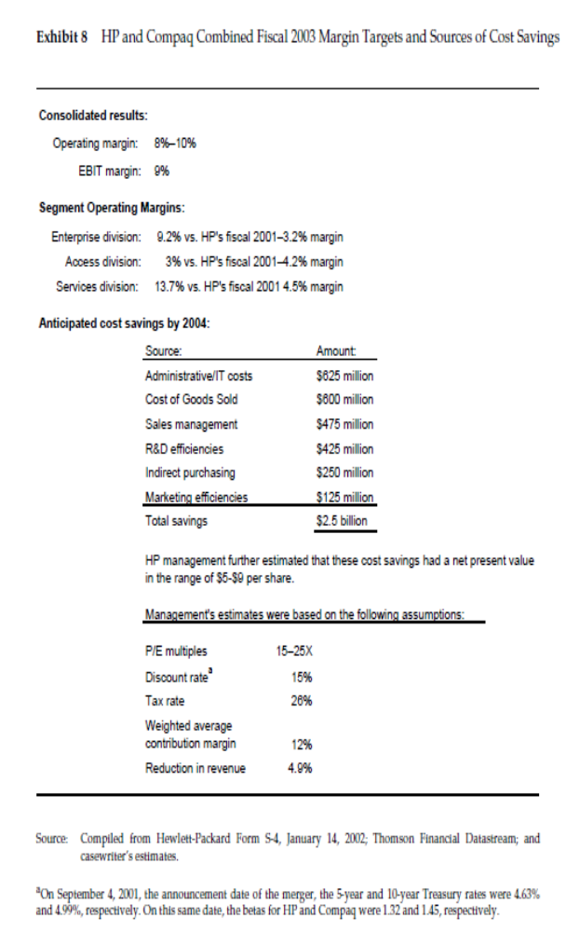
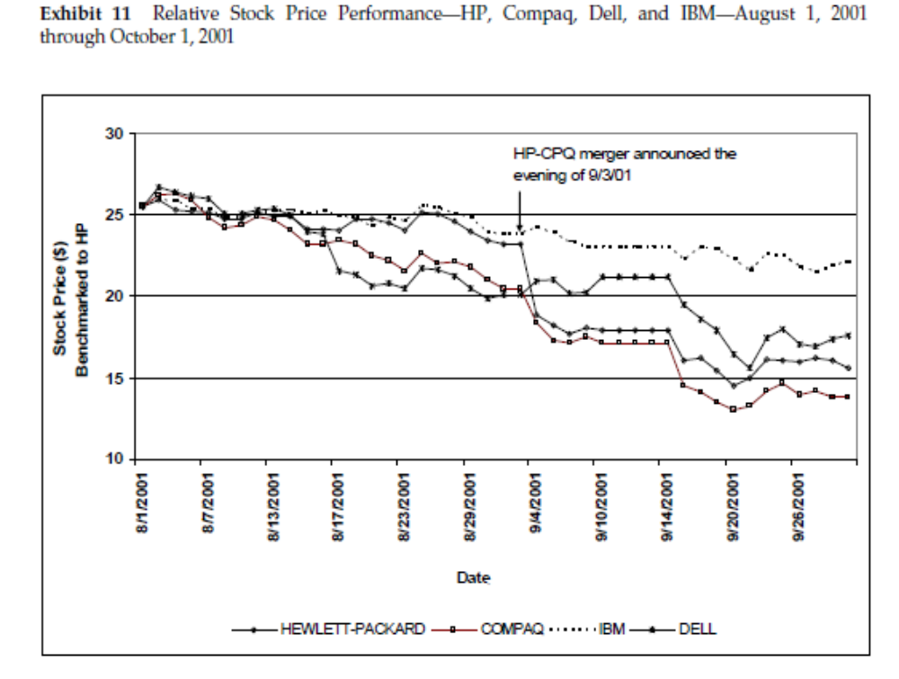

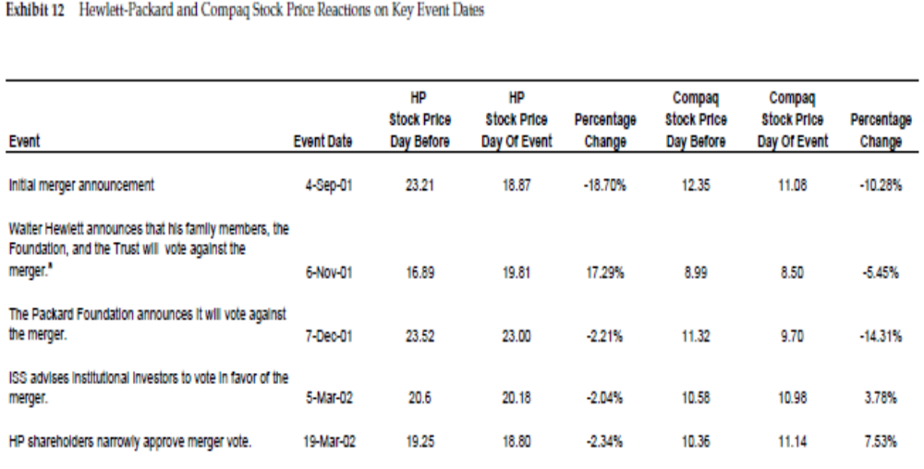

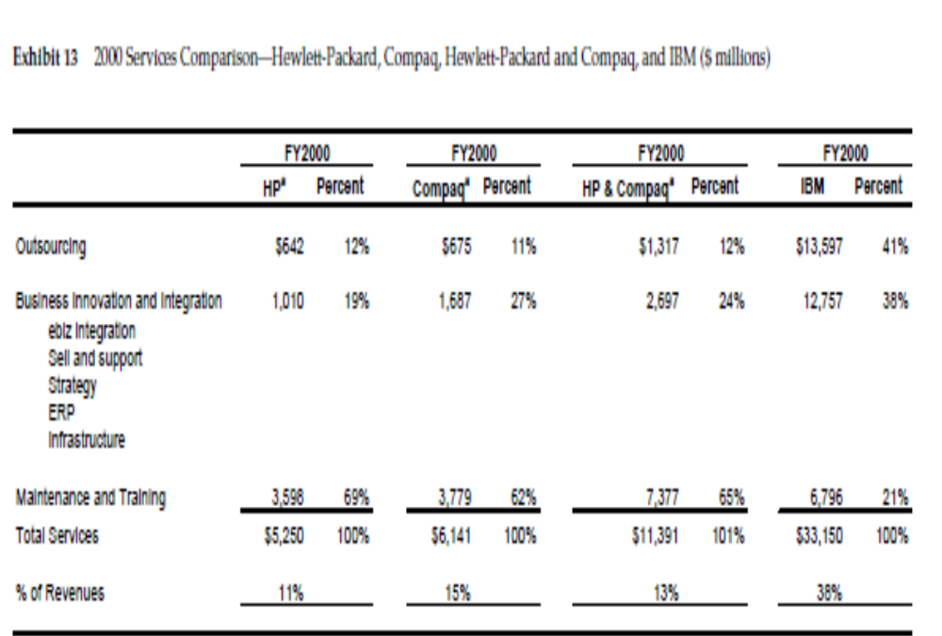

REFERENCES
Albo, W.P. and Henderson, R.A. (1987). Mergers andAcquisitions of Privately-held Businesses, Canadian Cataloguing in Publication Data.

Halpern, P. (1983). ‘‘Corporate acquisitions: a theory of special cases? A review of event studies applied to acquisitions.’’ Journal of Finance

Roll, R. (1986). ‘‘The hubris hypothesis of corporate takeovers.’’ Journal

