Why is it important to follow a process when making healthcare-related decisions?
 |  | This assignment helps you apply your knowledge from this week’s modules and readings.
 |  | We are constantly surrounded by information and technology that has the power to influence our beliefs. Despite this information overload, it’s important to question not only the information, but your own viewpoints and perspectives. Asking questions to evaluate all sides of an issue will help you form an accurate and well-reasoned opinion.
50

Perceiving and Believing
Thinking is how you make sense of the world. Your perceptions and beliefs are shaped by your experiences and an interpretation of the world around you.



- Look at the image above. What do you think this man does for a living?  
I think this man in the picture is a teacher or professor

- How did you arrive at your decision? (Hint: Explain how your individual perspective - or “lens” - has shaped and influenced your answer.  
Teachers are always seen to be demonstrating or explaining a concept to the students. one of the way to explain is use of gestures and body like that in the picture to maintain the attention of the audience.

- The man in the image is actually a pastor named Carl Lentz. Does knowing this change the way you will perceive others in the future? Explain why or why not.
Yes this makes me consider various options and do more investigation or analysis before making a conclusion. Having perceptions is one barrier to effective communication.

- Match each different type of belief with its definition below:  
A. Reporting
- Inferring
- Judging

Reporting | Describing the world in ways that are based on factual information, and using this information to go beyond the known in order make statements about the unknown.
Inferring | Describing something in a way that can be seen, shown, or proved through investigation.
Judging | Describing the world in a way that is dependent on your opinion or predetermined criteria.

- Observe the image below of a scene in a healthcare office. Make three (3) observations about the image, one reporting, one inferring, and one judging. 

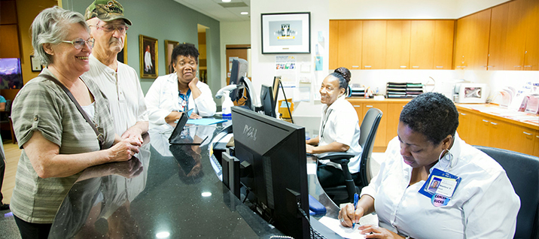

OBSERVATION TYPE | YOUR OBSERVATION STATEMENT
Reporting | The visitors in the office are visiting the reception to seek information about the organization.
Inferring | This is a reception office in an institution where enquiries are made by visitors.
Judging | The visitors in the picture are happy for news they have heard.

Evaluating the Credibility of Sources
Fake news is defined as intentionally or unintentionally misleading information presented as factual news. You must think critically about information to determine its reliability.

- Read the list below and decide which of the characteristics would qualify as fake news. 
CHECK YES IF IT’S FAKE NEWS | CHARACTERISTICS OF NEWS
Yes | News is not properly researched
No | News is supported by 3rd-party fact checkers
No | News has either grammar/spelling errors or information accuracy errors
Yes | News shows evidence of being plagiarized
No | News is from 1997
Yes | News is satirical in nature (i.e. – Weekend Update with Saturday Night Live)
No | News comes from an unbiased source
No | New includes properly cited quotations from multiple experts

- How do you get your news and learn about current affairs and world events?

Through verified social media and digital platforms

- We’ve recently seen that even major news personalities and organizations have published flawed news stories. Read the article HERE to answer questions 8-9. Explain your feelings about the journalist after reading the article.
Type answer here

- What are the dangers of fake news?

Fake news would lead to war in between different parties.

- List three (3) things you can do determine if news is credible and not fake.

Do individual research on the news to ascertain its credibility.

Determine whether the author has a history of being biased.

Compare the news with more than one sources.

Decision Making
Imagine you have friend who struggles with depression. Your friend has tried several different methods and therapies to overcome the depression, including exercise, meditation, acupuncture, and even hypnosis. When you ask her if she has considered medication, she states that she will never try it because of an interview she saw on the news. Click HERE to watch the interview with Tom Cruise.

- Your friend believes Tom Cruise is an authority (or trustworthy source) on the topic of psychiatric medication. Evaluate the reliability and credibility of using Tom Cruise as a source.

To determine credibility and reliability, ask yourself: | Explain if Tom Cruise fulfills the criteria to be considered a reliable source
Is the source of the information able to make accurate observations? | The source has no expertise to make accurate observations on matters psychiatric medication since he is just an actor.
What do you know about the past reliability of the source of information? | The source has been an actor always and not reliable source of information.
How knowledgeable or experienced is the source of information? | He is not knowledgeable on matters above and cannot be a credible source of information.

Decision Making Scenario 1
Pretend that you are a surgeon at a local hospital. Seven patients need a heart transplant but there is only one heart donor at this time. All of the patients are eligible to receive this heart. All patients are physically able and all have compatible tissue and blood typing. From the list below, you will need to choose which patient should receive the heart.
Patient Waiting List
- 31-year-old male; dentist at the height of his career; married but no children
- 12-year-old female; accomplished violinist; blind
- 40-year-old male; teacher; married with 2 children
- 15-year-old female; unmarried, 6 months pregnant
- 35-year-old male; Roman Catholic priest
- 17-year-old female; waitress; high school dropout; supports/cares for a brother who is severely disabled
- 38-year-old female; pharmacy technician; engaged to be married next year.

When we make ethical decisions (like the one above) they are shaped by our values, past experiences, and our attitudes about life, people, and ethics. Please reflect carefully and give a thoughtful response to the next three (3) questions. Your answers should reflect how your life experiences, values and attitudes have shaped your decision.

- What patient did you choose to receive the heart transplant?
The 38-year-old female; pharmacy technician; engaged to be married next year.
- How did you arrive at your decision? Explain your thought process. 

The female is the oldest and would not be able to withstand longer compared to the other patients in the waiting list.

- How was your decision influenced by your values? Attitudes? Prejudices?
I value saving life no matter what and when I have an opportunity to save I always take it. In my practice I have identified that old females are weaker compared to other patients in the hospital.

Reflection 
Reflect on what you have learned this week to help you respond to the question below. You may choose to respond in writing or by recording a video!

- How do you make decisions each day? In other words, what influences your decision-making process? 
before making a decision I’m always influenced by the credibility of the news that I get. I always determine various options available and take the one which has more benefits than risks.

