Homework Assignment #7 (due by 11:59pm CST on Sunday, June 27th)
Please study CH11 to finish this homework assignment. You can calculate the answers following steps in the textbook (Five Steps in Hypothesis Testing: A Summary on Page 381-382), practice and weekly materials on Blackboard. Also, please familiar with how to interpret the results using your own words following each definition (See interpretation on Page 382; Learning Check 11.3 on page 382). Please continue to remind yourself about the issue of rounding error and should develop a general classroom rule to round to a specific decimal point (i.e., 2 decimal points) for all calculations.

Problem set 1: Use the following data to answer questions 1-5 (40 points):
A researcher is interested in whether there is a significant difference between the mean age of marriage across three racial groups. Based on the data below, answer these questions.

Race | N | Mean
Black | 318 | 22.17
White | 772 | 24.78
Other | 110 | 23.55
All Groups | 1,200 | 23.58
- Calculate the value of the between group sum of squares (SSB, 15 pts).

Race | Y bar for each group | Total mean | Group mean – Total mean | Square of the difference | The number of cases | Nk*Square of the difference
Black | 22.17 | 23.58 | -1.41 | 1.9881 | 318 | 632.22
White | 24.78 | 23.58 | 1.20 | 1.44 | 772 | 1111.68
Other | 23.55 | 23.58 | -0.03 | 0.0009 | 110 | 0.099
 |  |  |  |  |  | Sum up=1743.995

SSB = 318 * (22.57 – 23.58)² + 772 * (24.78 – 23.58)² + 110 * (23.55 - 23.58)²
= 632.22+1111.68+0.099
= 1743.995

- Calculate the degrees of freedom for the between group sum of squares. Then, use this quantity to calculate the mean square between (8 pts).

The df1 (between) = number of columns - 1 = 3 - 1 = 2

Therefore, Mean Square, MSB = SSB / df1 = 1743.995 / 2 = 871.9974

- If the F statistic calculated for these data is 12.56, what is the value of the mean square within (6 pts)?

F = MSB / MS error

Therefore, MS error = MSB / F = 871.9974 / 12.56 = 69.43

- Following answer of #3, calculate the within group sum of squares and the number of degrees of freedom for the within group sum of squares (8 pts).
df2 (df error) = Total Observations - k = (318 + 772 + 110) - 3 = 1200 - 3 = 1197

Therefore, MS error = SS error / df2

SS error = MS error * df2 = 1197 * 69.43 = 83103.57

- Imagine you are interested in whether there is a significant difference between the mean age of marriage across educational groups. If the critical value for an F statistic of 12.56 is 2.99, are these results statistically significant or not (7 pts)?

Since 12.56 > 2.99, it falls in the rejection region. Therefore, reject the null hypothesis and conclude that there is a statistically significant evidence of the difference between the mean age of marriage across educational groups.

Problem set 2: Use the following data to answer questions 6-10 (40 points):
We take another look at health based on the practice question on Page 393-394, this time examining the relationship between educational attainment and perceived quality of health care. Data for three groups are presented based on the HINTS2012 data set. Present the five-step model for these data, using alpha = .01. QUALITYCARE is measured on a five-point scale: 1— excellenet, 2—very good, 3—good, 4—fair, and 5—poor. Note how a lower score indicates a higher quality of care. Chapter Exercises #1 and #3 on pages 393-394 are helpful to complete this problem set.
Less Than High School | Some College | College Graduate
3 | 1 | 2
4 | 2 | 2
3 | 2 | 2
3 | 2 | 1
4 | 3 | 1
4 | 2 | 1
- Find the answers for the worksheet (20 pts).
Less Than High School | Some College | College Graduate
3 | 1 | 2
4 | 2 | 2
3 | 2 | 2
3 | 2 | 1
4 | 3 | 1
4 | 2 | 1
Sum Y1=21 | Sum Y2=12 | Sum Y3=9
Mean Y1=3.5 | Mean Y2=2 | Mean Y3=1.5
Sum up square of Y1=75 | Sum up square of Y2=26 | Sum up square of Y3=15
n1= 6 | n2= 6 | n3= 6
Total mean =3.5+2+15=7
N = 18
- Calculate the degrees of freedom for SSB and SSW (6 pts).

SSB =6*(3.5-2.33)²+6*(2-2.33)²+6*(1.5-2.33)²
=6*1.3611+6*0.1111+6*0.6944
=8.1667+0.6667+4.1667
=13

- Calculate Mean Square within and Mean Square between (6 pts).

SSW=(75+26+15) –((21²+12²+9²)/6)
=116-111
=5
- What’s the F statistic in this data (4 pts)?
F=(13/(3-1))/(5/(18-3))
=(13/2)/(5/15)
=6.5/0.3333
=19.5

- Make decision if alpha was set up at .05, and please use Appendix E (Page 473-475 to discuss your decision making (4 pts).

From table, we get
FCri=3.6823

Since 19.5 > 3.68, it falls in the rejection region. Therefore, reject the null hypothesis and conclude that there is a statistically significant evidence of the difference between the samples.
Problem set 3: Use the following data to answer questions 11-12 (20 points):
Based on a sample of 21 Monitoring the Future respondents, we present their racial/ethnic background and the numbers of school days missed in the past 4 weeks (Please see details on Page 394-395).
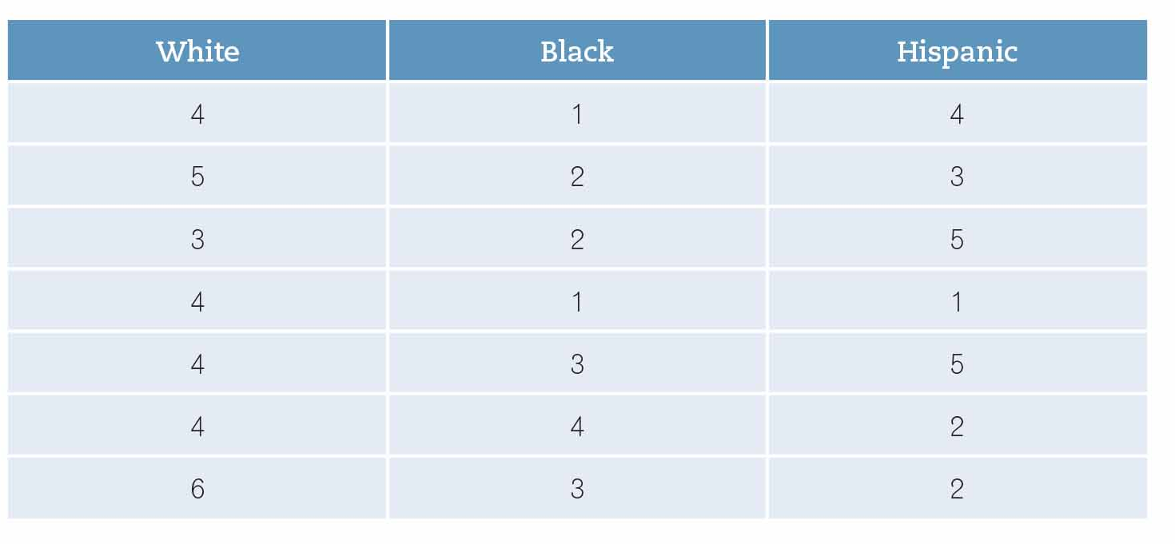
- Complete the five-step model for these data, set alpha at .05. (15 pts).
Y�1 =4.29 | �Y�2� =2.29 | �Y�3� =3.14
∑Y1 =30 | ∑Y2 =16 | ∑Y1 =22
∑Y12 =134 | ∑Y22 =44 | ∑Y32 =84
n1 = 7 | n2 = 7 | n3 = 7
�Y =
N =21

 | White | Black | Hispanic | Total
Sum | 30 | 16 | 22 | 68
Count | 7 | 7 | 7 | 21
Mean, Sum/n | 4.2857 | 2.2857 | 3.1429
Sum of square, Ʃ(xᵢ-x̅)² | 5.4286 | 7.4286 | 14.8571
Null and Alternative Hypothesis:
Ho: µ1 = µ2 = µ3
H1: At least one mean is different.
Number of treatment, k = 3
Total sample Size, N = 21
df(between) = k-1 = 2
df(within) = N-k = 18
df(total) = N-1 = 20
SS(between) = (Sum1)²/n1 + (Sum2)²/n2 + (Sum3)²/n3 - (Grand Sum)²/ N = 14.0952
SS(within) = SS1 + SS2 + SS3 = 27.7143
SS(total) = SS(between) + SS(within) = 41.8095
MS(between) = SS(between)/df(between) = 7.0476
MS(within) = SS(within)/df(within) = 1.5397
F = MS(between)/MS(within) = 4.5773
p-value = F.DIST.RT(4.5773, 2, 18) = 0.0247
Decision:
P-value < 0.05, Reject the null hypothesis.

- If alpha were set at .01, would your decision change? Explain (5 pts).

ANOVA
Source of Variation | SS | df | MS | F | P-value | F crit
Between Groups | 14.09524 | 2 | 7.047619 | 4.57732 | 0.024709 | 6.012905
Within Groups | 27.71429 | 18 | 1.539683
Total | 41.80952 | 20

Yes, we will change our decision at 0.01.
P-value > 0.01, we fail to reject the null hypothesis.

