Lab Test #2 
TERM | Name – Student ID | COURSE CODE | WEIGHT
Summer 2020 | REBAL ALI QURESHY-RAQURESHY | HWD101 | 12.5%
Test Instructions
- Enter your name and student ID above (Example: david – dtrinh)
- Answer questions and add screenshots into the corresponding textboxes
- Save the file on your computer for future reference
- Save the file again as a “.pdf” file
- Submit the PDF file for grading
- Submit your packet tracer file for grading
Test Format
- Duration: 90 minutes
- Total Marks: 41
- Weight: 12.5%
Test Materials
- Cisco Packet Tracer 7.2.2
- Open book

Part 1: Network Address [1 mark]
Log into Blackboard to find the network you have been assigned. The network will appear under “My Grades”.
Enter your network address: 152.152.152.0 /24

Part 2: Scenario
Seneca’s Lab Assistants are starting an organization to provide lab support for existing students. They want to setup 3 teams in this organization which are assigned their own networks. They will need the following:
- 1 network for each department called
  - HWD101
  - IOS110
  - ULI101
- Each network will have 3 PCs
- PCs must be able to communicate within its own network
- PCs must be able to communicate with PCs from other networks
- Gateways in each network need to be configured with the first available IP address in their networks

Part 3: Subnet the Network [16 marks]
Determine the number of networks needed and subnet your network accordingly.
List out ALL the subnets created and their corresponding ranges. Enter the information in the attached table (add additional table rows as needed):
Subnet # | Subnet ID | Subnet Mask | Host Address Range | # of Valid Hosts | Broadcast ID
1 | 152.152.152.0 | 255.255.255.0 | 152.152.152.1-152.152.152.254 | 254 | 152.152.152.255
. 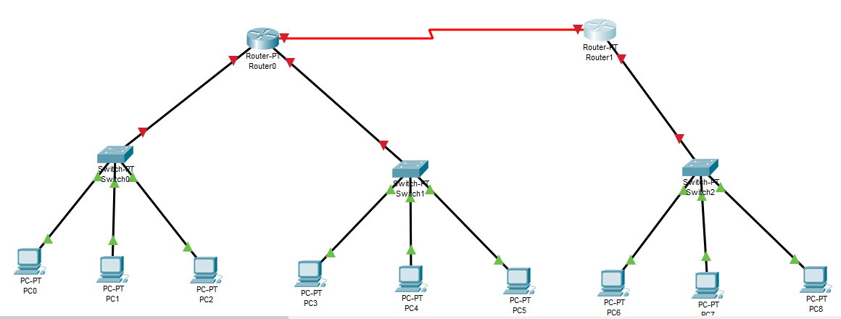

Part 4: Create the Networks [24 marks]
Using Cisco Packet Tracer version 7.2.2, create the networks. Configure the networks using the subnets you calculated. Remember the network requirements:
- Each network will have 3 PCs
- PCs must be able to communicate within its own network
- PCs must be able to communicate with PCs from other networks
- Gateways in each network need to be configured with the first available IP address in their networks
Remember to submit your packet tracer file for grading!

