Homework: Empirical Rule and Z-score

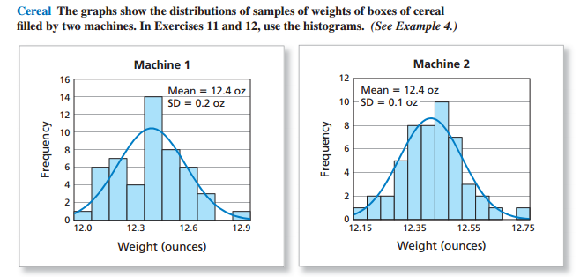
- The graphs above are from MathAndYou.com Section 9.3 (page 431). In the graphs above, explain the real-world, practical significance of the fact that the standard deviation of Machine 1 is greater than the standard deviation of Machine 2.
Standard deviation is an essential statistical tool that has wide application. Standard deviation gives the degree of spread from the mean or expected value. Considering machine 1 and 2, the standard deviation of machine 1 is twice that of machine two. This implies that the weight of machine 1 is widely spread as compared to that of machine 2. Consequently, this implies that the size of machine 1 is bigger than the size of machine 2 hence one can determine which appropriate machine to purchase that adequately meets his needs and specifications.

2) The graphs above are from MathAndYou.com Section 9.3 (page 431). In the graphs above, use the Empirical Rule to estimate the percent of boxes that would weigh at least 12.2 ounces for each Machine. Show your work/explain how you arrived at your answer.
Solution
Machine I
P (w >12.2)
Mean (µ) = 12.4
SD = 0.2
= p [(x - µ)/σ > (12.2 – 12.4)/0.2]
= p (z > -1)
= 1- p (z ≤ -1) = 1 – 0.1587 = 0.8413

Machine 2
P (w >12.2)
Mean (µ) = 12.4
SD = 0.1
= p [(x - µ)/σ > (12.2 – 12.4)/0.1]
= p (z > -2)
= 1- p (z ≤ -2) = 1 – 0.0228 = 0.9772

3) Lengths of pregnancies are normally distributed with a mean of 268 days (which is about 9 months) and a standard deviation of 15 days.
  - Sketch the normal curve, and label everything appropriately using the Empirical Rule, z-scores, and data values with the appropriate pregnancy lengths.

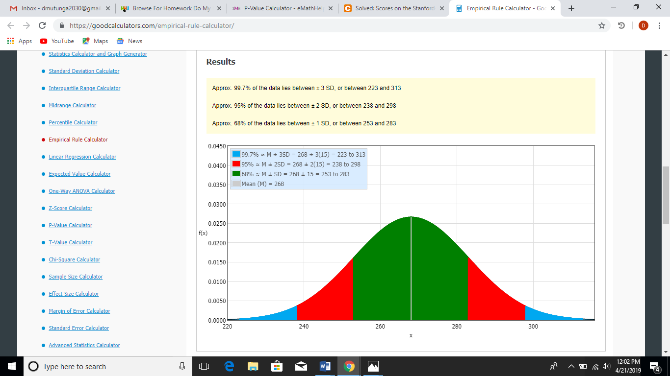

  - What percent of women have a pregnancy that lasts less than 253 days?
Solution
P (w < 253)
Mean (µ) = 268
SD = 15
= p [(x - µ)/σ < (253 – 268)/15]
= p (z < -1) = 0.1587
= 15.87%
  - What percent of women have a pregnancy that lasts less than 238 days?
Solution
P (w < 238)
Mean (µ) = 268
SD = 15
= p [(x - µ)/σ < (238 – 268)/15]
= p (z < -2) = 0.0228
= 2.28%

  - What percent of women have a pregnancy that lasts more 313 days?

P (w >313)
Mean (µ) = 268
SD = 15
= p [(x - µ)/σ > (313 – 268)/15]
= p (z > 3)
= 1- p (z ≤ 3) = 1 – 0.9987 = 0.0013

4) Stanford Binet IQ scores have a mean of 100 and a standard deviation of 16. IQ scores are roughly normally distributed.
- Sketch the normal curve, and label everything appropriately using the Empirical Rule, z-scores, and data values with the appropriate IQ scores.

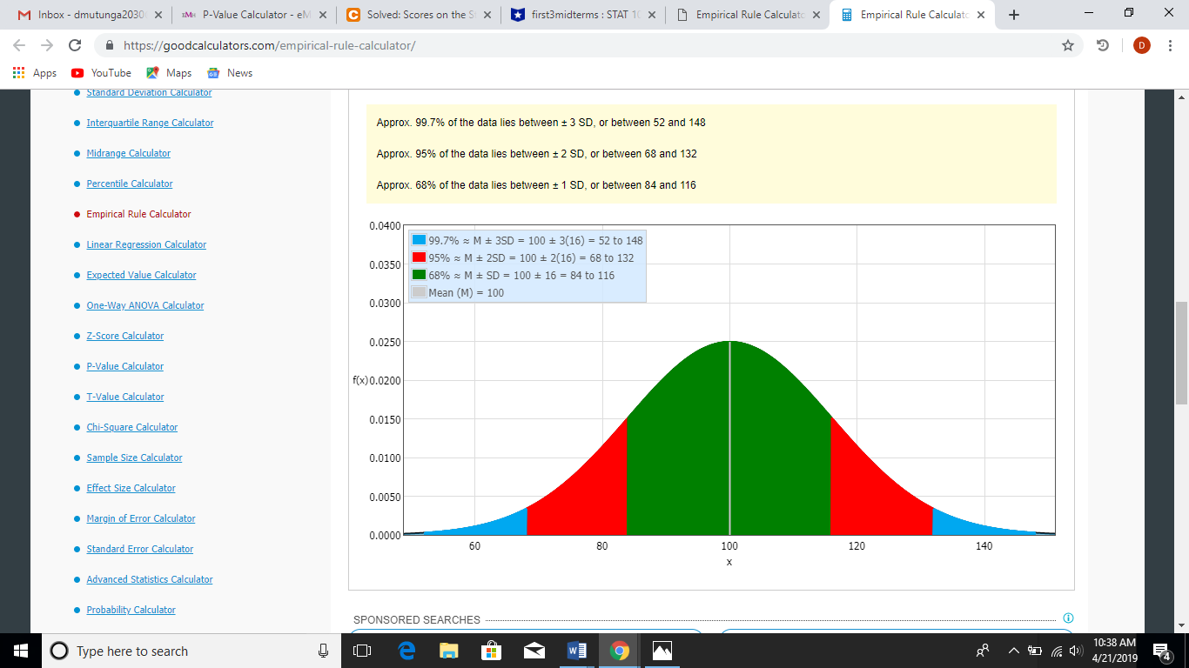

- If a person's IQ has a z-score of −0.3, then explain what that tells you about how the person's IQ
compares to other people's IQ.

The IQ is unusual since for the usual IQ level lies between ± 2 SD
- A person has an IQ of 82. Find the z-score for this IQ score, and explain exactly what it tells you about how this person's IQ compares to other people.
Solution
Mean (µ) = 100
SD (σ) = 16
X = 82
= p [(x - µ)/σ = (82 – 100)/16] = -1.125
This means that the IQ of -1.125 is not unusual since it is within the usual range of ± 2 SD

- To have an "unusually high" IQ, a person would need to have an IQ with a z-score of 2 or more. How high would a person's IQ need to be to be considered "unusually high?" Show your work.
Solution
= µ + 2σ
Mean (µ) = 100
SD (σ) = 16
= 100 + 2(16)
= 100 + 32 = 132.
Therefore, any IQ more than 132 is considered unusually high
- Albert Einstein had an estimate IQ of 160. Convert Einstein’s IQ score to a z-score (show your work). What does the z-score tell us about Albert Einstein’s IQ? Is it unusual?
Solution
Mean (µ) = 100
SD (σ) = 16
X = 160
p [(x - µ)/σ = (160– 100)/16] = 3.75
z – score is 3.75 which is more than 2σ The IQ level considered normal. Therefore, the IQ of 3.75 is unusually high hence unusual.

