Homework: intro to statistics, averages

Problems 1 through 4 below are taken from http://math.andyou.com/pdf/419.pdf .
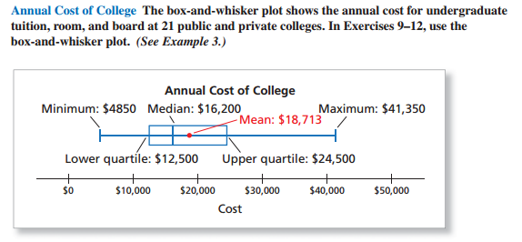
1) Refer to the box plot above taken from a sample of 21 public and private colleges. How many colleges have an annual cost between $12,500 and $24,500? Show your work/explain.

2) Refer to the box plot above taken from a sample of 21 public and private colleges. Are there more colleges above or below the mean annual cost? Explain your reasoning.

3) Refer to the box plot above taken from a sample of 21 public and private colleges. The annual costs are divided into four quartiles, each of which contains about 25% of the data. In which quartile are the data most spread out? In which quartile is the data least spread out? Explain.

4) Refer to the box plot above taken from a sample of 21 public and private colleges. The annual cost to attend college A is $10,780. In which quartile does this college belong?

5) Acme has ten employees. Nine employees are line-workers, and then tenth employee is the CEO. Here are the salaries of the employees:
$42,000 | $39,000 | $40,500 | $43,200 | $40,570
$39,750 | $41,800 | $42,000 | $42,000 | $375,000
(a) Find the mean, median, and mode salary. Show any work/calculations.
(b) Are there any outliers? If so, what are they?
(c) Calculate the mean, median, and mode salary if the CEO's salary of $375,000 is NOT included in the salary list.
(d) In general, if there is a very high outlier value in a data set (like in this example), what is the effect that the outlier data-value has upon the mean, the median, and the mode of the data set?

6) Bob is moving to a new town. He looks online and learns that the mean cost of 2 bedroom houses in the town is $435,000. He also learns that the median cost of a 2 bedroom house in the town is $185,000. Bob isn't sure which "average" he should use when thinking about how much the average house costs in that area. Write an explanation to Bob explaining why it would make more sense for Bob to use the MEDIAN. Then explain why the mean housing cost would be so much higher than the median.

