Medical Financial Handout

Medicaid and End-of-Life Care
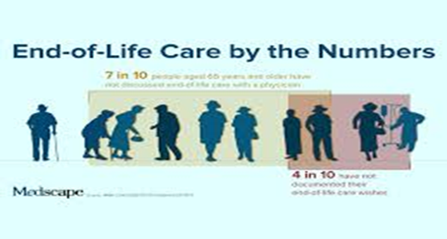
Health is a universal fundamentality. It is the reason this plan is of great necessity as piece of lifespan policy. With Medicaid it is possible to get cover for a family’s health needs regardless of age, sex or race. Medicaid helps by providing health and long-term maintenance coverage of children, young or old. Medicaid program is jointly funded by states and the federal government. The financial implication of a family is the primary concern for Medicaid. It is cheaper and wholesome in coverage. Folks with low incomes and high costs of health care in long-term upkeep amenities like nursing home care, and hospice are well supported by this cover. Medicaid is advantageous as it is a major source of financing for end-of life care requirements.

Medicare
Medicare is a federal funded lifespan insurance policy. It is a cover for folks within age brackets of 65 and above. Registering with one of these lifelong programs is determinant to how far one can go with battling perturbing illness. It is also eligible for younger people with disability cases. Individuals with underlying or terminal conditions are also part of beneficiaries of this scheme.

With considerable partial funding from federal governments, this cover allows up to dialysis or transplant of permanent underlying conditions such as kidney failure. Pick a cover that best suits today.

Third-Party Insurance
Third-party insurance is perceptibly acclaimed as the latest essential system of liability insurance. It is purchased by a preexisting insurance holder for the sake of another person. A person who owns a car for instance is the first party to be insured. Whoever provides him with insurance services is the second party. In the cases of accidents on a highway, the other party also becomes an insured party with this plan and he is also the third party in this case. This insurance scheme makes the first party responsible for all indemnities or losses, irrespective of the reason behind those indemnities. This scheme is advantageous as it ensures complete peace of mind when one does not have to pay for the damages from his own pockets. It is also cost-effective and helpful to the underwriter in any unexpected event. This policy is beneficial to older people on retirement with little funds to spare in accruing responsibilities of damages.
Pick a plan today.

