Geological Hazards
Student’s Name
Institutional Affiliation
Date

Geological Hazards
Geological hazards are occurrences that have led to significant loss of life and property destruction in the world. In 20th century, more than 1 million individuals lost their lives due to earthquakes alone. In the current era, various geological hazards remain to be a great challenge as they continue to influence increased life loss and property destruction. There are five significant hazards that the globe is facing currently, which include volcanic eruption, earthquakes, tsunami, floods and landslides.
Earthquakes
Earthquakes are among the geological hazards that the earth is facing currently. The shaking intensity generated by earthquakes leads to the destruction of structures such as dams, bridges and buildings. The occurrences lead to the falling of objects which may injure or bury anyone close to the items. One of the most recent earthquake events occurred in West Sulawesi in Indonesia. This event caused damages in the Mamuju regency (including hospital and hotel collapse. It led to a loss of 105 lives, with more than 3300 injuries (Paddock &Sijabat, 2021). This earthquake was reported as a fatal earthquake in 2021. It is among the many earthquakes that have been reported, which leads to global hazards due to the increase of the cases in the world. Another point of the earthquake has been reported in San Juan in Argentine recently, which led to 14 injuries and properties destruction. In the current era, earthquakes are a tremendous geological hazard. Earthquakes are influenced by abrupt stress release along the faults of the earth. The events lead to the consistent movement of the tectonic plates, which leads to an increase of pressure in the strata until the stress is released through the abrupt, jerky movements. National geographics (2021) states that stored energy release influences earthquakes in the crust. However, it can be affected by volcanic materials. Therefore, earth tremors can be a warning sign of a volcanic eruption.
Conceptual question: How can we incorporate technology to establish earthquake-proof structures?
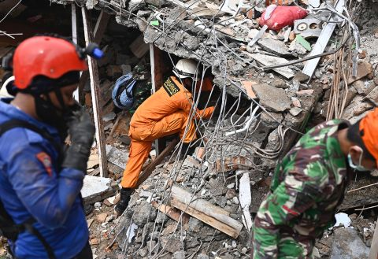
Retrieved from: https://edition.cnn.com/2021/01/15/world/gallery/sulawesi-indonesia-earthquake/index.html
Volcanic Eruptions
Volcanic eruptions involve the opening of the earth's crust which influences gases, volcanic ash or lava to escape into the earth's surface. Volcanic eruptions have been suggested to occur once every four months, leading to destructive effects. The recent volcanic eruption to be reported is the Mount Etna eruption in Italy. The explosion led to more than 20,000 mortalities and destructed many homes leaving more than 27,000 people homeless (Euronews, 2021). More so, people have been complaining of health impacts such as infectious diseases and respiratory issues linked to the volcano. Mount Etna has been suggested to be the most active volcanoes in the world due to its consistent eruptions. This remains among the many cases of volcanic eruptions that have led to hazardous impacts. Other volcanic eruptions reported recently include Taal eruptions in the Philippines, which led to 39 mortalities, White Island in New Zealand, which killed 21 people and Anak Krakatoa in Indonesia, which led to 426 mortalities. Deep in the earth crust, there are melted rocks that form a flowing substance called magma. Since the substance is lighter, it collects in the magma chamber. Eventually, the magma escapes through the fissures and vents to the earth surface leading to eruptions. Explosive eruptions are harmful and lead to the destruction of structures, injuries and mortalities. Explosive eruptions are hazardous as they can blast hot tephra from the top or side of the volcano, and they destroy everything on their path. Ashes can also lead to the suffocation of human, animals and plants.
Conceptual question: Is there a way in which volcanic eruptions can be predicted to enhance prevention of disasters?
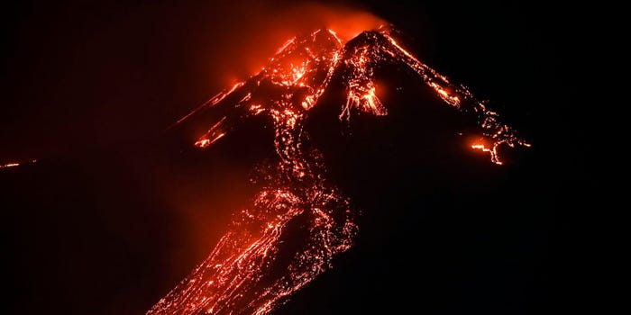
Retrieved from: https://www.businessinsider.com/photos-europes-most-active-volcano-mount-etna-covers-sicily-ash-2021-2?IR=T
Tsunamis
These are serious waves that originate from the water bodies as the displacement of large water volume is displaced from the lakes or oceans. The recent tsunami event to be reported as destructive was in Indonesia. The tsunami occurred after Anak Krakatau's eruption, leading to flooding in Java and Sumatra. The tsunami killed an estimated 2000 people with more than 800 injuries (Amos, 2019). This was a tsunami that was reported alongside earthquake and volcanic eruption, which leads to a continuous hazardous impact on people and properties' lives. The tsunami displaced more than 212,000 people as their homes' destruction occurred. Also, approximately 1200 educational facilities from early childhood to secondary education institutions were affected. More than 184,000 students and 12,000 teachers were affected by the occurrence. More than 50% of the population was displaced in Palu city, and telecommunication was seriously affected. A tsunami can be explained through various geological influences. They are caused by the sudden displacement of water body surfaces when events such as landslides, volcanic eruptions or earthquakes occur. Also, tsunamis are influenced by the increase in tidal waves and the rapid falling and rising of the tides caused by the gravity of the earth, sun and moon. National geographic (2021)explains that earthquakes influence tsunamis, and the ocean floor falls or rises suddenly. More, so the volcanic eruptions materials lead to changes in the sea's topography, leading to waves. Pollution of water bodies is also linked to the increased tsunamis cases in the current era.
Conceptual question: Can man-made explosions, meteorites or asteroids cause tsunamis? What are the factors that determine the severity of destruction from tsunamis?
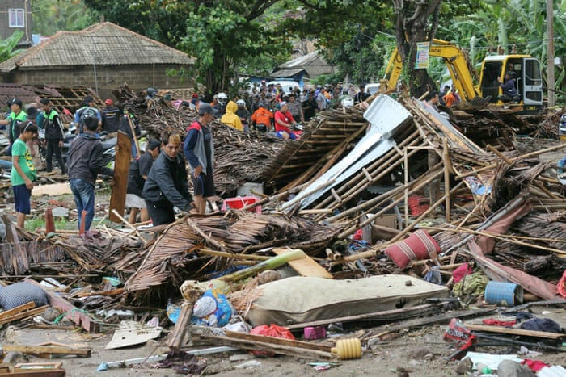
Retrieved from: https://www.theguardian.com/world/gallery/2018/dec/23/arak-krakatoa-tsunami-in-pictures#img-3

Floods
Floods are influenced by excessive and rapid rainfall that raises the water bodies so fast, which channels the water to the roads and infrastructures, leading to injuries, fatalities and displacement. One of the recent floods to be reported occurred in Minas Gerais, Brazil, where the incidence killed two people. More so, 14 people were missing due to a house collapse. The floods affected other parts of the state, such as Matipo, Carangola and Caparao, and authorities are distributing supplies to help the communities. The city had experienced 138.6 mm of rain within 24 hours (BBC News, 2020). More so, the floods were associated with landslides in the town. The floods were reported after another fatal flood incident in Esparto Santo where six people lost their lives. The floods displaced more than 3,000 residents in the city, leaving them homeless. The floods were caused by landslides, a geological concept that explains the influence of flood. Flooding and landslides are related as they are linked to high rainfall, ground saturation and runoff. When there is heavy rainfall, debris flow from the landslides causes blockage of stream channels and valleys, forcing water to stagnate to cause floods. This explains the occurrence of floods in Minas Gerais. National geographic (2021) suggests that climate change is one of the leading causes of floods. Climate change leads to rising water bodies and high rainfall, leading to floods. Therefore, there is a need to evaluate climate change and environmental protection to prevent occurrences.
Conceptual question: How does environmental conservation and prevention of pollution prevents occurrence of floods?
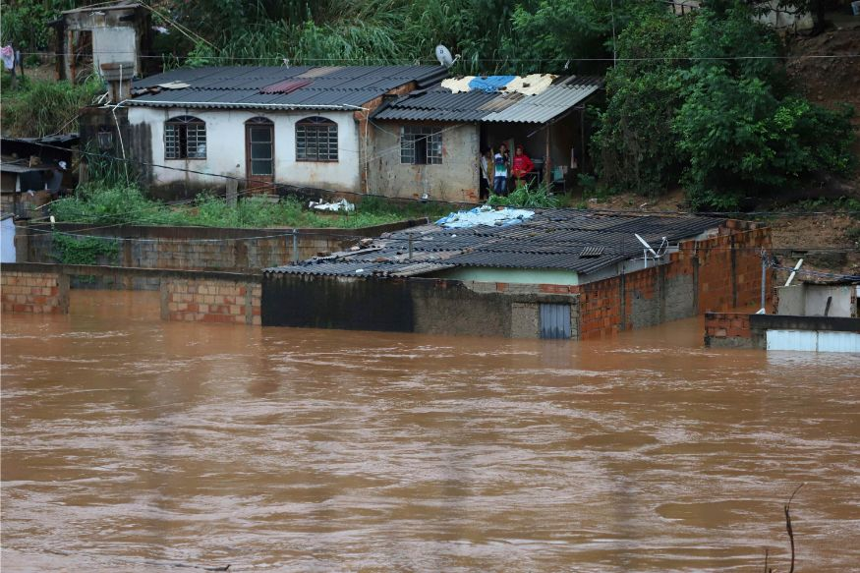
Retrieved from: https://www.news18.com/photogallery/world/brazil-rain-photos-heavy-rains-continue-flooding-minas-gerais-cities-2479651-11.html
Landslides
Landslides are mentioned to be influential in developing other hazards such as floods, volcanic eruptions and tsunamis. Landslides lead to increased events of property destruction, injuries and fatalities. A recent landslide in Gjerdrum, Norway, was recently reported. The landslide had a flow of debris that affected 300 by 700 meters of land (BBC News, 2020). Nine hectares of land were affected, and buildings were destroyed, including apartments and houses. The landslide killed approximately ten people. The government and other organizations established a search process to enhance the recovery process. The process was successful; however, the institutions reported a significant loss. The geological explanation of the landslide is the presence of various forces on the land. The slope movement is influenced by the forces that act downwards the slope, which exceeds the land's strength. A combination of factors such as disturbance of the land by human activities such as constructions and mining, earthquakes and erosions was mentioned to be among the landslide causes. National Geographic (2021) suggest that various reasons, such as human activities and erosions, should be limited to ensure that landslides are prevented. There is a need to enhance novel environmental conduct, which will ensure that the adverse impacts influenced by landslides are prevented.
Conceptual question: How can geologists incorporate landslide and rainfall probability to enhance future hazard map?
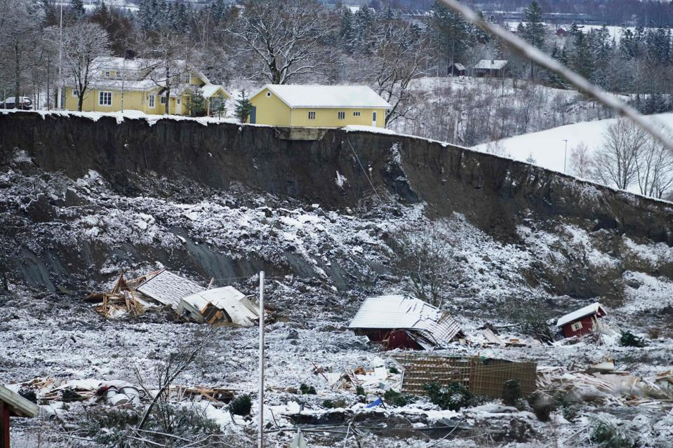Retrieved from: forbes.com/sites/davidnikel/2021/01/02/shocking-photos-reveal-full-horror-of-norway-landslide/?sh=748c669b6d43

References
Amos, J. (2019). Anak Krakatau: Volcano's tsunami trigger was 'relatively small'. BBC News. Retrieved 22 February 2021, from https://www.bbc.com/news/science-environment-49568107.
Brazil floods: Dozens dead in severe Minas Gerais rainstorms. BBC News. (, 2020). Retrieved 22 February 2021, from https://www.bbc.com/news/world-latin-america-51254669.
Euronews. (, 2021). Retrieved 22 February 2021, from https://www.euronews.com/2021/02/19/mount-etna-spews-ash-and-lava-as-europe-s-most-active-volcano-erupts-again.
Natural Disasters. National Geographic. (, 2021). Retrieved 22 February 2021, from https://www.nationalgeographic.com/environment/topic/natural-disasters-weather.
Norway landslide: Houses buried in Gjerdrum village near Oslo. BBC News. (, 2020). Retrieved 22 February 2021, from https://www.bbc.com/news/world-europe-55484627.
Paddock, R., &Sijabat, D. (2021). At Least 46 Killed and Hundreds Injured as Quake Hits Indonesia. Nytimes.com. Retrieved 22 February 2021, from https://www.nytimes.com/2021/01/15/world/asia/indonesia-earthquake-sulawesi.html.

