Heart Disease
Student’s Name
Institution

Background
Heart disease is any disorder that affects the heart. The heart requires a supply of blood like all the other tissues in the body. Two coronary arteries are rising from the aorta, and courses across the heart surface supply the heart with blood. In a situation when the two arteries or their branch narrows, it can lead to a heart disease known as coronary artery disease.
Types of heart diseases are coronary artery disease, myocardial infarction, hypertensive heart disease, congestive heart failure, and congenital heart disease. Coronary artery disease, also termed as coronary heart disease, is mainly caused by building up and accumulation of plaque on the walls of the arteries, thus narrowing of the arteries. The process of building up of plaque inside the walls of the arteries is called atherosclerosis. Coronary heart disease is a type of heart disease that can be both genetically inherited and caused by other risk factors.
Signs and symptoms
The symptoms associated with heart attack are chest pains or discomfort, upper back or neck pain, indigestions, heartburn, nausea or vomiting, extreme fatigue, upper body discomfort, dizziness, and shortness of breath (Centers for Disease Control and Prevention, 2020).
Fluttering feelings in the chest, known as palpitations, are the sign and symptoms of arrhythmia. At the same time, some of the signs associated with heart failure are shortness of breath, fatigue, or swelling of the feet, ankles, legs, abdomen, or neck veins.
Risk Factors
There are several risk factors associated with heart disease, but high levels of blood pressure, high levels of cholesterol, and smoking are the three leading risk factors. High blood pressure is one of the leading causes of death for Americans. In some instances, there are no signs of high blood pressure, and one might need to get tested to know their blood pressure level. Several other medical conditions and lifestyle including diabetes, overweight and obesity, unhealthy diet, physical inactivity, and excessive use of alcohol are risk factors for heart disease (Centers for Disease Control and Prevention, 2020).
Heart disease is preventable by choosing to live a healthy lifestyle. A person can keep their blood pressure low, have low cholesterol, and control their levels of blood sugar to reduce the risk of heart diseases. Choosing health habits such as healthy eating, keeping heath weight, getting regular physical activity, and not smoking will reduce the risk of getting the disease.
Data/ Results
. Approximately 647,000 Americans succumb to heart disease each year. The state spent an average of $219 billion each year from 2015 to 2015 in treatment associated with heart diseases.
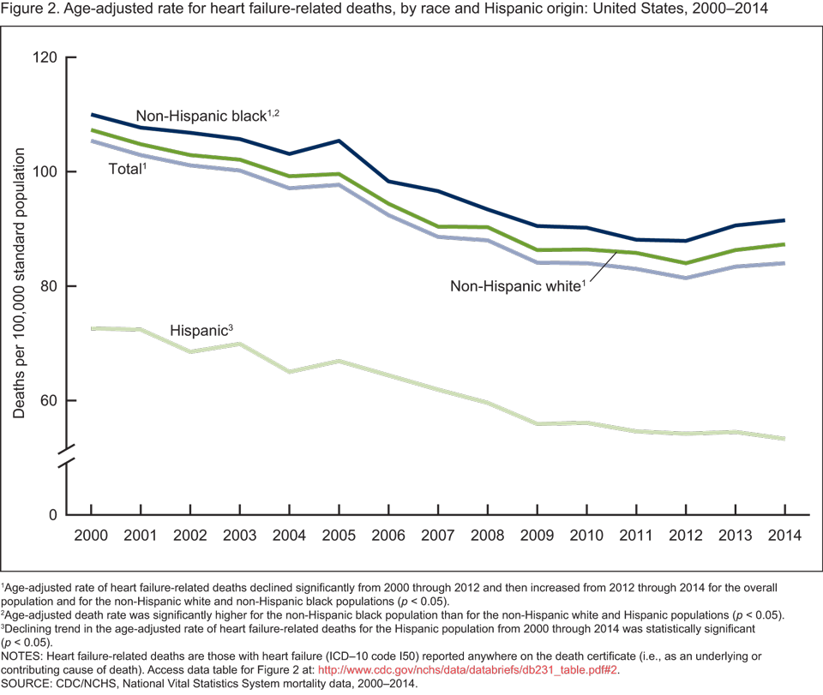

Heart Disease Disparities in Age, Gender, and Race
Heart disease outcomes vary by age, gender, race, ethnicity, and sexual orientation, among many other characteristics. For example, in the case of a coronary artery, women present different outcomes than men. Commonly, in the chronic situation of the disease, women show symptoms referred to as atypical. The atypical symptoms that women present may lead to underappreciating the risk in some cases. Atypical symptoms commonly include stomach pain, breathlessness, as well as constitutional symptoms such as nausea and fatigue (Khamis, Ammari, & Mikhail, 2016). The signs and symptoms for men with coronary artery are most likely chest pains and arms pain. For younger women, the sings of chest pain tend to delay, and the outcomes are more severe in comparison to the younger men.
In the case of congenital heart disease among children, there are also racial and ethnic disparities. Researchers from several studies have suggested that there is a relationship between race or ethnicity and various outcomes in congenital heart disease (CHD). In a population-based study in California, the results of the study show that in particular, non-Hispanic black patients with CHD continued to have at least 19% disparity in death compared with non-Hispanic white patients (Peyvandi, Baer, Moon‐Grady, Oltman, Chambers, Norton, & Steurer, 2018). Also, social, economic factors such as poverty, lack of access to care, and inadequate insurance status play a role in outcomes of CHD utilizing traditional analyses.
According to the Centre for Disease Control and Prevention, deaths resulting from heart disease also vary in terms of sex, race, and ethnicity. The National Vital Statistics published a report that shows the percentage of deaths caused by heart disease in the United States in terms of gender and race. For American Indian Alaska or Native, 19.4% of men died from heart disease while the percentage of women was 17.0%. For Asian American or Pacific Islander, 22.9% of men and 19.9% of women died of heart diseases. For Black non-Hispanic, 23.9% of men and 23.1% of women died of heart disease. For White non—Hispanic, 24.9% of men and 22.5% of women died of a heart attack. For the Hispanic, 2.6% of men and 19.9% of women died of a heart attack.
Uses, Strengths, and Weaknesses of Various Data Sources
The patient-reported data is one of the data sources in conducting healthcare-related studies. The purpose of this data source is to obtain intended compliance information and to give patient or caregivers outcomes. The source has a unique perspective. The need for development for validated data collection instruments is a weakness of this data source.
Clinician reported data is another data source for healthcare-related studies. This source is reliable as it gives more specific information than available from coded data or medical records (Gliklich et al., 2014). However, the source has some shortcomings in that there may be a lack of consistency in recording data of patients.
Conclusion
Heart disease is any disorder that affects the heart. The heart requires a supply of blood like all the other tissues in the body. Two coronary arteries arising from the aorta and course across the heart surface supply the heart with blood. In a situation when the two arteries or their branch narrows, it can lead to a heart disease known as coronary artery disease. There are various types of heart diseases with coronary artery disease, myocardial infarction, hypertensive heart disease, congestive heart failure, and congenital heart disease as the most common types. Coronary heart disease as an example of heart disease that can be both genetically inherited and caused by other risk factors.
According to the Center for Disease Control and Protection, heart disease is the leading cause of death for men and women and people of most racial and ethnic groups in the United States. In the country, every 37 seconds, a person dies of heart disease. Approximately 647,000 Americans succumb to heart disease each year. Heart disease outcomes vary by age, gender, race, ethnicity, and sexual orientation, among many other characteristics. For example, in the case of a coronary artery, women present different outcomes than men.

References
Gliklich,, R., Dreyer, N., & Leavy, M. (2014). Registries for Evaluating Patient Outcomes (3rd ed.). Agency for Healthcare Research and Quality (U.S.).
Heart Disease Resources | cdc.gov. Centers for Disease Control and Prevention. (2020). Retrieved 15 April 2020, from https://www.cdc.gov/heartdisease/about.htm.
Khamis, R. Y., Ammari, T., & Mikhail, G. W. (2016). Gender differences in coronary heart disease. Heart, 102(14), 1142-1149.
McPherson, R., & Tybjaerg-Hansen, A. (2016). Genetics of coronary artery disease. Circulation research, 118(4), 564-578.
Peyvandi, S., Baer, R. J., Moon‐Grady, A. J., Oltman, S. P., Chambers, C. D., Norton, M. E., ... & Steurer, M. A. (2018). Socioeconomic mediators of racial and ethnic disparities in congenital heart disease outcomes: a population‐based study in California. Journal of the American Heart Association, 7(20), e010342

