I will post the chapters text that needs to be used to do this work. Please see below for instructions and what needs to be done.

To help you in writing your Week 4 assignment, make sure to include the following:
- Introduction - Include an introductory paragraph that provides an opportunity to capture the reader's attention with a “hook” on the content of the paper with a clear thesis statement. Check out the thesis generator under Writing Center – Writing Resources – Thesis Guides.
- Discusses Any Organizational Differences in the Way Each Corporation Discusses its Annual Performance – This part of the assignment requires that you focus on the delivery of reporting the companies' performance (the way each corporation discusses its annual performance) and not on the actual performance of the corporations. Please see our previous course learning on organizing information (Chapter 4.5, for example). You can also read ahead - Chapter 14.
- Discusses the Goals, Challenges, and Plans Top Managers Emphasize in Discussion of Results – This is your opportunity to demonstrate your understanding on adapting to your audience and this week's course reading. You can also read ahead - Chapter 14.
- Discusses How the Format and Organization of Each Report Enhance or Detract from the Information Presented - This is your opportunity to demonstrate our course learning on organizing your information, Chapter 4.5; use of visual design to support and enhance the message. You can also read ahead - Chapter 14.
- Conclusion - Include a concluding paragraph that summarizes the main idea and ties the main points presented in the earlier paragraphs together neatly for the reader and ends with a sense of finality.
FINALLY, use APA style of writing:
- Use double space, 1” margins on all sides, font size 12
- Use at least first level heading to separate the main points of your paper, which will help you write clearly and concisely and not stray off topic. Use bold and centering for first-level headings. Capitalize all major words. Do not use the prompt as a heading, shorten it, use different words, etc.
- The word conclusion is always used.
- Avoid the use of the first person (the pronouns I, we) and second person (the pronoun you). Avoid saying, "I think” or “I feel” or "in my opinion.” It weakens your argument. Simply state your assertion.
VERY IMPORTANT: To ensure that you clearly and completely address the key elements of the assignment, please be sure to refer to the rubric for information on what is required in the assignment.
Please see attached sample APA paper to help you with organization and content development.

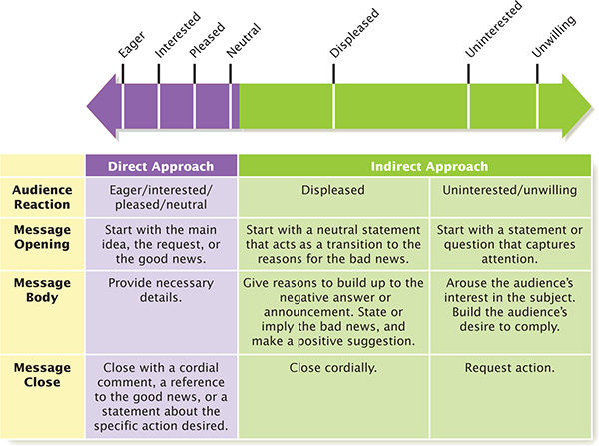

Discusses Any Organizational Differences in the Way Each Corporation Discusses its Annual Performance
Total: 1.50
Distinguished - Thoroughly discusses the organizational differences in the way each corporation discusses its annual performance.
Proficient - Discusses the organizational differences in the way each corporation discusses its annual performance. Minor details are missing.
Basic - Briefly discusses the organizational differences in the way each corporation discusses its annual performance. Relevant details are missing.
Below Expectations - Attempts to discuss the differences in the way each corporation discusses its annual performance; however, significant details are missing.
Non-Performance - The discussion of the organizational differences in the way each corporation discusses its annual performance is either nonexistent or lacks the components described in the assignment instructions.

Discusses the Goals, Challenges, and Plans Top Managers Emphasize in Discussion of Results
Total: 1.50
Distinguished - Thoroughly discusses the goals, challenges and plans top managers emphasize in the discussion of results.
Proficient - Discusses the goals, challenges and plans top managers emphasize in the discussion of results. Minor details are missing.
Basic - Briefly discusses the goals, challenges and plans top managers emphasize in the discussion of the results. Relevant details are missing.
Below Expectations - Attempts to discuss the goals, challenges and plans top managers emphasize in the discussion of the results; however, significant details are missing.
Non-Performance - The discussion of the goals, challenges, and plans top managers emphasize in discussion of the results is either nonexistent or lacks the components described in the assignment instructions.

Discusses How the Format and Organization of Each Report Enhance or Detract from the Information Presented
Total: 1.50
Distinguished - Thoroughly discusses how the format and organization of each report enhance or detract from the information presented.
Proficient - Discusses how the format and organization of each report enhance or detract from the information presented but minor details are missing.
Basic - Partially discusses how the format and organization of each report enhance or detract from the information presented. Relevant details are missing.
Below Expectations - Attempts to discuss how the format and organization of each report enhance or detract from the information presented; however, significant details are missing.
Non-Performance - The discussion of how the format and organization of each report enhance or detract from the information presented is either nonexistent or lacks the components described in the assignment instructions.

Written Communication: Control of Syntax and Mechanics
Total: 0.13
Distinguished - Displays meticulous comprehension and organization of syntax and mechanics, such as spelling and grammar. Written work contains no errors, and is very easy to understand.
Proficient - Displays comprehension and organization of syntax and mechanics, such as spelling and grammar. Written work contains only a few minor errors, and is mostly easy to understand.
Basic - Displays basic comprehension of syntax and mechanics, such as spelling and grammar. Written work contains a few errors, which may slightly distract the reader.
Below Expectations - Fails to display basic comprehension of syntax or mechanics, such as spelling and grammar. Written work contains major errors, which distract the reader.
Non-Performance - The assignment is either nonexistent or lacks the components described in the instructions.

Written Communication: APA Formatting
Total: 0.13
Distinguished - Accurately uses APA formatting consistently throughout the paper, title page, and reference page.
Proficient - Exhibits APA formatting throughout the paper. However, layout contains a few minor errors.
Basic - Exhibits basic knowledge of APA formatting throughout the paper. However, layout does not meet all APA requirements.
Below Expectations - Fails to exhibit basic knowledge of APA formatting. There are frequent errors, making the layout difficult to distinguish as APA.
Non-Performance - The assignment is either nonexistent or lacks the components described in the instructions.

Written Communication: Page Requirement
Total: 0.12
Distinguished - The length of the paper is equivalent to the required number of correctly formatted pages.
Proficient - The length of the paper is nearly equivalent to the required number of correctly formatted pages.
Basic - The length of the paper is equivalent to at least three quarters of the required number of correctly formatted pages.
Below Expectations - The length of the paper is equivalent to at least one half of the required number of correctly formatted pages.
Non-Performance - The assignment is either nonexistent or lacks the components described in the instructions.

Written Communication: Resource Requirement
Total: 0.12
Distinguished - Uses more than the required number of scholarly sources, providing compelling evidence to support ideas. All sources on the reference page are used and cited correctly within the body of the assignment.
Proficient - Uses required number of scholarly sources to support ideas. All sources on the reference page are used and cited correctly within the body of the assignment.
Basic - Uses less than the required number of sources to support ideas. Some sources may not be scholarly. Most sources on the reference page are used within the body of the assignment. Citations may not be formatted correctly.
Below Expectations - Uses inadequate number of sources that provide little or no support for ideas. Sources used may not be scholarly. Most sources on the reference page are not used within the body of the assignment. Citations are not formatted correctly.
Non-Performance - The assignment is either nonexistent or lacks the components described in the instructions.

Powered by 

