Math Lab 2
Name
Institutional Affiliation
Course
Date

Math Lab 2
- What z-score represents Penny's sleep assuming Penny sleeps 10 hours a day?
Standard Score, Z=$\frac{X-μ}{∂}$
Where µ = mean, $∂=standard deviation$, X= Score
Z= $\frac{10-13}{1}$ = -3 (unusual)
Meaning that the standard deviation is below the mean by 3
- What z-score represents Abby's sleep if Abby sleeps 16 hours a day?
Z= $\frac{16-13}{1}$ = 3(unusual)
Meaning the standard deviation is above the mean by 3
- What z-score represents Holly's z-score is she sleeps 14 hours a day?
Z=$\frac{14-13}{1}$=1(usual)
Meaning that the Z score value is one standard deviation from the mean
- What is Penny's Puppy Sleep percentile? Type answer rounded to the hundredths with NO % sign
To determine the percentile of sleep, we need to find the probability of Z=-3 from the Z score table .The probability of -3 from the Z table is 0.0013
Sleep percentile =0.0013 x 100=0.13

- What is Abby's Puppy Sleep percentile? Type answer rounded to the hundredths with NO % sign.
Z=3, from the Z score table we find the probability (3) = 0.9987
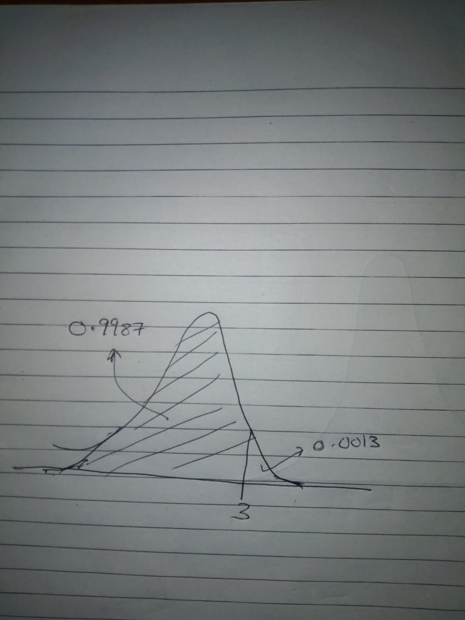
Percentile = 99.87

- What is Holly's Puppy Sleep percentile? Type answer rounded to the hundredths with NO % sign.
Z=1, the value from the Z table = 0.8413
Sleep percentile = 0.8413 x 100% = 84.13
- Using the 68-95-99.7 Rule, what percent of dogs sleep between Penny's and Abby's sleep times? Type as a percent rounded to the tenths.
68% the value lies = 13 ± 1= 14 hours or 12 hours
95% the value lies = 13± 2= 15 hours or 11 hours
99.7% the value lies = 13 ± 3 =10 hours or 16 hours
Hence the percentage of sleep between Penny’s and Abby’s is 99.7%
- What percent of dogs sleep between the interval from 12 to 14 hours given a mean of 13 and standard deviation of 1? Type using % symbol
x =$μ+Zσ$
For 12 hours, z= x –$μ$ =12-13 =-1
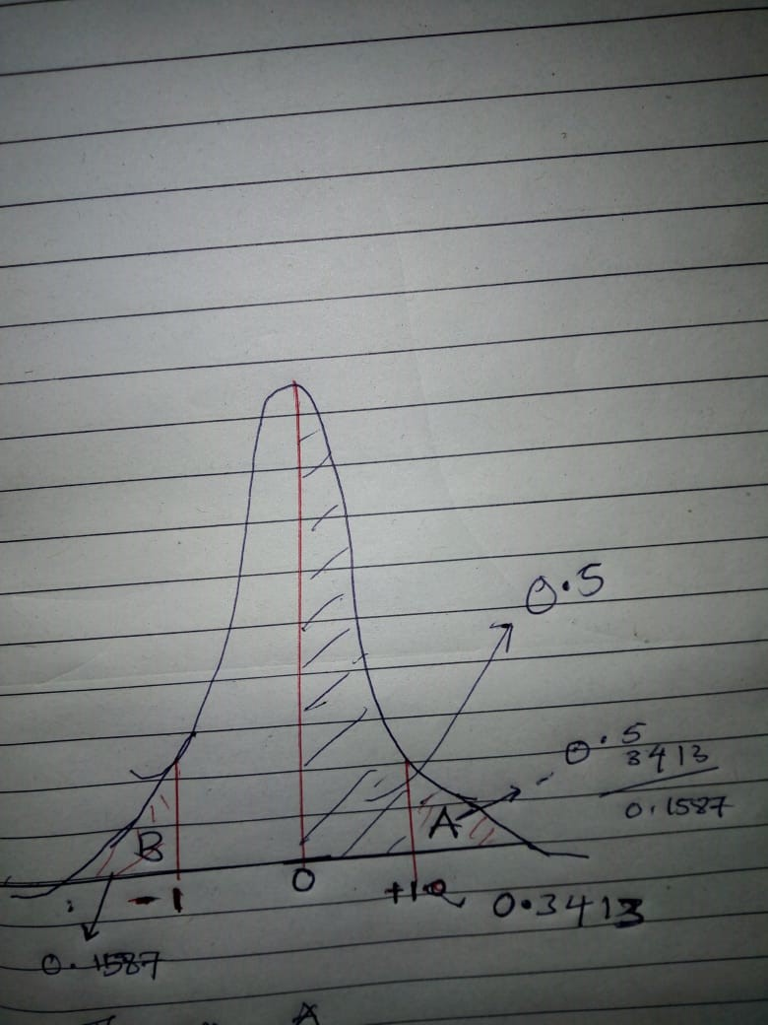
For 14 hours, z =14-13=1

Figure 1
To find the area between -1 and + 1 as shown in figure one
The size of the whole curve =1
The two halves is 0.5 each
The percent interval between 12 and 14 hours lies in the area between -1 and + 1
To find the area left of +1 =0.5-(the area between 0 and +1)=0.5-0.3413=0.1587
Thus, the area of percent interval =1-(A+B)= 1-(2x 0.1587)=0.6826
Percentage= 0.6826 x 100%=68.26%.
- What interval about the mean includes 95% of the data in the survey?
To compute the 95% percentile we use x =$μ+Zσ$
Mean=13
Standard deviation= 1
The corresponding Z score of 0.95 from the Z table =1.645
The interval about the mean = $μ ±Zσ$ = 13 ± 1.645(1) = (13-2) or (13+2) =11 or 15
Therefore, the interval about the mean= (11, 15)

