- #2.4.1 Just do the last two sentences (the cubic interpolating polynomial p3 and its integration to get formula (2.4.9)).
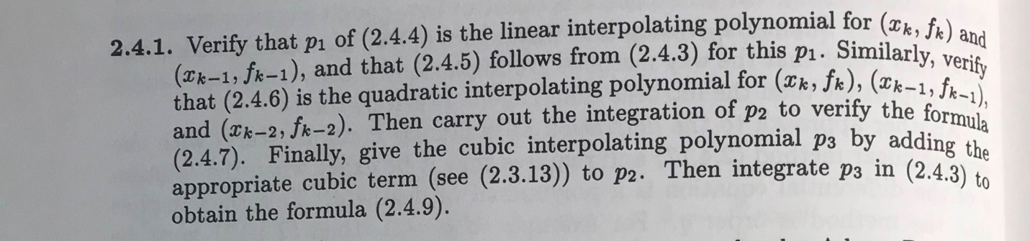
2.4.3
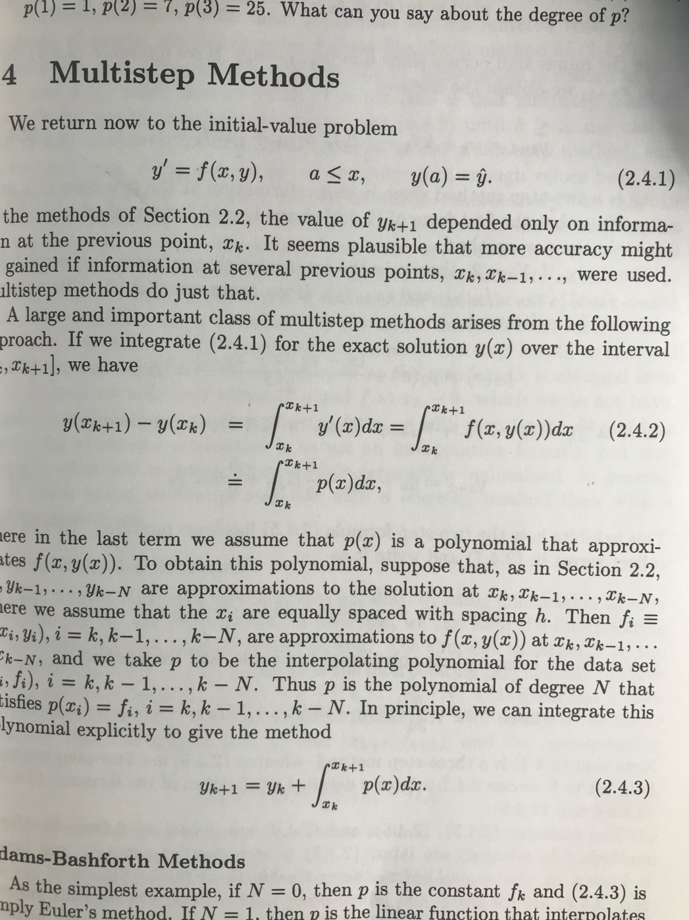
2.4.4 , 2.4.5 ,2.4.6, 2.4.7 and 2.4.9
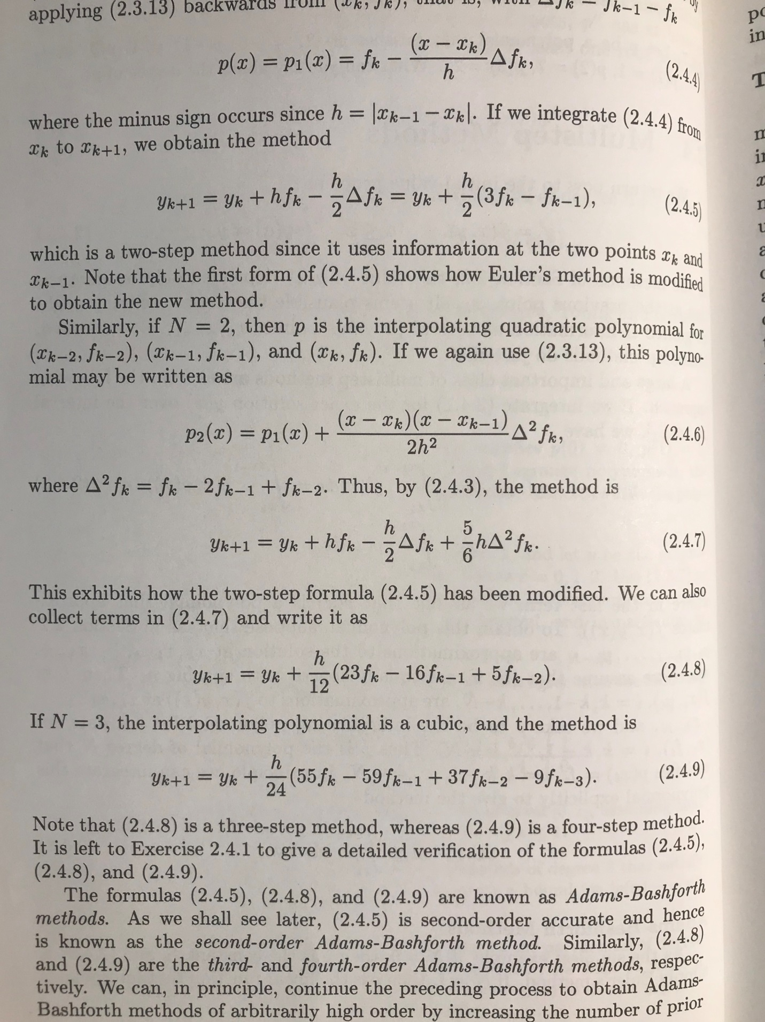

2.4.13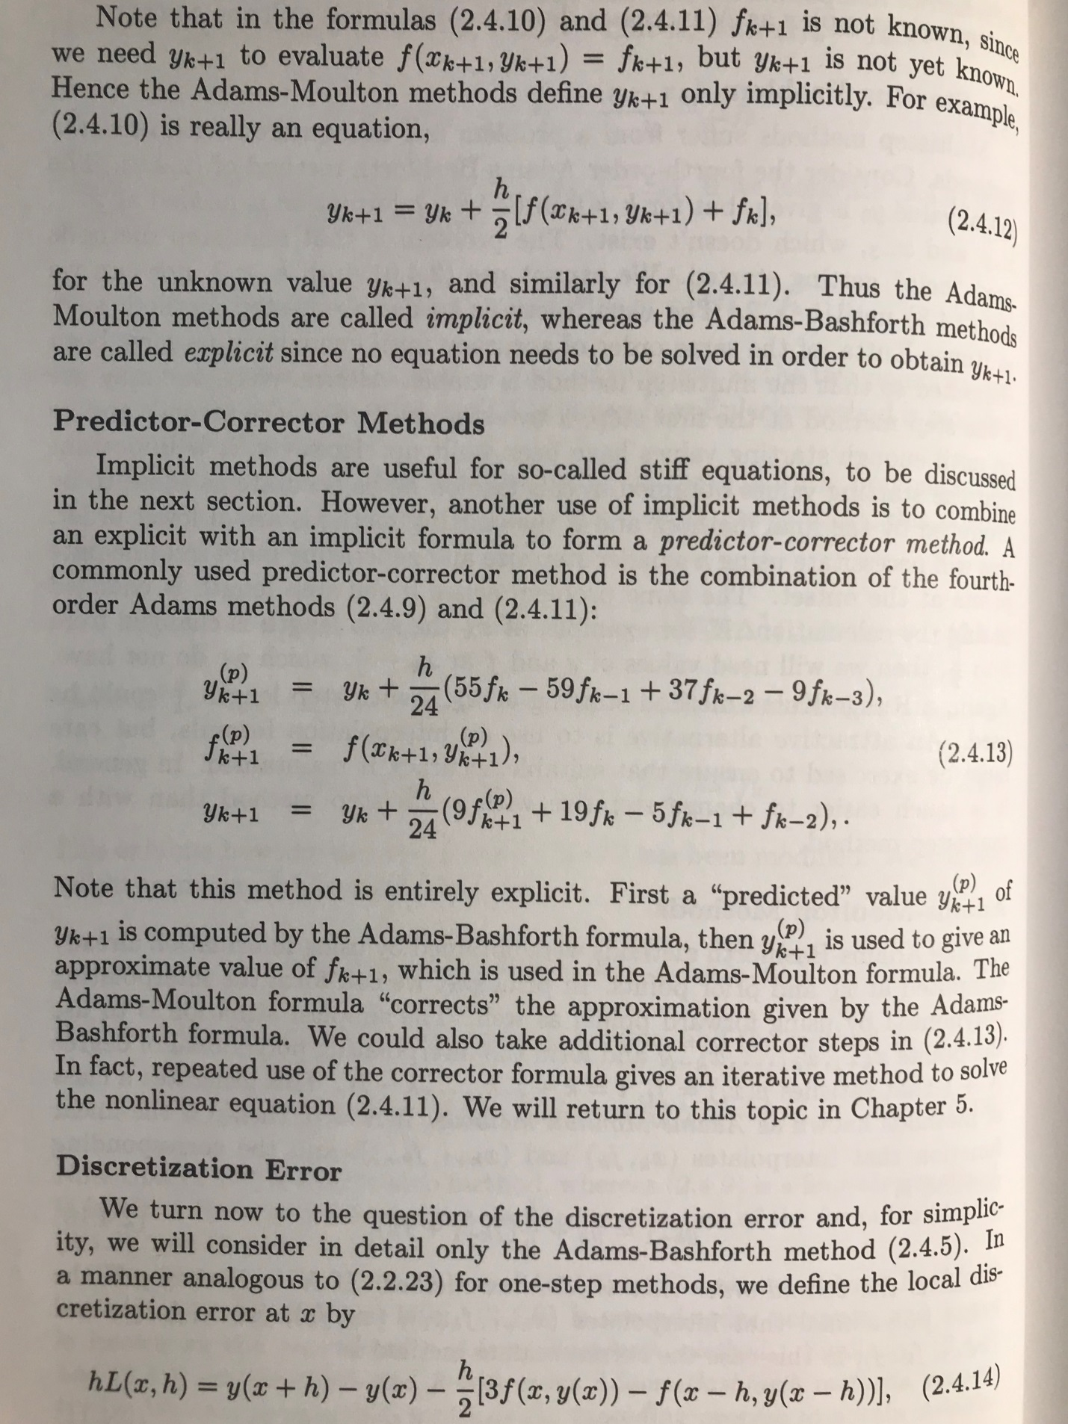

- #2.4.2 When applying your program to 2.2.2, just use the step size h = 0.125, and also compute the absolute errors (and compare these to those using Euler and Heun). And instead of the IVP in 2.2.8, repeat this on the IVP y ′ = 2xy² with y(0) = 1 on the interval [0, 1].
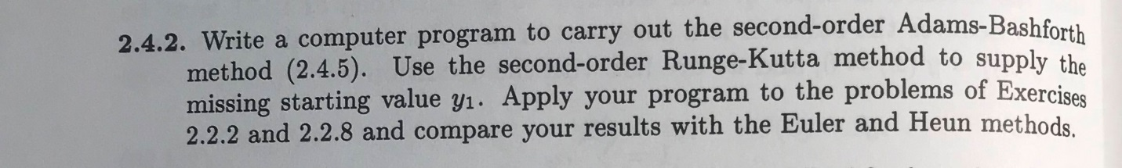

Method ( 2.4.5)
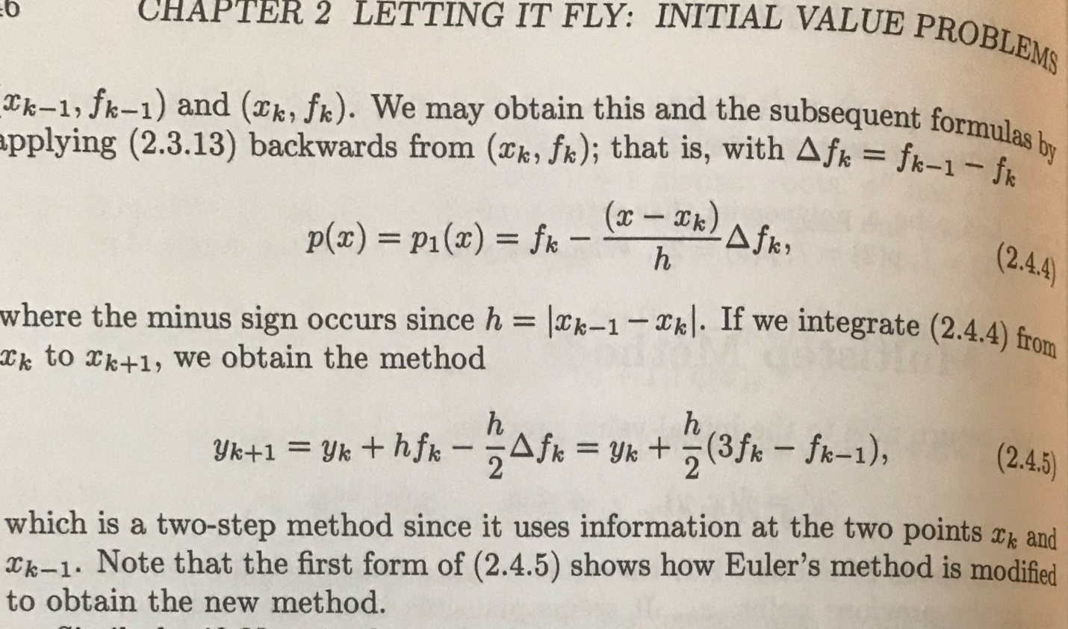
Exercise 2.2.2 and 2.2.8

- #2.4.5, for the method listed in the problem (which is ABM2), but not for (2.4.13). Just use the step size h = 0.125, and compare the absolute errors to AB2, Euler, and Heun. Repeat for the IVP y ′ = 2xy² with y(0) = 1 on the interval [0, 1] and compare with prior results.
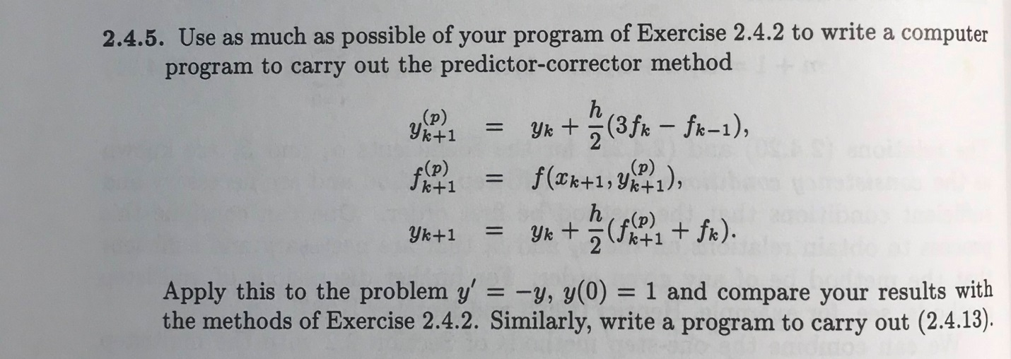
Exercise 2.4.2
2.4.13
