Question A

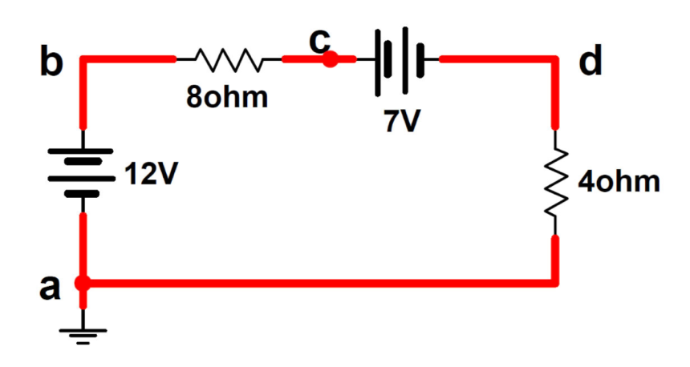

- The net of e.m.f. is 19V
- The total resistance is 12Ω
- The current flow is 1.5A
- The potential drop across bc is 12V
- The voltage at point a is 0V
- If the voltmeter is connected across ba then it would read 12V
- If the voltmeter is connected across ca then it would read 12V
- If the voltmeter is connected across da then it would read 19V

Question B

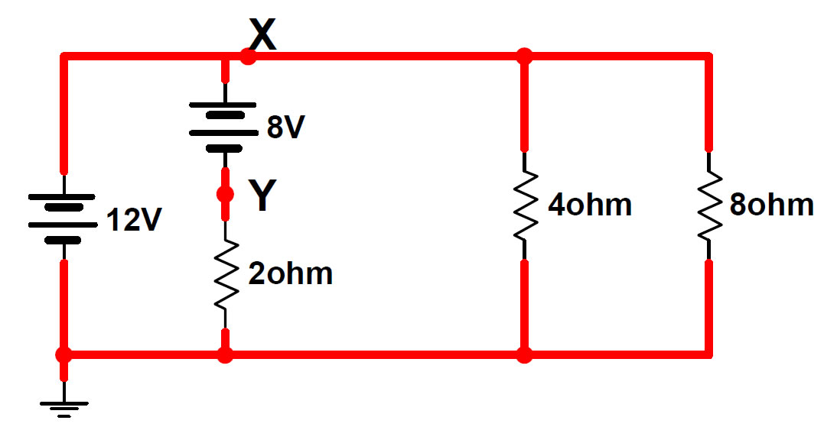
For the Circuit above, if you calculated the equivalent resistance R_{TOT} of the 4 ∥ 8Ω combination you would end up with 8/3(2.667) Ω

Question C
Redraw the circuit from question B with R_{TOT} replacing the two parallel resistors.

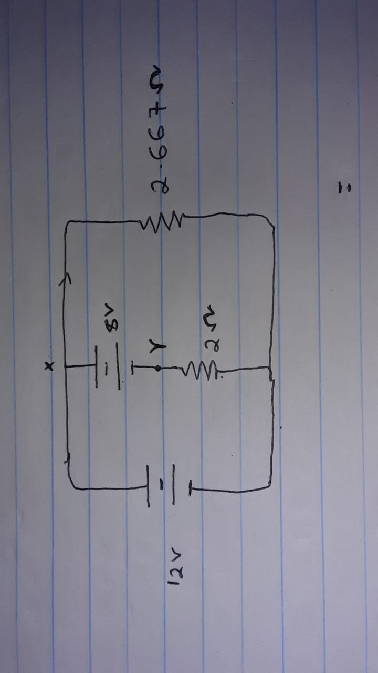

Question D

Using the circuit, you drew for question C, answer the following questions.
- The voltage at point X is 12V
- If you calculate the current through R_{TOT} it would be 4.5 A
- The voltage at point Y is 4V
- The current through the 2ohm resistor is 2A
- The current through the 12V battery is 6.5A

Question E

Using the circuit above, calculate the power provided by each battery and the power loss in each resistor:
- The power provided by a 12V battery is 78W with power Lost (type either lost or provided)
- The power provided by a 8V battery is 16W with power Lost (type either lost or provided)
- The power provided by a 8Ω resistor is 18W with power Provided (type either lost or provided)
- The power provided by a 4Ω resistor is 36W with power Provided (type either lost or provided)
- The power provided by a 2Ω resistor is 8W with power Provided (type either lost or provided)

