
Spring 2021
ENGL100. Homework (10%)
Answer Sheet
Type your answers IN THE BOXES.

Fill in your identification information in the box below.
Full name | ID Number | Section

1. Insert the screenshot of your Completion Status.
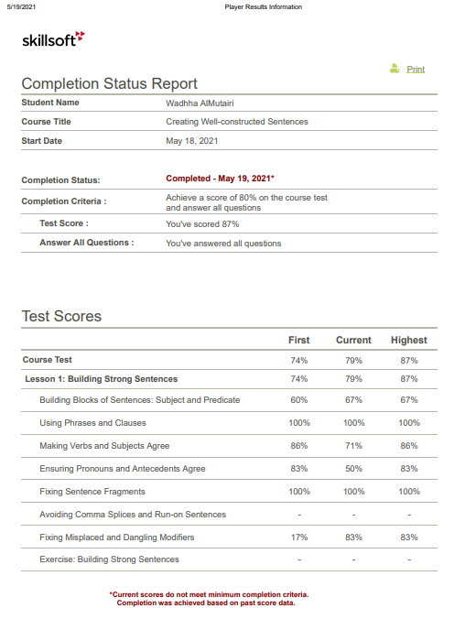

2. Write TWO comments about the good sides of the grammar structures used in the paragraph. Explain your answer.
1. Proper punctuation in sentence 6

2. Correct spelling in the whole paragraph

3. Find FIVE mistakes and explain how they should be corrected.
1. use of clauses in sentence 2
There are two independent clauses that are improperly joined with a comma. This can be corrected by first making two separate sentences and second by joining the clauses through the use of a semicolon.

2. Subject-verb agreement error in sentence 12
There seems that the verb make does not agree with the subject. This can be corrected by changing the verb form. The subject of the sentence should agree with the verb. Thus, since in our sentence there is a singular subject we need a singular verb such as makes.

3. Fragments for sentence 7, 8, 9.
The sentences tend to be pieces of sentences which tend to be disconnected from the main clause. This can be corrected by removing the period between the fragment and the main clause.

4. Misplaced modifiers in sentence 11
The modifier tends to be far away from the thing it is supposed to modify. Thus the sentence should have been “Finally, do not keep walking if you think you are lost”

5. Consistency of pronouns in sentence 3
The sentence has mixed the use of you and he in the same sentence. Therefore the sentence should have been “First, always tell someone where you are going and what time you expect to return”

