Horticulture

Students Name
Institutional Affiliation
Course Code and Name
Instructors Name
Date

Horticulture
Honey locust (Gleditsia triacanthos) before the results.
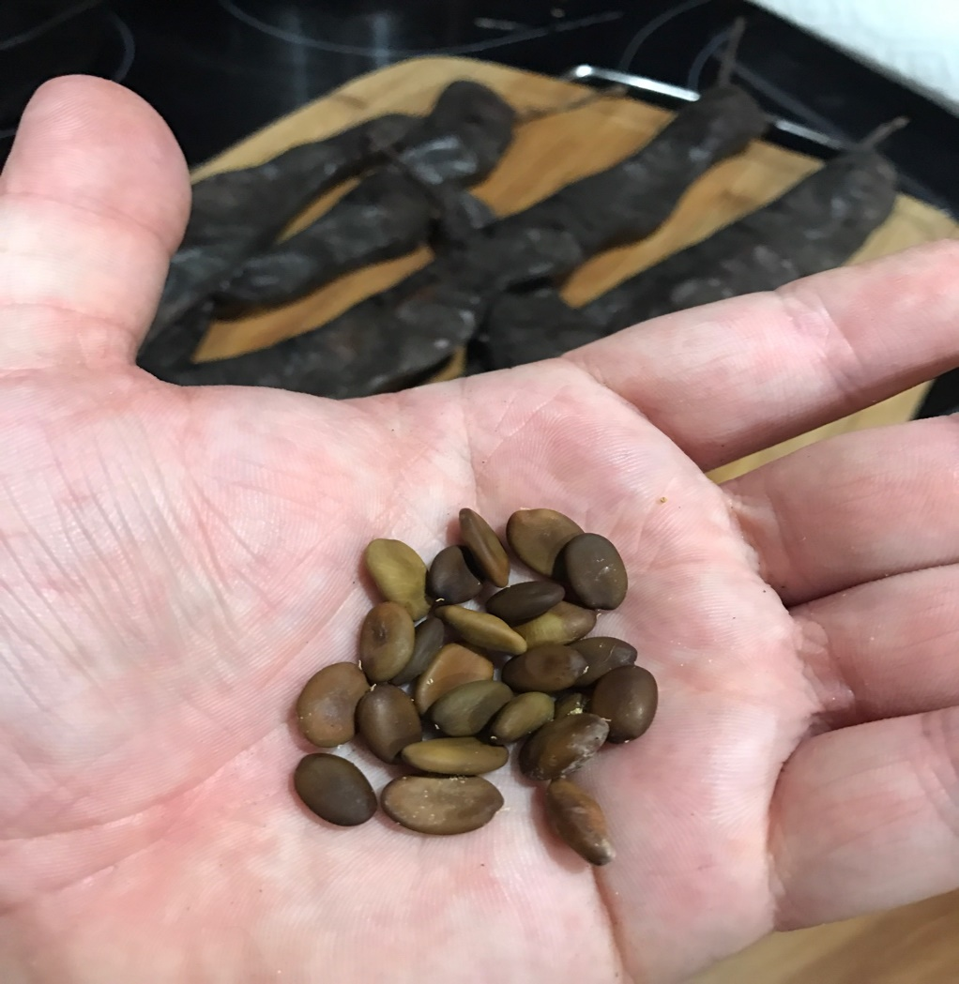

Honey locust (Gleditsia triacanthos) after the results.
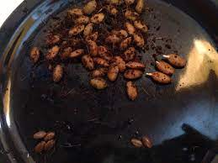
Kentucky coffeetree (Gymnocladus dioicus) before the results.
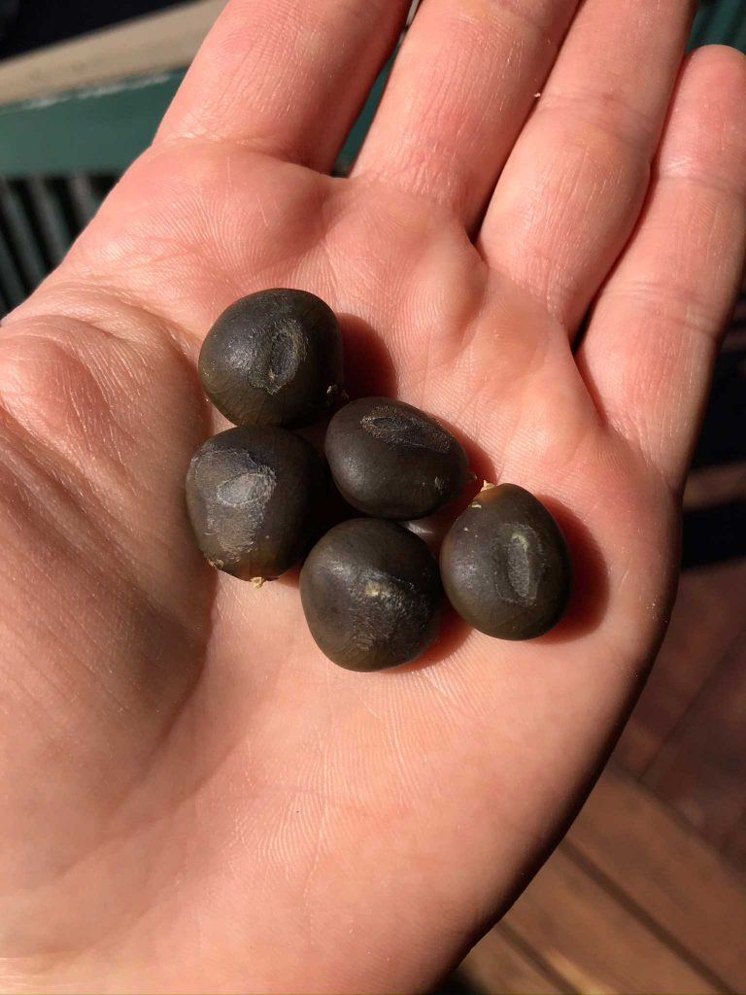
Kentucky coffeetree (Gymnocladus dioicus) after the resuts the results 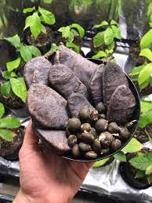
Hot water treatment for the seeds had most seeds germinating. Soaking seeds in hot water loosened the hard outer covering of both seeds (Govindaraj et al., 2017).

Rereference
Govindaraj, M., Masilamani, P., Albert, V. A., & Bhaskaran, M. (2017). Effect of physical seed treatment on yield and quality of crops: A review. Agricultural Reviews, 38(1).

