Hybridization

Tutor:

Name:

Subject:

Date:

Topic #1
Explain the concept of hybridization as if you were explaining it for the first time to a person with a limited science background(i.e, a 10 year old child).
Hybridization is a concept in which two atomic orbitals are mixed to form a new atomic orbital. In simple terms, it is like mixing two things together to form one new component. This new component will have the combined properties of the individual constituents that were mixed. In the case of hybridization, the resultant orbital will have the average of the properties of its individual constituents(Alabugin et al., n.d.). The properties involved in this case involve energy and number of electrons.
Orbitals represent the behavior of electrons within molecules. It is represented in the following format:
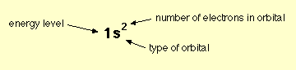

Examples of hybridization in elements include:
- Methane (CH₄)
Methane consists of a central carbon atom and four hydrogen atoms. The central carbon atom is sp³ hybridized. This is as a result of three 2s orbitals in the carbon valence shell combining to form four sp³ hybrid orbitals(McMurry, 2014). These hybrid orbitals are of equal energy and shape. The four hydrogen atoms also use these four sp³ hybrid orbitals of carbon to form C-H sigma bonds which leads to formation of methane molecule.
- Water (H₂O)
Water molecule consists of a central oxygen atom and two hydrogen atoms. The oxygen atom can form four sp³ hybridized orbitals. Two of these orbitals are used for bonding while the other two are occupied by the lone pairs on the oxygen atom.
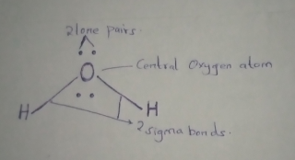
The two lone pairs plus the two sigma bonds form the four sp³ hybridized orbitals.
- Ammonia (NH₃)
Ammonia consists of a central nitrogen atom and three hydrogen atoms. The nitrogen atom forms four sp³ hybridized orbitals. This is due to the overlapping of the three half filled orbitals of nitrogen with the three orbitals of hydrogen. The result is a full filled sp³ orbital. Due to the presence of a lone pair, ammonia forms a pyramidal or distorted tetrahedral. 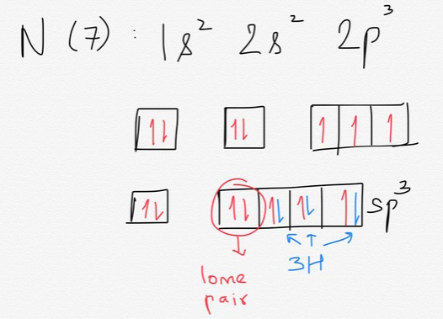
Topic #2
Describe the structural feature (s) that you feel influence the basicity of a molecule. Be sure you explain how the feature(s) work and rank your features from most to least influential.

- Inductive effects
The inductive effect is the process by which an atom or group of atoms other than those bonded with hydrogen can induce a change in distribution within the molecule. It has the biggest influence in the basicity of a compound. The inductive effect can weaken the O-H bond in a compound and allow hydrogen to be more easily lost as hydrogen ions.
- Bond Strengths
The stronger the A-H bonds, the les likely the bond is to break to form hydrogen ions (H⁺) and therefore the more basic the substance. The variation in bond strengths is due to the steady decrease in overlap between the 1s orbital of hydrogen and the valence orbital in a halogen.
- Stability of the conjugate base
A conjugate base contains one or more lone pair of electrons compared to the parent molecule. A factor that stabilizes the lone pair on the conjugate base favors the dissociation of hydrogen ions and this makes the parent base a weaker base.

References
Alabugin, I., Chemistry, S. B.-… O., & 2015, undefined. (n.d.). Orbital hybridization: a key electronic factor in control of structure and reactivity. Wiley Online Library. Retrieved September 11, 2020, from https://onlinelibrary.wiley.com/doi/abs/10.1002/poc.3382
McMurry, J. (2014). Organic chemistry with biological applications. https://books.google.com/books?hl=en&lr=&id=KDIeCgAAQBAJ&oi=fnd&pg=PR5&dq=Organic+chemistry+with+biological+applications+3rd+edition+by+John+McMurry&ots=2erOd9-BWY&sig=fgGOp35X4_Ghn-MHva28AVPKeE8

