 | Hydrogen | Carbon | Nitrogen | Oxygen
Protons | 1 | 6 | 7 | 8
Neutrons | 0 | 6 | 7 | 8
Electrons | 1 | 6 | 7 | 8
Color of ball in kit | colorless | black | colorless | colorless

Atom | Number of shells | No of electrons in outer shell | Number of electrons needed to fill outer shell | Number of bonds the atom can make
Hydrogen | 1 | 1 | 1 | 1
Carbon | 2 | 4 | 4 | 4
Nitrogen | 2 | 5 | 3 | 3
oxygen | 2 | 6 | 2 | 2

Molecule | Simple formula | Structural formula | Inorganic or organic | Single or double bonds
Hydrogen gas | H₂ | H-H | ORGANIC | SINGLE
Methane | CH₄ | H  H-C-H  H | ORGANIC | SINGLE
Oxygen gas | O₂ | O-O | INORGANIC | DOUBLE
Carbon dioxide | CO₂ | O-C-O | INORGANIC | DOUBLE

Formula for glucose CH₂O
COO-
Amino acid molecule H₃⁺N-C-H
R
PEPTIDE BOND
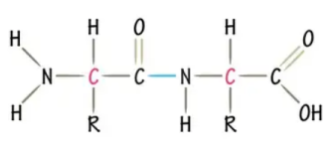
In condensation water is being lost
Resulting molecule will be larger since 2 monomers are being combined to a single polymer
In hydrolysis reaction water is being added to breakdown polymers into monomers
Resulting molecule will be smaller

