
Home | About | Products | Careers | Media | Contact
Hello Borough of Manhattan Community College (CUNY)
HOME > INDUSTRY MARKET RESEARCH > US INDUSTRY REPORTS (NAICS) > COMMERCIAL REAL ESTATE
PDF

PRINT

IEXPERT

ARCHIVE

SEARCH


TUTORIAL

- About this Industry
- Industry
at a Glance
- Industry Performance
- Industry Outlook
- Products &
Markets
- Competitive Landscape
- Major Companies
- Operating
Conditions
- Key Statistics

Products & Markets

Supply Chain


KEY BUYING INDUSTRIES
42 | Wholesale Trade
 | Small wholesalers use industry operators to store merchandise and other goods.

44-45 | Retail Trade
 | Retailers use commercial real estate companies to rent space that is used for retail activities.

52 | Finance and Insurance
 | Many establishments in this sector require accurate valuations for financing and insurance activities.

54111 | Law Firms
 | Lawyers working on property dispute cases use real estate appraisers and valuation companies to determine the value of the holding.

99 | Consumers
 | Consumers use commercial real estate companies for housing and storage rentals.

KEY SELLING INDUSTRIES
23 | Construction
 | Specialty contractors are used for maintenance purposes and during the construction of buildings.

51114 | Database & Directory Publishing
 | Real estate service companies use property- and other information-databases for reports, client meeting and other real estate related activities.

51 | Information
 | Real estate agents and brokers use newspapers and other media for business and property advertising.

56172 | Janitorial Services
 | Commercial property owners and management companies use janitors to ensure buildings are properly cleaned and maintained.

54111 | Law Firms
 | Commercial real estate companies use council during property acquisition, lease negotiations, development activities and project zoning filings.

51121 | Software Publishing
 | Real estate appraisers and valuation companies use software to help determine asset values and develop reports.
Back to top

Products and Services
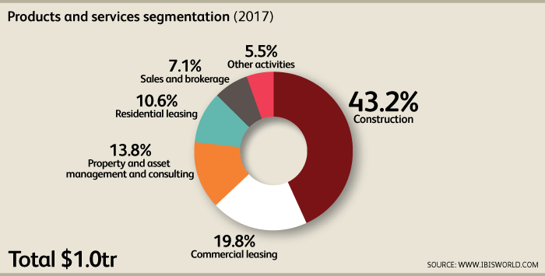
The Commercial Real Estate industry comprises a diverse set of operators that specialize in a variety of real estate activities, including brokerage, property and facilities leasing and management, research and analytics, consulting, valuation, appraisal, construction and asset management. These activities can be grouped into five major segments: construction, residential leasing, commercial leasing, property and asset management and sales and brokerage.
Construction
Construction activity accounts for an estimated 43.2% of industry revenue. Companies in this service segment include national and international general contractors (GCs) able to undertake massive retail, institutional, entertainment and hospitality projects, such as shopping malls, hospitals, sporting arenas and hotel casinos. GCs also construct multifamily residential structures. GCs typically assume all the responsibility for the project's completion, including hiring subcontractors and procuring materials. Most construction contracts are “design-bid-build,” an arrangement in which the property owner or developer hires the architect and then accepts bids from GCs to manage the build-out. During the past five years, however, “design-build” contracts, in which the GC and architect are the same entity, have become more popular. Commercial construction has experienced increasing service convergence, in which larger operators offer a variety of design, construction, consulting and management services.
This segment also includes redevelopment or remodeling work conducted on existing buildings, which property owners or developers often choose over new construction during market slumps. Occasionally, remodeling involves altering the type of building (e.g. conversion of warehouses to offices), but it typically involves restoring an existing premise to its original position within the property market. Offices are generally restored to a class-A rental through internal renovations, new external cladding, installing building automation and upgrading facilities for modern data and communication transmission. During the past five years, remodeling work has grown as a share of this segment, though new construction has picked up in recent years.
Commercial leasing
Commercial leasing is the second-largest segment in this industry, accounting for about 19.8% of industry revenue. Property owners generate revenue through rental income, net gains from property sales and real estate brokerage fees. According to US Census data and IBISWorld estimates, nearly 90.0% of commercial property owner income is associated with rents. Rental rates are generally determined by the type, class and location of the leased property. Net gains from sales account for less than 5.0% of commercial property owner income. Similar to rental rates, income fluctuates with general economic cycles since demand and valuation of real estate are often based on business growth, consumer spending and corporate profit. The remaining income for commercial lessors (5.5% of commercial leasing income) is associated with general fees, such as late-payment penalty charges. Falling property values and a strong supply of vacant commercial space has led to lower rental rates during the past five years, decreasing this segment's share of overall revenue.
Property and asset management and consulting
This group of real estate services is estimated to contribute about 13.8% of industry revenue. Property managers work on behalf of owners and are responsible for the daily upkeep and operation of a building or property, including rent collection, accounting, staffing and building maintenance. Property managers also act as the liaison between owners and tenants and often negotiate tenant leases and process maintenance requests.
Real estate asset managers and consultants provide long-term strategic planning for clients investing in real estate. Activities within this segment include real estate investment analysis and advice, estate acquisitions and disposals, real estate risk management, property finance and loan advice and loan restructuring. These services are generally provided to operators within the commercial sector that have extensive real estate portfolios. This segment also includes real estate appraisal services, which reassess the value of a property based on current conditions. Appraisal services come into high demand during volatile periods when property values rise or fall quickly; this service grew as a share of revenue during the early recovery.
Residential leasing
The leasing of multifamily residential property (i.e. apartment buildings, or residential properties with five or more units) accounts for about 10.6% of industry revenue. Apartments are generally differentiated by the type, style, size and location of the property. Apartments are also distinguished by quality, including finishes, appliances and amenities, such as gyms and pools. On the higher end, some complexes also offer premium services, such as valet, personal security and dry cleaning assistance. Apartment rental has grown more lucrative during the past five years as the single-family housing market collapsed and many consumers and families were forced to begin renting.
Sales and brokerage
Real estate sales and brokerage activities account for about 7.1% of revenue in 2017. Agents and brokers may represent either the buyer or seller of a property and receive a percentage of the sale value as their commission or fee; because most agents operate on a 100.0% commission basis, these fees comprise this segment's revenue. Additionally, this convention ties this segment's share of revenue directly to property values. During periods of falling prices, agents receive smaller fees; when prices appreciate quickly, agent commissions also increase. This segment's share of revenue has fallen sharply during the past five years, though it has begun rising recently in the wake of rebounding commercial property prices.
Other activities
Other activities include land development and leasing services and the leasing of storage and warehouse space. These services combine to account for about 5.5% of industry revenue and have increased slightly as a share of revenue over the past five years.
Back to top

Demand Determinants
Demand for commercial real estate is generally associated with corporate expansion and a rise in consumer spending. Investment in commercial real estate is influenced by many factors, including the prevailing level of interest rates and availability of finance; company profitability and the capacity to invest into new premises or expand rental accommodation; current and expected rates of general economic growth; expected yield on investment (both long-term rental yield and speculative capital gains); taxation treatment of building investment compared with other types of assets; vacancy rates of existing building stock; and changes in the structure, distribution and size of the population. The specific factors that influence demand for commercial building construction vary according to the type of building (e.g. hotels, retail stores or offices).
Office space demand
Demand for office space is largely determined by general economic cycles, as business expansion traditionally coincides with strong economic growth. The office segment is composed of a variety of different industries and segments, including finance, healthcare, insurance, communications, law and entertainment. Typically, demand peaks during periods of strong economic growth, because the need for space rises as new businesses enter the market and existing operators expand operations.
Demand for space can also vary by the kind or quality of office building. Office structures are classified into three main segments: Class A, Class B and Class C, each of which denote a certain size, quality of construction or location, which in turn affect the rental rates an owner can charge for space. Demand for office space is also impacted by corporate policies and trends, such as telecommuting, which reduces the need for space as employees are allowed to work from home. Additionally, the average age of commercial office stock is an important determinant of demand for the addition of new stock or the upgrade of existing stock.
Demand for retail and hotel space
The ability for retailers to expand services or the rise of new entrants into the marketplace is largely dependent on consumer spending, as businesses must be profitable to successfully expand operations. Retailers require space that is highly visible and conveniently located. Retailers that are looking for space in malls generally rely on foot traffic and sales metrics to make lease determinations. Hotel construction is determined by growth in international and domestic tourism; major cultural, sporting, entertainment and business events; growth in casino licenses; and an area's existing supply of accommodation.
Apartment demand
Economic cycles yield varying results for apartment rental. During times of strong economic growth, individuals tend to spend more money on living expenses, driving up demand for residential leasing. At the same time, strong economic growth may also lead to a rise in homeownership levels, which can adversely affect industry demand.
US demographics are also strong indicators of residential leasing and construction demand, as homeownership is largely affected by marriage rates, divorce trends and family sizes. Marriage and divorce rates are important indicators for rental demand because singles tend to rent housing at higher rates due to lower household incomes. Birth rates and family sizes are also important indicators of leasing demand because larger families typically need the living space offered by owning a home.
In addition to demographics, population trends tend to indicate demand for residential leasing. Generally, densely populated areas such as New York City or Los Angeles often have lower homeownership rates than rural areas. Cities are characterized by homeownership costs that are significantly higher than the national average. In areas where homeownership costs are significantly higher than rental expenses, industry demand tends to be high.
Municipal and industrial building demand
The key determinants of demand vary across the various building markets (e.g. schools, hospitals, museums and law courts); however, with the majority of construction funded by public-sector clients, demand for industry services is heavily weighted toward trends in public sector expenditure.
Demand for industrial space is largely dependent on market conditions, industry trends and the proximity of distribution channels. Local taxes and regulations are also important for determining demand for industrial space. Additionally, any infrastructure developments or other initiatives designed to improve accessibility and distribution of manufactured goods is also important for demand.
Back to top

Major Markets
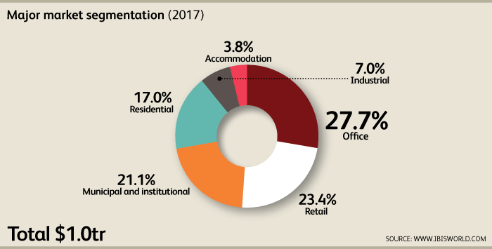
The Commercial Real Estate industry can be divided into six major market segments: office, retail, hotel and motel accommodations, residential, industrial and municipal. On an aggregate basis, fluctuations in revenue from each of these segments are relatively stable since the industry comprises a wide variety of operators that offer a diverse group of products and services. Additionally, commercial lease contracts are typically five or more years, reducing overall industry volatility.
Office
The office market accounts for about 27.7% of industry revenue. Office accommodation can be differentiated by the type, style, age, condition, tenant identity and location of the property. The office sector is often segmented into three general classes: A, B and C. Class A office spaces are generally characterized as buildings that are managed professionally and have high-quality tenants, an excellent location and high-quality building materials and common areas. Banks, law operators, investment operators and other high-profile companies often occupy these properties. Class B buildings are often slightly lower in quality and craftsmanship in comparison to Class A structures. Class B buildings are usually newer, wood-framed buildings or older, former Class A buildings. These buildings are also not located in “excellent” locations. Instead, Class B office buildings are often found in the suburbs or less-expensive business districts. Class C buildings are the cheapest buildings to rent and are typically 15 to 25 years old.
Office construction is principally focused on the central business districts (CBDs) of major cities, though significant construction also occurs in suburban areas. On CBD building projects, the large-scale construction companies dominate, while smaller contractors are more prevalent on non-CBD office construction projects.
Retail
Retailers account for about 23.4% of industry revenue. This market is largely composed of shopping centers. Similar to office buildings, regional shopping malls can be categorized by property class, though classes are determined by sales per square foot. The three property classes are Class A, with tenant sales of at least $400.00 per square foot; Class B, with tenant sales of less than $400.00 per square foot; and Class C, with tenant sales of less than $250.00 per square foot. Simon Property Group and General Growth Properties are the two largest Class A shopping center owners in the country.
Municipal and institutional
The municipal and institutional markets account for about 21.1% of revenue. This market segment includes hospitals, schools, universities, churches, prisons and other government buildings. Educational building construction comprises one of the largest market segments for this industry. Since the late 1990s, there has been a substantial lift in public-sector funding to renovate structurally deficient public schools. There is a growing trend for regional school authorities (county or municipal) to enter into long-term refurbishment and maintenance contracts with large-scale construction operators, which cover all the public schools within a jurisdiction. Demand from the education and healthcare construction markets has remained strong over the past five years, as these markets do not generally follow economic trends and did not experience a contraction during the early recovery.
Residential
The residential market accounts for about 17.0% of revenue in 2017 and primarily includes apartment buildings and complexes. The construction, leasing, management and other industry services related to the residential market have fallen as a share of revenue over the five years to 2017 as other markets more closely tied to consumer spending recovered after a shaky early recovery. Demand for apartments has slowed as the decline of the national homeownership rate has started to slow. This market is most lucrative in high-density urban areas, such as New York City, where downtown locations are desirable and owners can justify high rates.
Industrial
The industrial market accounts for about 7.0% of revenue in 2017. Industrial properties are generally categorized into two distinct property segments, light and heavy, depending on the type of activity that is being conducted at the site. A light industrial facility usually employs fewer than 500 people and has an emphasis on activities other than manufacturing. Typically, light industrial activities include printing plants, material testing laboratories and assemblers of data processing equipment. All light industrial facilities are also freestanding and devoted to a specific use.
In contrast, heavy industrial facilities usually have a higher number of employees per industrial plant and can also be categorized as manufacturing plants. Overall, industrial tenants are engaged in a wide variety of businesses, including manufacturing, wholesale trade, distribution and professional services. Prospective tenants usually seek property in areas located close to suppliers, customers and staff. In addition, industrial properties generally have convenient access to major transportation systems, including interstate highways, railroads and airports.
Accommodation
The hotel and motel market (i.e. lodgings or commercial accommodation) is expected to generate about 3.8% of industry revenue in 2017. Over the past five years, demand for hotel and motel construction has fallen in response to contractions in consumers' ability and willingness to spend on nonessential travel. With slow income growth and rising unemployment during the early recovery, households were forced to forgo taking vacations to save money; likewise, business travel decreased markedly as businesses tightened their budgets. With lower demand for accommodation, demand for new hotels and motels stayed low. This market is expected to remain a minor part of industry revenue.
Back to top

International Trade
Exports in this industry are low and steady More Info
Imports in this industry are low and steady More Info
The industry comprises commercial property that is located in the United States, and international trade is therefore not applicable. However, the industry does contain companies that own property abroad or offer services on a global scale. For more information on industry globalization and foreign investment, please see the Industry Globalization section of this report.
Back to top

Business Locations
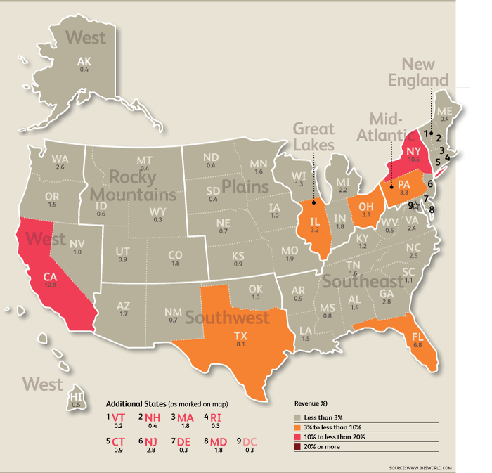
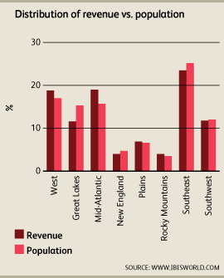
The geographical distribution of the Commercial Real Estate industry reflects the size and distribution of the US population, which is mainly driven by economic activity since individuals tend to work and live in areas with strong business and employment prospects. Local regulations and tax laws also play a role in determining the location of industry participants. As a result of the general economic and population distribution within the United States, the majority of industry participants are located in the Mid-Atlantic, Southeast and West regions.
California, Texas and New York have the highest percentage of industry revenue due to the value and size of their local economies and populations. California is the largest economy in the United States and the most heavily populated state in the country. Texas is the second-largest economy in the United States, and it is also the location of the majority of the Fortune 500 companies’ headquarters. New York is the third-largest economy in the United States and is home to the most expensive commercial real estate in the United States. New York is a hub of the global financial market and includes the Federal Reserve, NYSE and NASDAQ trading floors.
During the past decade, the US population has been migrating toward warmer climates, such as the Sunbelt region. According to the US Census, the 10 counties with the largest population increases were in California, Nevada, Arizona and North Carolina. As the population migrates toward these states, the need for office buildings, apartments, homes and retail centers increases. As a result of this trend, the number of establishments and revenue generated by these sectors has outpaced the overall industry. As more individuals migrate toward these climates, more agents are needed to facilitate property purchases and lease agreements. Development and leasing activity also rises because more space is needed to meet higher demand.
As a result of the long-term population trends, the majority of industry participants are located in the Mid-Atlantic, West and Southeast regions, with activity concentrated in the states with the largest metropolitan populations (i.e. Florida, New York, California, Texas and Illinois). Together, these five states are estimated to account for about nearly half of industry revenue and more than 40.0% of establishments.
Mid-Atlantic
The Mid-Atlantic region is expected to account for over a fifth of industry revenue and 19.1% of industry establishments in 2017. This region is the largest market within the Commercial Real Estate industry due to the presence of large metropolitan areas, including New York and Philadelphia. This region has a high level of commercial office properties because most skilled jobs are in finance, insurance, biotechnology and healthcare. Within the residential sector, homeownership tends to be lower in these major metropolitan areas since the value of real estate is relatively high.
West
This region comprises 17.2% of the US population and 18.9% of the industry’s establishments. It contains a greater number of larger real estate service providers that benefit from regional name recognition and a highly skilled workforce. The concentration of larger operators in the West is due to the historic development of the industry in the region and a higher level of franchising and consolidation among operators across these states. The high revenue proportion reflects high property values as well as the size and value of the regional economy and population. The bulk of activity in this region was concentrated in California (with 16.6% of industry revenue), reflecting the value of real estate and the size of the local economy.
Southeast
The Southeast region is the third-largest market in the Commercial Real Estate industry by revenue, and yet the largest by establishments. This is because establishments are more reflective of the region’s growing population, its considerable amount of development activity and investment in income producing properties. The region is a strong destination for baby boomers and retirees looking for better weather and warmer climates. Consequently, the Southeast region accounts for 23.6% industry establishments, the most of any US region.
Back to top
< Industry Outlook | Competitive Landscape >

