Information and Communications Technology (ICT) Regulations and Standards
[Name]
[Institution]
[Date]

Question 1: Explain and discuss the term ICT and its impacts on the global and local economy
Information and Communications Technology (ICT) is a term extracted from the word IT to stress the significance of technology in unification and integration of communications and telecommunications such as cloud computing, data privacy, internet access, transactions, wire signals, computers, networking hardware and software, cellular phones, satellites, radio, TV, management systems, transmission systems, and network controller among others (Lacy et al., 2020). Recently, ICT has been termed to articulate multiple technologies and telecommunications integrating and converging using transmission lines to transfer diverse information and communication formats at the same time. ICT entails the integration of both mobile technology and the Internet using wireless networking (Vilhelmson et al., 2017). Unlike IT, ICT deals with broader components of computer networking and telecommunications integration.
ICT plays a vital role in many aspects and operations in modern society. Through ICT, the effectiveness of communication has improved social interactions. IoT is an example of ICT innovations that enhances the efficiency and productivity of global business operations in the modern economy (Vilhelmson et al., 2017). ICT is a technological tool for improving society in both the personal and professional lives of individuals. Among the most crucial importance of ICT is enhancing the development of both the local and global economy. The dependence of regional economic growth on business development and growth has been very monumental (Vilhelmson et al., 2017). The economic growth and business performances are regarded as the fourth industrial revolution. The economic benefits of ICT can be traced in the contemporary digital markets, industrial business operations, and society. Advancement of ICT has revolutionized the marketing and business operations leading to a drastic rise in both local and global economies.
Question 2: Discuss the importance of ICT regulations and standards
Regulations and policies have a significant role in the ICT industry for the facilitation of vital goals and objectives. The criteria and rules of the ICT are essential for the management of a business, telecommunications, ICT materials, and equipment. Regulations are necessary for managing the privacy of information and data by protecting from hackers. Data security is an important aspect when it comes to confidential information concerning different things. The protection gives confidence to the owners (Lacy et al., 2020). Hackers restrict business flexibility unless the problem of fragmentation is tackled. Another challenge facing the big data is, it proves it so hard for one to source important information in the big data and ignore the rest of the information from the big data determines it very hard as the getting desired data from the significant information may not be needed at that time (Vilhelmson et al., 2017). ICT regulations and standards also have crucial roles in the efforts of response and recovery. In what appears to be a constant occurrence of natural disasters, information and the dissemination of information are essential.
With technological advancements in various fields, both emergency response staff and survivors will be better equipped to tackle immediate challenges during the occurrence of a disaster. The use of ICT standards and policies and its popular connectedness means a more efficient and necessary flow of information, especially in areas where many people get stranded. Therefore real-time data provides for an emergency management team to develop more informed and targeted response and recovery plans (Vilhelmson et al., 2017). However, the most potent tool in disaster response is ICT standards and policies. For instance, Facebook and Twitter have been very influential and widespread in disseminating information about survivors, in case of an occurrence of a disaster. Hence, ICT standards and policies platforms allow for speedy emergency response and enable crews to connect with survivors and direct their attention accordingly. ICT standards and procedures used by survivors during an occurrence of a disaster can allow the rescue crew to communicate and connect with them more effectively.

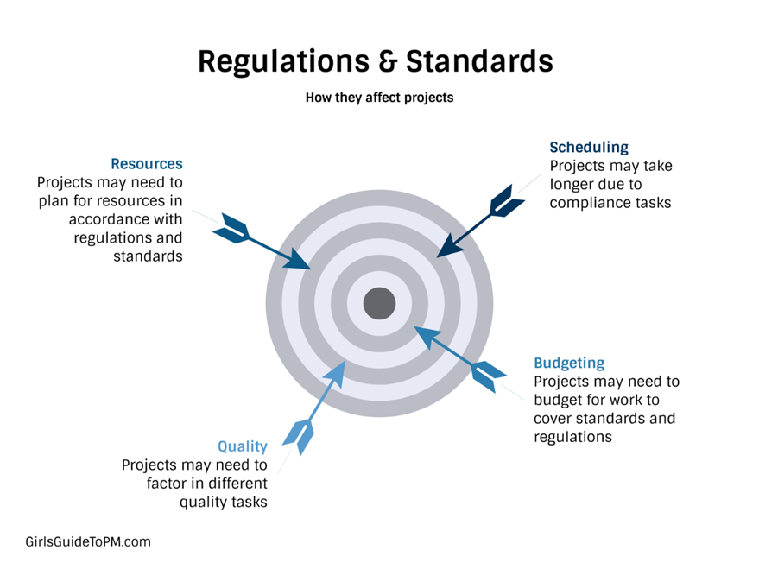
Figure 1: ICT regulations and standards

Question 3: Explain and discuss the FCC
FCC (Federal Communications Commissions) is an independent federal agency of the United States government, which is accountable for overseeing the media industry such as mobile companies, radio, and TV Corporations within the United States. On of the roles played by the FCC is issuing licenses for operating the TV and radio stations, as well as enforcing the policies and standards that consider the well-being of the public (Lacy et al., 2020). The FCC is responsible for regulating all the interstate communications and telecommunications companies operating in the industry. The five commissioners leading the FCC agency are appointed by the president for a 5-year contract and confirmed by the Senate. One of the commissioners is then designated by the president to be the chairperson of the agency. Only three of the commissioners appointed should be members belonging to the same political party (Nath & Liu, 2017). None of the commissioners are allowed to have financial aids and interests while performing their commissioning duties.
The FCC is not only accountable for regulating the interstate telecommunications and media, but also responsible for improving the economic opportunities and reducing challenges facing the growth and development of the U.S economy in a rapidly evolving information technology. As a result, the FCC agency promotes the competition, innovation, and investment in the industry, improves the nation's economy, encourages global business expansion, and improves the infrastructure by regulating the operations of the media business. The organization structure of the agency encompasses offices and bureaus that are function-based. The members and staff in the bureaus and offices provide a range of services to the clients. The agency has an advisory committee, which is accessible to the public. The FCC agency is organized to control the industry by establishing, expanding, operating, and terminating operations for the safety of the people.

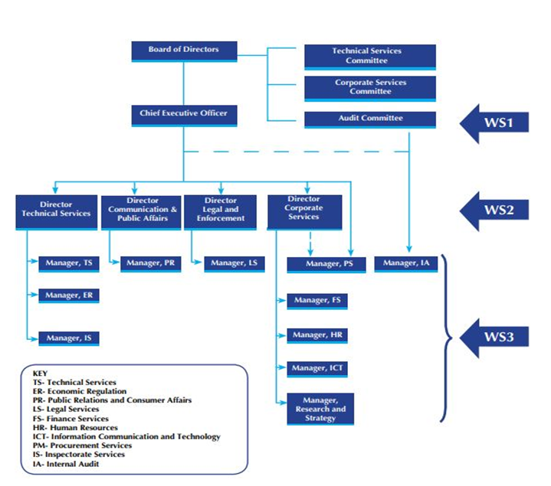
Figure 2: Organizational Structure

Question 4: Explain and discuss ITU
International Telecommunication Union (ITU) is an agency of the United Nations, specializing in ICTs networking. In the year 1865, the ITU agency was established to enhance international communication networking and connectivity (Lacy et al., 2020). The agency also allocates the satellite orbits and radio spectrum. It develops the policies and technical regulations that govern the interconnection of networks and technologies to improve the global access of ICTs network and techniques in the underprivileged regions (Lacy et al., 2020). ITU is famous for enhancing the effectiveness and efficiency of technology and communications via medium and telecommunications. The membership of ITU is global and allows a capacity of 193 State members, 900 companies, institutions, and voluntary organizations. The agency's organization is based on the activities and sectors of ITU operations. For a starter, radio communications are among the organizations of the agency, which enables satellites for mobile phones, radio, television, online maps, and navigations.
Radio communication is a sector of the ITU agency with a vast range of services, as well as management of satellite orbits and radiofrequency. Standardization is another organization of ITU, which articulates the regulations and policing of the ITU operations and services. In the ICT networks, standards, and rules of ITU are essential for the connectivity and networking of mobile phones and the Internet (Nath & Liu, 2017). Standards of ITU suggest the most appropriate strategies for facilitating the operations and connectivity of telecommunications and communication media. Lastly, the development sector of telecommunication offers a learning program for individuals interested in expanding their experience, knowledge, and skills, as well as the presence in the emerging markets, which display the global management of ICT (Nath & Liu, 2017). In this regard, development telecommunication is essential for improving the performances of a company, as well as the employee’s productivity.
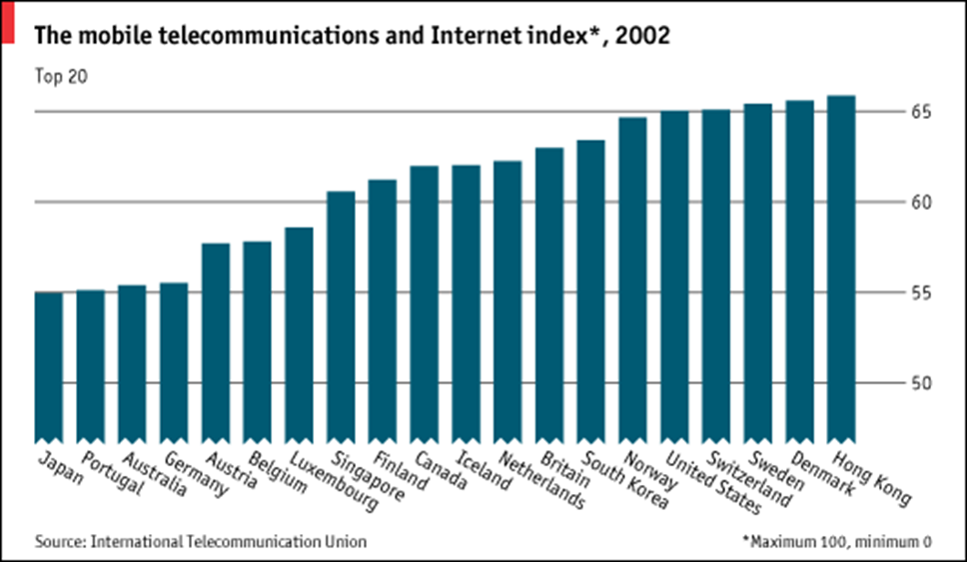

Figure 3: International Telecommunication Union (ITU)

Question 5: Explain the importance of Saudi CITC for the ICT sector in Saudi Arabia
CITC is vital to the development of the ICT sector in Saudi Arabia. Saudi Arabia has been experiencing rapid growth in the GDP with the future vision of the two holy mosques custodian. The development effort of the government contributed to the rapid growth by increasing the use of ICTs in-home and workplace, government organizations, and business meetings (Nath & Liu, 2017). As a result, the expenses of ICT services and products increased. CITC emphasizes the adoption of ICT in every sector of modern day-to-day life. The use of ICTs in business operations and other activities enhance the effectiveness and efficiency of performing a task (Nath & Liu, 2017). CICT sets policies and standards to be followed by companies to ensure that the ICT's suggestions are improved.

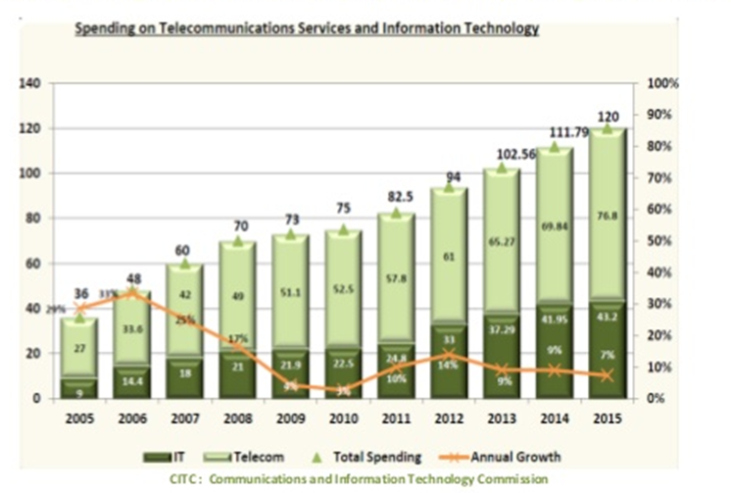
Figure 4: ICT Spending

Question 6: Explain and discuss the ISO, ETSI briefly, and other standard organizations and their importance to the ICT sector.
ISO is a standard agency accountable for regulating the operations and activities based on the use of ICTs in business to protect the rights, safety, and well-being of the public and the society at large. ISO is an organization that ensures the expansion of a trade by issuing the certified ISO standards for the global development of the company (Barcenas, 2019). ETSI, on the other hand, is a standard organization that regulates the ICT based operations in a company to enhance the freedom of use and maintenance of telecommunications and media devices. All standards of organizations are essential to the ICT sector for improving the growth and development of the organization based on the adoption and use of ICT. The ICT sector benefits from standard organizations such as ISO and ETSI on numerous perspectives (Nath & Liu, 2017). The conventional firms provide the platform for the effective use of ICT telecommunications and media. The standards guide the organizations towards utilizing and taking advantage of the ICTs and other technologies to improve the productivity of a business, as well as enhance the growth and expansion of an organization.

References
Barcenas, L. L. A. (2019). ICT regulation and regulatory authority.
Lacy, P., Long, J., & Spindler, W. (2020). Information & Communications Technology (ICT) Industry Profile. The Circular Economy Handbook (pp. 139-147). Palgrave Macmillan, London.
Nath, H. K., & Liu, L. (2017). Information and communications technology (ICT) and services trade. Information Economics and Policy, 41, 81-87.
Vilhelmson, B., Thulin, E., & Elldér, E. (2017). Where does time spent on the Internet come from? Tracing the influence of information and communications technology use on daily activities. Information, Communication & Society, 20(2), 250-263.

