Nutrition and Diabetes
Student
School name
Instructor:
22/09/2018

Part 1: Networking
I met all of my professionals namely Mohammed, Duncan, Adams, and Omar in an annual nutrition conference in Colorado called SCDA. All are members of the Southern Colorado Dietetic Association (SCDA) who came up with the association and have collaborated with other associations and nutrition and dietary centers to reach out more people in the U.S. All the professionals are members of SCDA who have collaborated in the field on nutrition. Their activity involves meeting and connecting with local dietitians in the effort to improve human nutrition of people living in United States. The association enables a fast networking of nutrition professionals in the State all the way to the country.
Part II: Information Interview
I decided to interview Adams whom we met in a nearby hotel where she was having a meeting earlier in the day. Adams was the best option for me since I did not require traveling thus minimal costs. She is a member of SCDA and holds a position of the events organizing officer of the association. Adams is a degree holder in psychology and has a MBA in science and nutrition.
In summary, Adams scheduled for a short interview approximately 30 minutes and was conscious with time. In answering of the interview questions, Adams describes the need or importance of networking health professionals to enhance health and wellbeing of individual sin the U.S. according to her; this can reduce chronic diseases such as diabetes, heart disease, and stroke among many others. What I learned from the interview is that millions of people in America are food insecure or malnourished. It is therefore, the duty of health and nutrition professionals to network and fin d a solution to this problem. According to Adams, partnership among different associations that support healthy living could help come up with policies that support nutritious food access in America and empower individuals to live a healthy live. The main purpose of Adams being in SCDA is to organize for networking and partnership of nutrition professionals together with other administrative tasks such as planning and implementation of agendas set by the organization. The interview once again reaffirmed my interest and desire to the nutrition career field. After conducting the interview, I felt energized and informed on the need of a healthy living as an individual as well as the community. The interviewee made it easier for me to have a smooth interview process, which was interesting and less hectic to conduct. Next time I will plan to interview my professional in time to avoid rush.
Scanned business card
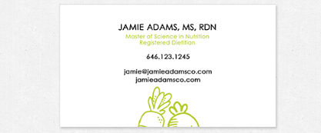
Thank you note
