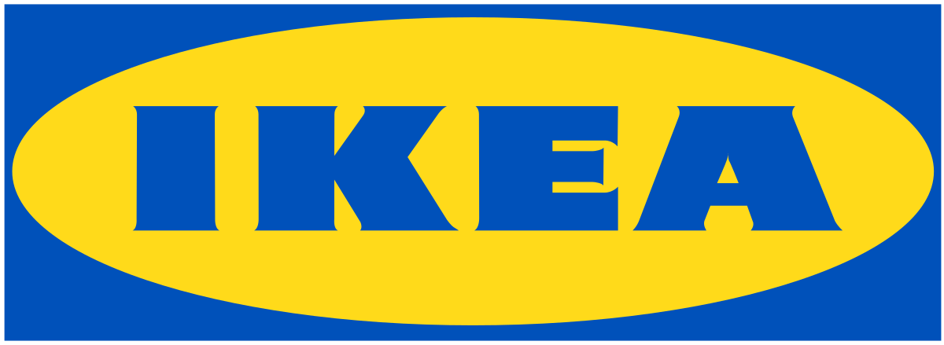

IKEA COMPANY
Name of student
Name of tutor
The institution of affiliation
Date

Assignment Task 1
Introduction
IKEA, a company founded in 1943 by Ingvar Kamprad, mainly deals with home furnishings. Ingvar began by merely peddling useful home items to his neighbors on a bicycle. The company fancies home as a special place and children are its important people. Since the inception of IKEA Company, its vision has geared towards the championing of a better life for people across the globe through offering home furnishing materials at a price that can be afforded by most people. The mission and vision statement state that "at IKEA our vision is to create a better everyday life for the many people. Our business idea supports this vision by offering a wide range of well-designed, functional home furnishing products at prices so low that as many people as possible will be able to afford them (Collins, 2010)."
The company is recognized across the world for the unique designs for different types of products in a home setting. Also, the company's interior design work is known for its eco-friendly simplicity. Moreover, the company is well recognized for its ability to embrace cost control, attention on operations, and the continuous development of its products. IKEA is also recognized for its key milestones in the corporate sector. 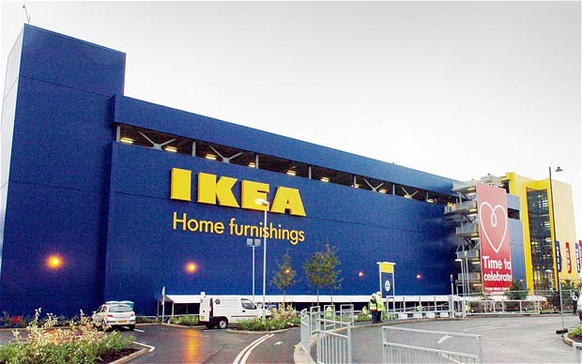
Products and Services
IKEA offers a wide range of furniture. Many of IKEA’S products are designed in a way that customers can easily assemble them at their homes. Kamprad claims that this helps reduce the cost of packaging. It is also of convenience for those consumers using public means to transport the furniture to their homes. The furniture is made of Medium-Density Fireboard (MDF) hence meeting material expectations in this 21st century. IKEA, therefore, use4s MDF in producing high quality products needed by its customers. They have also formed a partnership with Phillips Hue. It has ventured into the wireless charging furniture hence seeks to change the home furniture business. IKEA has also ventured into flat-pack houses and apartments. This is aimed at reducing the prices involved in an individual purchasing a house for the first time. The joint venture with other companies like Skanska in Sweden ensures diversity in the housing industry. Also, IKEA ventures in solar PV systems sold in some of its stores across the globe. The company also sells solar systems online in the United Kingdom. IKEA is also the owner and operator of a shopping mall chain based in Russia. The company also launched the IKEA Family Mobile, which runs on T-Mobile in the United Kingdom. Also, the company partnered with TCL to provide entertainment system products.
IKEA Corporate Structure
IKEA Company is run by many corporations aimed at profiting the company’s returns. IKEA’s organizational structurer has two significant areas: franchising and operation. Operational part deals with store management, design practices, purchasing criteria, supply functions and the production of furniture. A private for-profit Dutch company known as INGKA Holding manages the operational part of IKEA. The IKEA Foundation is geared towards creating better opportunities for vulnerable children and youth, especially in poor countries by providing donations to enhance holistic and long-term programs aimed at long term changes. Founded in 1982, this foundation has become active in addressing issues regarding child labor and has also partnered with different major corporations in the world to promote children's rights in the society. Today, the foundation has expanded its charter and works with reliable partners to enhance innovation in fundamental areas concerning a child: some place to provide housing amenities; a good beginning of life; essential education; and financial capability (Ljungblom, 2014). Kamprad, other five executive committees and her wife chair the INGKA foundation. Two companies in Australia run IKEA. INGKA Holding manages stores located on the Eastern part of the Coast Line. Cebas Pty Limited owns and operates the other stores in Australia including the Southern and Western Australia. All IKEA stores operating its main stores across the globe are mandated to pay 3% of sales which is a franchise fee. The company's consumers are distributed mainly in Europe, America, Middle East, and Asia. Along with helping the company generate profits without much taxation, IKEA's corporate structure allows Kamprad to micro-manage the operations of INGKA Holding and therefore, the easy control of other IKEA stores.
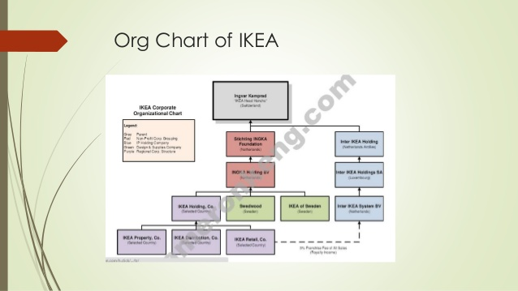
IKEA Corporate Strategies
Globalization is one aspect of trending currently for most companies across the globe. IKEA corporate strategies are geared towards determining its sustainability and gaining a competitive advantage among its competitors to achieve a higher share in the ever-changing competitive market especially new entry countries like Asia. For example, the company's strategy to inspire globalization in Asia comprises of a joint venture, localization, and pricing strategies. IKEA’s has entered into a joint venture with some Chinese companies which is aimed at achieving the principle of equality and mutual benefits in different sectors of the economy. The joint venture strategy by IKEA is due to the political policy of the Chinese government. IKEA also embraces the localization strategy to bind with the local culture in Chinese. For example, the company provides a balcony section in housing because many people in China stay in apartments. The pricing strategy allows the company to remain competitive among other companies. For example, IKEA reduced the price of a single-cat Ektorp in the United States market as compared to prices offered by its rival companies. IKEA’s corporate level strategies have allowed the company to attain impressive growth over the years.
IKEA Operation Strategy
IKEA's mission and vision are to ensure the availability of varying home furniture and designs at reduced prices affordable to the majority in the society. Kamprad's innovative strategy was to design products that was affordable to customers, readily available at stores and displayed in showrooms with detailed information and tickets making it unnecessary for the requirement of salespersons. Customers at IKEA often take most of their time in the stores as compared to the time taken shopping in rival shopping stores. The company distinguishes itself from its competitors with the arrangement in the stores. The company's stores are designed like warehouses. All their furniture are displayed in an open room just like in a home setting. In this manner, customers get to choose their products on a broad scale. Employees are available for questions in the stores, but customers would often do all their tasks including transportation of their furniture.
IKEA has adapted an operation strategy different from their business rivals. The company's operation often has to deal with large volumes of goods since IKEA products have a high value. The concept of variation to be embraced in operation is often low since IKEA’s sales on their products vary steadily across the year and are usually predictable. Customer relationship is also low. Hence IKEA’s operation strategy mainly focuses on low cost. Furthermore, the target market for IKEA is quite different from other companies. Their main target is young adults ranging from low to middle-class family earners who have or may have no children. The company also targets business customers who may be running small to medium size offices. Since their target group is often low to middle-class income earners, IKEA is more cautious on its pricing strategy. IKEA’s strategy is defined by delivering quality products, speedy deliverance of services, dependability, flexibility, and cost, which all impact other working strategies defining the company. There are four main vital aspects that make IKEA unique from their competitors: volume of their outputs, variety of the outputs, variation in demand for their outputs, and the degree of customer contact that IKEA has. These four components as described below illustrate why IKEA is the furniture retailer revolutionizing the furniture industry today.
The Quantity Dimension
Since IKEA is run in the mode of a warehouse, it manufactures large volumes of furniture and other essential products which the capability of being self-assembled The company has also stores in other countries hence can allow economies of scale by lowering costs on products with the high-volume production realized in the company. However, economists view that despite IKEA being a high-volume production business, most of their products are sold in high stocks. This ensures there is no possibility of stock remaining after production.
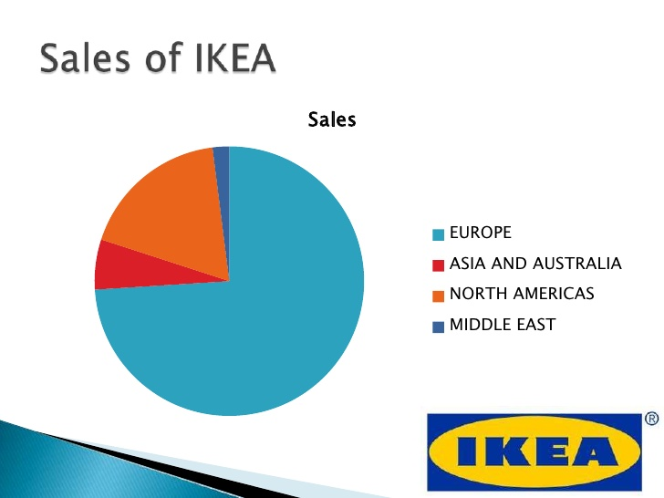

The Variety Strategy
IKEA's furniture is often the value for money with a comprehensive option for furniture choices offered. Most of IKEA’s products are designed in a manner which they can be stored and sold in a warehouse kind of setting and are capable of being assembled easily by their customers. The design from the Swedish point of view emphasizes bold colors and styles. IKEA advocates for its products to be modular. This allows changes in to the same product to be customized in order to produce a better taste of furniture. This strategy allows the company to always restock their shelves with new products in the market. Customers also have the change to walk around and pick any products they want without waiting for sales personnel to serve them. They are flexible to browse through the stores and pick whatever they need. The variety dimension allows customers to save on time while picking their products. The philosophy in the company is to let customers make their decisions regarding shopping at their own time. The staff only needs to help customers find their way around the showroom.
The Variation in Demand
The demand pattern is variable. Though not so many significant factors may influence customer’s need for IKEA furniture, there exist specific factors that will impact the demand for these products. Because IKEA stores are located many kilometers from urban centers, it can prove challenging for customers who don't drive to access the stores. Few customers may access the stores especially during the rainy season hence may not feel it necessary to drive away from town to get the furniture. For this same reason, customers may prioritize doing their shopping on weekends. Therefore, it means the weekends will be full of activities unlike during the weekdays. One problem associated with this is that customers who need to do their shopping at IKEA will be turned off by the large crowds of people shopping during the weekend.
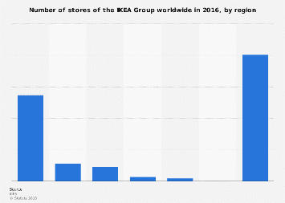
The Visibility Dimension
This refers to the operation contact the operation has. Even though IKEA has adopted the self-service concept among customers, the company stills adheres to serving the needs of their customers. In order to make shopping an experience, the company provides essential tools like catalogs, receipts, shopping lists, and writing materials for customers. Free catalogs are provided to customers to help them see the available range of products available in the stores. Moreover, stores provide an ultimate family shopping experience where customer care services and other essential facilities like restaurant, daycare facilities and also a Swedish shop are offered. The need to inculcate these essential aspects into their business is what makes them unique from other traditional retailers. The company's success can be linked with its vast experience in the retail market, offering varying products, and cost leadership. Based on the unique operation strategies described above, IKEA still is one of the highest ranked retail operators across the globe.
Operational Challenges
IKEA's vision is to provide their products at a price that can be afforded by a majority of people in the society. However, they fail to maximize on profit when they sell products at a cheap price than expected. This threatens their profit as well as the overall growth of the company. Therefore, the company compromised on this factor to achieve its aim of providing a full range of well-manufactured housing products at a cost affordable by a majority of people in the society. However, IKEA's low-cost operation strategy may backfire in a market where customers value expensive goods with the notion of them being of high quality. If buyers see IKEA's goods as cheaper as compared products from other retailers, the goods may be seen to be of inferior quality. So the IKEA is compromising on not catering for the needs of buyers interested in premium quality furniture. The company is also striving to maintain the status of its quality furniture hence it has sometimes been not easy to meet standards set on an international level. Lowering costs has also led to customer care not getting proper attention, and the workers do not have the time or resources for proper international training (Levine, 2010).
Quality management has also been heavily impacted in the company. The company uses crucial advertising campaigns that have affected the marketing of their products. IKEA is unable to research thoroughly on their potential market because of being cautious with their pricing strategy, and hence have missed on potential customers in the market. The company also needs to maintain its international brand in host countries. They need to keep a keen eye on the customs and traditions practiced in their host countries and experts view they have failed to so for a long time. It has failed to do so hence profits falling in certain countries like the United States. To improve quality, the company can take different steps. IKEA can adopt Total Quality Management (TQM) in their operation to ensure quality. It needs to inject more money into its processes to realize more profits. IKEA also needs to develop customer focus and should conduct training activities for their employees to enable them give the best customer care services. Customer care focus is vital to both internal and external working environment of the organization. The company also needs to focus on leadership in their stores. Leadership in each store should have a similar standards of operation in order to realize transparency. Leaders can be trained in stores together to realize more profits.
The process
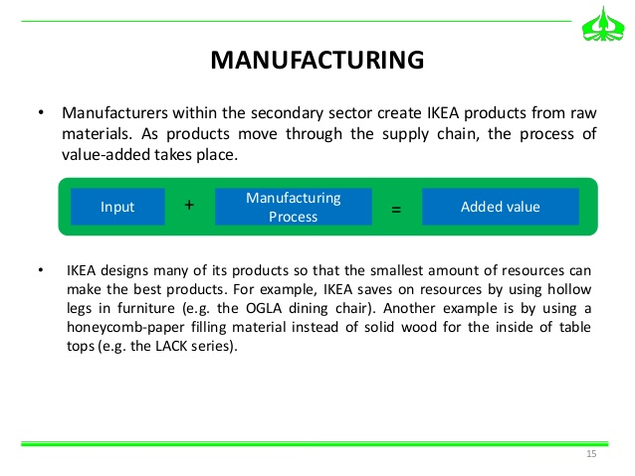
Supply Chain Management
IKEA's supply chain is well organized and gears towards satisfying the needs of all relevant partners involved with the company. Supply chain management is involved with the acquisition of materials, manufacturing and the delivery to all of their consumers. One of the main challenges in supply chain management is maintaining high quality products while sticking to a low pricing strategy. The raw materials used in the company are of high quality hence making the final products produced to be of high quality too. These materials are expensive. This is a challenge to the company since IKEA needs to attain a break-even despite such an occurrence. Because of this occurrence, the company has been forced to minimize other costs to cater for the cost of raw materials. One of the measures to prevent this occurrence is taking the manufacturing process to develop nations. In such countries, labor and other factors of production are cheap. Therefore, the company can attain a break-even. Another challenge facing the company supplies is issues regarding criticism from some agencies associated with environmental aspects. IKEA works on the grounds of ensuring the maintenance of the environment and social sustainability. Some bodies criticize their products as not being environmentally friendly. For example, formaldehyde scandal revealed the impact the acid had on human health. Due to such scandals, IKEA had to reduce formaldehyde levels in its products (Collins, 2010). They also employed scientists that would shape the future of products produced by the company. All these strategies resulted in increased costs in IKEA's supply chain.
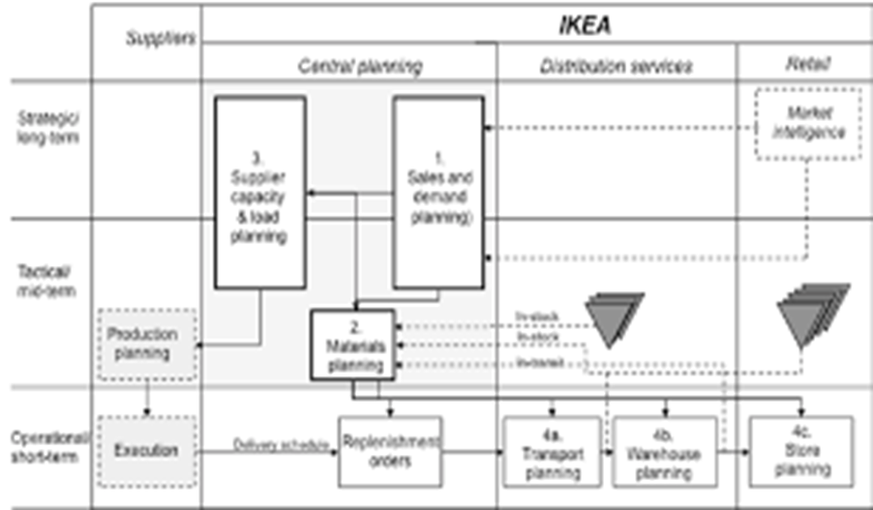
The company is also being faced with the threat of receiving low-quality products form some of their suppliers of raw materials. The company deals with more than fifty suppliers of raw materials. The suppliers have varying objectives and goals to realize. This implies that their motives may influence their actions. For this reason, cases of supplying low-quality products may arise. Once such a scenario has been experienced, the company is supposed to return the materials to such suppliers. This delays the process of production hence affecting other operations (Edvardsson and Enquist, 2009). Today, the company is dealing with already established suppliers with a good history with the company over the years.
Lean Management and Quality Management Approaches
Lean management is a way of running a company that embraces the aspect of continuous improvement and hence the overall achievement of efficiency and quality. Lean management is geared towards eliminating waste of time, effort or money in the effort towards realizing success in business. One way of increasing efficiency and cutting costs at IKEA is in the manner they sell their furniture parts separately. This allows customers in making their choice of what they exactly need. In this manner, the company does not need spend more on packaging and storage of all their different combinations and also customers can customize their selections. Their warehouses is also an example of how the company reduces cost by letting consumers take care of their legwork. The well-organized aisles make it faster for employees to stock the shelves, faster for customers to navigate the showroom, and hence saving on time. Quality management approach defines business processes focused on improving and meeting the requirements of customers and hence satisfying their needs (Turban, 2010). TQM is a process of managing an entire organization towards ensuring success in every department geared towards satisfying the customer demands. IKE is well organized to ensure the overall success of the company.
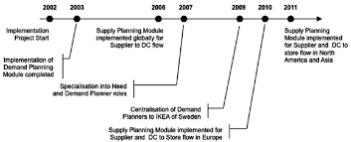
Artificial Intelligence in Business
Artificial intelligence is the latest trend embraced in the many aspects of the economy today. Artificial intelligence brings the most significant benefits to finance. In this era, financial experts use this innovation to keep track of prices and indices hence providing the best financial decisions. Artificial intelligence makes trading easy and also less risky. Artificial intelligence also may prevent fraud activities in the business sector. For example, the use of machine learning algorithms provides financial security in business. Kount is one of the best platforms to help to prevent fraud in business hence increasing their sales. Digital marketing may also offer the best platform to market products (Larsen, 2007). The goal of such platforms is to ensure profit-generating means for a company. Some challenges may arise if a company like IKEA tries to implement artificial intelligence. One of the challenges is the loss of people power. Technology may impact the labor required in a company hence loss of some important jobs in the organization. Another challenge is in ensuring the right speed and quality of products on the platforms. An example is the 3D materials used. However, artificial intelligence needs to be embraced especially in this changing world of technology.
This report focuses on IKEA history, operational strategy, supply chain management, lean management and quality management approaches as well as artificial intelligence in business. All these aspects describe IKEA's business strategy in the ever-changing business world.
Assignment Task 2
ONLINE MOBILE TECHNOLOGY PROJECT
Purpose of the Plan
The plan will define the project plan, including its goals and objectives. In addition, this plan will be a basis of bringing together different parties, including the project’s sponsor, the steering committee, manager, team, and other people associated with the project. The project plan highlights the following:
The Purpose of the Project
The goals and objectives of the project
Scope and the different expectations
The Roles and responsibilities of different people in the project
Assumptions and constraints
Approach on the Management of the Project
The set Ground rules for the project
The Budget of the whole project
The projected Timeline of the project
Background Information
This section needs to highlight the completed work on the project to date, the choices available regarding the hardware/software, and a highlight of how one decided to use relevant technology in the app.
Project Approach
This section needs to outline how one intends to implement the technology and includes the milestones in the project. For example:
Step One: Gain an understanding of the customers
Step Two: Installing the equipment
Step Three: Installing or Testing the software
Step Four: Conduct tests on the Hardware/Software
Step Five: Conducting training
Goals and Objectives of the Business
The goals and objectives of the project gear towards embracing a mobile technology that:
Guarantees the satisfaction of customers and their safety as well
Facilitates an easy way of sharing information considering the internal and external environment in the organization
Fastens the performance of tasks by the staff
Improves shopping security by reducing fraud
Guarantees data security
Provides a reliable technology base for the future
That is easy to use by all people
Goals and Objectives of the Project
Sample project goals and objectives:
Ensure that the consumers of this application have an input into this design process
Accomplish the goals and objectives of the project within the defined budget and set time
Establish an agreement with the consumer in the target market and Departments in the company
SCOPE
The project will introduce a new mobile technology to enhance the shopping experience for IKEA customers. It includes the following:
A 3D view platform
Visual search
Wireless charging
Smart lighting
The initial attempts at risk assessment aimed at identifying, characterizing, prioritizing and documentation of a sustainable approach relative to such risks that can be realized before the start of this project. The risk assessment of this project will continuously be monitored throughout this project and will be well documented by the project manager. Additional time needs to be given to each steering committee meeting for them to be able to solve current risks and discuss strategies to solve such issues.
Project Assumptions
The assumptions highlighted below were made in preparing the project plan:
IKEA customers are willing to embrace business operations to take advantage of revolutions brought about by the new mobile technology
The company's management will ensure the availability of team members to complete tasks and objectives valued in this project.
The steering committee will play a key role in ensuring the project is executed
Team members in the project will embrace the communication plan
The advancing technology today will help support innovation of the application
The project plan can be changed as new information and relevant issues are revealed
Constraints in the Project
The discussion below represents known constraints of the project:
Sources to provide financial support to start the project are limited
There is a limited number of smart phone users in most parts of the world
There is a possibility of eliminating funders of the project
In the event of any of the above happening, it would be challenging to implement the project.
Roles and Responsibilities
Project sponsor
The sponsor makes the final decisions
Provides the guidance needed to conduct the project-
Reviews and approves some decisions guiding the project
The Steering Committee
The committee issues the resources needed for the project
It approves crucial funding and resource allocation strategies
It helps in resolving conflicts and issues arising in the implementation of the project
Project Manager
Manages the whole project according to the project plan
Acts as the supervisor of all consultants
Provides guidance and direction of the project
Helps in resolving problems
Project Participants
Understanding the user needs and business operations in their areas
Advocates for the consumers in the area
Responsible for creating work products
Help identify and deal with challenges experienced in the project
Issue Management
It is essential to note that information may change while undertaking the project. Any of these changes may have an impact on these factors regarding success of the project: available timeline, available resources, or the quality of the project. Coordination may be implemented in the following steps:
Step 1: The project manager has to save any changes that may have an impact on the scope, schedule, or staffing of the project
Step 2: The manager will review the changes and forward to the steering committee for reviewing process
Step 3: A consensus decision is reached upon by the committee and gives their decision on the issue.
Step 4: Final decision provided
Communication Plan
Providing vital information about the project is essential for the success of the overall project. The participants need to have information on the progress of the project and how they may be affected as the project progresses. The more people are educated and talked to about the project, the more likely they may be able to participate in the project. The communication methodology may utilize the following directions to promote effective communication.
Top-down: It is important for all participants in the project to embrace a unified communication platform. The executives of the organization will be able to listen to all people in the organization
Solutions need to be communicated to ensure the morale of all people involved in realizing the changes in the project. All members need to embrace good communication skills to realize the success of the project.
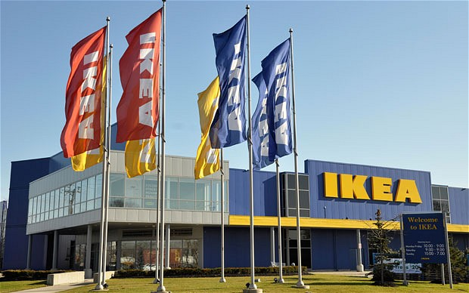

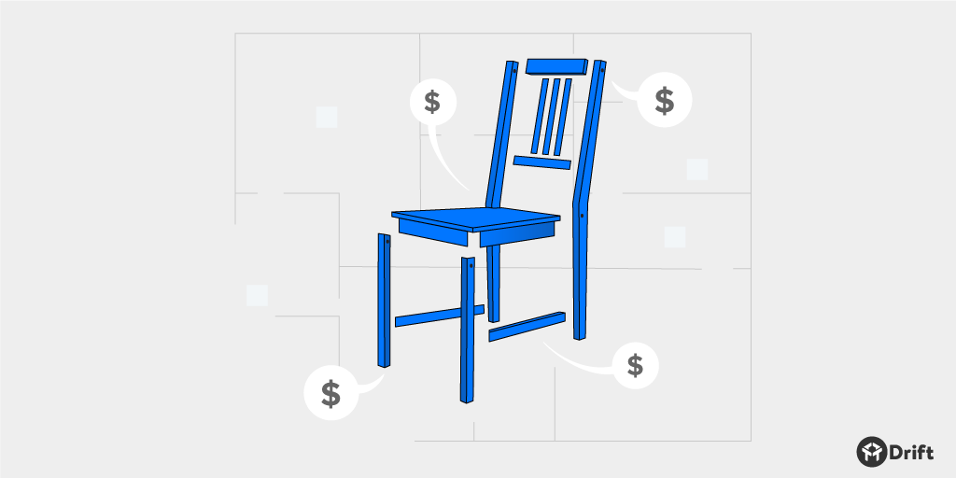

Reference
Collins, J. D., Worthington, W. J., Reyes, P. M., & Romero, M. (2010). Knowledge management, supply chain technologies, and firm performance. Management Research Review, 33(10), 947-960.
Edvardsson, B., & Enquist, B., 2009. Values-based service for sustainable business: lessons from IKEA. London: Routledge.
Larsen, T., 2007. Managing the global supply chain (3rd Ed.). Copenhagen: Copenhagen Business School;
Ljungblom, M. (2014). Ethics and Lean Management–a paradox?. International Journal of Quality and Service Sciences, 6(2/3), 191-202.
Tarnovskaya, V., Elg, U., & Burt, S. (2008). The role of corporate branding in a market driving strategy. International Journal of Retail & Distribution Management, 36(11), 941-965.
Turban, E., Sharda, R., & Delen, D. (2010). Decision Support and Business Intelligence Systems (required). Google Scholar.

