IMPERFECTLY-COMPETITIVE INDUSTRY
Institutional Application
Course Name
Date

An imperfectly competitive industry is a sector with many sellers where they are all selling dissimilar goods through which they earn profits by rising the prices of the good. This happens when there are two or more sellers in which one controls the price of the goods to gain profit. The imperfectly competitive sector has a nature of imperfectness. They are two types which are oligopoly and monopolistic competition. A real-life example of this industry is the tire manufacturing industry which is an example of oligopoly part of the imperfectly competitive industry. This company does higher its price goods, block the beginners buying their goods from accessing them and even slow to introduce new products to harm the customers. The company sets its product prices through a cartel, thus making a lot of profits.
It's a fact that that we have so many vehicles on the road or off-road that use tires, thus making the tire sector very virtual. Around eleven million commercial vehicles are being manufactured to cater for the same number of passengers using the vehicles. In the United States of America, around seventeen million vehicles are sold, and this calls for a large number of tires produces to enhance the selling of vehicles. In 2019, the tire sector got almost 43 billion dollars subject to tire production. The leading segment in the tire market is the passenger tire which is shipped in over 220,000 units. A pneumatic segment is where the most used tire the world lies. These tires are operated by gas or air pressure. Their main purpose is to bring about the smooth ride on the road in vehicles and bicycles as well as provide shock absorption. In US Goodyear Tire and Rubber Co. and copper Tire and Rubber Co. manufactures have their headquarters. The leading tire company in the world is Bridgestone in Asia seconded by Michelin found in Europe https://www.statista.com/topics/3769/tire-market-in-the-us/.
Economic graph for tire company
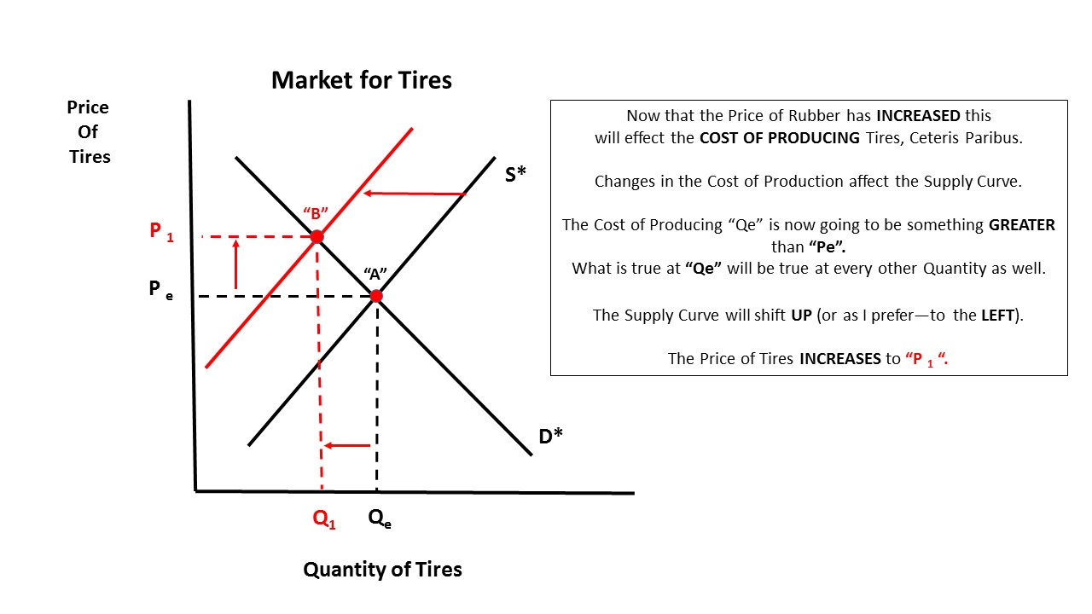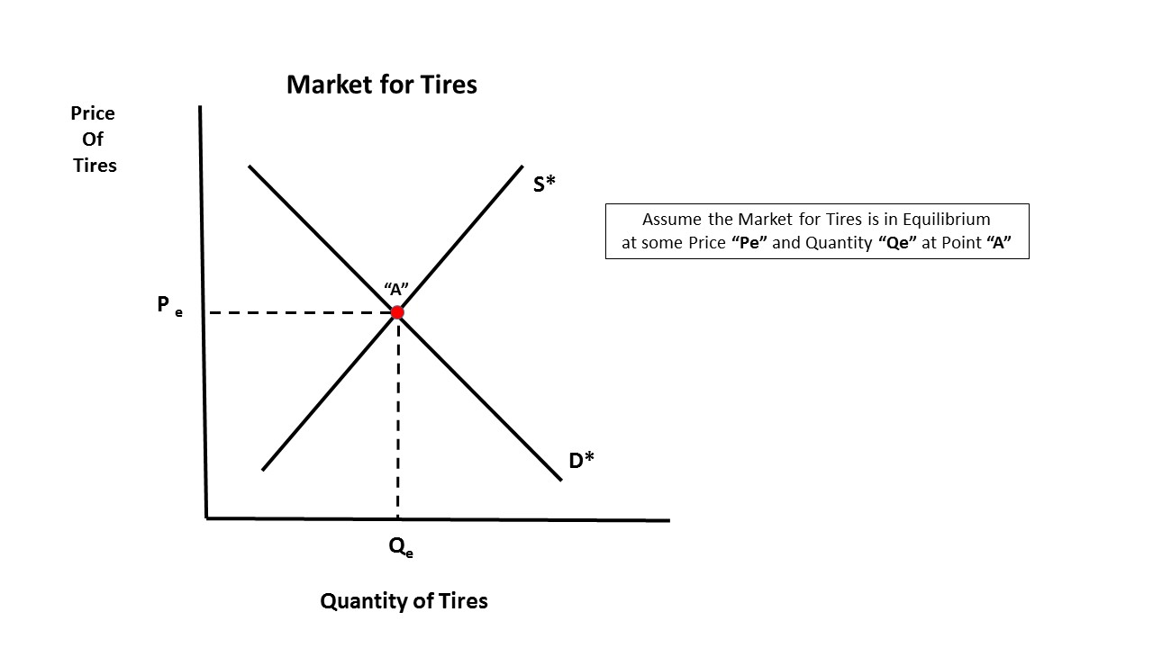
Barriers to entry are the hindrances making new companies not access the products of a market. It can be because of reasons such as stiff competition in the tire sector, the buyers bargaining too much, the bargaining of those supplying and customers exchanging their products as a threat. In a field, how the market presents its products determines the competition faced by the field. These factors can be categories into two, that is innocent or deliberate factors. Some of the barriers are
Capital Requirement
Tire industry require require financial resources for advertising, R&D and machinery. By outsourcing parts of the operation to companies capable of using existing investments, start-ups can deal with capital demands.
Government Policy
Government can restrict or prohibit entering industries with different controls (e.g. authorization requirements, restrictions on access to commodities). Venture capitalists in competitive markets will consider that according to policy, party leaders have perfected their businesses.
Distribution channels access
This can be an obstacle if the established parties have locked plausible distribution channels.

The tire industry is an industry that manufactures tires as its products used in bicycles, vehicles. The products are of different types depending on the company. In the tires industry, we have many companies involved, Bridgestone in Japan, Michelin in France, Goodyear in the United States and Continental in Germany as the top three companies in the world. Bridgestone is the leading company seconded by Michelin in terms of positions one and two in tire leading companies.
There are four market structures which are one, perfect competition which involves huge numbers of seller and buyers where the seller is a small seller in the competition. Monopolistic competition involves large numbers of buyers and sellers but each seller has his or her own product different from the other in terms of the types. Oligopoly influence their market to set high prices for their products and in so doing making profits. Monopoly structure involves one seller who controls the whole market. Potential competitors are not actual competitors and rarely have effect on the market. They can be direct or indirect competitors, those who do nothing, the suppliers who know how to bargain and DIYers

Table 1 Output decision of Bridgestone tires company

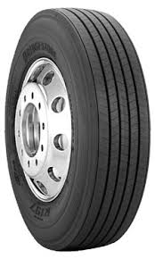
Figure 1 Output decision of Michelin Tires Company
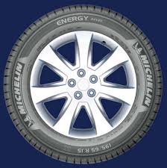
Figure 2 Output decision of Goodyear Tires Company
The bearers experienced by the companies are difficult to overcome as one strategy can't help in overcoming thus requires many strategies to overcome it. Some of the strategies include: choosing a company not affected by penalties to export your goods, using different markets to trade and offer different services, have value-adding goods and produce your own goods to avoid importations, exporting to different markets, check on economic bears to reduce cost, produce goods as per customers desire and partnering with organizations among others.

Reference

Wagner, I. "Topic: Tire Market In The United States". Statista, 2020, https://www.statista.com/topics/3769/tire-market-in-the-us/.

