Impressionism Project
Name
Course
Instructor
Institution affiliation
Date

Impressionism is a movement of painting with its origin believed to be France in the 1870s. The artwork went against the presiding art work which were guided by beaux-arts which refers to fine art. The artists behind the work came up with a new way of perceiving and illustrating the universe in their work, foregoing the realistic portrayals for fleeting impression of their surroundings which was often found outside. Impressionists went against the norm of painting in a studio but instead, preferred working in an open air in front of their subjects in order to capture the momentary and transient effects of the sunlight. Impressionism therefore gave birth to the awareness of light and colour and shifting pattern of the natural scene.

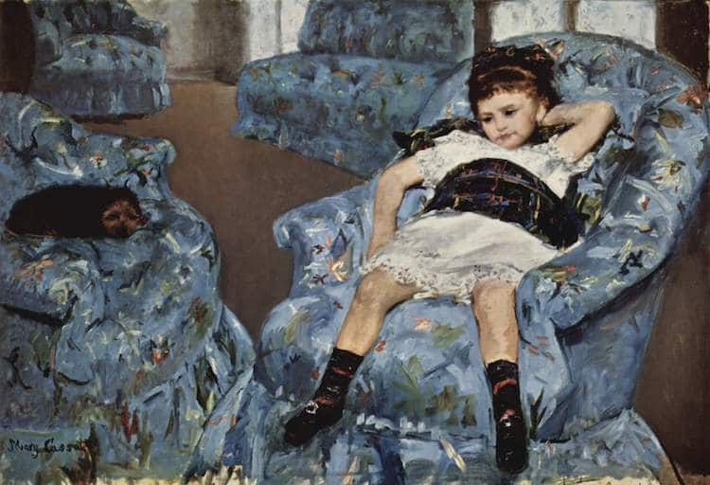Little girl in a blue armchair by Marry Cassatt, 1878,
The painting was a testament of Marry Cassatt and impressionism and her acceptance of a freer style of painting. With a limited palette and vibrant brushstroke, she created a dynamic interplay of forms that is echoed in this captured moment between resting and playing. The painter manages to make sure that every object in the room is seen differently by using the light that illuminated the room through the French doors in the background. The tilted picture plane makes it possible for the audience to notice the haphazardly arranged four large, blue chairs and the brownish-grey floor which is seen in between them. By painting the floor with energetic brushwork makes sure that life is given to it.
Furthermore, the girl is also seen to be flopped on a chair in what seems to be a moment of boredom or exhaustion while the dog on the other hand lying on one of the blue chairs in a state of utter repose. The painting can be said to have been a successful work of impressionism for the fact that every object in it was able to communicate independently even though it was not done in a studio. People in the modern-day society can relate to the painting even though it was done so many years down the line. As we have seen, the posture at which the girl takes shows that she was either tired or bored. The dog lying on the other chair could mean that it was either afraid of the girl, or it was also tired from playing with the same girl outside the house before coming in and resting.
The haphazard way in which the chairs are arranged can also represent the playful nature of the girl. In most families with little children, chair arrangements are one of the major things that visitors or any other person could tell of their playful nature. The colour of the chairs on the other hand could be the favourite colour of the girl. The position and the arrangements of the chairs proves that the painting was impressionist of which it was done in an unplanned manner yet it gave us the right impression as could have not been the case in studio where things are organized and controlled.

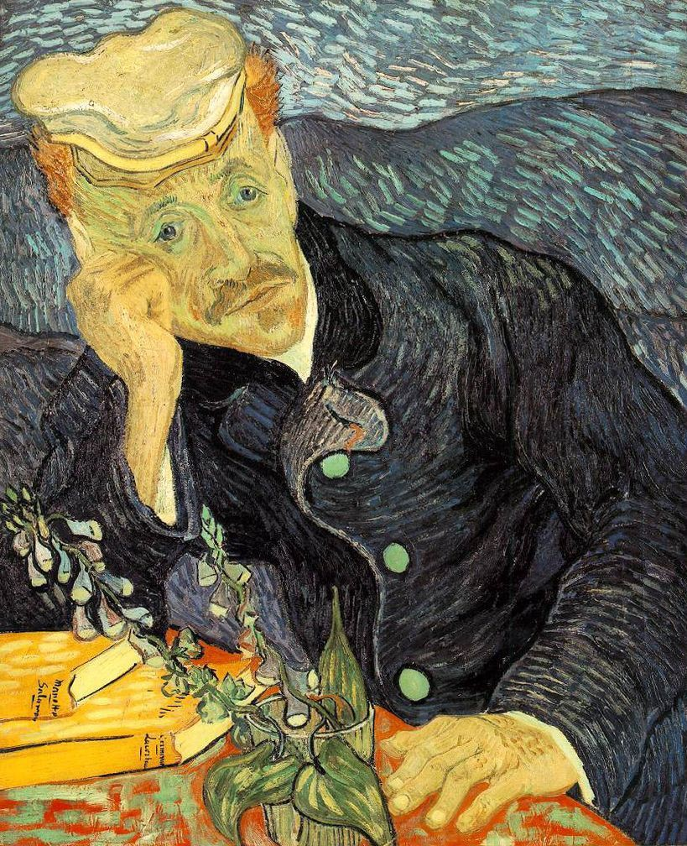
Portrait of Dr Gachet by Vincent Van Gogh
The portrait of Dr Gachet by Vincent van Gogh’s artwork is one of the most captivating and famous pieces the world has ever had. This is because of its ability to tell a story in a very special and simple way. Critics have argued that this portrait is one of the saddest paintings of all times although there is much to it than just sadness. What makes the image so real is because Van Gogh and Dr Gachet has lived together just after van Goph had been released from rehabilitation facility after cutting off his ears. The portrait could tell that the Gogh was more depressed than Dr Gachet. What makes the portrait an impressionist one the gloomy colour and Dr Gachet’s expression which showed that he was sad.
Furthermore, the painting shows Dr Gachet resting his head on his hands in a defeated sort of position. Van Gogh’s in his letter argues that the expression represented a heart-broken situation of their time. he further argues in his following letter to his brother, he said that Dr Gachet painting was done with a melancholy expression which might as well seem grimace to those who see it but also represented sadness and gentleness yet clear and intelligent.
The artist in this case was able to use impressionists’ tactics of art to pass the message of the real situation happening to Dr Gachet. The books present on the table showed that Mr Gachet was trying to learn something which is the case today when someone is faced with a difficult situation. The flower lying on the table in from of Dr Gachet could represent having been stood up on a date but in an unclear way. Maybe he was trying to get back to his lover through apologizing. I can say that the painter managed to pass on the intended message through playing around with colours and light.

