Information System Model
Name
Instructor
Course
Date

An information system is an integration of information technology and activities of the individuals that support the management, operation and decision making of the businessprocesses.Abstractly, the term information system is used to refer to the interaction between persons, process, information, and technology. Information System, therefore, does not only apply to the information technology and the informationthat a company utilizes but also the various ways the individuals interact with the technology within the organization (Laudon, and Laudon, 2015).Therefore, information system includes all the ICT components,andthe end use of the information explicitly concerns it.And it assists in the performance of the business process.
A CBIS (computer-based information technology) is a form of aninformation system which significantly depends on the computer. CBIS contains the; hardware, software, data, procedures, and people(Laudon, and Laudon, 2015). Hardware is the term used to refer to the machinery. This elementcomprises of theC.P.U (central processing unit), the computer itself and its support equipment such as the input and output devices, memory devices, and the communication devices. The software, on the other hand, incorporates all the programs that facilitate the running of the computer.Then Computer programs are setto machine instructions and commands that direct the circuitry within the hardware of the CBIS to promote the production of useful information form data. These programsare usually stored in a disk or tape. Data are setof facts that the program uses to produce information. Similar to the programs, dataare also stored in tapes or disks. While Procedures are the rules that govern the operation of the computer system. Lastly, all the CBIS need people to function. However, these elements are overlooked in most cases,but one needs to keep in mind that the success or failure of any information system largely depends on people (Laudon, and Laudon, 2015).
These five elements of thecommunication system are common to all the information system. The five elements models assist in understanding information system. The outer parts (people and hardware) are the actors in the model. Instructions and procedures are the commands that give direction to the hardware while the procedureis the actor’s instruction. Data on the other hand act as a bridge that connects the computation and people (Laudon, and Laudon, 2016). These five components do not function in isolation,butthe business process externally supports them. Therefore, the system design is the step where all the five element’s specifications are generated,and maintenance are made to functionality.

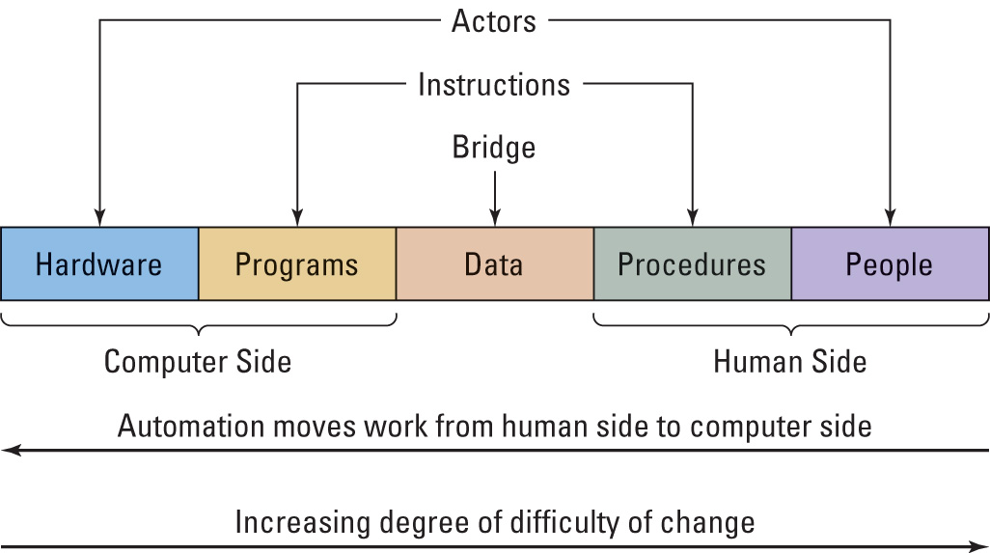

The five elements model canbe used in accessing new system’s scope. Additionally, it is utilized in analyzing the size of the investments. Also, the model can be applied in the evaluation of new systems by posing evolving question regarding the elements. For instance,which task will be affected, will training be necessary (Laudon, and Laudon, 2016).

References
Laudon, K. C., & Laudon, J. P. (2015). Management Information Systems: Managing the Digital Firm Plus MyMISLab with Pearson eText--Access Card Package. Prentice Hall Press. Managing the Digital Firm Plus MyMISLab with Pearson eText--Access Card Package. Prentice Hall Press.
Laudon, K. C., & Laudon, J. P. (2016). Management information system. Pearson Education India.

