

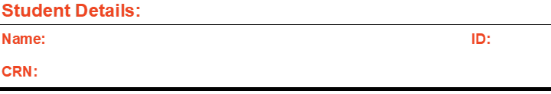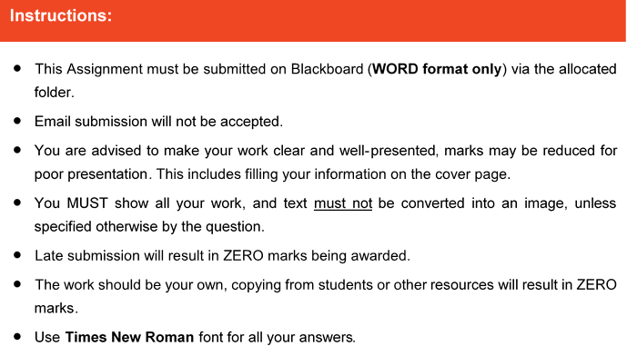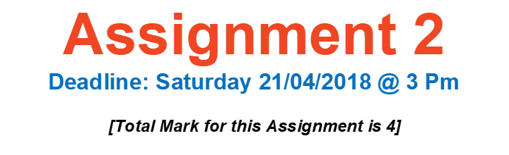

#####

#####

#####

# Question One



# Question Two



# Question Three



# Question Four

