Walmart Application Ideation Chapter
Suraj M Pandya
ISEM 502

Walmart Application Development: Ideation Phase
Introduction
System development cycle is an aggregation of distinct phases and ideas that govern how the final product of the project will function, feel like, and even interact with its users (IDEO.Org). In these levels of development, each is associated with a collection of similar tasks to be carried out in relation to the project in the study. The Ideation stage involves the generation of ideas and scenarios regarding the functionality of the system. Given the fact that the development of the Walmart Shopping app is to designed in accordance with Human-Centered Design (HCD) methodology, much of the ideas to be generated in relation to the functionality of this project will be aimed at improving the overall satisfaction of the user and ease of usability of the application (Maguire, 2001).
This particular project phase is a buildup of the previous phase that included a collection of data and analysis of user requirements about the application to be developed. Therefore, as a continuation, the ideation phase will involve the incorporation of the earlier identified requirements and problems faced with the current system at Walmart. Through this, the development team will be come up with ideas regarding the features, processes, and functionality of the application to be developed in order to solve the issues identified earlier. The critical guideline here will be the ability to achieve customer satisfaction and ease of usability of the application by the end user, is an equally important aspect around the HCD methodology (Harte, et al., 2017). The following is an analysis and interpretation of job stories from the interviews carried out in the previous phase.
Job Stories
During the collection of data, the identities of the interviewees were protected as per their requests. However, we encouraged each participant to allow us to use their real identities for better analysis.
Job story 1 and 2: Age of users: 22, 24 years, Occupation: Student
These particular students provided critical insights during the interview. Firstly, the researcher observed interest in new technologies and new ways of doing things. Given their age bracket, the participants were conscious about the amount of time it took for them to accomplish a task. The team noted that the time preferences to complete an order for these users were less than 3 minutes.
This provides a valuable insight to develop an application that embraces new modes of payment and redefinition of order processing techniques, such an observation concurred with the previous suggestions about the same developments.
Job story 3: Age of User: 28, Occupation: Procurement Officer
This particular user revealed a particular emphasis on the security of transactions and the usability aspect of the existing system. The development team, in response to this, deduced that the application should be made accessible to use with functions and interaction points well defined to ease in navigation. The inspiration behind this idea is because this user preferred to have an easy to checkout system rather than using the existing web platform.
It was observed that as the age bracket rises, customers tend to concentrate on how easy and secure is the system being proposed to them is.
Job story 4: Age: 30 Occupation: Web designer
This was an important persona in establishing if there was indeed a need to develop a mobile platform. As a web designer, this user tended to relate to the overall productiveness to the mobile platform. In their view, the user stated that as much as they are a website developer, they hate redirections to new pages during navigation.
This response confirmed that idea of developing a mobile platform for Walmart so that the company can be in apposition to retain such customers.
Job story 5: Jessica Jones Age: 27 Occupation: Software Engineer.
This was the main persona in our previous research, observations made in relation to their occupation and developing an application system is that ability to be able to keep track of her records without losing them is important to her. In addition to this, It became clear that the application to be developed needs to communicate clearly with its user through a relay of the correct information a product description. This will be achieved through the use of High-resolution images of the product.
Ideas and Solutions
Following our discussion, the team decided to develop a prototype of an application that embraces new technological designs, to target the young adults in the age brackets of 20- 30. However, there was a considerable though to develop a low-tech product as per the expectations based on results from job story 4. The application to be developed was decided to be highly reliable on simplicity policies such as minimal navigations to specific product this will reduce the time required to locate a product.
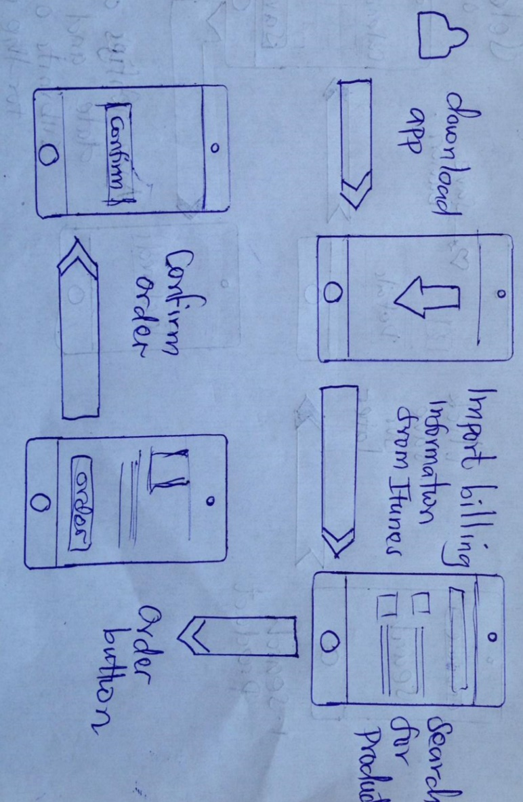
Finally, the idea to develop an application that requires the user to entire their billing information at the initial launch of the app was also agreed. The application should also be able to import billing information from popular platforms such as Apple iTunes TM and Google TM. This will eliminate the need to renter the information again.
Interaction Scenarios

Scenario 1:
The user downloads the app to their mobile phone the proceeds to registration, upon registration the user is prompted if they have billing information from companies such as Google or iTunes which are then imported according to the liking of the user. This process saves time to create duplicates of information hence achieving high levels of satisfaction.
This scenario calls for the development team to join hands with the identified companies in sharing their billing information upon user consent.

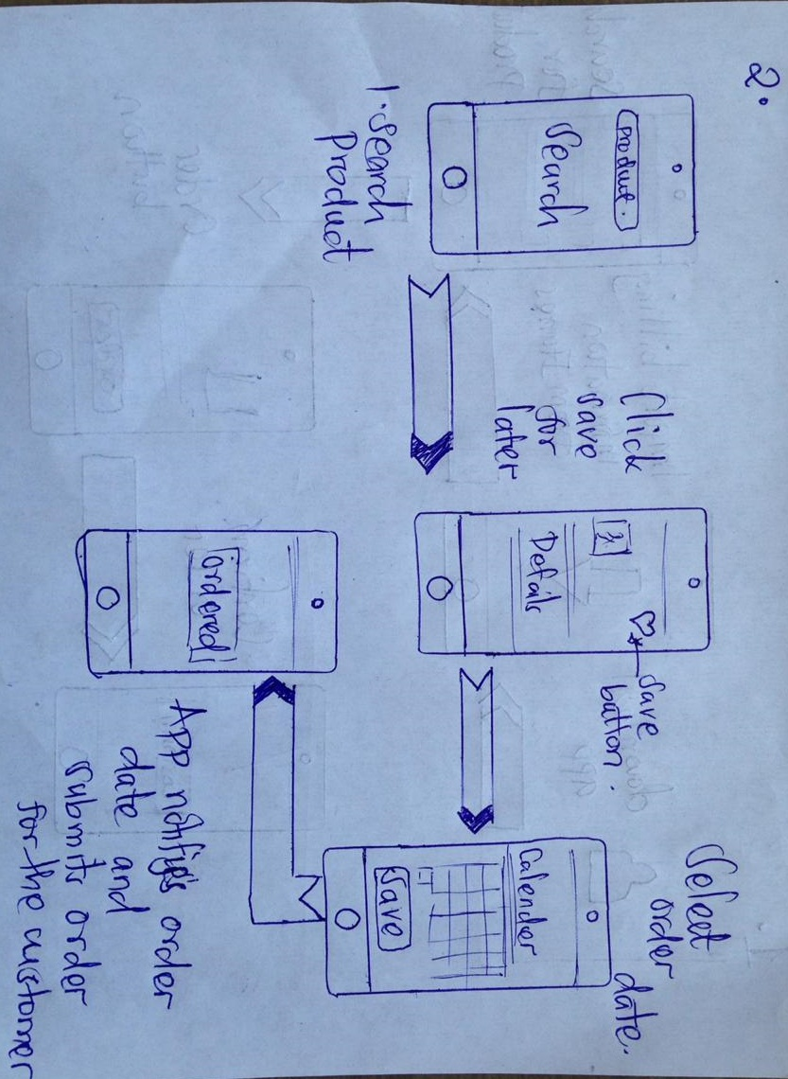Scenario 2:
This interaction scenario is based on the application’s ability to remember and track user activities over time. Through this, the user can search for the product, then save it to for ordering on a given date. When this date reaches, the application will ask the user to confirm it then submit the order automatically. This saves time as a resource.
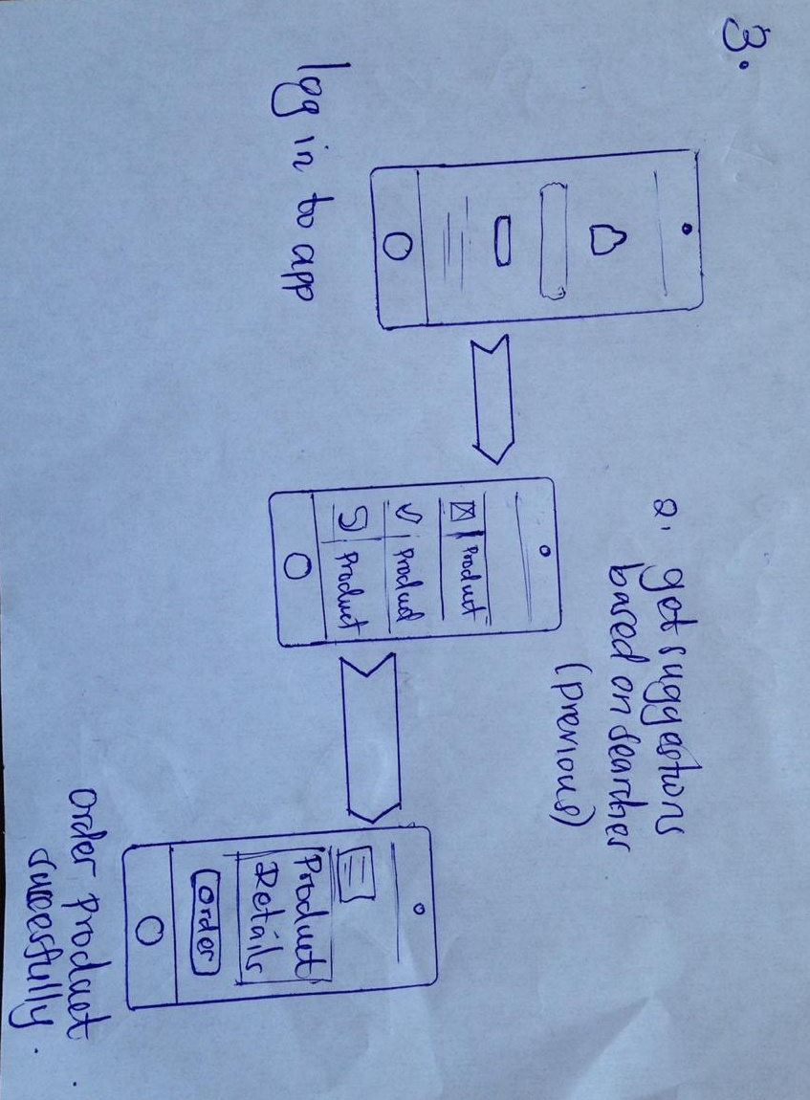
Scenario 3:
The above scenario involves a situation where the application provides suggestions based on previous searches of the user; this is made possible through analysis of big Data collected on the Walmart’s search database. Following a successful identification of the product, the user will go ahead an order the desired product.

Conclusion
In regards to these developments, the idea of developing a dynamic yet an easy to use the platform is key to achieving the overall objective of the project. The prototyping phase will be highly characterized with developing and testing of the above-identified aspects of the system and evaluation of their adherence to HCD methodologies.

References
Harte, R., Glynn, L., Rodriguez-Molinero, A., Baker, P. M., Scharf, T., Quinlan, L. R., & ÓLaighin, G. (2017, March 16). A Human-Centered Design Methodology to Enhance the Usability, Human Factors, and User Experience of Connected Health Systems: A Three-Phase Methodology. (A. Moorhead, Ed.) JMIR Human Factors, 4(1), e8. doi:10.2196/humanfactors.5443
IDEO.Org. (n.d.). Ideation Phase: Prototyping. In IDEO.Org, The Course for Huma-Centered Design (pp. 2-18). Ideo.Org.
Maguire, M. (2001, June 26). Methods to Support Human-centered Design. International Journal of Human-Computer Studies, 587-634. doi:doi:10.1006/ijhc.2001.0503
Ratcliffe, J. (2009, August 1). Steps in a Design Thinking Process. Retrieved from The K12 Lab: Stanford Edu: https://dschoolold.stanford.edu/groups/k12/wiki/17cff/steps_in_a_design_thinking_pr ocess.html

