Inefficiency in Inventory Management
Student’s Name
Course Number and Name
Instructor’s Name
University Name
Date

Inefficiency in Inventory Management
Based on my work experience, I perceive inventory management as one of the problematic issues in my previous working environment. Inventory management involves the process of tracking and controlling the inventory of a business (Singh & Verma, 2018). Some of the inventories include raw materials and finished goods. It is important to have effective inventory management. One of the importance of effective inventory management is that it ensures that the organization has the appropriate quantity of the products. It is also crucial to note that inventories can either be tangible or intangible, like software.
The nature of inefficiency in inventory management in my previous work environment can be described in various ways. One of the reasons why this organization had poor inventory management is based on the aspect of tracking. This organization had poor tracking of products. For instance, the management did very little in tracking the inventory in transit. In most cases, some inventories took so long to be delivered. Similarly, the organization recorded high cases of understocking and overstocking. Some goods ended up expiring before being delivered, thus leading to losses. This business also lacked a proper organization of inventory. The person in charge of the warehouse usually failed to make a proper arrangement of goods. Some of the products in the warehouse were not properly labeled and stored on the correct shelves. The organization also lacked proper recording of the inventory. Some goods were dispatched without being recorded, thus causing confusion. Another incidence that I witnessed was that some customers also received the wrong items. All these issues depict inefficiency in inventory management in this organization. The image below aids in demonstrating inefficiency in inventory management (Bin Syed et al., 2016).
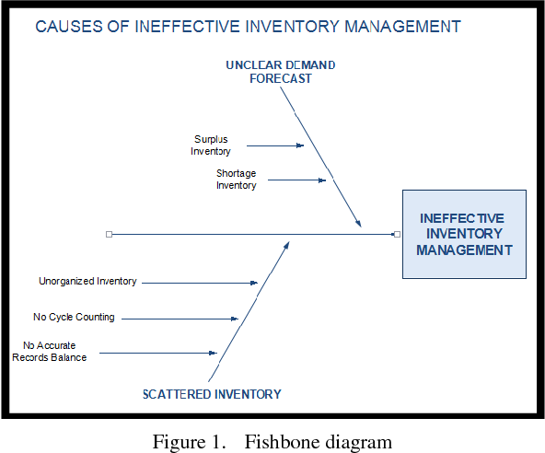
Poor inventory management is an inefficiency that impacts the organization at large. One of the impacts of this inefficiency in the organization is that it reduces its competitive advantage (Atnafu & Balda, 2018). Competitive advantage is a fundamental issue that determines a company’s success. In the case of this organization, it is likely to lose out to its competitors. The competitors are likely to perform better because they can uphold a smooth logistics of products from the company to the consumers. The potential customers can only trust companies that deliver the actual quantity and quality of the ordered products in time. Therefore, failure to satisfy the above variables implies that consumers might shift to other companies. Another disadvantage of this problem is that it might attract higher holding costs. The act of holding inventories for a longer period means that the company will spend a lot of money in managing those inventories in the warehouse. For instance, the company has to pay for several costs such as power and security costs. Also, some products can be destroyed when stored poorly. Finally, this organization is likely to be very uncertain about the cash flow when most products are stored for a longer period.
This inefficiency can also be addressed by several strategies. One of the approaches to solve this problem is through enhancing real-time tracking of inventory. This organization should try to keep its record on point. Every good that enters and leaves an organization should be recorded immediately. Also, goods in transit should be tracked in order to detect the delivery progress.

References
Atnafu, D., & Balda, A. (2018). The impact of inventory management practice on firms’ competitiveness and organizational performance: Empirical evidence from micro and small enterprises in Ethiopia. Cogent Business & Management, 5(1), 1503219.
Bin Syed, S. J. A. N., Mohamad, N. N. S., Rahman, N. A. A., & Suhaimi, R. D. S. R. (2016). A study on the relationship between inventory management and company performance: A case study of a textile chain store. Journal of Advanced Management Science, 4(4).
Singh, D., & Verma, A. (2018). Inventory management in the supply chain. Materials Today: Proceedings, 5(2), 3867-3872.

