Internet

Student’s Name
Institution Affiliation
Course Name & Number
Instructor’s Name
Due Date

Internet
- Identify the functions, purpose, advantages, and disadvantages of the following operating systems.
All operating systems usually perform similar important functionalities.
- Microsoft Windows operating system
The Microsoft Windows OS is a standard operating system that provides a platform to facilitate other programs running. It is the most popular operating system widely used in personal computers and some mobile phones (Tanenbaum, 2015). Microsoft windows perform vital functions that involve the management of files as well as programs. Besides, the operating system hosts various websites by providing network servers.
Microsoft Windows has a wide range of advantages. Firstly, a wide range of software programs is available for use, making it efficient for users. Besides, it compatible with most computer types from various manufacturers (Madnick & Jonovan, 2011). On the contrary, Microsoft windows also bear limitations that can interfere with its usability. For instance, multiple viruses have been designed to attack windows, making users risk losing data from their computers. Therefore, users have to incur extra costs purchasing antivirus software to increase protection from malicious software that can cause data loss.
- Mac OS
This operating system is widely used to run all Macintosh computers. It is specially designed and used to run UNIX and Macintosh applications (Madnick & Jonovan, 2011).
Mac OS's most crucial advantage over other operating systems is that it has the most attractive design, and the user interface is most streamlined and more straightforward to use. Additionally, Mac OS devices are less vulnerable to malware and security threats, making them safer than windows. It is because rigorous testing of Mac OS AppStore applications ensures that no suspicious programs are allowed in the system. Contrary to the advantages, Mac OS bolsters a wide range of limitations to its use (Tanenbaum, 2015). For instance, it is costly to purchase and operate when comparing it to windows.
- Linux OS
Linux OS is an operating system that serves as an open-source operating system. It is used in running computer and mobile phone hardware. Programmers use this operating system as a platform for program writing and compilation.
The main advantage of using Linux OS is that it is offered freely. Besides, it can also power a computer that cannot run on current operating systems. On the other hand, its disadvantage is that its usability is cumbersome compared to other operating systems (Blurtit, 2021). Also, very few people get to use the operating system, thereby making it difficult to acquire the necessary help if a problem arises.
- Android OS
It is the most common operating system designed by Google. It powers mobile phones, smartwatches, and tablets, as well as some personal computers. It enables users to interact with mobile devices easier by manipulating the device's applications.
The advantage of using this operating system is that it is cheaper to operate as most applications are available freely in Google's play store. Numerous devices are compatible with the operating system, such as Samsung and Huawei. Moreover, it is regularly updated to enhance the user experience. It's a disadvantage because sometimes it runs slow when many applications are running simultaneously.
- I OS
Apple devices run through this operating system. It mainly supports iPhone mobile phones, pads, and Apple televisions, making it easier to manipulate applications running in it (Vermaat et al., 2014).
The advantage of using IOS software is that the battery life is excellent and high processing speed even when numerous applications are running. The limitation of using IOS devices is that it is expensive since most applications need to be purchased from the AppStore.
- Blackberry OS
Multitasking capabilities is one of the main purposes of using the blackberry operating system. The advantage of using this OS is that it is efficient, user-friendly, and executes tasks very fast. Its limitation is that it has a poor battery life, and the support system is inefficient.
- Describe the file management system on your desktop or laptop computer
The New Technology File System is the file management system present on my laptop device. This management system helps in the storage and retrieval of files from the computer's hard disk. File clusters on my computer are tracked using a tree command scheme (Tanenbaum, 2015). Each cluster contains information on the different files saved on the computer system by showing their folders and subfolders. NTFS makes it possible to access certain files since it uses an access control list, supports numerous bytes. Besides, a Unicode system of naming resulting from file compression that is integrated makes it easier to access various files. Moreover, file names that are usually long can also be supported by NTFS. Finally, data in all disks are protected by the NTFS.
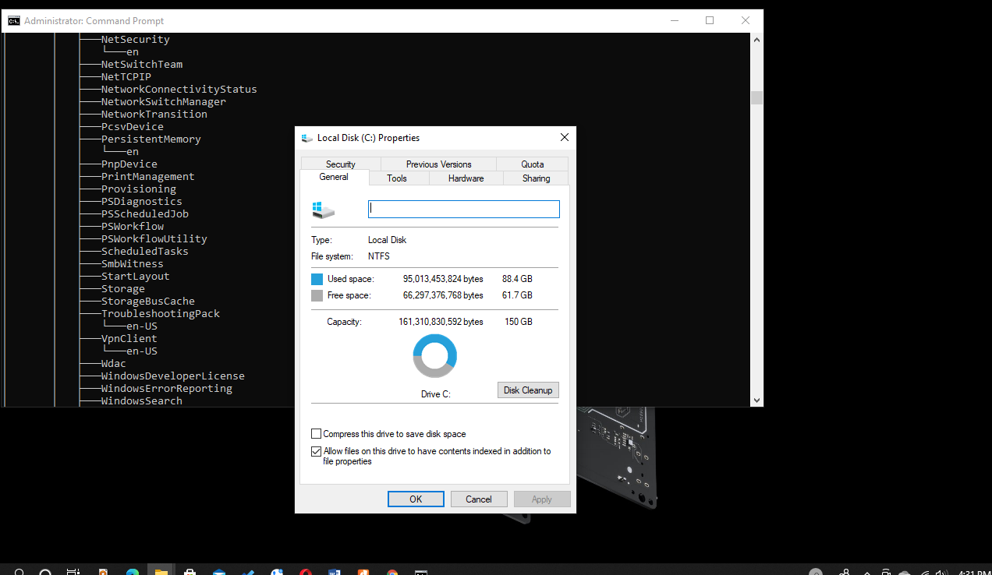
- Explain the process and programs used to backup both Windows and the Mac OS.
- Windows
Backup and restore is the program that Windows uses to back up data. Firstly, an external storage device is plugged into the computer. When displaying a list of drives in a different window, the user double clicks on The Computer (Madnick & Jonovan, 2011). A drop-down menu is displayed by right-clicking the primary hard drive. Click on properties, followed by tapping the tools tab of the displayed window. The next step is clicking on back up now. The backup drive is then selected, followed by clicking next. Scheduling a backup automatically is achieved by choosing a backup frequency and then clicking Ok to initiate a backup.
- Mac OS
The Time Machine is the program Mac OS uses to backup files. A pop-up window will open, prompting the user to choose the drive disk likely to be used for data backup (Vermaat et al., 2014). Navigating to the system's preferences and selecting Time Machine is carried out if the pop up prompt does not appear. Immediate initiation of the backup will take place until full storage. Old backup deletion is then initiated, thereby establishing space for the new files.

- Explain the function and importance of each of the following system utilities.
- Disk Clean Up utility
A disk cleanup utility is used to navigate computer files that can be deleted safely, thereby removing them to create space in the computer's storage. The user can choose the type of file to eliminate and the ones to keep. Therefore, unwanted files are removed from the hard disk to improve the efficiency of the computer.
- Disk defragmenter utility
This utility consolidates files and is important in ensuring the overall performance of the computer is enhanced. It makes user’s access data faster as the consolidated files ensure that space is made relatively smaller.
- Disk checking utility
This utility is used in the diagnosis of errors. Moreover, bad sectors are also diagnosed and fixed using the appropriate corrective mechanism. This disk utility ensures that the user's data is protected from being corrupted.

- Discuss three common computer problems and the actions you would take to troubleshoot the problems.
Using a computer makes it helpful to efficiently execute tasks that would otherwise be difficult to achieve using manual means. However, various problems can hinder the normal functioning of computers (Tanenbaum, 2015). Such problems may result in files getting destructed or even direct destruction of the whole system. Common problems associated with computers involve the inability to effectively ensure that applications are installed, missing DLL files, and the appearance of a blue screen as a result of hardware failure when booting the operating system.
The inability to install applications is a problem that is usually brought about as a result of hard disk running low on space. The best way to troubleshoot this problem is by freeing up space by initializing commands to delete unnecessary files.
The blue screen is a major problem that could result from hardware failure, some key software failing, or Dynamic Link Library files that have been corrupted. The best troubleshooting method identifies the problem, which involves determining the code lines and having them fixed independently.
The dynamic link library, abbreviated as the DLL, creates an environment for running various Operating System activities (Vermaat et al., 2014). Missing DLL files resulting from getting damaged makes it difficult for the computer to read data that has been corrupted. The best way to troubleshoot this problem is by downloading and installing new DLL files to replace the damaged ones.

References

Freund, S. M., Sebok, S. L., & Vermaat, M. E. (2014). Discovering Computers: Technology in World of Computers, Mobile Device, and The Internet. Shelly Cashman Series. Cengage Learning. Boston USA, hal, 54.
Madnick, S. E., & Jonovan, J. J. (2011). Operating systems. New Delhi: Tata Mcgraw Hill Education Private Ltd.
Tanenbaum, A. S., & Bos, H. (2015). Modern operating systems. Pearson.

