Intro to Circuitry and Resistance 2021 NAME _________________
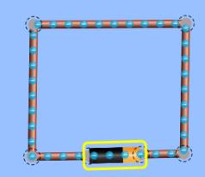
Investigate the effect of resistance on the current (I) in a circuit.

- Create a battery and wires circuit as seen to the right
  - What happens when the circuit is connected?

There is flow of electrons which results to a fire.

  - What explanation can you give for this result?
There is a short circuit that leads to the fire.

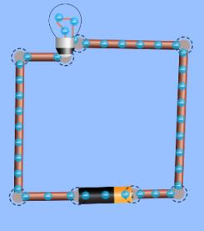
- Place a light bulb into the circuit as seen to the right
  - What happens to the flow of electrons as compared to the circuit without the bulb?

The flow of current is slower
  - Explain what is happening inside of the bulb.

The resistance of the tungsten wire cause heating, which produces light.

  - What happens when you flip the position of the battery?
The current flows in the opposite direction

- Take the “AMMETER” and place the scope anywhere along the circuit wire.
  - What does the AMMETER read?
___0.9A______________ A

Now place the AMMETER on the bulb:
  - What does the AMMETER read?
___0.9A______________ A

Now place the AMMETER on the battery:
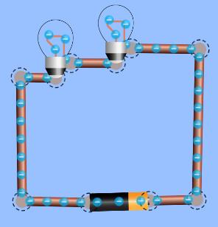
  - What does the AMMETER read?
__0.9A_______________ A

  - What can you reason about the current (amperes) of the circuit?

The current is equal since the whole system is in series. Current flowing into a circuit is the same as the current flowing out of a circuit.

- Place a second bulb into the circuit as shown to the right
  - What do you notice about the brightness of the light?
The brightness of the bulb reduces.

  - Place the ammeter BETWEEN the battery and the first lamp. (Use the direction of electron flow to determine the first lamp.) What does the ammeter read?
__0.45A_______________ A

  - Place the ammeter BETWEEN the 2 bulbs. What does the ammeter read here?
__0.45A_______________ A

  - Place the ammeter BETWEEN the 2nd lamp and the battery. What is the reading?
_0.45A________________ A

- Now aim the scope of the AMMETER anywhere along the circuit. What does it read?
_0.45A________________ A
DISCUSSION QUESTIONS
- Looking at the circuit with 1 bulb vs. the circuit with 2 bulbs, does the current change as it flows through the circuit?
Yes

- How did the current change as the lamps (resistance) were added to the circuit?

Decreased

Recreate the circuit with a single bulb –

- Take the VOLTMETER and place the BLACK prong at the black end of the battery and the RED prong at the copper end of the battery.
  - What does the VOLTMETER read?
_9.00V________________ V

- Take the VOLTMETER and place the BLACK prong on the bulb as the electrons are entering and the RED prong on the bulb as the electrons are exiting.
-9.00 V
  - What does the VOLTMETER read?

Recreate the circuit with 2 bulbs –

- Take the VOLTMETER and place the BLACK prong at the black end of the battery and the RED prong at the copper end of the battery.
____9.00V_____________ V
  - What does the VOLTMETER read?

- Take the VOLTMETER and place the BLACK prong on the FIRST bulb as the electrons are entering and the RED prong on the bulb as the electrons are exiting.
___-4.50V______ V
  - What does the VOLTMETER read?

- Take the VOLTMETER and place the BLACK prong on the SECOND bulb as the electrons are entering and the RED prong on the bulb as the electrons are exiting.
_____-4.50V ________ V
  - What does the VOLTMETER read?

- Using Ohm’s Law – determine the resistance of the bulb(s).

Ohm’s Law: $current= \frac{voltage}{resistance}$ or $resistance=\frac{voltage}{current}$

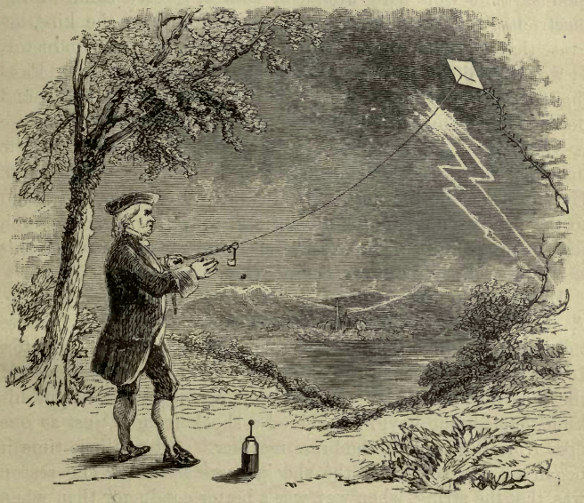
What is the resistance of the bulb in ohms?
Resistance = 4.5 ÷ 0.45 = 10Ω

