Introduction
- The need that is being satisfied is people will be to print photos directly from their phone right after taking them.
- The Polaroid Madness would save people much time that would be spent going somewhere, such as Walgreens or Office Depot, to upload their photos and print them out there.
- This is a much faster and more convenient way for people to get their photos printed, and they would also get them to anybody that wants them faster after printing them.
- Introducing Polaroid Madness: A way to print Polaroids right from your phone!
- It’s a new invention that will drive your artistic mind mad!
- Polaroid is one of the most revolutionary types of cameras ever invented and now with this new technology, you have the ability to take a photo and then be able to hang it up or pin it to a display board for all to see…all contained in such a small camera.
- With Polaroid Madness you can attach a small portable printer right to the back of your phone. Plug it into your phone and through the handy camera app, any photos taken will be instantly printable.
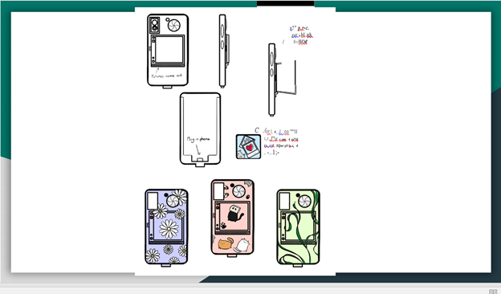

C. The industry this would be in is the Photo Electronics Consumer Industry.
- The size of this industry is pretty big. It was estimated it made $2.9 trillion dollars last year.
- It is estimated it will grow another 7% by 2026. This industry main competitors are Canon, Sony and GoPro.

D. Fits within Photo Electronics Consumer because it is an electronic product that produces physical photos.

- Differs from other cameras in the industry because of the ability to print out the picture right after taking it.

