

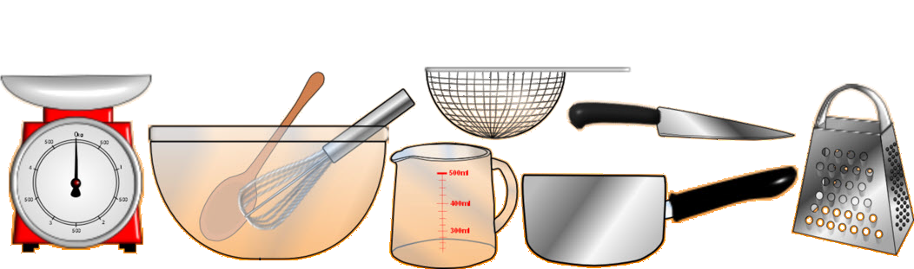
A recipe for Jerky,

Jerky,
Ingredients
  - 2 pounds beef round steak, cut into thin strips.
  - ¼ cup soy sauce.
  - 2 tablespoons Worcestershire sauce.
  - 2 tablespoons liquid smoke.
  - 2 tablespoons brown sugar.
  - 2 teaspoons salt.
  - 1 teaspoon ground black pepper.
  - 1 teaspoon meat tenderizer. 1 tsp. instant coffee (optional)

Procedure
Place beef strips in the bottom of a large bowl. Pour soy sauce, Worcestershire sauce, liquid smoke, brown sugar, salt, pepper, meat tenderizer, garlic powder, onion powder, and paprika over beef. Mix to assure all the meat is evenly coated. Cover and marinate in the refrigerator for 8 hours or overnight Makes 16 servings.
Remove meat from bowl and place between two pieces of plastic wrap; pound to 1/8-inch thickness.
Arrange the meat strips on the tray of a dehydrator and dry at your dehydrator's highest setting until done to your liking, at least 4 hours. Store in an airtight container or resealable bags.

MENU (OFFER) 50$
- Fish,
- Jerky,
- Fajitas,
- Cioppino
- Banana Split,
- Baked Beans
- Steak,
- Pasta & Vegetarian Dishes

YOU ARE WELCOME

