Judaism
Introduction to Religion 2011
Prof. Eric Isaac

This paper will observe and debate the central idea of Judaism, and how the history of Judaism shapes the Jewish faith. Judaism is the world’s oldest monotheistic religion, dating back nearly 4,000 years. Jewish people believe that there is one transcendent God who has established a covenant with them, and who revealed himself through ancient prophets. The history of Judaism is crucial to understanding the Jewish faith, which is why this paper will review the researcher’s experience at The Jewish Museum of Florida-FIU. The Jewish Museum of Florida, established in 1995, is the only museum dedicated to telling the story of more than 250 years of Florida Jewish history. This paper will demonstrate that Jewish history plays an essential role in shaping its faith. This will be accomplished through observing The Jewish Museum of Florida’s extensive collection of artifacts, documents, photographs, and oral histories. On the other hand, this paper will also discuss that the central idea of Judaism is based on structural beliefs such as Monotheism, and Covenant (an agreement between God and his people), and it will demonstrate this by basing its research on the religion’s history, and how its beliefs have remained so solid over thousands of years.
Judaism has endured so many years as a strong religion because it sticks to some basic strong beliefs. Jews believe that there is only one God who not only singlehandedly created the universe, but with whom every Jew has a personal and individual relationship. Jewish people feel that God continues his work in the world influencing people’s actions. Foremost, Judaism is a monotheistic religion, which means they believe there is only one God who is the creator of everything. This belief is enforced by the sacred texts inside the Torah and the Talmud. The Torah, or Jewish Written Law, consists of the five books of the Hebrew Bible - known more commonly to non-Jews as the "Old Testament". The Torah is sacred to Jews as it uniquely provides the basic laws and the tenets of Judaism. (AICE 2010) On the other hand, the Talmud, which stands for “learning” in Hebrew, is a collection of writings that covers the full gamut of Jewish law and tradition, compiled, and edited between the third and sixth centuries. (Shurpin 2016) Jewish people worship in holy places known as synagogues, and their spiritual leaders are called rabbis. The six-pointed Star of David is the symbol of Judaism. Today, there are about 14 million Jews worldwide. Most of them live in the United States and Israel. Traditionally, a person is considered Jewish if his or her mother is Jewish. (Onion 2018)
Furthermore, the Jewish relationship with God is a covenant relationship. According to Judaism, the covenant is a promise that God made with Abraham in which God would offer safety and land to Abraham and his descendants, but in return, they must follow the path of God. Under this covenant, the land of Israel was given to the Jewish people through the Prophet Moses at Mount Sinai. As a symbol, this covenant was sealed by proceeding to command Abraham and his future generations to undergo circumcision (brit milah). Even today, the Jewish people undergo circumcision as a way of honoring the promise. Jewish tradition comes from Abraham’s covenant with God, which makes it an Abrahamic religion, like Christianity and Islam. Since the Jewish relationship with God is a covenant, in return for all the good deeds that God has done and continues to do for the Jewish people the Jews keep God's laws and seek to bring sanctity into every aspect of their lives. However, the covenant can have different meanings to different people based on their stream, belief, practice, and culture.
Another strong belief in Judaism is that Judaism is the faith of a community. Jews believe that God appointed the Jews to be His chosen people to set an example of holiness and ethical behavior to the world. (BBC 2009) Jewish life is based on living as a community and there are many activities they must do as a community as well. They feel part of a global community as well because they share a close bond with Jewish people spread around the world. Many Jewish religious customs revolve around the home. One example is the Sabbath meal when families join to welcome in the special day. (BBC 2009)
Aside from basing their faith in some basic beliefs, the Jewish faith is very influenced and shaped by their history. I observed and explored this further by visiting the Jewish Museum of Florida-FIU. The Jewish Museum of Florida is the only museum dedicated to telling Jewish history in Florida by representing arts and culture, with a growing collection of more than 100,000 items. The Museum is housed in two re-established historic buildings that were once synagogues for Miami Beach's first Jewish congregation. This museum is accredited by the American Alliance of Museums, and it has achieved a standard of excellence in its research, archiving, collecting, conservating, safekeeping, and interpreting its property. (FIU 2012)
The museum makes the experience reflective and creates awareness of the Jewish immigrant experience in our multicultural society here in Miami, Florida. The Museum's core exhibition, MOSAIC: Jewish Life in Florida 1763 to today, originated by Marcia Jo Zerivitz, began as a gathering of photographs, artifacts, and oral histories from the lineage of pioneer families, including recent. Mosaic generated so much interest that by 1995, it evolved into the Jewish Museum of Florida. (FIU 2012)
Observing this museum made me realize that the history of Judaism is key to understand the Jewish faith, which has an abundant heritage of culture, law, and tradition. This museum’s purpose is to promote and support tolerance, further global understanding and create connections to Jewish culture, history, arts, and culture. The museum's holdings focus on the people who have shaped and continue to influence the development of the Jewish faith in this country. "Most importantly, even though the museum focuses its history on the development of the Jewish religion in Miami Beach, it still managed to clearly explain the history of Judaism and how Jews interact as a community while maintaining their faith and beliefs strong. Visiting this museum and observing its extensive collection of artifacts, documents, photographs, and oral histories can be very eye-opening, informative, and soulful. Along with their thought-provoking exhibitions that change periodically, workshops, family activities, lectures, and presentations. (FIU 2012)
This paper has revealed that history plays a big and essential role in Judaism and shaping the faith of those who follow the religion. After analyzing the collection of artifacts, documents, photographs, and oral histories that belong to The Jewish Museum of Florida this paper was able to demonstrate that the central idea of Judaism is based on set main beliefs such as: Monotheism, Covenant (an agreement between God and his people), living the faith as a community, and following the sacred writings in the Torah and the Talmud. This paper has proven that to understand the Jewish faith and their beliefs one must be educated on their history.

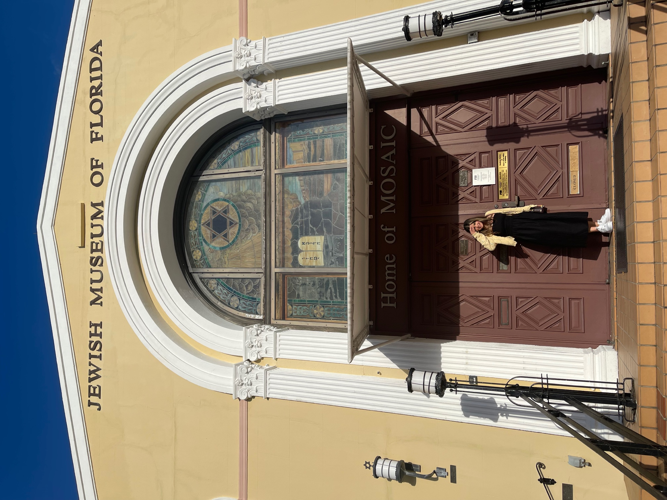

Works Cited
AICE. 2010. Jewish Virtual Library. Accessed October 5, 2021. https://www.jewishvirtuallibrary.org/the-written-law-torah.
BBC. 2009. BBC. September 14. Accessed October 5, 2021. https://www.bbc.co.uk/religion/religions/judaism/beliefs/beliefs_1.shtml.
FIU. 2012. JMOF FIU. Accessed October 5, 2021. https://jmof.fiu.edu/about/index.html.
Onion, Amanda. 2018. HISTORY. January 5. Accessed October 8, 2021. https://www.history.com/topics/religion/judaism.
Shurpin, Yehuda. 2016. Chabad Org. Accessed October 5, 2021. https://www.chabad.org/library/article_cdo/aid/3347866/jewish/What-Is-the-Talmud-Definition-and-Comprehensive-Guide.htm.

AICE, “Judaism”
Shurpin, “Talmud”
Onion, “Today”
BBC, “Jews believe”
BBC, “Many Jewish religious customs”
FIU, “The Jewish Museum of Florida”
FIU, “MOSAIC”
FIU, “Along with their thought-provoking”

