SEEDLESS VASCULAR PLANTS

This group includes the Club Mosses (Phylum Lycophyta), Horsetails (Phylum Sphenophyta), and Ferns (Phylum Pterophyta). These are very ancient plants that were prevalent during the Carboniferous period of Earth formation.
The SPOROPHYTE IS DOMINANT in the Seedless Vascular Plants, Meaning that they spend slightly more time as a sporophyte than a gametophyte. The sporophyte has adaptations to help it survive the harsh conditions of land, such as a VASCULAR SYSTEM and WIND DISPERSED SPORES (don’t need water). The spores will germinate and produce a small gametophyte generation. The gametophyte generation retains properties that are not adapted for land, such as NO VASCULAR SYSTEM and FLAGELLATED SPERM.

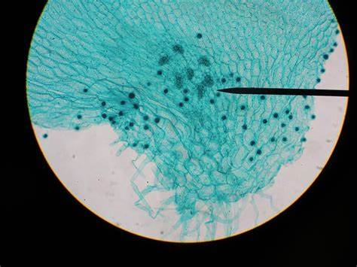
STRUCTURE: ENTIRE
PROTHALIUM
Domain: Eukarya
Kingdom: Plantae
Group: Polypodiophyta
Phylum: Ptreidophyta
Genus:Prothallus

STRUCTURE: ANTHERIDIA
(Located on Prothalium)
Domain: Eukarya
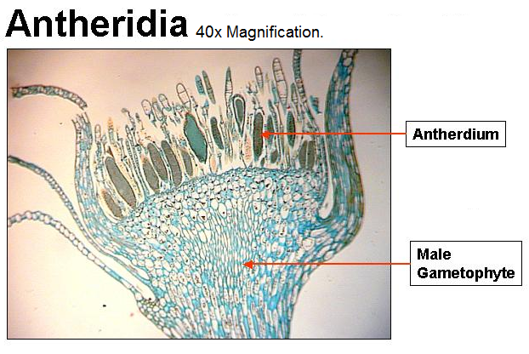
Kingdom: Plantae
Group: polypodiophyta
Phylum: pterldophyta
Genus: polypodium

STRUCTURE: ARCHEGONIA
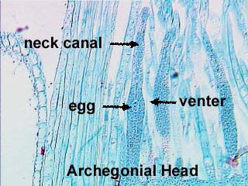
(Located on Prothalium)
Domain: _Eukarya_____________
Kingdom: _plantae____________
Group: ____ polypodiophyta
Phylum: ____ pterldophyta
Genus: _polypodium____

STRUCTURE: INDUSIUM/
SPORANGIUM/SORUS
Domain: _Eukarya 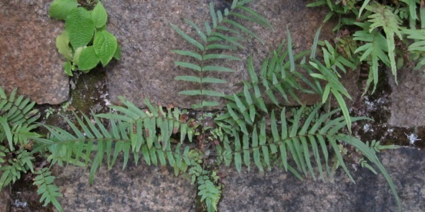
Kingdom: __plantae
Group: __ polypodiophyta

Phylum: pterldophyta
Genus: ___Pteris L.

STRUCTURE: PROTHALIUM
WITH SPOROPHYTE
Domain: _Eukarya 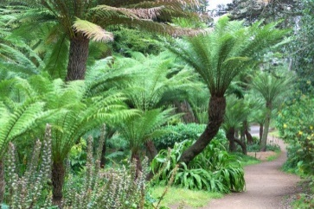
Kingdom: __plantae
Group: antartica___
Phylum: pteridophyta
Genus: Diksonia

STRUCTURE: FERN
FROND WITH SORI
Domain: Eukarya
Kingdom: plantae 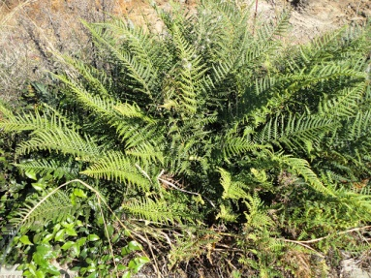
Group: Polypodiophyta
Phylum: Filicophya
Genus: Pityrogamma

STRUCTURE: WHISKFERN
Domain: Eukarya
Kingdom: plantae 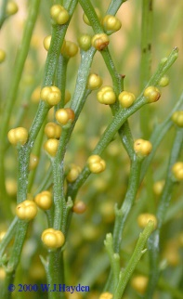
Group: pteridophytes
Phylum: psilotophyta
Genus: Psilotum

STRUCTURE: LYCOPHYTE
Domain: Eukarya
Kingdom: plantae 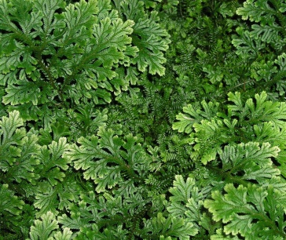
Group: Pteridophyte
Phylum: Lycophyta
Genus: Selaginella

