Introduction:
The main goal of this lab is to determine the types of volcanos, elevation, history, and the activity of each volcano. Volcanos are ruptures in the crust of a planetary mass object where such as the earth, where that can let and allows the lava to be buried on the earth and cause eruptions and some deaths for people. Also, volcanos activities cause earthquakes and other geological activity on the earth, such as changing on mountain shape and size, born new rocks, and re create different types of rocks.
Methods:
In this lab, each student must go through twelve volcanos in different areas and be allow to answer the ten questions and take a screenshot of each volcano after researching for the history and activities of each volcano. After researching of each volcano, the group was able to find the location of the volcano, and the latitude, longitude, and highest elevation of each mountain. After that, the group was able to find the type of the volcano and decided if it is shield, stratovolcano, or cinder cone, and if the volcano is active or inactive. Every volcano might cause eruption, deaths, and damages, so for each volcano, th group was able to find last recored of the eruptions, if it is still erupting, how big the damage was, and how many people dies in the last eruption. Also, students had to find where the volcano located, if it is in convergent boundary plate, divergent plate, or in hotspot. Last, each volcano had a specific question had to be answered by the students after researching.
Lab Materials:
- Google Earth
- Pen
- Google Seach
Results:
- A) Kilauea:
1)Pacific Ocean in Hawaii, North America, Northern Hemisphere
2) Latitude :19⁰24’24.81”
Longitute:155⁰70’00.16”
Elevation: 4,190’

3) Shield
4) Active
5) Beginning of March 2018
6) Yes
7) Significant damage to surrounding village
8) Hotspot
9) No deaths
10) Lo’ihi
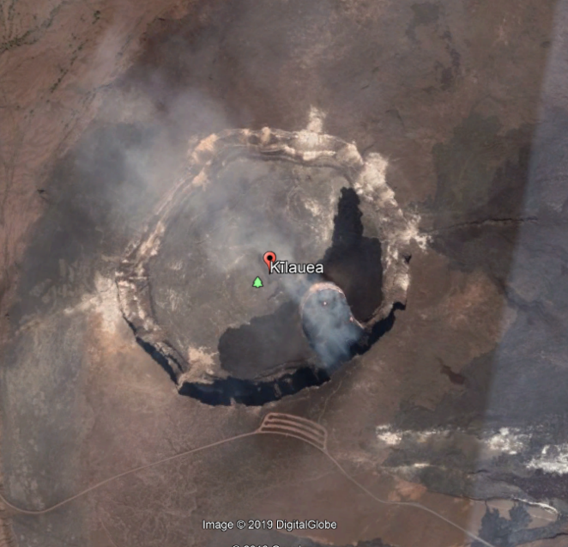
- Mauna Loa:
- Located in Pacific Ocean in Hawaii, USA, North America, Northern Hemisphere
- Latitude :19⁰28’46.16”
Longitute:155⁰36’10.18”
Elevation: 13,678’
- Shield
- Active
- Mid April 1984
- No
- Near by homes, stores and gas stations
- Hotspot
- None
- Lo’ihi
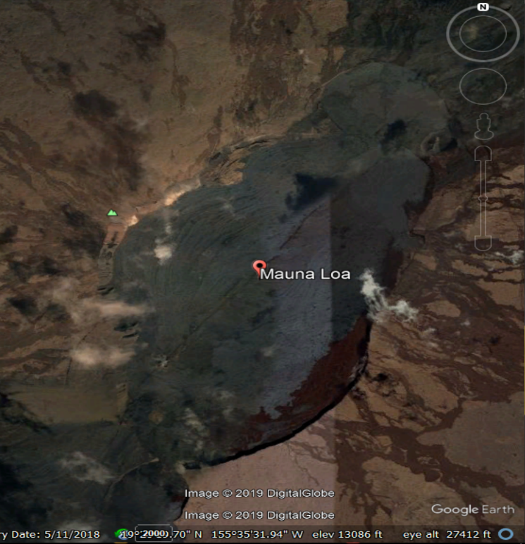

- Mauna Kea:
- Hawaii, USA; Pacific Ocean; Northern Hemisphere
- Latitude :19°49’15.31” N
Longitude: 155°28’05.42” W
Elevation: 13669’
- Cinder Cone
- Dormant
- 2460 B.C.
- No.
- Not recorded.
- Hotspot
- Not recorded
- Loihi Seamount
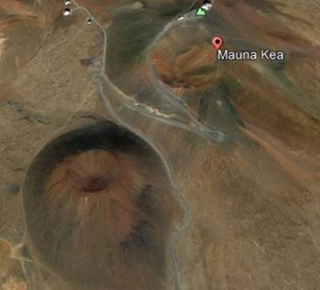

- Mt. Fujiyama:
1) Japan, Asia, Northern Hemisphere, Pau’ fic
2) Latitude: 35°21’ 38.00” N
Longitude: 138°43’40.00” W
Elevation: 12401

3) Stratovolcano
4) Active
5) December 16, 1707
6) Not erupting
7)
8) Continental convergent boundary
9) No deaths
10) Remains a powerful force in Japanese celled
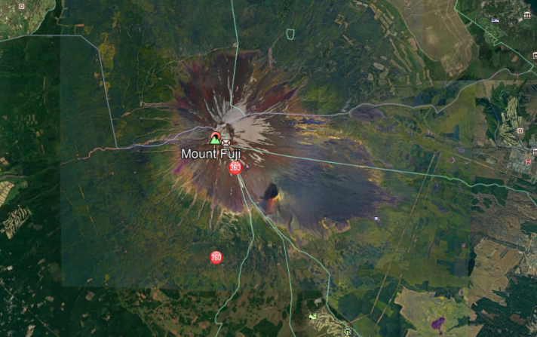

- Mt. Krakatoa:
1) Southern Indonesie, Atlantic, Asia
2) Latitude: 06°07’ 07.62” S
Longitude: 105°25’22.75” E
Elevation: 2667’
3) Stratovolcano
4) Active
5) December 2018
6) Not erupting
7) Caused a tsunami and Killed People
8) Convergent plate Boundary
9) Killed 373 people because of the tsunami
10) In the northern atmosphere the Tempe ratting fell by as much 1.2 C weather pattern continued to be chaotic for years and temp did not return ti normal until 1889.

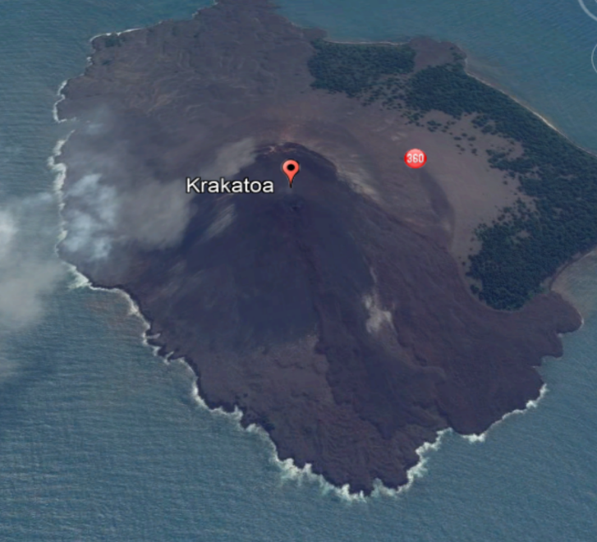

- Mt. St. Helens:

- Located in Pacific Ocean in washington, USA, North America, Northern Hemisphere
- Latitude :46⁰12’0.1”N
Longitude: 122⁰11’12.68” W
Elevation: 8,363 feet
- Stratovolcano
- Active
- July 10, 2008
- No
- This eruption did not cause much damage to the surrounding areas. It did release a significant amount of ash into the air.
- convergent
- 57 people
- North
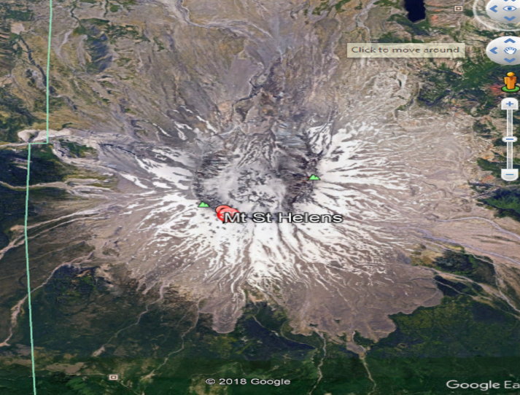
- Mt. Pelee:

1) Northern Hemisphere
2) Latitude: 14°48’ 33.72” N
Longitude: 61°09’59.10” W
Elevation: 4583’
3) Stratovolcano
4) Active
5) 1902
6) No
7) The city was pretty destruction and killed the whole population and 2 people survived
8) Convergent plate boundary
9) 30,000 People
10) Formed a second dome in the Etang sec caldera and produced pyroclastic flows emptying into the blanche river valley
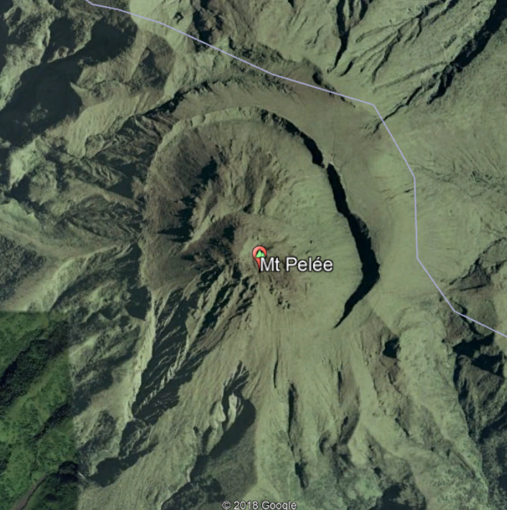
- Surtsey Volcano:

1) Northern Hemisphere
2) Latitude: 63°18 08.24” N
Longitude: 20°36’03.86” W
Elevation: 509’
3) Shield Volcano
4) Active
5) November 14, 1963
6) No
7) Columns of ash were sent 30,000 ft into the sky and can bee have seen as Reykjavik
8) Divergent plate boundary
9) 0 People
10) The Island stood 942 ft above sea level and covered an area of 2 sq miles.

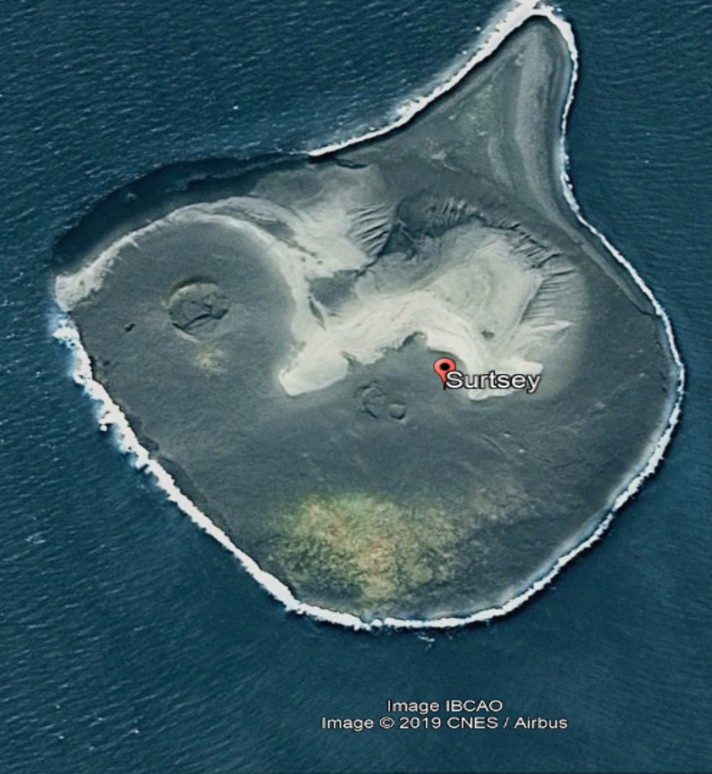

- Eldfell Volcano:

- Iceland; Atlantic Ocean; Northern Hemisphere
- Latitude: 63°25’57.79” N,
Longitude: 20°14’58.30” W
Elevation:650 ft
- cinder cone volcano
- Active
- January to June 1973
- No.
- 400 Buildings destroyed
- Mid-Atlantic Ridge; Hotspot
- One
- Pumped a large amount of water to the advancing lava to cool the advancing flow
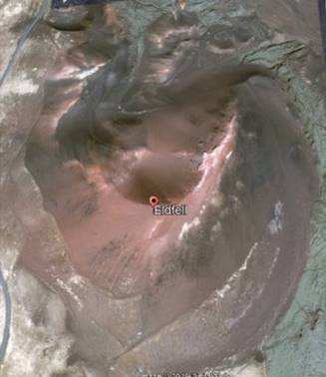

- Mt Erebus :
1) Ross Island, Antarctica, southern hemisphere
2) Latitude: 77°31’48” S
Longitude: 167°10’12”E
Elevation: 12,448
3) Bottom is shield and top is stratovolcano
4) Active
5) 1977-2016
6) Yes
7) No Damage
8) Intraplate and lies on a rift (hotspot)
9) 0 deaths
10) This volcano is one of the hottest ever reaching temperatures of 1700 F. this is interesting because everywhere around the volcano there is frozen water and snow. The magma chamber is thought to be miles deep.
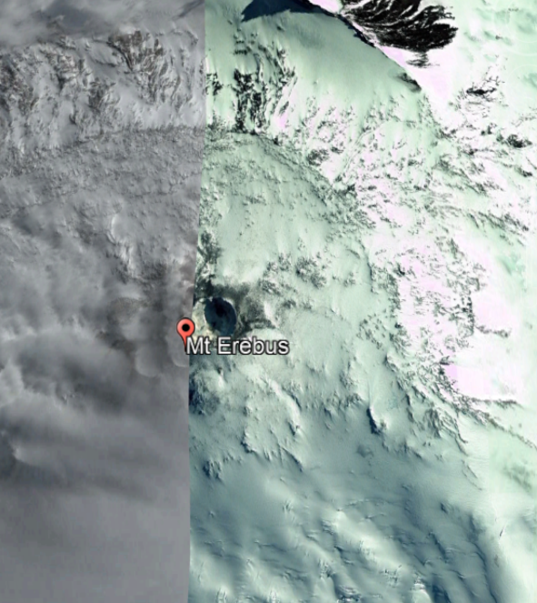

- Mt. Vesuvius:
1) Naples, Italy, Northern Hemisphere
2) Latitude: 40°49’21”N
Longitude: 14°25’44”E
Elevation: 3190 ft, Highest: 4203 ft
3) Somma-stratovolcano
4) Active
5) Erupted last March 1944
6) Yes
7) Destroyed villages of San Sebastiano al Vesuvio, Massa di Somma, and Ottavanio
8) Hot Spot
9) 0 deaths
10) Mt. Vesuvuis erupted and destroyed and buried the cities of Pompeii, Herculaneum, Oplontis, and Stabiae
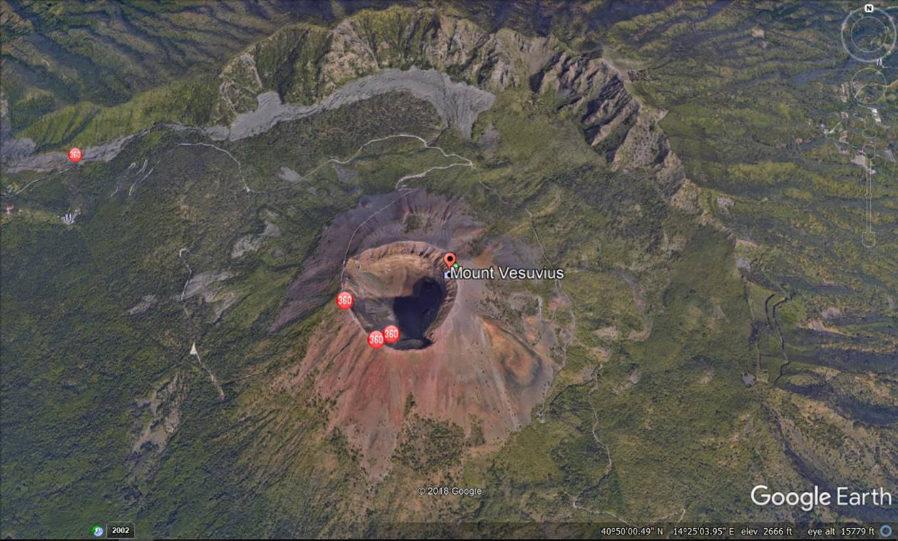

- Mt. Pinatubo:
1) Zambales, Philippines, Northern Hemisphere
2) Latitude: 15°08’34”N
Logutute: 120°20’58”E
Elevation: 3045ft., Highest: 4875 ft
3) Caldera-Stratovolcano
4) Active
5) Erupted last June 1991
6) No
7) Infrastructure was destroyed due to volcanic matter, reforestation projects were destroyed, agriculture and livestock were destroyed and killed. 2.1 million people were affected by the eruption.
8) Convergent plate boundary, Eurasian plate and Philippine plate
9) 847 deaths
10) Operation Fiery Vigil was when the United States Air Force initiated a massive airlift effort to evacuate American troops and their families in the two affected American bases after the eruption. Most personnel were relocated to Guam, Okinawa and Hawaii, although some returned to the United States.
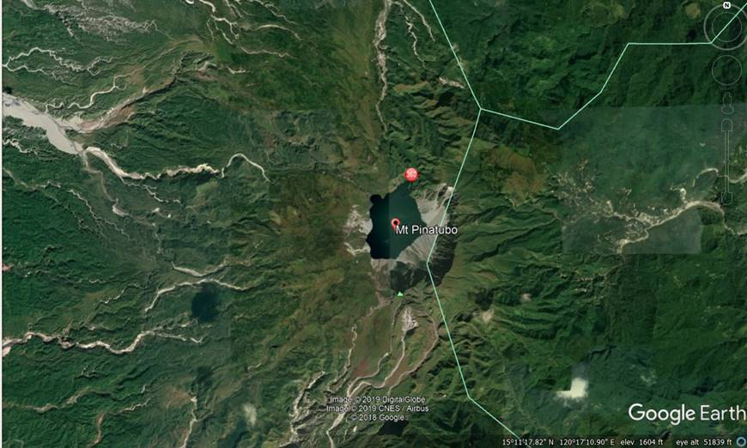
Conclusion:
This lab help the student to understand more of identfying types of volcanos amd compare and fining the difference between them. Those identifications achived by using google erth amd doing some reserches to answer the qustions, which finding the eruptions, deaths, damges, and location of each volcano.

