Name: [type name here]

Short answer questions. Each question’s value is indicated in points. Make sure to answer all questions in complete sentences and are grammatically correct statements.

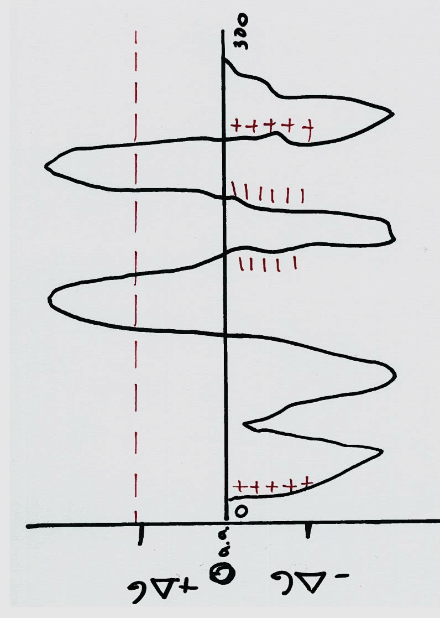
Membrane protein orientation. I have drawn a hypothetical membrane protein that has a hydrophobicity plot. Please answer the following questions about the protein’s predicted structure. Each question has two parts, make sure to answer both!

1.) How many transmembrane domains does the protein have? Tell me what part of the plot allows you to determine the number of transmembrane domains. 4pts

[insert answer here]

2.) Where is the N-terminal part of the protein found? What charge allows you to determine the orientation of the N-terminus? 4 pts

[insert answer here]

3.) Where is the C-terminal part of the protein found? What charge allows you to determine the orientation of the C-terminus? 4pts

[insert answer here]

The Nuclear Localization Signal (NLS) was discovered to play a role in protein import into the nucleus. Two different experiments were performed to demonstrate that the NLS was both necessary and sufficient for protein localization inside the nucleus.

4.) Explain the experiment that was performed to demonstrate that the NLS is necessary for import into the nucleus. Include the control and experimental 'sample'. 6pts

[insert answer here]

5.) Explain the experiment that was performed to demonstrate that the NLS is sufficient for import into the nucleus. Include the control and experimental 'sample'. 6pts

[insert answer here]

6.) X-chromosome inactivation is a complex stepwise process. Describe the process on how an X-chromosome is inactivated. 4pts

[insert answer here]



7.) Why are calico cats only female?
How do you get the calico coat pattern? 5pts

[insert answer here]

8.) What is an aquaporin? What does it transport? How is it specific for that molecule and doesn’t other ions or molecules pass through the aquaporin? 3pts

[insert answer here]

9.) What is a facilitative transporter? What is an example of one that we went over? 2pts

[insert answer here]

10.) What is indirect active transport? What are the two types that can occur? What directions are the molecules going in both types? 5pts

[insert answer here]

11.) What are the 3 types of membrane proteins? Where are they located in relation to a membrane? 3pts

[insert answer here]

The H⁺/K⁺ATPase is found in the stomach and plays a role in the transport of H⁺ and K⁺ between the lining of the stomach and the contents of the stomach.
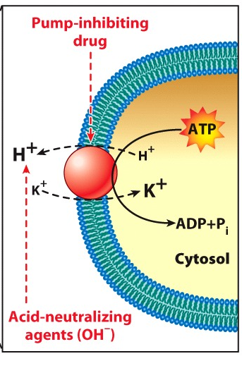
To the left you have used a drug that inhibits the activity of the H⁺/K⁺ATPase.

12.) Describe what the normal balance of H⁺ and K⁺ in an untreated cell would be. e.g. tell me where there would be a high concentration of each ion. 2pts

[insert answer here]

13.) Then when you add the drug, tell me how the concentration of both ions (H⁺ and K⁺ ) will change. 2pts

[insert answer here]

