

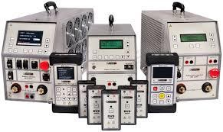
Selected Topics Course
(Communication Lab)

Abstract

The purpose of this report is to reflect theoretical and practical knowledge that gained from a Master course “Selected Topics in Communication Lab”. This educational course/lab designed to cover many features and topics that wasn’t practically clear/understandable from previous theoretical courses. The report theoretical part in this report only to explain and support students to get the highest-quality of knowledge from this course. The report practical part is reflecting trainee’s results from each experiment. Moreover, the Lab contains software and practical equipment that delivers an advance level of knowledge in Communication Systems.

Table of Contents

Abstract 2
Table of contests 3
Communication Systems 4
Frequency Ranges 5
LAB Transmitter Board and Another Measurement Equipment 5
Amplitude Modulation (AM) 7
Generation of DSB-AM 7
Frequency Modulation (FM) 13
Amplitude-shift keying (ASK) 16
Phase shift-keying (PSK) 17
Frequency shift-keying (FSK) 18
Quadrature amplitude modulation (QAM) 20

Communication Systems

In communication, modulation is defined as the process by which some characteristic of a carrier wave is varied in accordance with an information- bearing signal. The carrier is needed to facilitate the transportation of the modulated signal across a band-pass channel from the transmitter to the receiver.

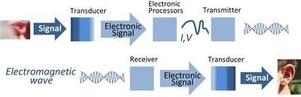

Starting from the speaker, voice signal passing through transducer. Then we can get an electrical signal. The electrical signal is processing across electrical processor after that it will be ready for transmitting as electromagnetic wave signal. Therefore, the electromagnetic signal would reach to a receiver which translating the electromagnetic signal to electronic signal. Across transducer, the electronic signal will be changed to be normal voice signal and ready for the ear.
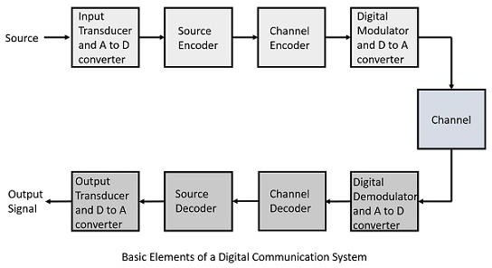

Frequency Ranges

Due to their various attributes and depending on the application, electromagnetic waves of differing wavelengths are used for message transmission. The usable frequency range stretches from a few kHz to many GHz.
Therefore, the radio wave is an electromagnetic wave of a frequency between about 10⁴ and 10¹¹ or 10¹² Hz, as used for long-distance communication.

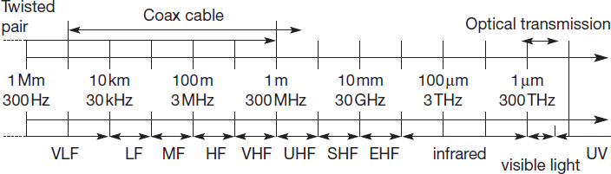

LAB Transmitter Board and Another Measurement Equipment

At the LAB, we have many components which support us to understand the deferent telecommunication technologies.
One of the main components at the LAB is the experiment board which is broken down into various functional units.

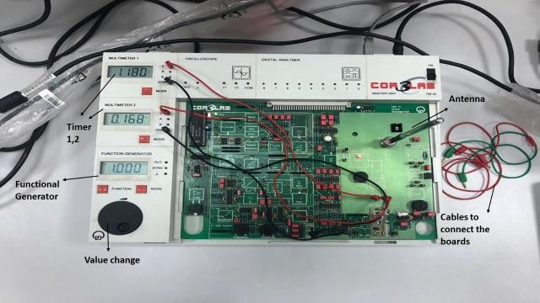

So, we started first experiment at this course using a simple transmission way.
- We connected a mobile phone with a board through Bluetooth technology.
- Through the experiment board, the signal was amplitudes.
- After that the signal transmitted through the antenna (wireless communication).
- So, the 2nd experiment board received the signal through another antenna (receiver).
- The 2nd board is has a decoder to decoding the signal and make is normal signal to be presented through the speaker.

The following are some of the most important pieces of measurement equipment used in transmission technology:
- Oscilloscope,
- Frequency counter,
- Spectrum analyzer
- Network analyzer
- Reflectometer
- SWR meter.

Amplitude Modulation (AM)

In communication world, modulation is defined as the process by which some characteristic of a carrier wave is varied in accordance with an information- bearing signal.
To simplified the meaning of AM, basically AM is a modulation technique used in electronic communication, most commonly for transmitting messages with a radio carrier wave. In amplitude modulation, the amplitude (signal strength) of the carrier wave is varied in proportion to that of the message signal, such as an audio signal.
AM was the earliest modulation method used for transmitting audio in radio broadcasting. It was developed during the first quarter of the 20th century beginning with Roberto Landell de Moura and Reginald Fessenden's radiotelephone experiments in 1900.

Generation of DSB-AM

In the following experiment the multiplication of 2 oscillations is investigated in the time and frequency domain.
- Carrier 10 kHz.
- Variable sine.
- Wave from the function generator.
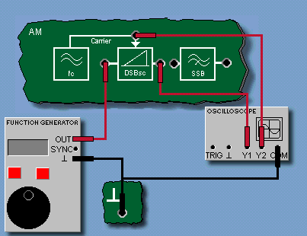

- Connect the function generator and the oscilloscope in accordance with the circuit diagram. Set the function generator to: DC, 1 V.
- Open the oscilloscope and measure the amplitudes of Y1 and Y2. Calculate the modulation coefficients kM and enter the result into the appropriate field. As the left input of the modulator is biased with 1 V DC.
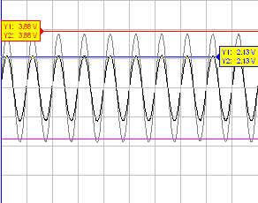

- Set the function generator to: Sine, 200 Hz, 10 Vpp. Open the oscilloscope and adjust the settings to view the curve (X/div = 0.5 ms).
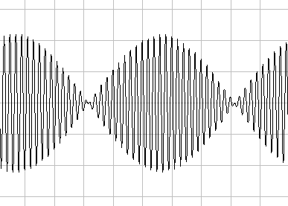
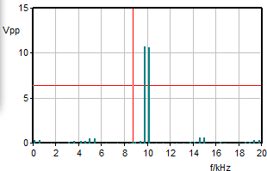

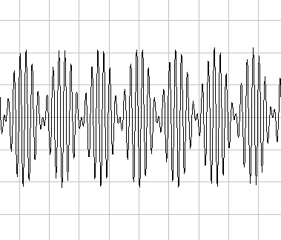
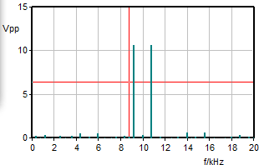
- Increase the frequency of the function generator up to 4 kHz in several steps and observe the changes in the curve displayed on the oscilloscope.

Frequency (780 Hz)

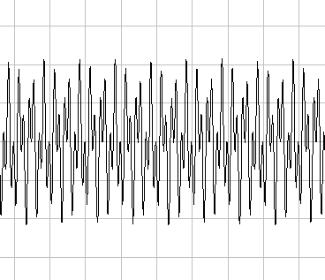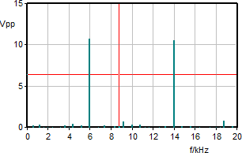
Frequency (4000 Hz)

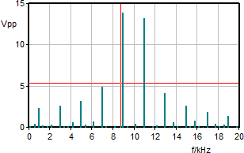
- Next, set the frequency of the function generator to 1 kHz and change the signal shape one after the other to Triangular and Square-wave.
- Remove the connection to the function generator and use a connecting lead to connect the Carrier socket to the input of the modulator. Observe the signal first with the oscilloscope and then the FFT module.
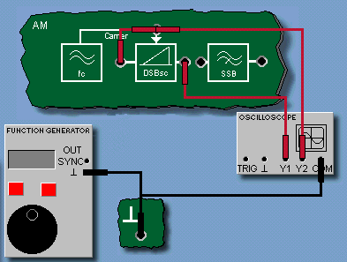

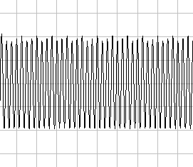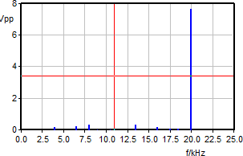

- Furthermore, connect the circuit as shown in the circuit diagram. AM transmitted carrier (full AM).
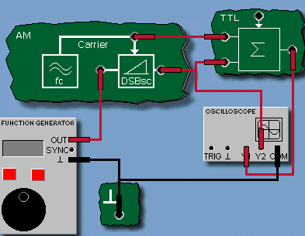

- Set the function generator to: Sine, 1 kHz, 10 Vpp, DC = 0 V. Open the oscilloscope and adjust it so that the curve characteristic is clearly displayed (X/div = 0.5 ms).
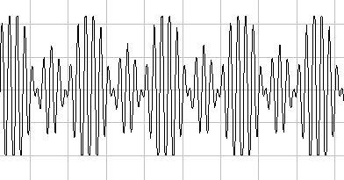
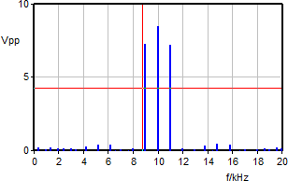

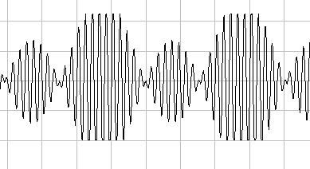
- Randomly vary the frequency setting of the function generator between 500 Hz and 2000 Hz and set the amplitude between 0 Vpp and 10 Vpp.

F=500Hz, V=10 Vpp
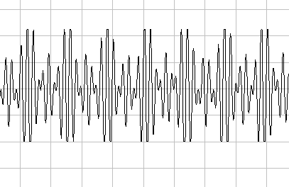
F=1500Hz, V=10 Vpp
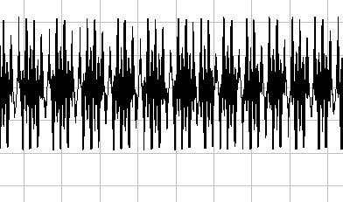
F=2000Hz, V=10 Vpp

F=1000Hz, V=5 Vpp
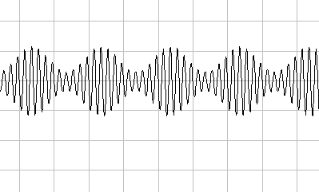
F=1000Hz, V=2 Vpp
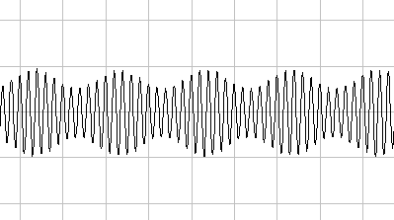
F=1000Hz, V=2 Vpp

- As shown in the circuit diagram remove the connection between the carrier and the upper input of the summation stage. The carrier should now disappear from the spectrum. Slowly increase the DC component to approx. DC = 2 V on the function generator. As a result the carrier reappears in the output signal.
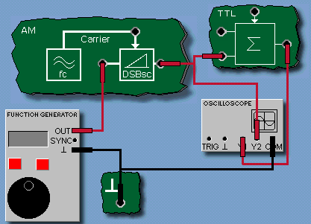

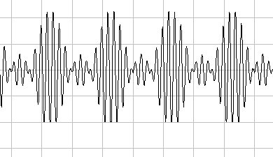

Frequency Modulation (FM)

It is the encoding of information in a carrier wave by varying the instantaneous frequency of the wave. The technology is used in telecommunications, radio broadcasting, and signal processing. Frequency modulation (FM) and phase modulation (PM) together form the group of angular modulation methods.
Frequently FM modulators are designed as voltage-controlled oscillators or VCOs.

In this experiment the static characteristic of the VCO is recorded. This depends on the middle frequency presetting using Frequency. Using the Amplitude controller the amplitude of the VCO output signal can be set.
- Connect the function generator and the oscilloscope to the experiment board according to the Figure above. Set the function generator initially to DC = 0 V.
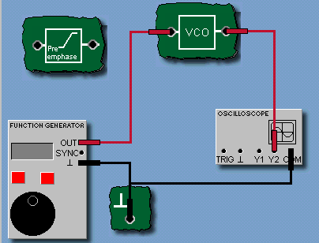

- Open the frequency counter. In the operating panel of the frequency counter set the Trigger to +Y2. Turn the Amplitude potentiometer to the far right stop (max). Set the Frequency potentiometer so that there is a frequency of approx. 10 kHz at the output.
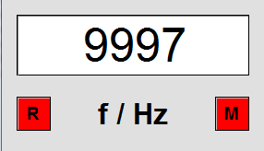

- Set a DC voltage of -10 V on the function generator. Open the characteristics plotter and enter the value pair (U, f) into its table. Increase the voltage at the VCO input in steps of 2.5 V until you reach 10 V and enter the measured value pairs into the Table. Then set the voltage at the input to 0 V.
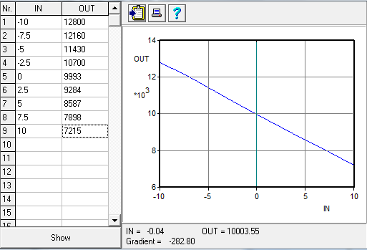

- Determine the modulation coefficient k in the region around Uin = 0 V based on the slope of the characteristic. Use the markers of the characteristics plotter to accomplish this task. Enter the result in the appropriate field. Make sure you note down the correct sign. K=-282.8.

Another experiment done related to the FM signal.
- Connect the function generator and the oscilloscope to the experiment board according to the above illustration. Set the function generator initially to DC = 0 V.
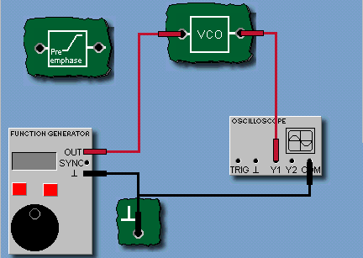

- Besides the oscilloscope, open the FFT module and set it to: Y1, f max=20 kHz. Start the measurement.
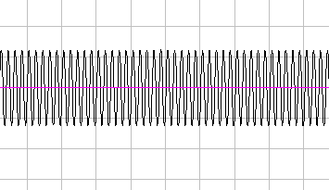
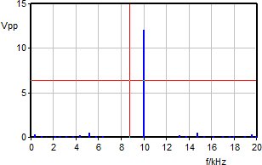

Input voltage=0 v DC

Amplitude-shift keying (ASK)
It is a form of amplitude modulation that represents digital data as variations in the amplitude of a carrier wave. In an ASK system, the binary symbol 1 is represented by transmitting a fixed-amplitude carrier wave and fixed frequency for a bit duration of T seconds. If the signal value is 1 then the carrier signal will be transmitted; otherwise, a signal value of 0 will be transmitted.
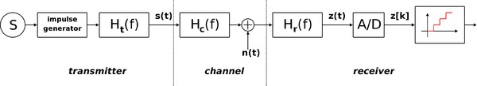
ASK diagram
ASK system can be divided into three blocks. The first one represents the transmitter, the second one is a linear model of the effects of the channel, the third one shows the structure of the receiver. The following notation is used:

- ht(f) is the carrier signal for the transmission
- hc(f) is the impulse response of the channel
- n(t) is the noise introduced by the channel
- hr(f) is the filter at the receiver
- L is the number of levels that are used for transmission
- Ts is the time between the generation of two symbols
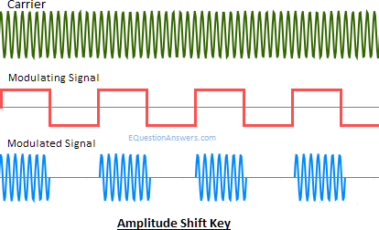

Phase shift-keying (PSK)
It is a digital modulation process which conveys data by changing (modulating) the phase of a constant frequency reference signal (the carrier wave). The modulation is accomplished by varying the sine and cosine inputs at a precise time. It is widely used for wireless LANs, RFID and Bluetooth communication.
In addition to the advantages found in FSK, PSK also benefits from a higher immunity to interference. In the experiment the PSK signal is produced by the operation of the AM modulator in conjunction with a pure AC signal. The spectrum of the PSK corresponds to that of a DSB-AM signal without carrier.
- Connect the function generator to the oscilloscope as specified in the circuit diagram.
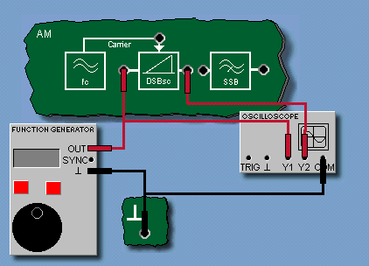
- Set the function generator to: curve shape square-wave, frequency 1kHz, amplitude 4 Vpp, 0 V DC, pulse duty cycle 50%.
- Open the oscilloscope and make the following settings: Curve Dual, X/div 100 μs, Y1/div = Y2/div = 5 V, Trigger Off. Start the measurement.
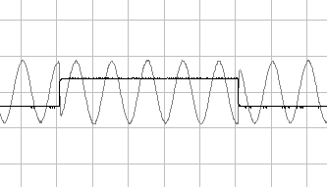
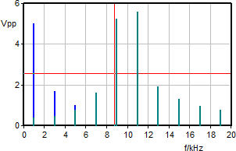
- Also open the FFT module and set it to: Y2, fmax = 20 kHz and then start the measurement.

Frequency shift-keying (FSK)
It is a frequency modulation scheme in which digital information is transmitted through discrete frequency changes of a carrier signal. The (binary) FSK transmits information at the discrete frequencies f1 and f2. Any lack of transmission signal must automatically be attributed to faulty transmission. FSK represents a special case of FM transmission. As such it has a similarly expanded and complicated spectrum. FSK is the preferred form of data transmission via the telephone system using modems. Regarding modems a distinction is drawn between the following operating modes:
- Simplex
- Duplex
- Half-duplex
The simplest FSK is binary FSK (BFSK). BFSK uses a pair of discrete frequencies to transmit binary (0s and 1s) information.
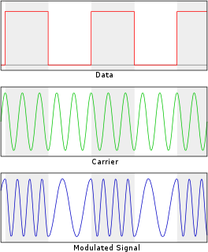
An example of binary FSK

The demodulation of a binary FSK signal can be done using the Goertzel algorithm very efficiently, even on low-power microcontrollers. The Goertzel algorithm is a technique in digital signal processing (DSP) for efficient evaluation of the individual terms of the discrete Fourier transform (DFT). It is

useful in certain practical applications, such as recognition of dual-tone multi- frequency signaling (DTMF) tones produced by the push buttons of the keypad of a traditional analog telephone.

- In the experiment, connect the function generator G1 and the oscilloscope to the experiment board as shown in the illustration above. First set the function generator to DC = 0 V.
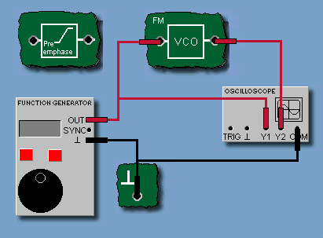
- Open the frequency counter. In the operating panel of the frequency counter set trigger to Y2. Turn the Amplitude potentiometer to the right far limit. Set the Frequency potentiometer so that a frequency of approx. 10 kHz is applied to the output.
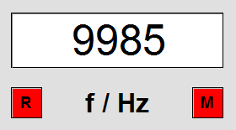

- Set the function generator as follows: square-wave, 1 kHz, 20 Vpp, DC = 0
V. Open the oscilloscope and set it to: X/div = 200 μs, Y1/div = Y2/div = 5 V, Curve Dual, Trigger Off. Start the measurement.
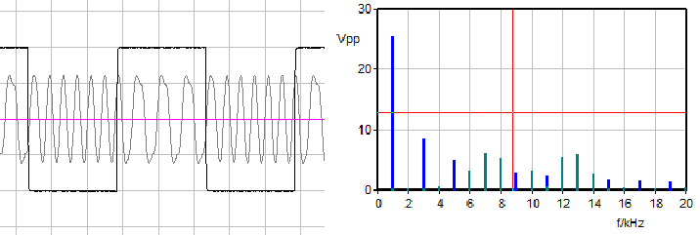
- In addition to the oscilloscope also open the FFT module and set it to: Y2, f max = 20 kHz and then start the measurement.

Quadrature amplitude modulation (QAM)
The family of digital modulation methods and a related family of analog modulation methods widely used in modern telecommunications to transmit information. It conveys two analog message signals, or two digital bit streams, by changing (modulating) the amplitudes of two carrier waves, using the amplitude- shift keying (ASK) digital modulation scheme or amplitude modulation (AM) analog modulation scheme. The two carrier waves of the same frequency are out of phase with each other by 90°, a condition known as orthogonality or quadrature. The transmitted signal is created by adding the two carrier waves together. At the receiver, the two waves can be coherently separated (demodulated) because of their orthogonality property. Another key property is that the modulations are low-frequency/low-bandwidth waveforms compared to the carrier frequency, which is known as the narrowband assumption.
QAM is used extensively as a modulation scheme for digital telecommunication systems, such as in 802.11 Wi-Fi standards. High spectral efficiencies can be achieved with QAM by setting a suitable constellation size, limited only by the noise level and linearity of the communications channel. QAM is being used in optical fiber systems as bit rates increase; QAM-16 and QAM-64 is evolutions of the QAM family.
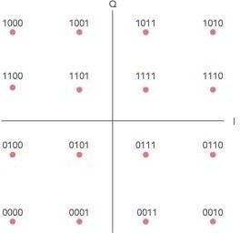
Bit sequence mapping for a 16QAM signal
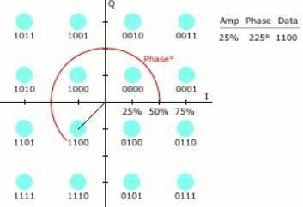
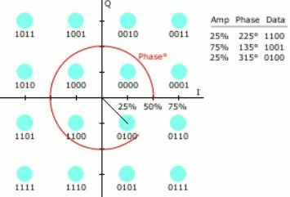
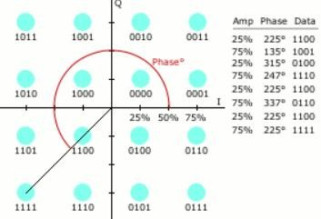
Digital 16-QAM with example constellation points

