Lab 5

Student Name
Institution Affiliations
Course
Instructor Name
Date

- +37°00’
- Yes it matches the latitude.
- Also known as Cas. (Ra/Dec 01h 01m00.5s +60°03'17.4" Az/Alt 027°43'47.6" +19°58'01.9" Visibility; always visible tonight).
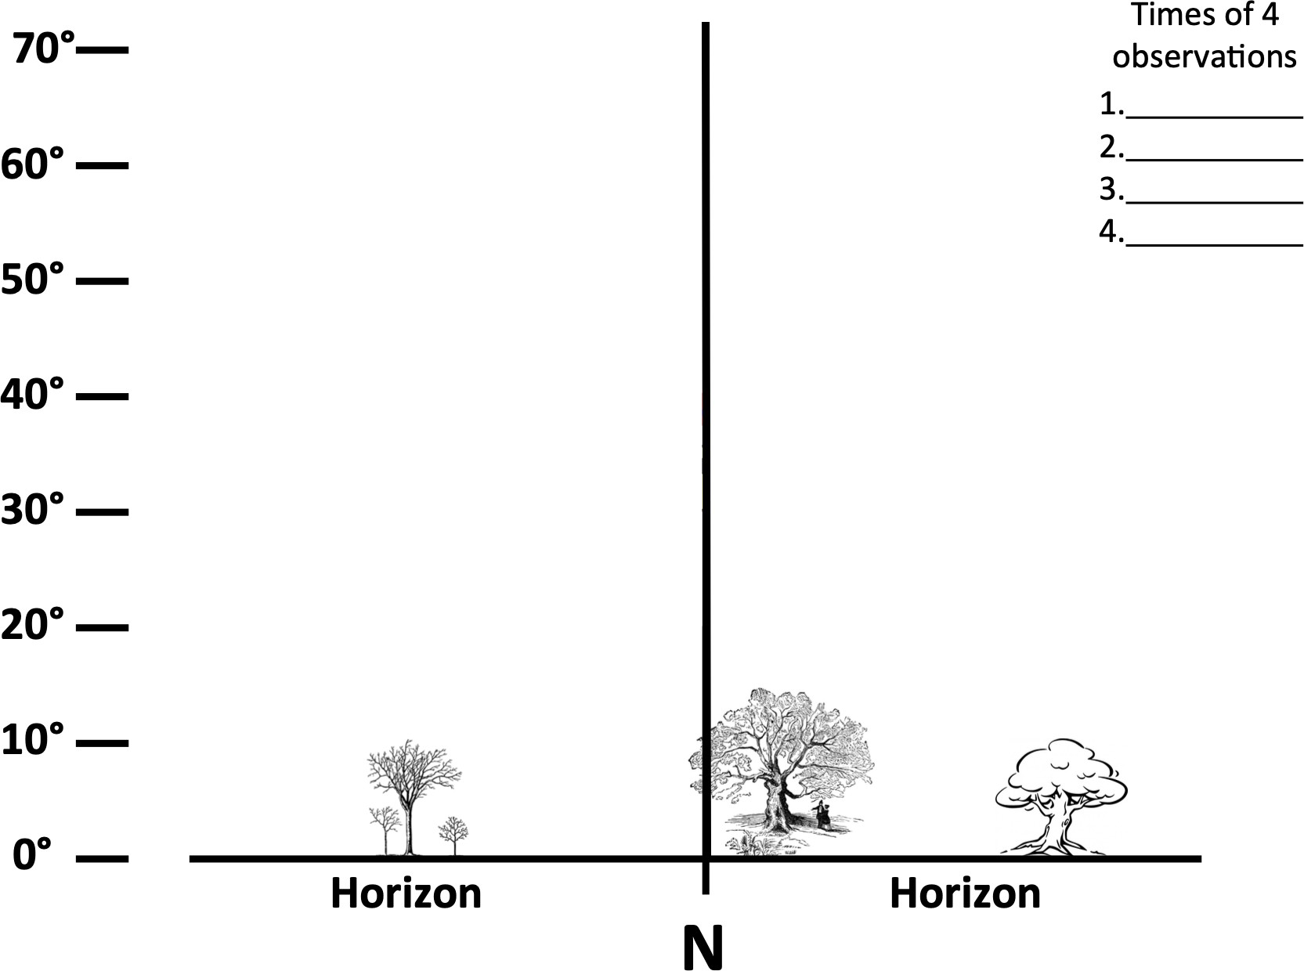
Cassiopeia is a constellation in the northern sky, named after the vain queen Cassiopeia in Greek mythology, who boasted about her unrivaled beauty.

Times of Observation: 2200h, 0400h, 1000h, 1600h
- Each star of the Cassiopeia traces out a circular parttern.
- Anticlockwise
- Yes. Polaris does not move at all.
- Stars are moving in a clockwise motion on the southern sky.
- All stars are moving none is stationery
- Southwest
- It sets due west.
- South
The prediction is 12hours. The constellation took approximately 12 hours to return to its original position. My prediction was good.

Tracking the Sky with a Star Wheel
2. June 18th 2020.
3. August 4th 2020.
4. 0900h
5. Anticlockwise
6. Clockwise
7. a) 0900h
b) You need to look East to see Orion rising.
c) No.
8. a) North East
b) Altair will set first. It will set in the West at 1100h.
c) Deneb will set last at 1500h in the North.
9. a) North East
b) 1000h
c) East.
d) 1200h
10. a) North.
11. a)0600h
b) South East
c) 1600h
d) South West

