Lab08
- The technical operations department of an Internet Service Provider (ISP) wants to ensure that the mean target upload speed for all Internet service subscribers is at least 0.97 on a standard scale in which the target value is 1.0. The data set “AMS9.csv” represents the upload speed measured 50 times in a day.
  - What type of test should we use?

One sample t test

  - At the 0.10 level of significance, can you test whether the mean upload speed is less than 0.97? Please plot the following graph as shown. What is the absolute value of the critical point?
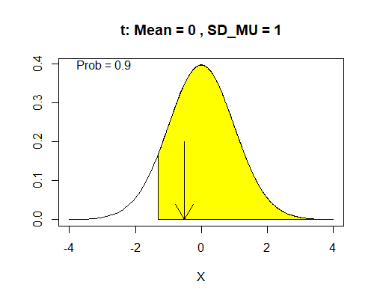
Let 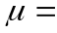mean upload speed for all Internet service subscribers
H₀: 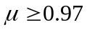
H_{A}: 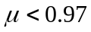

The absolute value of the critical point is |-1.2991| = 1.2991.

data1 = read.csv(file.choose(), header= TRUE) # Upload data set
upload.speed = data1$Upload.Speed
t.stat = (mean(upload.speed)-0.97)/(sd(upload.speed)/sqrt(length(upload.speed)))
t.stat
-0.5113981
x <- c(-3,seq(-3,t.stat,0.01),t.stat)
y<-c(0,dt(seq(-3,t.stat,0.01),df=49),0)
curve(dt(x,df=49),xlim=c(-3,3))
polygon(x,y,col="yellow")

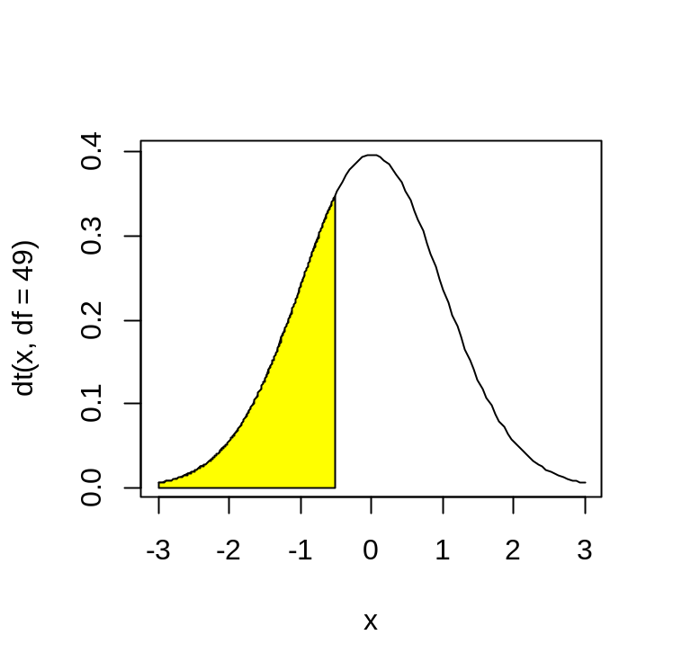

  - Can you confirm your conclusion in part a using p value approach? Can you also replicate p value from t.test using the pt function?

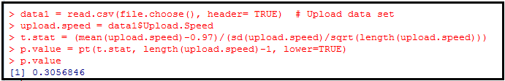
data1 = read.csv(file.choose(), header= TRUE) # Upload data set
upload.speed = data1$Upload.Speed
t.stat = (mean(upload.speed)-0.97)/(sd(upload.speed)/sqrt(length(upload.speed)))
p.value = pt(t.stat, length(upload.speed)-1, lower=TRUE)

Output:
0.3056846

The p-value is greater than the alpha level of 0.10 so we do NOT reject the null hypothesis.
Given a p-value of 0.3057, there is NO evidence that the mean upload speed is less than 0.97.

  - Can you confirm your conclusion in part a using CI approach? No need to use CI function from Question 1. You can use result generated from t.test directly.

t.test(upload.speed, conf.level = 0.90)
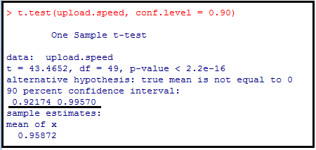

The 90% confidence interval (0.92174, 0.99570) contains 0.97. Therefore, the mean upload speed is NOT significantly different from 0.97 at 10% level of significance.

t.test(upload.speed, conf.level = 0.90, alternative = "less")
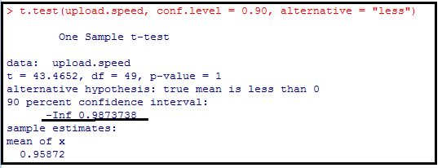

In addition, the one-sided 90% confidence interval (-inf, 0.98737) contains 0.97. Therefore, the mean upload speed is NOT significantly less than 0.97.

- Bioboom today identified the top Biomed startup firms in 10 geographic regions across the United States. A characteristic description of the Biomed startup firms in the Southeast and Gulf Coast regions included the number of partners in the firm (“BRPartners2.csv”). We can assume the variance between two populations are equal. We want to test whether the mean numbers of partners between the two regions are different.
  - What type of test should we use?

2-Sample t-Test

  - At the 0.05 level of significance, can you graph the critical value approach?
The critical values are -2.045 and 2.045.

> qt(.975,length(SE)+length(GC)-2)
[1] 2.04523
x1 <- c(-3,seq(-3,qt(.025,length(SE)+length(GC)-2),0.01),qt(.025,length(SE)+length(GC)-2))
y1<-c(0,dt(seq(-3, qt(.025,length(SE)+length(GC)-2),0.01),df=29),0)

x2 <- c(qt(.975,length(SE)+length(GC)-2),seq(qt(.975,length(SE)+length(GC)-2),3,0.01),3)
y2<-c(0,dt(seq(qt(.975,length(SE)+length(GC)-2),3,0.01),df=29),0)

curve(dt(x,df= length(SE)+length(GC)-2),xlim=c(-3,3))
polygon(x1,y1,col="yellow")
polygon(x2,y2,col="yellow")

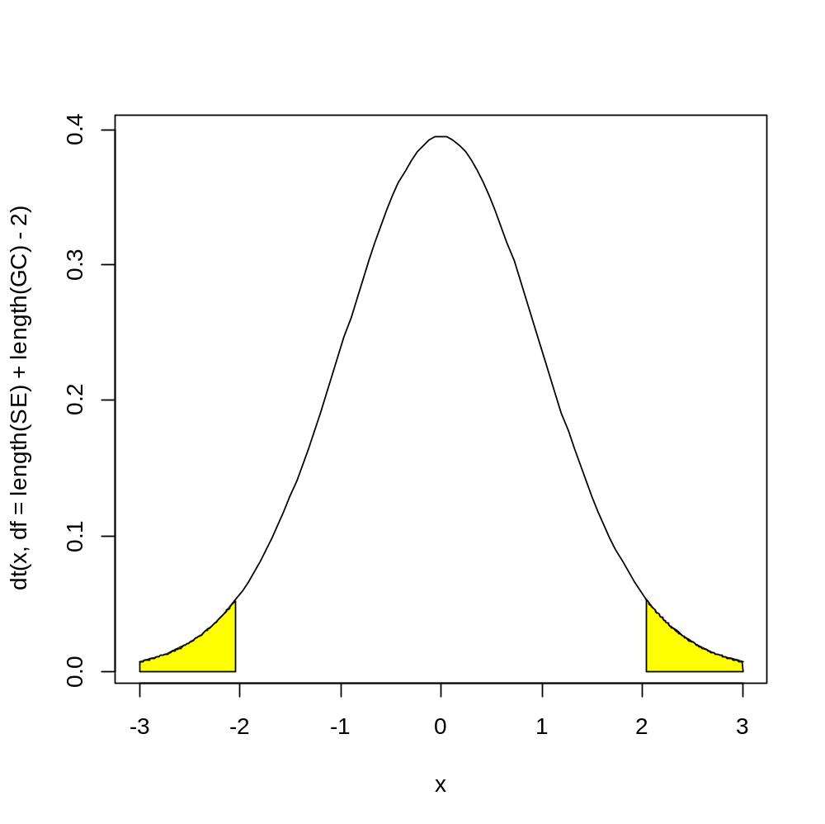

  - Can you carry out the same test using p value approach and duplicate the p value from t.test?

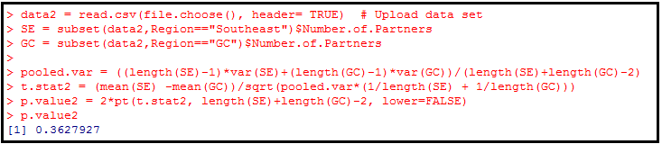
data2 = read.csv(file.choose(), header= TRUE) # Upload data set
SE = subset(data2,Region=="Southeast")$Number.of.Partners
GC = subset(data2,Region=="GC")$Number.of.Partners

pooled.var = ((length(SE)-1)*var(SE)+(length(GC)-1)*var(GC))/(length(SE)+length(GC)-2)
t.stat2 = (mean(SE) -mean(GC))/sqrt(pooled.var*(1/length(SE) + 1/length(GC)))
p.value2 = 2*pt(t.stat2, length(SE)+length(GC)-2, lower=FALSE)
p.value2

Output:
0.3627927

The p-value is greater than the alpha level of 0.05 so we do NOT reject the null hypothesis.
Given a p-value of 0.3628, there is NO evidence that the mean numbers of partners between the two regions are different.

  - Can you carry out the same test using CI approach?
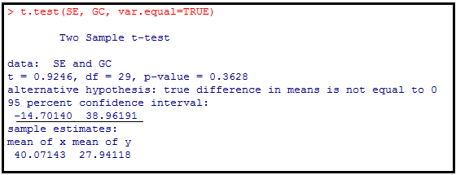

t.test(SE, GC, var.equal=TRUE)

The 95% confidence interval for the difference in means is (-14.70, 38.96) and this contains zero. Therefore, there is NO significant difference in mean number of partners between the two regions.

- The variable of interest is defined as the reported pain relieving time, in minutes, from the time the medication is taken to the time a patient reports positive response. Data are in “ReTime.csv”. We can assume the variance between two populations are equal. We want to determine the response time of A is shorter than B.
  - What type of test should we use?
2-Sample t-Test

  - At the 0.10 level of significance, can you graph the critical value approach?

data3 = read.csv(file.choose(), header= TRUE) # Upload data set
A = subset(data3,Med=="A")$Time
B = subset(data3,Med=="B")$Time

> qt(.10,length(A)+length(B)-2)
[1] -1.330391

x1 <- c(-3,seq(-3,qt(.10,length(A)+length(B)-2),0.01),qt(.10,length(A)+length(B)-2))
y1<-c(0,dt(seq(-3, qt(.10,length(A)+length(B)-2),0.01),df=length(A)+length(B)-2),0)

curve(dt(x,df= length(A)+length(B)-2),xlim=c(-3,3))
polygon(x1,y1,col="yellow")

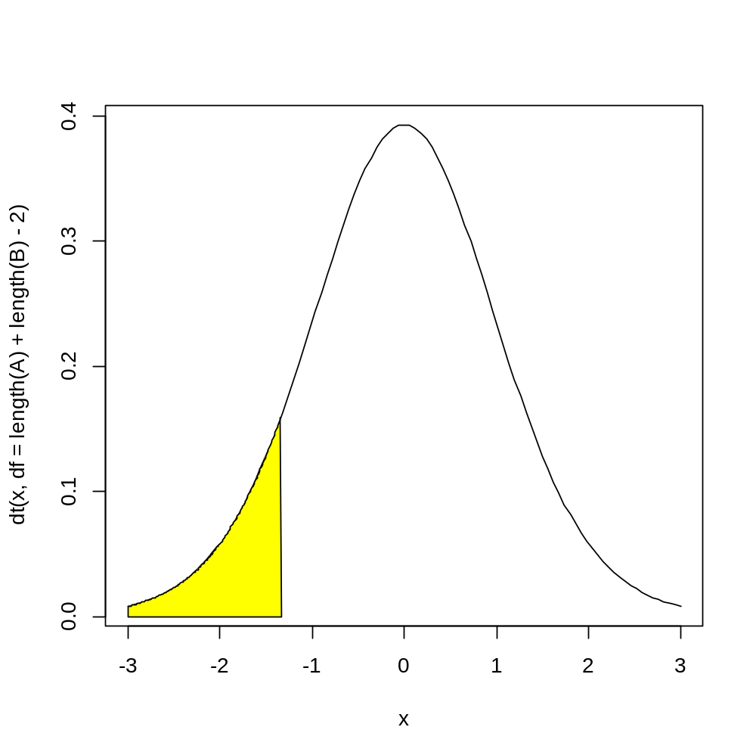
Reject H0 if test stat is less than -1.33

  - Can you carry out the same test using p value approach and duplicate the p value from t.test?

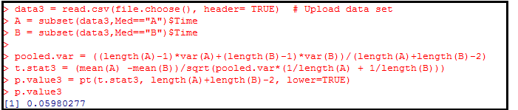
data3 = read.csv(file.choose(), header= TRUE) # Upload data set
A = subset(data3,Med=="A")$Time
B = subset(data3,Med=="B")$Time

pooled.var = ((length(A)-1)*var(A)+(length(B)-1)*var(B))/(length(A)+length(B)-2)
t.stat3 = (mean(A) -mean(B))/sqrt(pooled.var*(1/length(A) + 1/length(B)))
p.value3 = pt(t.stat3, length(A)+length(B)-2, lower=TRUE)
p.value3

Output:
0.05980277

The p-value is less than the alpha level of 0.10 so we reject the null hypothesis.
Given a p-value of 0.0598, there is slightly suggestive evidence that the response time of A is shorter than B.

  - Can you carry out the same test using CI approach?

t.test(A, B, var.equal=TRUE, conf.level = 0.90, alternative = "less")
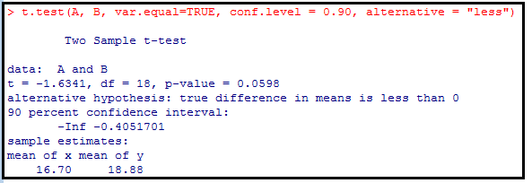

The one-sided 90% confidence interval (-inf, -0.4051) and less than zero. Therefore, the response time of A is significantly shorter than B at 10% level of significance.

- Multiple myeloma, or blood plasma cancer, is characterized by increased blood vessel formulation (angiogenesis) in the bone marrow that is a predictive factor in survival. One treatment approach used for multiple myeloma is stem cell transplantation with the patient’s own stem cells. The data stored in “Myeloma.csv” represent the bone marrow microvessel density for patients who had a complete response to the stem cell transplant (as measured by blood and urine tests). The measurements were taken immediately prior to the stem cell transplant and at the time the complete response was determined. We want to determine whether the mean bone marrow microvessel density is higher before the stem cell transplant than after the stem cell transplant.
  - What type of test should we use?

Matched Pairs t test

  - At the 0.01 level of significance, can you graph the critical value approach?

data4 = read.csv(file.choose(), header= TRUE) # Upload data set
Before = subset(data4,Time=="Before")$Density
After = subset(data4,Time=="After")$Density
difference = Before-After

> qt(.99,length(difference)-1)
[1] 3.142668

x2 <- c(qt(.99,length(difference)-1),seq(qt(.99,length(difference)-1),4,0.01),4)
y2<-c(0,dt(seq(qt(.99,length(difference)-1),4,0.01),df=length(difference)-1),0)

curve(dt(x,df= length(difference)-1),xlim=c(-4,4))
polygon(x2,y2,col="yellow")
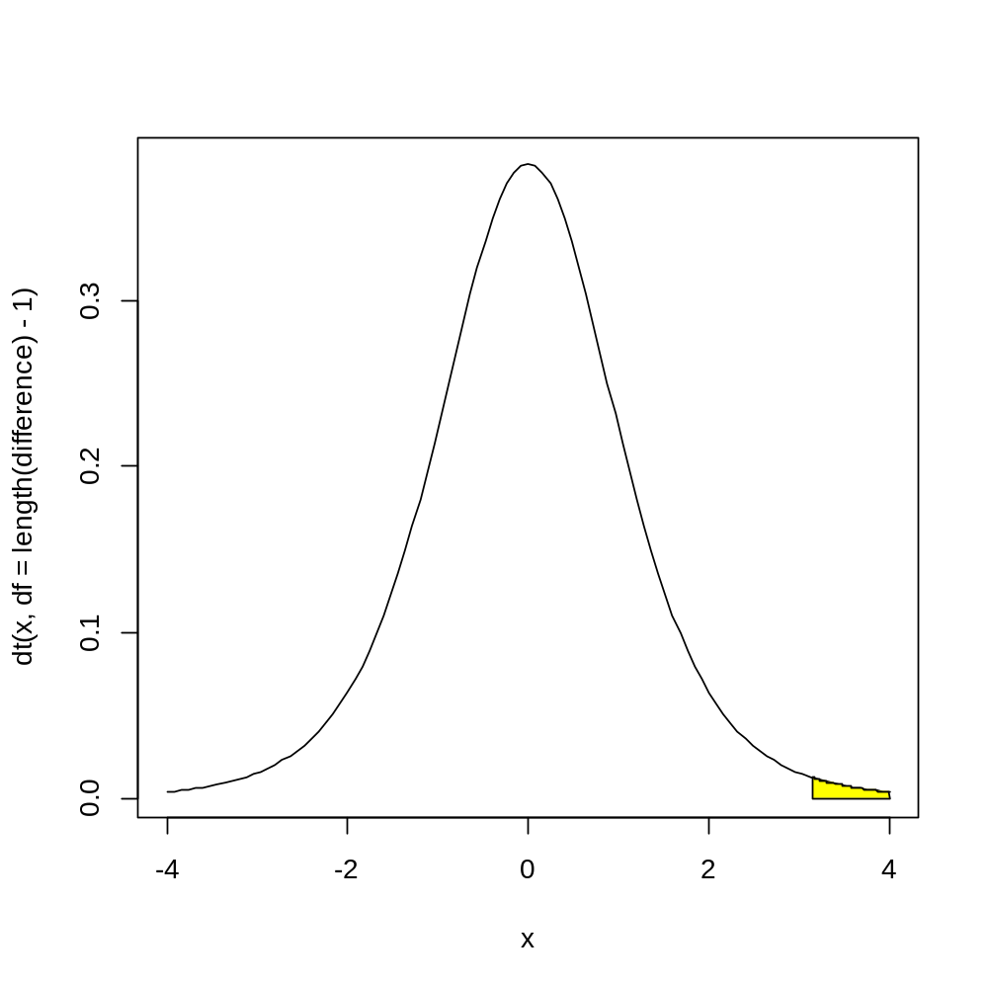
Reject Ho of test stat is greater than 3.1427, otherwise do NOT reject.

  - Can you carry out the same test using p value approach and duplicate the p value from t.test?

data4 = read.csv(file.choose(), header= TRUE) # Upload data set
Before = subset(data4,Time=="Before")$Density
After = subset(data4,Time=="After")$Density
difference = Before-After
t.stat4= (mean(difference))/(sd(difference)/sqrt(length(difference)))
p.value = pt(t.stat4, length(difference)-1, lower=FALSE)

Output:
0.05749313

The p-value is greater than the alpha level of 0.01 so we do NOT reject the null hypothesis.
Given a p-value of 0.05749, there is NO evidence that the mean bone marrow microvessel density is higher before the stem cell transplant than after the stem cell transplant

  - Can you carry out the same test using CI approach?

t.test(difference, conf.level = 0.99)
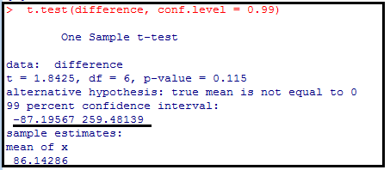

The 990% confidence interval (-87.19567, 259.48139) and contains zero. Therefore, the mean bone marrow microvessel density before and after the stem cell transplant are NOT significantly different.

t.test(difference, conf.level = 0.99, alternative = "greater")
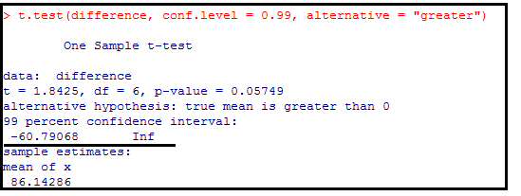
In addition, the one-sided 99% confidence interval (-60.79068, inf) contains zero. Therefore, the mean bone marrow microvessel density before is NOT significantly higher after the stem cell transplant.

