Lab 9: Spring Constant
Name: Farooq Ahmodu
PSY 2001

Objective:
To determine spring constant of a spiral spring.

Procedure:

Computer simulated lab:
https://phet.colorado.edu/sims/html/masses-and-springs-basics/latest/masses-and-springs-basics_en.html

It displays two springs, but you only need to use one of them. Set the “spring strength” to small and attach the 50g mass. Activate “unstretched length” and “resting position” markers in the upper right corner; and click the “play” button (bottom right). Use the provided ruler to measure by how much the spring extends when the mass is attached and compute the spring constant k = F/x, where F=mg is the weight of the attached object.
Repeat for the 100g and 250g masses. Confirm that you obtain the same k for all masses (Hooke’s law), within measurement errors; the value of k should be quoted in N/m. This tests the linear relation of the force of the spring to displacement. Now set the “spring strength” to large and repeat the above steps.
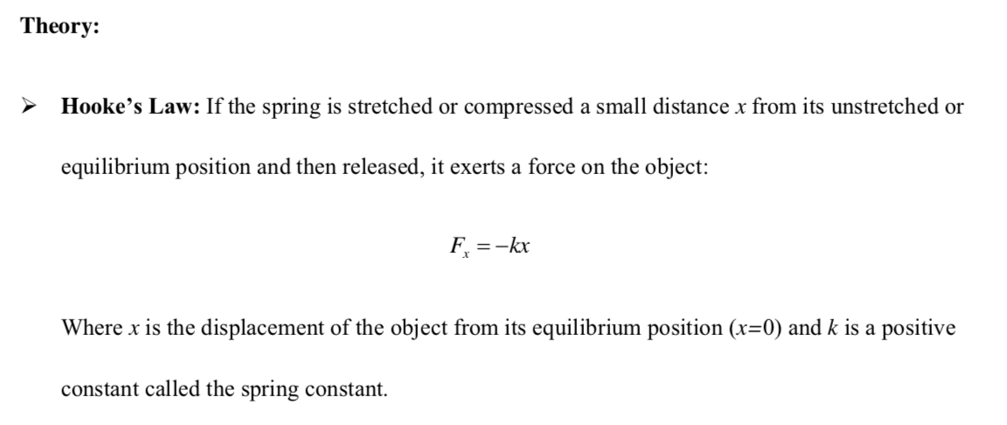

Experimental data:
Small Spring Strength
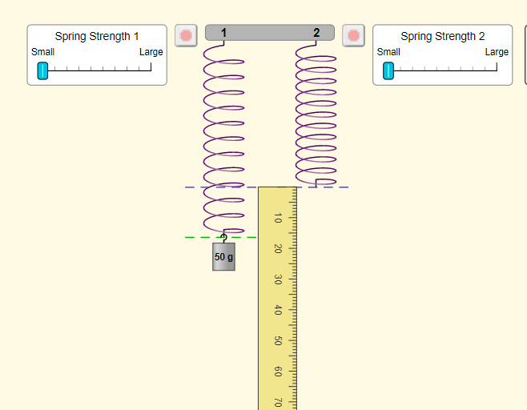
Fig1 :50g stretch

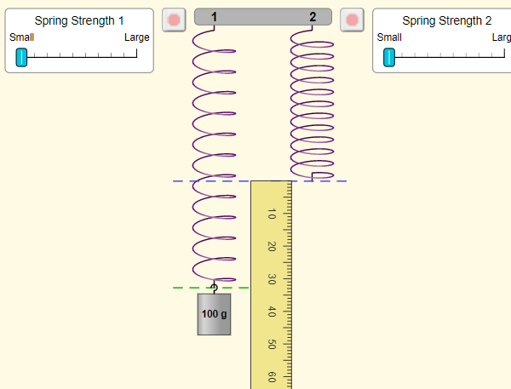
Fig2 :100g stretch
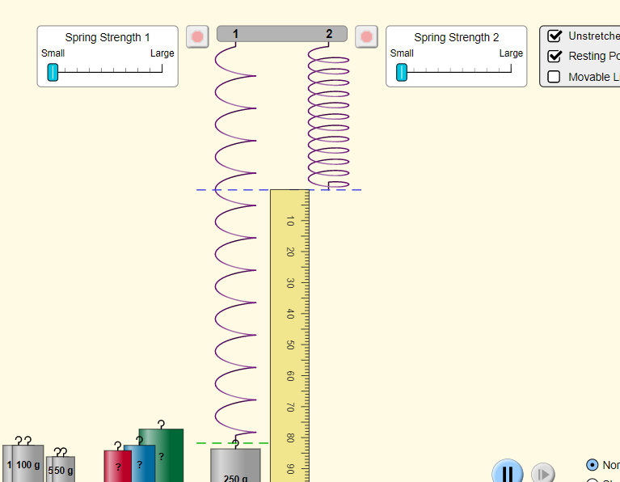

Fig3 :250g stretch

Masses | Stretch
50g | 16cm
100g | 32cm
250g | 80cm

Large Spring Strength
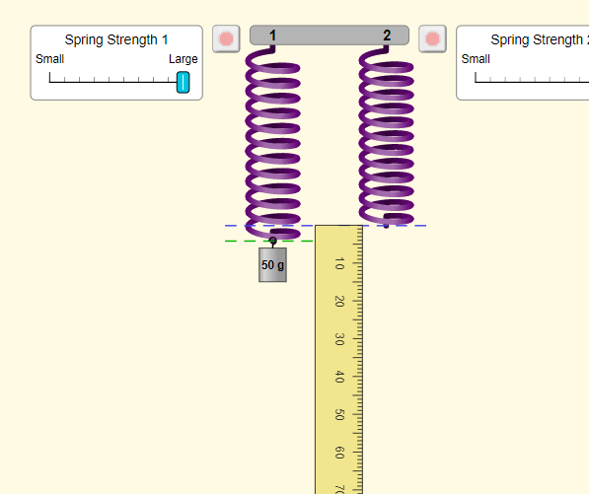
Fig4 :50g stretch
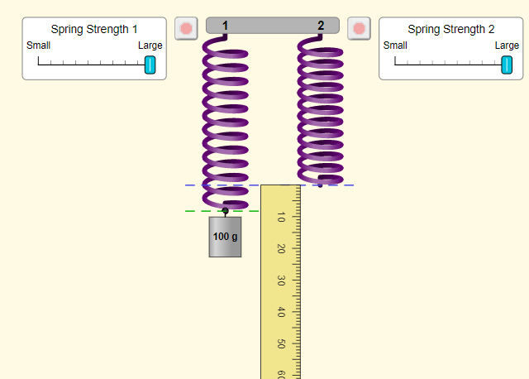
Fig5 :100g stretch
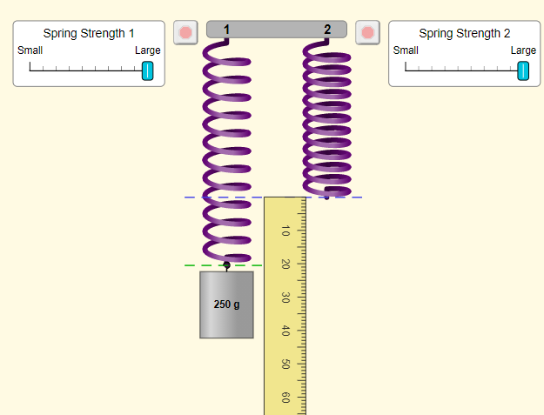
Fig6 :250g stretch

Masses | Stretch
50g | 5cm
100g | 10cm
250g | 20cm

Calculations and Error Analysis:
Small Spring Strength
Masses | Stretch | F = m*g | spring constant k = F/x
50g = 0.05kg | 16m = 0.16m | 0.4905 N | = $\frac{0.4905}{0.16}$ = 3.065 N/m
100g = 0.1kg | 32m= 0.32m | 0.981 N | = $\frac{0.981}{0.32}$ = 3.065 N/m
250g = 0.25kg | 80m= 0.80m | 2.4525 N | = $\frac{2.4525 }{0.81}$ = 3.065N/m
 |  | Average | = 3.065 N/m

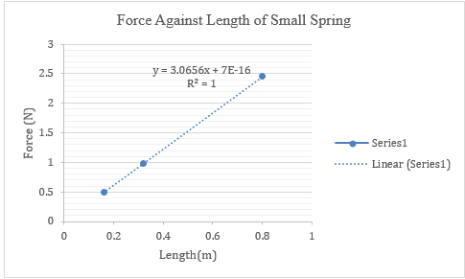

Large Spring Strength
Masses | Stretch | F = m*g | spring constant k = F/x
0.05 | 0.05 | 0.4905 | 9.81N/m
0.1 | 0.1 | 0.981 | 9.81N/m
0.25 | 0.2 | 2.4525 | 12.2625N/m
 |  | Average | 10.63N/m

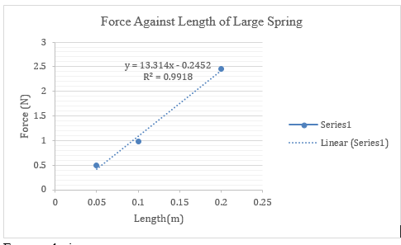
Error analysis

 | Calculated Spring Constants | % difference = $\frac{value-average}{average}*100\%$
Small Spring
Average k = 3.065 N/m
 | 3.065N/m | 0%
 | 3.065 N/m | 0%
 | 3.065 N/m | 0%
Large Spring
Average k = 10.63N/m
 | 9.81N/m | 7.71%
 | 9.81N/m | 7.71%
 | 12.2625N/m | 15.35%

Conclusion:

The experiment was conducted with success. The results shows that indeed the relationship between force and length is linear in that there is a direct proportionality between force and length of a spring. The slope of the graph presents the spring constant which is the ratio between force and the stretch. Error difference of the small spring strength is zero which shows that there is some consistency in this first experiment. The second experiment is that of large spring strength and the error difference is consistent for two trials and then it doubles in the next trial. This shows that that in the last trial, there was a larger spring constant because the spring stretched reached its threshold and stopped obeying Hooke’s law.

