BUSI 820

Students Name Quantitative Research Methods
Assignment 3 University of Affiliation School of Business
19 July 2021

Table of content pages
A3.1: Chapter 5, Problem 5.1, Math Courses Taken 3
A3.1. a. Narrative of Process 3
A3.1. b. Interpretation of Findings 3
A3.2: Chapter 5, Problem 5.2, Relabel and Recode Mother’s and Father’s Education 3
A3.2. a. Narrative of Process 3
A3.2. b. Interpretation of Findings 4
A3.3: Chapter 5, Problem 5.3, Compute and Recode Students Pleasure Scale Score 5
A3.3. a. Narrative of Process 5
A3.3. b. Interpretation of Findings 6
A3.4: Chapter 5, Problem 5.4, Compute Parent’s Revised Education and the Mean 6
A3.4. a. Narrative of Findings 6
A3.4. b. Interpretation of Findings 7
A3.5: Chapter 5, Problem 5.5, Errors and Normality check for the New Variables 7
A3.5. a. Narrative of Process 7
A3.5. b. Interpretation of Findings 9
A3.6, Application Problem ‐ Managing Data 9
References 15

Assignment 3

A3.1: Chapter 5, Problem 5.1, Math Courses Taken

A3.1. a. Narrative of the Process

For this problem, I used hsbdata.sav. I clicked on transform, followed by count values contained in the causes. First, I entered mathers as the target variable. The next step, I typed math courses that had been recorded in the Target Label Box. I then chose five math’s courses and added them to the Numeric variables. To define values, I allocated 1 as the value to be counted and clicked continue, followed by OK.

Output 5.1: Counting Math Courses Taken

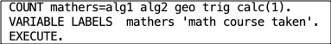

A3.1. b. Interpretation of the Findings

From the findings, we see that there are no tables or figures for this output and has a syntax A. A new column of mathers was added with participants 1, 2, and 3 having similar value 0 for the alg1, alg2, geo, trig, and calc columns. The results after running the descriptive statistics were; 59 students did maths, 16 students only did a single math course, and 8 students did all the five courses. Most of the other students did two or more math courses.

A3.2: Chapter 5, Problem 5.2, Relabel and Recode Mother’s and Father’s Education A3.2. a. Narrative of the Process
Making use of the hsbhdataset, I clicked on transform and the recode into different variables. I did this to relabel and give a new name for the documented values. It caused a new

window to appear, which contained all the variables that I would want to recode. From the variables on the left side, I chose the mother’s education and father’s education and moved them to the numeric variables box. Doing this permitted me to name the recorded variables faedRevis and maedRevis and put in new labels mother’s Educ revised and father’s Educ revised. I then clicked change, Old and New values. I was able to change old values to new values and chose how I wanted them to be recorded. I then chose the Range and allocated them accordingly. On c I finished, I clicked continue and then OK (Leech et al., 2005).

Frequencies

Table 1: Statistic Tables
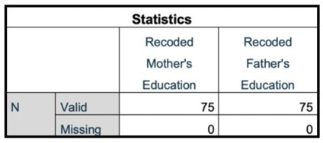

Table 2: Frequency Table for Mother’s Educ Revised
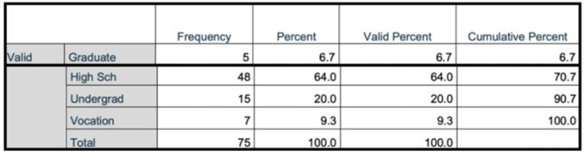
Table 3: Frequency Table for Father’s Educ Revised
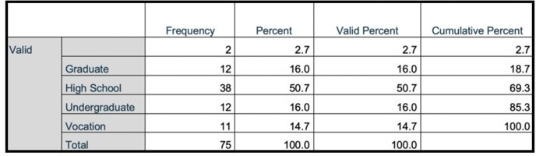

A3.2. b. Interpretation of the Findings

For the students who had valid data and those who had missing data is displayed by the first frequency table. However, there is no missing data. The second table shows the revised mother’s frequency distribution for the education variable. The mothers who a higher education or less was 64%. The father’s education distribution is shown on the third table, in which 50.7% of the fathers had higher education or less. The three tables indicate that all the data for both father’s and mother’s education has been entered. From the three tables, we see that a high number of parents, both fathers, and mothers, have attended high school. At the graduate level, however, a great difference between the mothers' and fathers' education is seen. The mothers have 6.7% while the fathers have 16.0%. Fathers have attended graduate-level education more than the mothers have.

A3.3: Chapter 5, Problem 5.3, Compute and Recode Students Pleasure Scale Tally in life A3.3. a. The Narrative of the Process

To recode and compute the pleasure scale score average, I followed this process; I clicked on Transform, then on recode into Different Variables, and then I clicked on Reset. A new window opened that contained all the variables that I would want to recode. A new window was opened that contained all the variables that I would want to recode. I then selected item06 from the list variable on the left and transferred it to the input variable using the right arrow key. I made use of the output variable item to name the recoded variable item06r. In the label box, I entered item06 reversed and finally clicked on change. I then repeated the same process with item 10. I clicked on the Old and New values segment to enter new data. A new window popped up that allowed me to specify the values and choosing how I would want to record them. To modify the values and allocate them new values, I used the default inputs.

Output 5.3a: Computing and Recoding Pleasure Scale Score
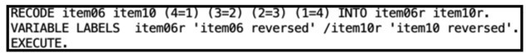
Output 5.3b: Computation of Pleasure Scale
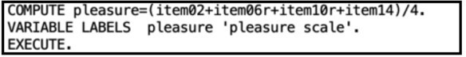
Table 4: Statistics
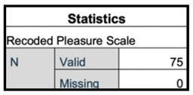

Table 5: Recoded Pleasure Scale
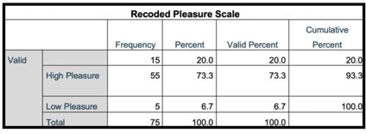

A3.3.b. Interpretation of the Findings

Interpreting the findings, we see that all the data was entered, and no data was missing; we can easily identify from the recorded Pleasure table that the highest number of students had a high pleasure. Only five of the students did not see the pleasure life offers.

A3.4: Chapter 5, Problem 5.4, Calculate Parent’s Revised Education and the Mean Function
A3.4.a. Narrative of the Process

I clicked on Transform followed by Compute, and reset to compute parents' education with the mean function. On the Target Variable box, I typed parEduc. To define the new variables parents’ education, I used the Type & Label and then clicked continue. In the Functions and Special Variables box, I highlight Mean and clicked the up arrow into the Numeric Manifestation box. Doing this enabled me to enter and feed with brackets and a comma between the variables. I then clicked OK. I then labeled the lowest and highest values using the variable view. I used the parents’ education variable row to add to the different values I wanted. Then I clicked OK. For any participant who has a score of any of the variables in use, the Mean function computes the average score of each participant. Next, I clicked on Analyze on the main menu and selected Descriptive Statistics, and then I selected Descriptives. I chose the newly created variable from the new window and clicked OK, which in turn generated the descriptive statistics (Morgan et al., 2013).

Output 5.4: Computation of Parents’ Education

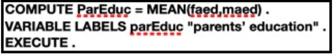

Table 6. Descriptive Statistics
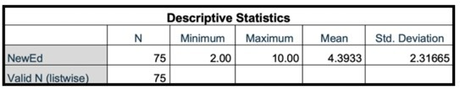

A3.4.b. Interpretation of the Findings

The mean is 4.3933, according to the findings. To interpret this, most parents have not had the opportunity to attend doctoral or master classes. The same value can, however, be used to indicate that most parents have attained a high school education

A3.5: Chapter 5, Problem 5.5, Errors and Normality check for the New Variables A3.5. a. Narrative of the Process

I used Descriptive statistics to check for errors sand normality of the New Variables. To do this, I went to the Analyze section on the main menu, then clicked Descriptive statistics and finally clicked on explore. I then selected the new variables that had been generated in the previous question s and put them on the Dependent list. I then selected plots from the pop-up window and checked on the Normality plots with tests and clicked continue generating the outputs.
Table 7: Case Processing Summary
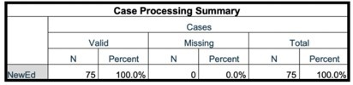
Table 8: Descriptive Statistics

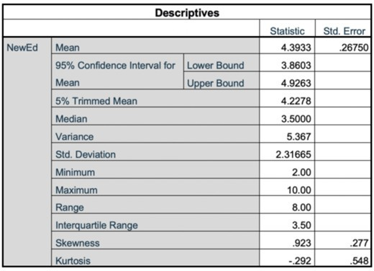

Table 9: Tests of Normality
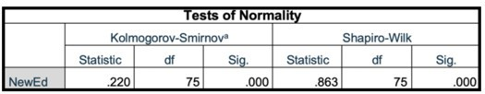
Figure 1: Normality Test for NewEd
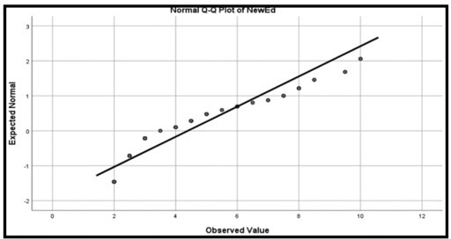

A3.5. b. Interpretation of the Findings

The above tables and figures represent the results, which can also be used to check for errors and normalities for the new variables. By interpreting the findings, we see that the program runs two types of normality tests. The Sharpio-Wilk test is used when the data set is less than 2000 values, and the Kolmogorov-Smirnov test is used when the elements are more than

2000 (Ghasemi& Zahediasl, 2012). For instance, in this particular case, we only have 75 values in the data set, and the Shapiro-Wilk test was applied. Looking from A, the p-value is 0.000, and through interpreting the findings, the data assumes a normal distribution. Observing the Normal Q-Q Plot of NewEd, it also assumes a normal distribution. As indicated along the line, the data follows a normal distribution.

A3.6, Application Problem ‐ Managing Data

- Calculate a new variable labeled “average overall evaluation” (aveEval) by computing the average score (evalinst + evalprog + evalphys + evalsoc)/4.
Narrative of the Process

To compute a new variable labeled “average overall evaluation,” I followed the following process; first, I went to the Transform tab and then clicked on Compute Variable. I went on to type aveEval on the Target variable name, which is on the new window. From there, I was able to express the numeric expression as SUM (evalinst, evalprog, evalphys, evalsoc)/4 to calculate the average Then, I clicked OK to calculate. It then enabled me to run the frequency descriptive es (McKendrick, 2003).

Table 10: Statistics for the Average
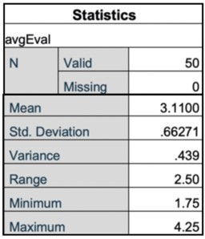

Table 11: Frequency Distribution for average evaluation

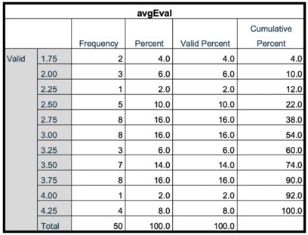

Interpretation of the Findings

From the above table, we can induce that the mean for the average overall evaluation is

3.11. It means most students have an average evaluation of all four variables. This is to means that students have a positive perspective on their main facilities. 38% of the students scored below 3.0, and 62% of the students scored 3.0 and above.

Calculate a similar variable (meanEval) using the Mean function. Compare with the aveEval score and discuss why they differ.
Narrative of the Process

To calculate the mean, I applied the following process; I began on the Transform Tab on the main menu, then clicked on Compute Variable, a new window appeared, and on it, I typed meanEval in the Target Variable name. Doing this allowed me to express the numeric expression as Mean (evalinst, evalprog, evalphys, evalsoc) to calculate the mean and clicked OK to begin computing, which enabled me to run the frequency descriptive.
Table 12: Statistics for Mean Evaluation

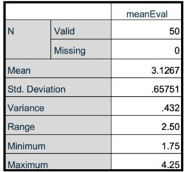

Table 13: Frequency Distribution for Mean Evaluation
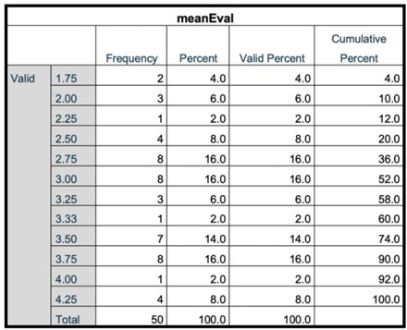
Table 14: Statistics Table for Average and Mean Evaluation
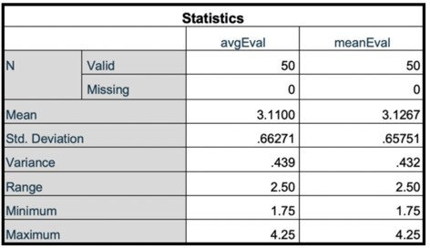

Interpretation of the Findings

Then after interpreting the findings, most students are seen to have a positive evaluation for all the variables in the data. The close resemblance is shared by the statistical data of both the average and the mean. The aveEval mean is 3.11, whereas the meanEval mean is 3.1267. it thus shows that both results are true.

Count the number and types of TV show that each student watches.

Narrative of the Process

I followed the following process to count the number and types of shows each student watches; first, I clicked on the Transform tab, which is on the main menu. I then clicked on count values within cases and typed tvWatched in the Target Variable name box and Tvwatched in the Target label of the new data. To select the Tv shows to be added to the numeric variable, I used the right arrow to make selections. 1 was the value to count, which defined the values, and then I clicked on continue and then OK. From there, I was able to run the descriptive statistics.
Table 15: Statistics for TV watched by Students
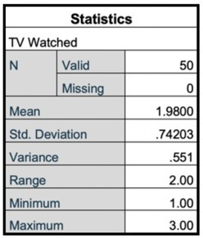
Table 16: Frequency Table for TV Watched by Students
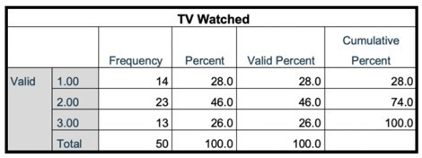

Interpretation of the Findings

Through interpreting the findings, we see that the mean is 1.98, meaning that most students more than one Tv program. Students who watched two or three Tv shows is 72%. No student watches more than three Tv shows.

Recode the “student’s current gpa” into three categories: 1 = 1.00 ‐ 1.99, 2 = 2.00 ‐ 2.99, 3

= 3.00 ‐ 4.00. Produce a Frequency Table for the recoded values.

Narrative of the Process

To recode the data, I clicked on Transform and selected Recode into Different Variables. From the Variable Lists, I selected currgpa and transferred it to the variable using the right arrow key. I then typed CurrentGPA in the output Variable Name. I typed CurrentGPA in the Output Variable Name, and I entered a label name Recorded Current GPA and then clicked on change. To add the new data to the new variables, I clicked on the Old and New Values button. I then identified the values to be recoded in the new window. To finalize, I clicked on continue and then OK.
Table 17: Statistics for Recoded Current GPA
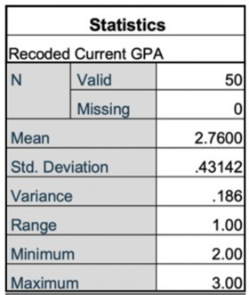
Table 18: Recoded Current GPA

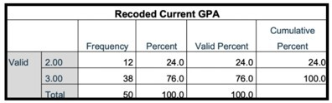

Interpretation of the Findings

Interpreting the findings, we see that most students have attained a GPA of 3.0 and above, which shows that the frequency is 38 for students who have attained a GPA of 3.0 and above.
The mean is 2.760, which ratifies the same.

References

McKendrick, J. H. (2003). Statistical analysis using SPSS. Key Methods in Geography, 425-443. Ghasemi, A., & Zahediasl, S. (2012). Normality tests for statistical analysis: a guide for non-
statisticians. International journal of endocrinology and metabolism, 10(2), 486.

Leech, N., Barrett, K. C. Morgan, G. A. (2005). SPSS for Intermediate Statistics; Use and Inte pretation. Lawrence Erlbaum Associates, Inc.: Mahwah, NJ.

