Leadership
Name
Institutional Affiliation

PART 1
Some of my leadership traits that I have continued to exhibit including improved communication that is focused on handling problems and providing solutions to all problems that have emerged in the workplace. The second leadership trait self-motivation that advances the way I communicate and engage with the followers. The third leadership trait is long term thinking, which is an effective way of ensuring individual engagement in the workplace has been enhanced over time. Being people oriented is also another leadership trait that has helped to advance my ideology and improve my engagement process. This is a trait that has helped to improve the manner in which I engage and communicate with other individuals in the society. Being more confident and improving the level of engagement is an effective leadership trait that has improved the manner I engage and communicate with others in the society (Cicak, 2017).
One of the motives that I have developed as a leader is asking a ton of questions, being accountable and rewarding integrity. These traits have helped to improve my engagement with other people in the workplace. Some of the leadership characteristics that I have tried to exhibit in the workplace include confidence, decision making capabilities, delegation and empowerment for others. I have always tried to exhibit improved engagement and empowerment of others in the society. This has improved the manner in which I engage with others and communicate with them in a more efficient way. I have always tried to inspire confidence, commitment and passion with others. This has been an example of my ability to involve and engage other people in the society. It has been a leadership trait that has helped to inspire my ability to engage and communicate with others in a more efficient manner (Bright & Cortes, 2019).
The most developed leadership quality that I have developed is inspiration for others, improved motivation and appealing vision for others. This has helped to inspire expectations from my followers as an efficient trait that has advanced my engagement process. Team spirit is one of the main elements that are advanced through leadership to improve the roles and responsibilities that advance the leadership traits of others. I have advanced communication skills, accountability skills, ability to motivate and good attitude for others. These traits are effective in advancing more engagement process. I believe that I am a charismatic leader. There are several ways that are used in the development of charismatic leadership traits. This begins by first establishing a clear vision, self-improvement and improved creative process that advances the engagement process. Idealized influence has always advance the ethical conduct and engagement process that improves the manner in which individuals engage with one another (Schuppel, 2014).
PART 2
According to NAEYC standards only a maximum group of 12 children can be kept by caregivers. The maximum ratios in the state of Georgia is that between the ages of 24 to 35 months the ratio is 3:1 with a maximum of 12 children. Between the ages of 3 years the maximum ratio is 7:1 with a maximum group of 12 children. Between the ages of 4 to 5 year olds the ratio is 8:1 for a maximum group of 12 children. Between the ages of 6 to 8 year olds the maximum ratio is 10:1 for a maximum of 12 in terms of group size (Schuppel, 2014).
The NAEYC standards have a major influence on the overall budget outcomes especially when compared to the state licensing regulations. This is due to the fact that the budget outcomes are only offered in accordance to research based on education and development for young children. The standards are helpful in defining the childhood programs, which in turn helps these organizations to shine in an effective way. The core values for NAEYC standards entail the respect for children, families and colleagues. It is clear that the number of children in compared to the adult size is essential for determining of much needed supervision for child to staff ratio and also the number of children that are allowed in terms of their group sizes (Bass & Riggio, 2006).
PART 3:
The following graph demonstrates the nursing and enrolment patterns in the early childhood organization.
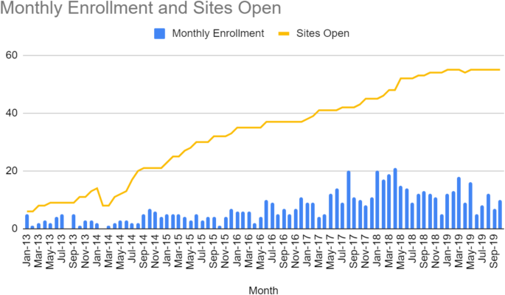
I plan to use the NAEYC standards so as to improve certification of the nursing standards and childhood development. These standards are effective in the improvement of developmental domains and processes for improved learning process. The use of these standards would be effective for advancing the NAEYC as the most improved childhood education. This accreditation system is effective for improvement of professional standards to enhance high quality programs. This NAEYC standards have helped to enhance worth, respect for improvement dignity, improved uniqueness of each individual. This has helped to enhance respect diversity in families, children and colleagues (Schuppel, 2014).
Some of the factors that are essential for determining wage and salary structures for workers. The several factors to consider include cost of living, ability to pay them, the existing supply and demand, productivity and ability to pay. The prevailing market rates are also essential for determining payment rates. These are essential for improved determination of the available payment options for workers. Government regulations are also essential for the determining the wages and benefits (Schuppel, 2014).
The strategies for hiring and employee retention includes offering a competitive benefit and salary. In addition, the focus for hiring process is one of the strategies that help to improve the retention strategies. In addition, training effective leaders and managers. It is also important to clear work objectives and goals and major strategies for improvement of work processes. Offering additional incentives are also important for ensuring employee retention. Reducing employee pain by encouraging competitive salaries and benefits is also major way for improvement of retention of employees (Schuppel, 2014).
The main components that are essential for improvement of policies and management systems that support efficient operations and that focus on the maintenance and improvement of early childhood environment’s. These include the use of small groups, improvement of culturally response environments, and inclusive care. Effective leadership is also a major strategy that needs to improve quality care and management. There is also a need to improve sustainable and sufficient set of funding mechanisms. These are major challenges that help to advance high levels of quality (Schuppel, 2014).
References

Bright, D. S., & Cortes, A. H., (2019). Principles of management. Houston: Texas

Cicak, T. (2017). Factors and characteristics of transformational Leadership. Bingley, U.K.: Emerald
Schuppel, F. (2014). Differences and similarities between charismatic and transformational leadership. Place of publication not identified: GRIN Publishing.

Bass, B. M., & Riggio, R. E. (2006). Transformational leadership. Mahwah, NJ: Lawrence Erlbaum Associates.

