Learning Activity 3 Student Instructions
This learning activity consists of a variety of problems from Chapters 13–15. Spaces for answers are provided; please type your answers directly in the document. Consider highlighting, starring*, or changing the font color of answers for ease of instructor grading.

      - (20 Pts, 1 Pt each). Calculate the mean, median, mode, standard deviation, and range for the following sets of measurements (fill out the table):

- 14, 8, 7, 7, 9
- 20, 13, 12, 11, 9
- 58, 58, 58, 58, 58
- 13, 13, 10, 9, 7, 62

DISTRIB | MEAN | MEDIAN | MODE | SD | RANGE
a. | 9 | 8 | 7 | 2.9155 | 7
b. | 13 | 12 | NA | 4.1833 | 0
c. | 58 | 58 | 58 | 0 | 0
d. | 19 | 11.5 | 13 | 21.1943 | 55

- (20 Pts, 5 pts each) Answer the following questions.

  - Why is the SD in (d) so large compared to the SD in (b)?
This is because the data in d is spread more than the data in b, especially since the data in d has an outlier.

  - Why is the mean so much higher in (d) than in (b)?
The mean in d is affected by the outlier hence it is higher than the mean in b which has no outliers. This is because the mean utilizes all values in a dataset hence extreme values will affect the mean.

  - Why is the median relatively unaffected?
The median is not affected by extreme values as it is the middle number and does not include all values of the data set. This is because it divides the distribution in half.

  - Which measure of central tendency best represents the set of scores in (d)? Why?

The median is the most preferred measure of central tendency as it is not affected by extreme values.
- (4 pts) Determine the semi-interquartile range for the following set of scores.

90, 120, 95, 95, 110, 105, 115, 115, 100, 105, 100, 105
$$Semi-interquartile range=\frac{Q_{3}-Q_{1}}{2}$$
Data from the smalles to the largest is
90, 95, 95, 100, 100, 105, 105, 105, 110, 115, 115, 120
Divide the data set into 4 equal portions
90, 95, 95, | 100, 100, 105, | 105, 105, 110, | 115, 115, 120

$$Q_{1}=\frac{95+100}{2}=97.5$$

$$Q_{3}=\frac{110+115}{2}=112.5$$

$$semi-interquartile range=\frac{112.5-97.5}{2}=7.5$$

- (24 pts, 2 pts each) Fill in the blanks on the table with the appropriate raw scores, z-scores, T-scores, and approximate percentile ranks. You may refer to the distribution curve below.

Note: the Mean = 50, SD = 5.
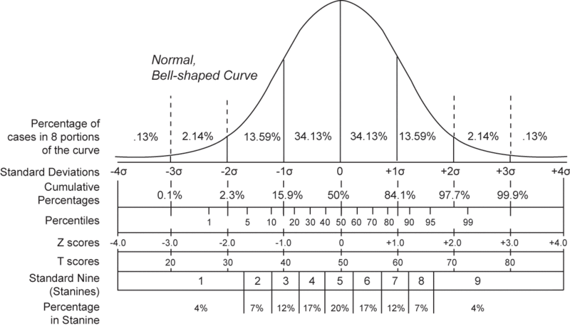

RAW | z | T | Percentile
30 | -4 | 10 | 0
65 | 3 | 80 | 99.7
57.5 | 1.5 | 65 | 93.3
38.5 | -2.3 | 27 | 1.07

- (4 pts, 2 pts each) The following are the means and standard deviations of some well-known standardized tests, referred to as Test A, Test B, and Test C. All three yield normal distributions.
Test | Mean | Standard Deviation
Test A | 500 | 100
Test B | 150 | 8
Test C | 70 | 15
- (2 pts) A score of 450 on Test A corresponds to what score on Test B?
$$z=\frac{x-μ}{σ}=\frac{450-500}{100}=-0.5$$
$$x=z*\left(σ\right)+μ=-0.5*\left(8\right)+150=146$$
A score of 450 on Test A corresponds to a score of 146 on Test B

- (2 pts) A score of 625 on Test A corresponds to what score on Test C?
$$z=\frac{x-μ}{σ}=\frac{625-500}{100}=1.25$$
$$x=z*\left(σ\right)+μ=1.25*\left(15\right)+70=88.75$$
A score of 625 on Test A corresponds to a score of 88.75 on Test C

- (12 pts, 2 pts each) The Graduate Record Exam (GRE) has a combined verbal and quantitative mean of 1000 and a standard deviation of 200. Scores range from 200 to 1600 and are approximately normally distributed. For each of the following problems:

- Indicate the percentage or score called for by the problem.
- Select the appropriate distribution curve (from below) that relates to the problem.

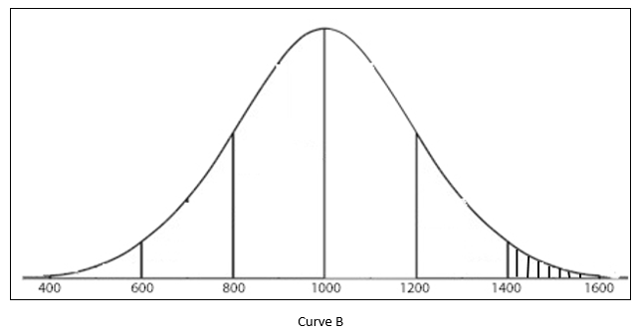
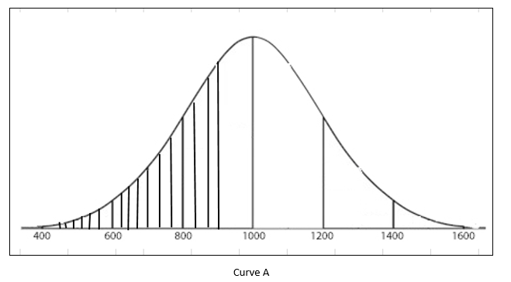

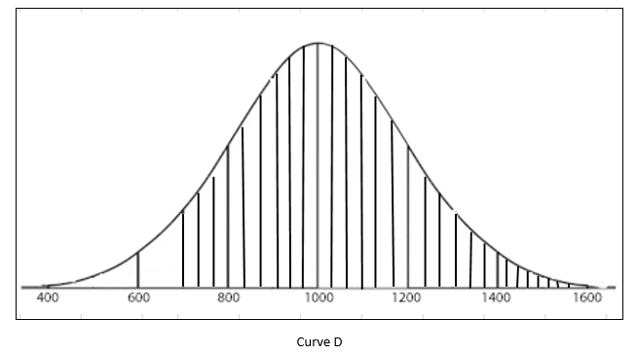
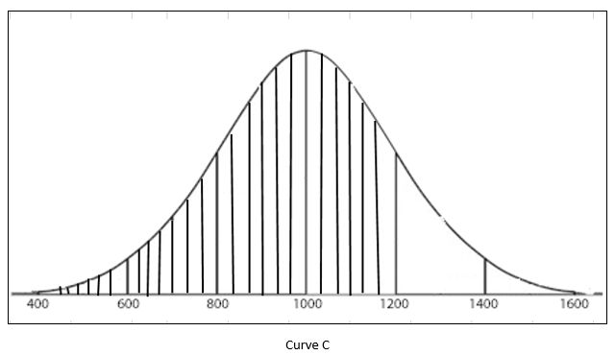

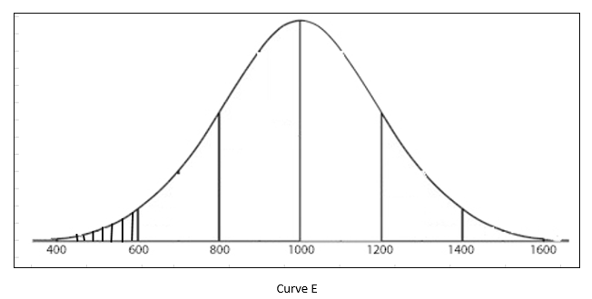

      - (2 pts) What percentage of the persons who take the test score above 1400? _2.28__

(2 pts) Type the curve best representing your answer: ___Curve B

      - (2 pts) What percentage of the persons who take the test score above 700? __93.32_

(2 pts) Type the curve best representing your answer: __Curve D_

      - (2 pts) Below what score do the bottom 30.9% of the test-takers score? _900.26__

(2 pts) Type the curve best representing your answer: __Curve A_

- (16 pts, varied) Refer to the following data and scatterplots to respond to questions 7a-f.

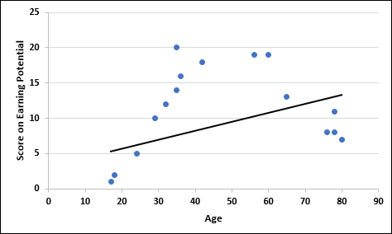
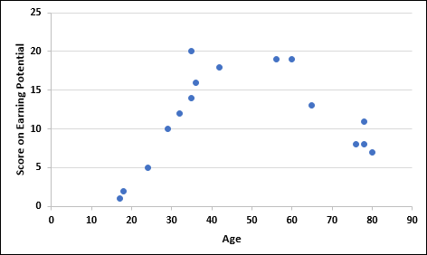
Figure B
Figure A
Individual | Age | Score on Earning Potential
1 | 24 | 5
2 | 56 | 19
3 | 78 | 8
4 | 76 | 8
5 | 80 | 7
6 | 35 | 14
7 | 32 | 12
8 | 42 | 18
9 | 18 | 2
10 | 17 | 1
11 | 35 | 20
12 | 36 | 16
13 | 29 | 10
14 | 60 | 19
15 | 65 | 13
16 | 78 | 11

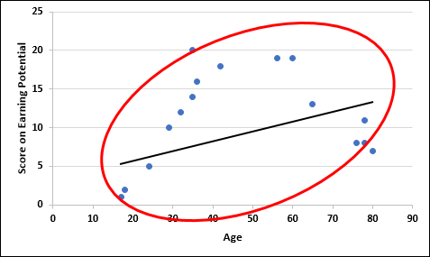
Figure C

Figure A represents a scatterplot constructed from the data; Figure B represents a regression line drawn through the scatterplot that “fits” the data points reasonably well; Figure C represents an ellipse drawn around the data points.

a. (2 pts.) What is the overall direction of the correlation? _Positive__

b. (2 pts.) Estimate the strength of the correlation coefficient: __Weak_

Consider Figure D (below).
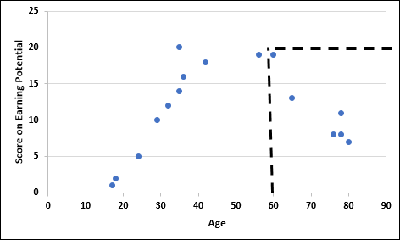
Figure D

c. (2 pts.) Using only the data points associated with age of 60 and above; what effect does this have on the direction and strength of the correlation coefficient?
The direction changes to negative and the strength increases.

d. (4 pts.) Explain why this is the case.
This is because the data curves and changes direction at the age of 60.

e. (2 pts.) Why is it beneficial to examine truncated parts of this graph instead of the graph as a whole?
It is beneficial since earning potential changes with age. Most persons 60 and above are retired and their earning potential declines as they get much older.
f. (4 pts.) Identify how likely it is that a causal relationship has been indicated.
While it seems that age affects earning potential, it is not likely that a causal relationship has been identified since correlation does not necessarily mean causation. Age could be one factor that has an effect on earning potential but there are other confounding factors such as ailments associated with age. The only way to prove causation is through a controlled experiment.

Submit Learning Activity 2 by 11:59 p.m. (ET) on Sunday of Module/Week 5.

