Thin Lenses

Name: ____________________________
Ray Diagrams for Converging Lenses
Figure (a) shows how a ray diagram is used to construct the image of an object located at a distance greater than the focal length of the converging lens. F and F’ are the focal points of the lens. Object is labeled as O and image as I. The height of the object is h_{o} and image height is h_{i}.
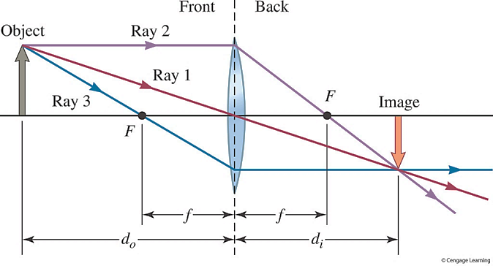
Figure (a)
Figure (b) shows how a ray diagram is used to construct the image of an object located at a distance less than the focal length of the converging lens.
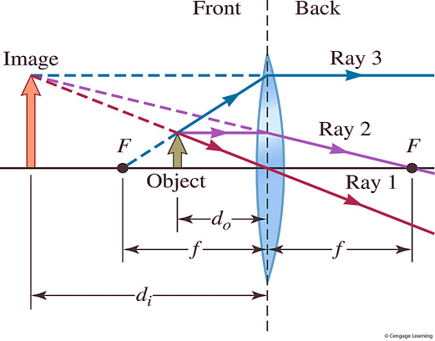
Figure (b)
The magnification M is defined as: $M= \frac{h_{i}}{h_{o}}=-\frac{d_{i}}{d_{o}}$
If d_{i} is +, the image is real.
If d_{i} is -, the image is virtual.
If M is +, the image is upright. If $\left|M\right|>1,$ the image is enlarged.
If M is -, the image is inverted. If $\left|M\right|<1,$ the image is reduced in size.

Open the simulation:
https://phet.colorado.edu/sims/geometric-optics/geometric-optics_en.html
If your computer does not have Flash Player 8, it will show you a “Get Adobe Flash Player”, click on it and install it on your computer.
You will see a pencil on the left (that is the object), a lens in the middle and the image of the pencil on the right hand side.
Step 1: Click on the button “Change Object” three times and the pencil will be replaced by an arrow. We will use the arrow as an object for the rest of this lab. On the top left menu click on the “Principal Rays”. Drag the “diameter” slider to the right and make it maximum (1.3). Check the ruler box, and place the ruler aligned with the principal axis (the horizontal line that goes through the center of the lens) wih its 0 at the lens. Drag the arrow to the right towards the focal point of the lens (marked with a X), alos move it up so that the bottom left edge of the arow is touching the pricipal axis, keep moving the object to the right until the image of the bottom edge of the arrow is touching the end of the ruler (200 cm mark). Now your simulation set up should look like the picture below.
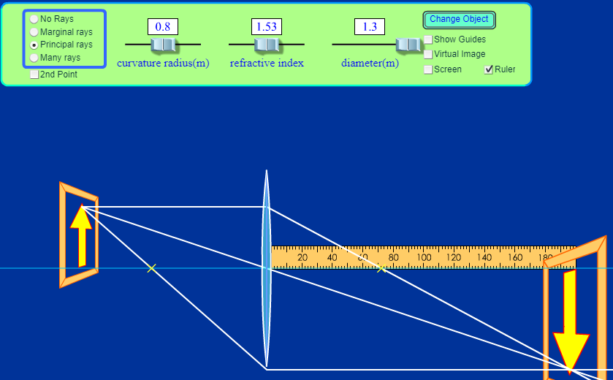
Step 2: d_{i} – the distance between the image and the lens d_{i} = 200 cm

Drag the ruler to the left and measure the distance between the bottom edge of the arrow (that is touching the principal axis) and the lens. This is the object distance.

d_{o} – the distance between the object and the lens d_{o} = 100cm
Step 3: Use the lens equation below to obtain the focal length. Show all your work below.

$$\frac{1}{d_{o}}+\frac{1}{d_{i}}=\frac{1}{f}$$

$$\frac{1}{f}=\frac{1}{200}+\frac{1}{100}$$

$$\frac{1}{f}=\frac{15}{1000}$$

f = 66.67

Focal length of the converging lens: f = 66.67

Step 4: Repeat this exercise two more times for different values of d_{o} by moving the object to the left, and find the average focal length from these measurements. Show all your work below.

$$\frac{1}{f}=\frac{1}{180}+\frac{1}{108}$$

$$\frac{1}{f}=\frac{148}{10000}$$

f = 67.50

Second measurement: f = 67.50

$$\frac{1}{f}=\frac{1}{150}+\frac{1}{124}$$

$$\frac{1}{f}=\frac{147}{10000}$$

f = 67.88

Third measurement: f = 67.88
Average focal length: f (experiment) = _____67.35_____ cm = ______0.6735____ m (1 m = 100 cm)
Find the power of the lens in diopters: P = 1/f = ____1.485______ D (remember 1 D = 1/m)
Step 5: Now you will use the lens maker equation to find the theoretical focal length.
$$\frac{1}{f}=(n-1)\left(\frac{1}{R_{1}}+\frac{1}{R_{2}}\right)$$
Refractive index of the lens material as well the radius of curvature are given on top of the simulation. In this case we are using a lens that has the same radius of curvature for both sides, i.e. R₁ = R₂
n = 1.53
R₁ = R₂ = 0.8 m = 80 cm
Use the lens maker equation to calculate the focal length f. Show all your work below.

$$\frac{1}{f}=(1.53-1)\left(\frac{1}{80}+\frac{1}{80}\right)$$
$$\frac{1}{f}=\left(0.53\right)(0.0250)$$
$$\frac{1}{f}=0.01325$$
f (theory) = 75.47
Step 6: Find the percent error. Show all your work below.
$$\% error= \left|\frac{f\left(theory\right)-f(experiment)}{f(theory)}\right| x 100$$
$$\% error= \left|\frac{75.47-67.88}{75.47}\right| x 100$$

$\% error=$ ______10.06%________
Step 7: Let’s make a prediction without using the simulation. Where would be the image if you placed the object in front of the lens at a distance of 320 cm, keeping the same focal length that we got in Step 5 above?
f = 75.47 cm
d_{o} = 320 cm
Use the lens equation to predict the image distance d_{i} from the lens. Show all your work below.

$$\frac{1}{d_{o}}+\frac{1}{d_{i}}=\frac{1}{f}$$

$$\frac{1}{di}=\frac{1}{f}-\frac{1}{do}$$

$$\frac{1}{di}=\frac{1}{75.47}-\frac{1}{320}$$

$\frac{1}{di}$ = 0.0101

d_{i} (prediction) = 98.76 cm
Is d_{i} positive or negative?

Your answer:
Positive

Based on the rules described on the first page of this handout, do you think that the image would be real or virtual?

Your answer (prediction):
The image is real.

Now calculate the magnification. Show all your work.
$$M=-\frac{d_{i}}{d_{o}}$$
$$M=-\frac{98.76}{320}$$

M (prediction) = - 0.31
Based on the rules described on the first page of this handout, do you think that the image would be upright or inverted?

Your answer:
The image is inverted.

Based on the rules described on the first page of this handout, do you think that the image would be smaller or bigger than the object?

Your answer:
The image is smaller than the object.

Step 8: Now you will test your predictions by performing the experiment. Go back to the simulation and place the object (the arrow) at a distance of 320 cm from lens. Measure the object distance accurately to make sure that it is exactly 320 cm. (the ruler is only 200 cm long but if you are creative you can use it to measure distances larger than 200 cm).
Explain how did you measure the distance of 320 cm even though the ruler is 200 cm long?
Your answer:
I measured the first 200 cm then marked the end point of the ruler. I then measured another 120cm from the end point of the first measurement of 200cm.

Use the ruler to measure the image distance now.
d_{i} (experiment) = 90 cm
How close was your prediction to the experimental value of the image distance?
Your answer:
It had a difference of 8.76 cm

Is the image real or virtual? How do you know if it is real or virtual? Was your prediction correct?
Your answer:
The image is real.
This is because the image is placed outside the focal length.
Yes, my prediction was correct.

Is the image upright or inverted? Is it smaller or larger than the object? Were your predictions of the two correct?
Your answer:
The image is inverted.
The image is smaller than the object.
Yes, my prediction was correct.

Step 9: Let’s make another prediction without using the simulation. Where would be the image if you placed the object in front of the lens at a distance of two third the focal length, keeping the same focal length that we got in Step 5 above?
f = 75.47 cm
d_{o} = (2/3) f = 50.31 cm
Use the lens equation to predict the image distance d_{i} from the lens. Show all your work below.

$$\frac{1}{d_{o}}+\frac{1}{d_{i}}=\frac{1}{f}$$

$$\frac{1}{di}=\frac{1}{75.47}-\frac{1}{50.31}$$

$$\frac{1}{di}=- 0.0066$$

d_{i} (prediction) = -150.91 cm
Is d_{i} positive or negative?

Your answer:
It is negative.

Do you think that the image would be real or virtual?

Your answer (prediction):
Virtual.

Now calculate the magnification. Show all your work.
$$M=-\frac{d_{i}}{d_{o}}$$
$$M=-\frac{-150.91}{50.31}$$

M (prediction) = 3.00
Do you think that the image would be upright or inverted?

Your answer:
The image is upright.

Do you think that the image would be smaller or bigger than the object?

Your answer:
The image is bigger than the object.

Step 10: Now you will test your predictions by performing the experiment. Go back to the simulation and place the object (the arrow) at a distance of (2/3)f from lens. Using the ruler, measure the object distance accurately to make sure that it is exactly (2/3)f.
Do you see an image?
Yours answer:
No.

Remember that in all the previous examples that we have looked at so far, the image was created where the light rays meet after passing through the lens. Do the light rays converge or diverge after passing through the lens in this case?
Your answer:
The light rays diverge.
Check “Virtual Image” box on the top menu. You will see the image now.
Use the ruler to measure the image distance.
d_{i} (experiment) = - 220 cm
How close was your prediction to the experimental value of the image distance?
Your answer:
There was a difference of 69.09 cm
Paste a picture (or screenshot) of the simulation in the space below.

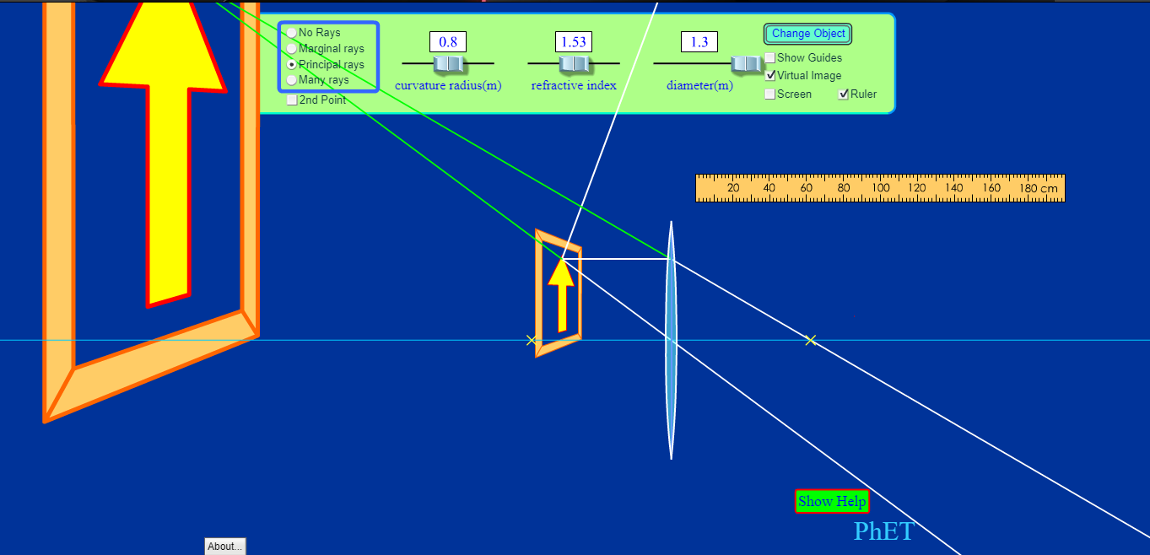

Is the image real or virtual? How do you know if it is real or virtual? Was your prediction correct?
Your answer:
The image is virtual.
The image is virtual because it appears on the same side as the object.
Yes, my prediction was correct.

Is the image upright or inverted? Is it smaller or larger than the object? Were your predictions of the two correct?
Your answer:
The image is upright.
The image is larger than the object.
Yes, my predictions were correct.

